msfvenom --payload linux/x86/exec –payload-options
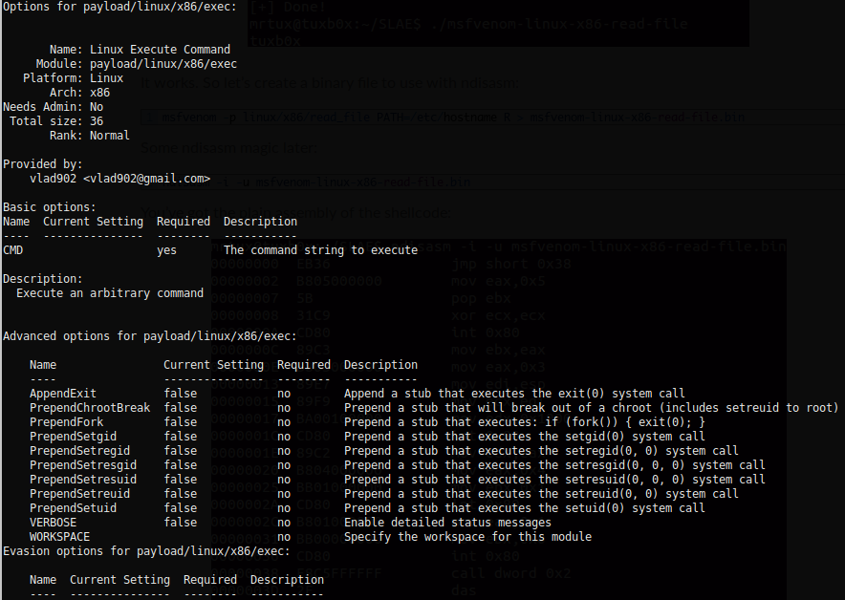
msfvenom --payload linux/x86/exec CMD='cat /etc/passwd' --arch x86 --platform linux --format raw | ndisasm -i -u -

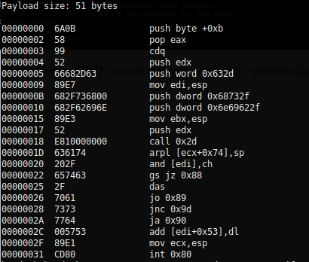

echo -ne "\x57\x53\x89\xe1\xcd\x80" | ndisasm -u -

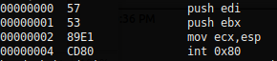

execve ‘/bin/sh -c’

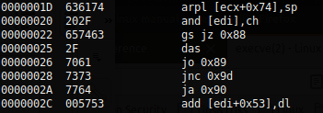

>>> '636174202f6574632f706173737764'.decode('hex')

'cat /etc/passwd'

