VERSION 1
REFERENCES 1
SCOPE 1
INTRODUCTION 1
1. Functions 2
2. MIPS 3
2.1 xDSL Summary sheet 3
2.2 ADSL detaiiled 4
2.3 MIPs per function types 5
3. References 9
3.1.1 Carmel article 9
3.1.2 M3-8 9
3.1.3 FILU-DMT on G.LITE 10
3.1.4 ADSL, VDSL ATU-R on C62x 11

VERSION
1.7 <4-Oct-00 > creation
1.7 <23-Oct-02 > from d_dsl.doc to a reclassified dap_dsl.doc

REFERENCES
- Carmel
- Systemonic
- Massana FILU
- C62x

SCOPE

INTRODUCTION

Functions
Line coding @ Sampling rate (2*276Khz Tx 2.2mhz RX )
Line coding @ frame rate (4Khz)

Rx HPF 2 biquads | Rx TEQ 24 coef | Rx FFT 512 real pts | Rx FEQ 256 cplx pts | Rx Demapper/Treillis decoder | Rx FEC = DeScrambler, RS decoder, DeInterleaver
Tx HPF 2 biquads | Tx Gain scaling | Tx IFFT 64 real pts | Echo cancellation - done in frequency domain | TX Mapper, Treillis coder | Tx FEC = Scrambler, RS encoder, Interleaver

MIPS

xDSL Summary sheet
 | DSP MIPS
ADSL (8M/768K) | 500 | TI (7* mdsl)
ADSL (8M/768K) | 500 | dresden
ADSL (8M/768K) | 600 | DFM
MDSL | 70 | C54x seattle
HDSL (2M/2M) | 250 | dresden
SDSL (2M/2M) | 300 | dresden
VDSL (52M/13M) | 3000 | 6 * ADSL

ADSL detaiiled

 | ADSL Function Name | DSP MIPS
Channel coding | Tx FEC = Scrambler, RS encoder, Interleaver, Mapper, Treillis coder | 30
Channel coding | Rx FEC = DeScrambler, RS decoder, DeInterleaver | 100-200
Line coding @ Sampling rate (2*276Khz Tx  2.2mhz RX ) | Tx HPF 2 biquads 16x32 | 9
Line coding @ Sampling rate (2*276Khz Tx  2.2mhz RX ) | Rx HPF 2 biquads 16x32 | 35
Line coding @ Sampling rate (2*276Khz Tx  2.2mhz RX ) | Rx TEQ 24 coef 16x16 | 53
Line coding @ frame rate (4Khz) | Tx Gain scaling | 1
Line coding @ frame rate (4Khz) | Tx IFFT 64 real pts 16x32 | 8
Line coding @ frame rate (4Khz) | Rx FFT 512 real pts - 16x32 | 35
Line coding @ frame rate (4Khz) | Rx FEQ 256 cplx pts 16x32 | 8
Line coding @ frame rate (4Khz) | Rx Demapper/Treillis decoder | 70
Line coding @ frame rate (4Khz) | Echo cancellation - done in frequency domain | 35
Total Channel coding |  | 130-230
Total Line coding frame rate (incl. EC) |  | ~90
Total Line coding frame rate (incl. EC + viterbi decode) |  | ~160
Total Line coding at Sampling rate |  | ~100
TOTAL |  | 390-490
Total DSP MIPS available on Carmel 2025 @ 240Mhz (1) |  | ~600
Total DSP MIPS available on Carmel 2025 @ 200Mhz (2) |  | ~400
(1) Carmel == 2.5 DSP MIPS/Mhz (2) Carmel = 2 DSP MIPS/Mhz

 |  |  | References
FULL RATE ADSL  FFT+IFFT+TEQ+FEQ | 70 | 70-90 | MACQ
G.LITE  FFT+IFFT+TEQ+FEQ | 32

MIPs per function types
Name |  | Details | MIPS
TX CRC check
TX Scrambler |  |  | 30 <C62x>
TX RS FEC encoder |  |  | 30 <C62x>
TX Interleaver |  |  | 30 <C62x>
TX Mapper/treillis |  |  | 30 <C62x>
Rx Deinterleaver |  |  | 175-275 <C62x>
Rx RS FEC decoder |  |  | 175-275 <C62x>
Rx Descrambler |  |  | 175-275 <C62x>
Rx CRC check
Tx Viterbi(Treillis coding)
Tx Mapper
Tx Gain scaling |  |  | 1 <C6x>
Tx ROTOR |  | 128 pts | 2 (4*N +25) <filu> | only FILU
Tx IFFT | (ATU-C G.Lite) | 256 real pt
Tx IFFT | (ATU-C G.dmt) | 512 real pt
Tx IFFT | (ATU-R) | 64 real pt | 8 <C6x>
Tx HPF | (ATU-C) | 2 -> 4 biquads | 8.8 --> 17.6 <RF> (1) (3)
Rx HPF | (ATU-C) | 2 -> 4 biquads | 35 --> 52 <RF> (2)(3) | only RF
Rx TEQ |  | 256 pts - 20 coef | 20 <filu>
Rx TEQ |  | 24--> 32 coef | 53 --> 70 <RF> (2)
Rx TEQ |  | ? | 8 <tlab> 4 <C62x>
Rx TEQ |  | 256 pts- 16 coef | 34 <C62x>
Rx FFT | (ATU-R ) | 512 real pt 16x32 | 36 <C62x>
Rx FFT | (ATU-R ) | 512 real pt 16x16 | 26 <Carmel>
Rx FFT | (ATU-R G-Lite) | 256 real pt | 6 <filu>
Rx FEQ |  | 128 pts | 1.6 <filu>
Rx FEQ |  | 256 complex pts <datapath> | - <DFM>  2.4 <tlab>
Rx FEQ |  | 256 cplx mul 16*32 | 8 <carmel>
Rx ROTOR |  | 128 pts | 4 <filu>
Rx demapper/Viterbi |  |  | 70 <Carmel>
EC |  |  | 40 --> 80 <C6x>
TEC |  | TEC 60-->120 coefs | 66 --> 133 <RF>
FreqEC |  |  | 4 <Carmel>
Circular echo synthesizer |  |  | 28 <Carmel>
EC |  |  | 3.2 <Tlab>
EC update |  |  | 4 <Tlab>
FFT 64 pts |  |  | 8 <Tlab>
- 552Khz ( 2 B channels)
- 2.208Mhz
- i used 14*32 bit = 2 cycles contrary to Rudi frenzel with 4/6 cycles

TX
 | (Filu-200)  GLITE | M3-8  or M3-16 | TI C6x  ATU-C | MACQ
CRC check |  | 330
Scrambl/descrambl |  | 700
FEC enc/dec |  | 200
Interlever/deinterlv |  | 350
Treillis coding
Mapper |  |  |  | ?
Tx processing |  |  | 1629
tone ordering |  | 400
Modulation |  | 250
IFFT |  | 100 | 5000 | ?
i/o |  | 75
overhead |  | 500

RX
 | (Filu-200)  GLITE | M3-8  or M3-16 | TI C6x  ATU-C | MACQ
CRC check |  | 330
Scrambl/descrambl |  | 700
FEC enc/dec |  | 200
Interlever/deinterlv |  | 350
TEQ  256 pts - 20 coef  N*(p+2)/2 + 15 | 2831 | 750 | 1030
FEQ  128 pts - 3*N + 8 | 392 | 750 | 320
FFT 256 pts - | 1566
FFT 512 pts - |  | 500 | NA
ROTOR 128 pts - (4*N +25) | 537
tone ordering/deordering |  | 400
Modulation/demod |  | 250
Rx processing |  |  | 194
OAM&P |  |  | 500
R/W 512 pts | 256 | 500

EC |  |  | 194
EC update |  |  | 500
FFT 64 pts - |  |  | 760

Now everything is turned into MIPS
All cycles must be multiplied by 4khz.
Then multiplied by 2 for dual MAC and by 8 for M3-8
 | (Filu-200)  GLITE | M3-8  or M3-16 | TI C6x  ATU-C | MACQ
TEQ | 20 | 24 | 8
FEQ | 3.2 | 24 | 2.4
IFFT 512 pts - |  | 32 | 40
FFT 64 pts | 6? | 6? | 6
FFT 256 pts | 13
FFT+IFFT+TEQ+FEQ |  |  |  | 70-90
Tx processing |  |  | 13
Rx processing |  |  | 0.8
ROTOR 128 pts - (4*N +25) | 4
FFT+IFFT+TEQ+FEQ | 46 | 85 | 70 | 70-90
Other DSP functions |  |  |  | 20-50

EC |  |  | 3.2
EC update |  |  | 4
FFT 64 pts - |  |  | 8

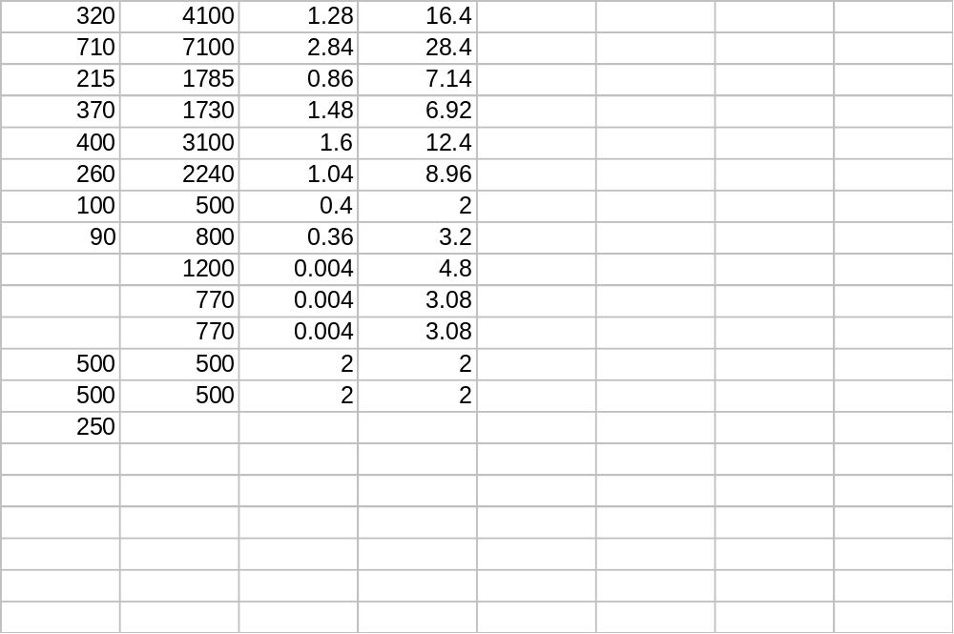

References

Carmel article
 | cycles | DSP MiPs | Carmel cycles | Carmel Mhz
TEQ 16 tap | 16 | 32 |  | 16
FFT 256pt cplx + 1 added stage | 8000 | 32 | 3320 | 13.2
FEQ 256 cplx mul 16*32 | 2048 | 8 |  | 4
FEC 256 cplx mul 16*16 precision | 1024 | 4 |  | 2
CES Circular echo synthesizer  (part of EC) | 7000 | 28 |  | 14
Adaptation of FEQ (dppr) and FEC
Viterbi decoder |  |  |  | 35
HPF

M3-8
 | cycles | Mhz
 |  | TX
CRC check |  | 1.3
Scrambl/descrambl |  | 2.8
FEC enc/dec |  | 0.8
Interlever/deinterlv |  | 1.4
tone ordering/deordering |  | 1.6
Modulation/demod |  | 1.0
idft/dft |  | 0.4
i/o |  | 0.3
Ec |  | 0
time equalizer |  | 0
frequency equalizer |  | 0
overhead |  | 2
 |  | Rx
CRC check |  | 16.4
Scrambl/descrambl |  | 28.4
FEC enc/dec |  | 7.1
Interlever/deinterlv |  | 6.9
tone ordering/deordering |  | 12.4
Modulation/demod |  | 8.9
idft/dft | 500 | 2.0
i/o | 800 | 3.2
Ec | 1200 | 4.8
time equalizer | 785 | 3.1
frequency equalizer | 785 | 3.1
overhead | 500 | 2.0
M3-8 (8 MAC) @100Mhz + 44 MIPs of I/O controller

FILU-DMT on G.LITE
RX tasks | cycles | Mhz = cycles*4Khz
TEQ  256 pts - 20 coef  N*(p+2)/2 + 15 | 2831 | 11.2
FEQ  128 pts - 3*N + 8 | 392 | 1.6
FFT 256 pts - | 1566 | 6
ROTOR 128 pts - (4*N +25) | 537 | 2.1
R/W 512 pts | 256 | 1
total | 5582 | 21.9
Filu-DMT = Filu-200 @100 Mhz
It is a dual MAC ; we can give 2-DSP MIPS per MHz

ADSL, VDSL ATU-R on C62x
 | ADSL |  | VDSL
Name | DSP MIPS | C6x cycles  C6x MIPS | DSP MIPS | C6x cycles  C6x MIPS
Tx FEC  Scrambler, RS encoder, Interleaver, Mapper/Treillis decoder | 30  (4 ALU) | 60 | 300 | 600
Rx FEC  DeScrambler, RS decoder, DeInterleaver, DEmapper/Treillis decoder | 175-275  (2 viterbi)  (4 ALU) | 350-550 | 800 | 1600
Tx gain scaling | 0.25 | 1 | 8.5 | 33
Tx IFFT 16x32 | 8 | 32 | 400 | 1600
Tx Windowing | 0 | 0 | 1 | 4
Rx TEQ | 4 | 8 Mhz | 0 | 0
Rx Windowing | 0 | 0 | 1 | 4
Rx FFT 16x32 | 36 | 18Mhz | 400 | 1600
Rx FEQ | 4 | 16 | 16 | 64
EC | 40-80 | 160-320 | 0 | 0
2048 tones , 8.832 Mhz , symmetric 26Mbit/s; half tone in each direction

