Audit Quiz Application

Report



Table of Contents

Introduction 3

Executive Summary 4

Final Result 4

Overview of answers soundness 5

Main remediations 7

Category 1 8

Result 8

Gap analysis 8

Remediations 8

Category 2 9

Result 9

Gap analysis 9

Remediations 9

Appendix 10

Section: Section 1 10

Section: Section 2 13

Section: Section 3 15

# Introduction

… hardcoded blabla …

# Executive Summary

## Final Result

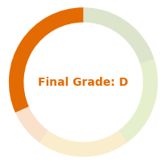

basic expectations are not met

This outcome stems from the following results per category:

* **Category 1:** your answers point substantial weaknesses regarding x and y, significant efforts should be put to address them
* **Category 2:** your answers point substantial weaknesses regarding z ant t, significant efforts should be put to address them

## Overview of answers soundness

* + 1. **View by Category:** As detailed in following chapters, each category addresses several points of interest and compile relevants items along the sections in the questionnaire. The figure below represents the grade achived for each category.

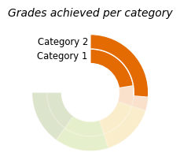

* + 1. **View by Section:** Sections are the various topics tackled in the questionnaire. The figure below represents the grade achieved for each section.

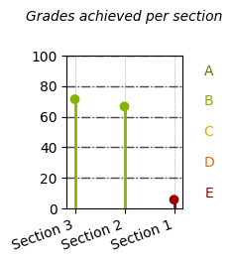

* + 1. **View by Items:** This last figure represents answers soundness regarding all items in the questionnaire. An answer has one of the 4 states:
* Ok: when the answer meet all expectations
* Partial: when the answer is partially suitable
* Ko: when the answer is not suitable
* Not answered: when client skipped the question

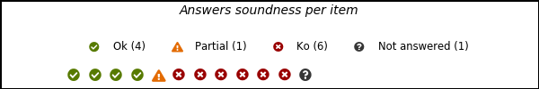

## Main remediations

Client is advised to apply remediations detailed in subsequent chapters, the major ones being listed in the table below.

|  |  |  |
| --- | --- | --- |
| Section | Priority | Remediation |
| Category 1 | | |
| Section 1 | high | Implement Option 1 |
| medium | Implement Z properly |
| Category 2 | | |
| Section 1 | high | Implement Z properly |
| Section 3 | medium | Implement Option 1 |

# Category 1

## Result

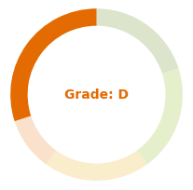

## Gap analysis

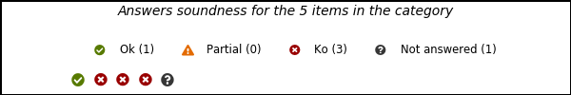

|  |  |
| --- | --- |
| **Section** | **Observations** |
| Section 1 | * Option 2 is not suitable for ... * Z is not suitable for ...: x is ... and y is ... * Information about X is missing |
| Section 2 | * Option 2 is not suitable for ... |
| Section 3 | * Option 1 is suitable for ... |

## Remediations

|  |  |  |
| --- | --- | --- |
| Section | Priority | Remediation |
| Section 1 | high | Option 1 must be implemented |
| medium | Z should be implemented properly, with x in ... and y in ... |
| low | Option 1 must be implemented |
| Section 2 | low | Option 1 must be implemented |

# Category 2

## Result

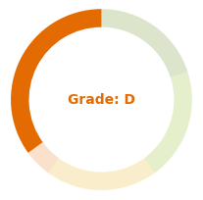

## Gap analysis

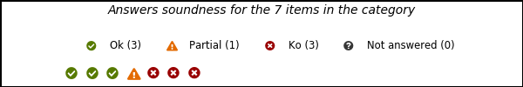

|  |  |
| --- | --- |
| **Section** | **Observations** |
| Section 1 | * Z is implemented, with ... but is lacking of ... * X configuration is not suitable for ... * Z is not suitable for ...: x is ... and y is ... |
| Section 2 | * Option 1 is suitable for ... * X is properly listed, with all element expected as col1, and all configured suitably for ... |
| Section 3 | * Option 2 is not suitable for ... * Option 1 is suitable for ... |

## Remediations

|  |  |  |
| --- | --- | --- |
| Section | Priority | Remediation |
| Section 1 | high | Z should be implemented properly, with x in ... and y in ... |
| low | X should be configured properly, with all col2 in ... |
| low | Z should be implemented properly, with x in ... and y in ... |
| Section 3 | medium | Option 1 must be implemented |

# Appendix

1. The appendix contains all questionnaire items per section, client answers as well as side notes if any.

## Section: Section 1

### Group 1

Introduction of items under section 1 - group 1.

* What
* Why those items

|  |
| --- |
| **Client comments:**  pouet |

**Item 1: ... question ...**

|  |
| --- |
| * selected: option 2 * other options: option 1, option 3 |

**Item 2: ... question ...**

|  |
| --- |
| foo |

**Item 3: ... question ...**

|  |  |
| --- | --- |
| **Column 1** | **Information** |
| bar1 | * Column 2:   + selected: option b   + other options: option a, option c |
| bar2 | * Column 2:   + selected: option a   + other options: option b, option c |
| bar3 | * Column 2:   + selected: not answered   + other options: option a, option b, option c |

### Group 2

Introduction of items under section 1 - group 2.

* What
* Why those items

|  |
| --- |
| **Client comments:**  none |

**Item 1: ... question ...**

|  |
| --- |
| blabla |

**Item 2: ... question ...**

|  |
| --- |
| blibli |

### Group 3

Introduction of items under section 1 - group 3.

* What
* Why those items

|  |
| --- |
| **Client comments:**  none |

**Item 1: ... question ...**

|  |
| --- |
| * selected: not answered * other options: option 1, option 2, option 3 |

## Section: Section 2

### Group 1

Introduction of items under section 2 - group 1.

* What
* Why those items

|  |
| --- |
| **Client comments:**  none |

**Item 1: ... question ...**

|  |
| --- |
| * selected: option 2 * other options: option 1 |

### Group 2

Introduction of items under section 2 - group 2.

* What
* Why those items

|  |
| --- |
| **Client comments:**  none |

**Item 1: ... question ...**

|  |
| --- |
| * selected: option 1 * other options: option 2, option 3 |

**Item 2: ... question ...**

|  |  |
| --- | --- |
| **Column 1** | **Information** |
| meow | * Column 2:   + selected: option a   + other options: option b, option c |
|  | * Column 2:   + selected: not answered   + other options: option a, option b, option c |
|  | * Column 2:   + selected: not answered   + other options: option a, option b, option c |

## Section: Section 3

### Group 1

Introduction of items under section 3 - group 1.

* What
* Why those items

|  |
| --- |
| **Client comments:**  none |

**Item 1: ... question ...**

|  |
| --- |
| * selected: option 1 * other options: option 2 |

### Group 2

Introduction of items under section 3 - group 2.

* What
* Why those items

|  |
| --- |
| **Client comments:**  none |

**Item 1: ... question ...**

|  |
| --- |
| * selected: option 2 * other options: option 1 |

### Group 3

Introduction of items under section 3 - group 3.

* What
* Why those items

|  |
| --- |
| **Client comments:**  none |

**Item 1: ... question ...**

|  |
| --- |
| * selected: option 1 * other options: option 2 |