Concurrent and Parallel Systems Assignment – High Throughput TCP Forum Server

Evaluation Report

By Jacob Whitehead

# Experiment Descriptions

# Analysis and Interpretation of Data

# Future Server Improvements

# Investigation Into Factor That Influence Throughput

|  |  |  |  |  |  |  |  |
| --- | --- | --- | --- | --- | --- | --- | --- |
| Poster thread count | Total post requests | Total post thread run time (s) | Average post requests per second per thread | Reader thread count | Total read requests | Total read thread run time (s) | Average read requests per second per thread |
| 1 | 198408 | 10 | 19840.8 | 1 | 215634 | 10.0092 | 21543.6 |
| 1 | 198972 | 10 | 19897.1 | 1 | 198052 | 10 | 19805.1 |
| 1 | 195713 | 10.0001 | 19571.2 | 1 | 185547 | 10 | 18554.7 |
| 1 | 196135 | 10 | 19613.4 | 1 | 195397 | 10 | 19539.7 |
| 1 | 196871 | 10 | 19687.1 | 1 | 195058 | 10 | 19505.8 |
| 1 | 200002 | 10 | 20000.2 | 1 | 199271 | 10 | 19927 |
| 1 | 200774 | 10 | 20077.4 | 1 | 199878 | 10 | 19987.8 |
| 1 | 199209 | 10 | 19920.8 | 1 | 197703 | 10 | 19770.3 |
| 1 | 205486 | 10 | 20548.6 | 1 | 203780 | 10 | 20378 |
| 1 | 200313 | 10 | 20031.2 | 1 | 197087 | 10 | 19708.6 |

Mean read requests per second: 19872.06

Mean post requests per second: 19918.78

Total threads: 2

Mean total requests per second: 19895.42

|  |  |  |  |  |  |  |  |
| --- | --- | --- | --- | --- | --- | --- | --- |
| Poster thread count | Total post requests | Total post thread run time (s) | Average post requests per second per thread | Reader thread count | Total read requests | Total read thread run time (s) | Average read requests per second per thread |
| 2 | 315978 | 20 | 15798.9 | 2 | 302102 | 20 | 15105.1 |
| 2 | 315603 | 20.0001 | 15780.1 | 2 | 304014 | 20.0001 | 15200.6 |
| 2 | 303702 | 20 | 15185.1 | 2 | 297774 | 20.0001 | 14888.7 |
| 2 | 313196 | 20.0001 | 15659.7 | 2 | 300931 | 20 | 15046.5 |
| 2 | 311091 | 20.0001 | 15554.5 | 2 | 304709 | 20.0001 | 15235.4 |
| 2 | 308011 | 20 | 15400.5 | 2 | 292596 | 20.0066 | 14625 |
| 2 | 313697 | 20.0001 | 15684.8 | 2 | 296580 | 20.0025 | 14827.2 |
| 2 | 312228 | 20 | 15611.4 | 2 | 302295 | 20 | 15114.7 |
| 2 | 315098 | 20.0001 | 15754.8 | 2 | 303987 | 20 | 15199.3 |
| 2 | 304209 | 20.0001 | 15210.3 | 2 | 295731 | 20.0001 | 14786.5 |

Mean read requests per second: 15002.9

Mean post requests per second: 15564.01

Total threads: 4

Mean total requests per second: 15106.6

|  |  |  |  |  |  |  |  |
| --- | --- | --- | --- | --- | --- | --- | --- |
| Poster thread count | Total post requests | Total post thread run time (s) | Average post requests per second per thread | Reader thread count | Total read requests | Total read thread run time (s) | Average read requests per second per thread |
| 3 | 333132 | 30.0004 | 11104.2 | 3 | 321573 | 30.0001 | 10719.1 |
| 3 | 333606 | 30.0001 | 11120.2 | 3 | 321656 | 30.0601 | 10700.4 |
| 3 | 329723 | 30.0002 | 10990.7 | 3 | 317375 | 30.0001 | 10579.1 |
| 3 | 323878 | 30.0002 | 10795.9 | 3 | 315677 | 30.0253 | 10513.7 |
| 3 | 323964 | 30.0002 | 10798.7 | 3 | 313754 | 30.0002 | 10458.4 |
| 3 | 326244 | 30.0001 | 10874.8 | 3 | 316843 | 30.0077 | 10558.7 |
| 3 | 326348 | 30.0002 | 10878.2 | 3 | 316613 | 30.0124 | 10549.4 |
| 3 | 324656 | 30.0002 | 10821.8 | 3 | 315008 | 30.0077 | 10497.6 |
| 3 | 340595 | 30.0001 | 11353.1 | 3 | 322626 | 30.0078 | 10751.4 |
| 3 | 322444 | 30.0001 | 10748.1 | 3 | 310329 | 30.0145 | 10339.3 |

Mean read requests per second: 10566.17

Mean post requests per second: 10948.57

Total threads: 6

Mean total requests per second: 10757.64

|  |  |  |  |  |  |  |  |
| --- | --- | --- | --- | --- | --- | --- | --- |
| Poster thread count | Total post requests | Total post thread run time (s) | Average post requests per second per thread | Reader thread count | Total read requests | Total read thread run time (s) | Average read requests per second per thread |
| 2 | 361595 | 20 | 18079.7 | 1 | 178014 | 10 | 17801.4 |
| 2 | 360852 | 20.0001 | 18042.6 | 1 | 176439 | 10 | 17643.9 |
| 2 | 361047 | 20.0001 | 18052.3 | 1 | 177220 | 10 | 17722 |
| 2 | 358108 | 20.0001 | 17905.3 | 1 | 177174 | 10 | 17717.4 |
| 2 | 374008 | 20 | 18700.4 | 1 | 169623 | 10 | 16962.3 |
| 2 | 363187 | 20.0001 | 18159.3 | 1 | 172202 | 10 | 17220.1 |
| 2 | 358738 | 20.0001 | 17936.8 | 1 | 176098 | 10 | 17609.8 |
| 2 | 366361 | 20.0001 | 18318 | 1 | 177360 | 10 | 17736 |
| 2 | 360759 | 20.0001 | 18037.9 | 1 | 176960 | 10 | 17696 |
| 2 | 360546 | 20 | 18027.3 | 1 | 168681 | 10 | 16868.1 |

Mean read requests per second: 17497.7

Mean post requests per second: 18125.96

Total threads: 3

Mean total requests per second: 17811.83

|  |  |  |  |  |  |  |  |
| --- | --- | --- | --- | --- | --- | --- | --- |
| Poster thread count | Total post requests | Total post thread run time (s) | Average post requests per second per thread | Reader thread count | Total read requests | Total read thread run time (s) | Average read requests per second per thread |
| 1 | 190784 | 10 | 19078.3 | 2 | 359107 | 20.0001 | 17955.3 |
| 1 | 182795 | 10 | 18279.5 | 2 | 359078 | 20 | 17953.9 |
| 1 | 181014 | 10 | 18101.3 | 2 | 353424 | 20 | 17671.2 |
| 1 | 180245 | 10 | 18024.4 | 2 | 355564 | 20 | 17778.2 |
| 1 | 180561 | 10 | 18056 | 2 | 347139 | 20.0001 | 17356.9 |
| 1 | 179553 | 10 | 17955.3 | 2 | 352419 | 20 | 17620.9 |
| 1 | 183180 | 10 | 18317.9 | 2 | 352615 | 20 | 17630.7 |
| 1 | 180516 | 10 | 18051.5 | 2 | 359110 | 20.0001 | 17955.4 |
| 1 | 179286 | 10 | 17928.5 | 2 | 353692 | 20 | 17684.6 |
| 1 | 180507 | 10 | 18050.7 | 2 | 352545 | 20 | 17627.2 |

Mean read requests per second: 17723.43

Mean post requests per second: 18184.34

Total threads: 3

Mean total requests per second: 17953.89

|  |  |  |  |  |  |  |  |
| --- | --- | --- | --- | --- | --- | --- | --- |
| Poster thread count | Total post requests | Total post thread run time (s) | Average post requests per second per thread | Reader thread count | Total read requests | Total read thread run time (s) | Average read requests per second per thread |
| 1 | 155334 | 10.0001 | 15533.3 | 3 | 452842 | 30.0001 | 15094.7 |
| 1 | 153732 | 10 | 15373.2 | 3 | 453435 | 30 | 15114.5 |
| 1 | 156603 | 10 | 15660.3 | 3 | 463344 | 30.0007 | 15444.4 |
| 1 | 153669 | 10 | 15366.9 | 3 | 454135 | 30.0001 | 15137.8 |
| 1 | 156541 | 10 | 15654.1 | 3 | 459728 | 30.0001 | 15324.2 |
| 1 | 159863 | 10 | 15986.3 | 3 | 454067 | 30.0001 | 15135.5 |
| 1 | 158947 | 10 | 15894.7 | 3 | 450799 | 30 | 15026.6 |
| 1 | 156890 | 10 | 15689 | 3 | 459983 | 30 | 15332.7 |
| 1 | 158581 | 10 | 15858 | 3 | 456733 | 30.0001 | 15224.4 |
| 1 | 155615 | 10 | 15561.5 | 3 | 457669 | 30.0001 | 15255.6 |

Mean read requests per second: 15209.04

Mean post requests per second: 15657.73

Total threads: 4

Mean total requests per second: 15433.39

|  |  |  |  |  |  |  |  |
| --- | --- | --- | --- | --- | --- | --- | --- |
| Poster thread count | Total post requests | Total post thread run time (s) | Average post requests per second per thread | Reader thread count | Total read requests | Total read thread run time (s) | Average read requests per second per thread |
| 3 | 453742 | 30.0001 | 15124.7 | 1 | 144026 | 10 | 14402.5 |
| 3 | 459409 | 30.0001 | 15313.6 | 1 | 147136 | 10 | 14713.6 |
| 3 | 462396 | 30.0001 | 15413.1 | 1 | 150417 | 10 | 15041.7 |
| 3 | 453448 | 30.0001 | 15114.9 | 1 | 147710 | 10 | 14771 |
| 3 | 451990 | 30.0001 | 15066.3 | 1 | 147143 | 10 | 14714.3 |
| 3 | 456599 | 30.0001 | 15219.9 | 1 | 148330 | 10 | 14833 |
| 3 | 465532 | 30.0001 | 15517.7 | 1 | 150720 | 10 | 15071.9 |
| 3 | 459471 | 30 | 15315.7 | 1 | 146699 | 10 | 14669.9 |
| 3 | 476838 | 30.0001 | 15894.5 | 1 | 153910 | 10 | 15391 |
| 3 | 476339 | 30.0001 | 15877.9 | 1 | 153629 | 10 | 15362.8 |

Mean read requests per second: 14897.17

Mean post requests per second: 15385.83

Total threads: 4

Mean total requests per second: 15141.5

|  |  |  |  |  |  |  |  |
| --- | --- | --- | --- | --- | --- | --- | --- |
| Poster thread count | Total post requests | Total post thread run time (s) | Average post requests per second per thread | Reader thread count | Total read requests | Total read thread run time (s) | Average read requests per second per thread |
| 5 | 344281 | 50.0006 | 6885.54 | 5 | 332197 | 50.0712 | 6634.49 |
| 5 | 355735 | 50.0006 | 7114.61 | 5 | 339101 | 50.0439 | 6776.07 |
| 5 | 346109 | 50.0005 | 6922.12 | 5 | 331959 | 50.0629 | 6630.84 |
| 5 | 346904 | 50.0006 | 6937.99 | 5 | 332980 | 50.0169 | 6657.36 |
| 5 | 351255 | 50.0004 | 7025.04 | 5 | 343224 | 50.0634 | 6855.78 |
| 5 | 348610 | 50.0049 | 6971.51 | 5 | 336710 | 50.0402 | 6728.79 |
| 5 | 345451 | 50.0003 | 6908.98 | 5 | 331584 | 50.0664 | 6622.89 |
| 5 | 348361 | 50.0293 | 6963.14 | 5 | 332755 | 50.0191 | 6652.56 |
| 5 | 347172 | 50.0009 | 6943.32 | 5 | 340077 | 50.0804 | 6790.63 |
| 5 | 347689 | 50.0004 | 6953.72 | 5 | 338288 | 50.019 | 6763.19 |

Mean read requests per second: 6711.26

Mean post requests per second: 6962.597

Total threads: 10

Mean total requests per second: 6836.929

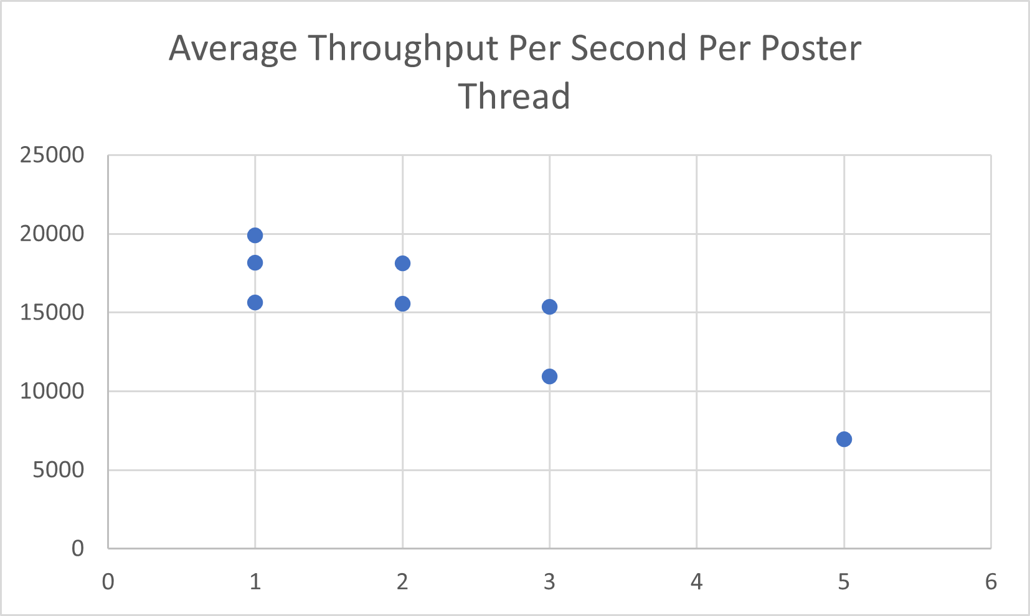

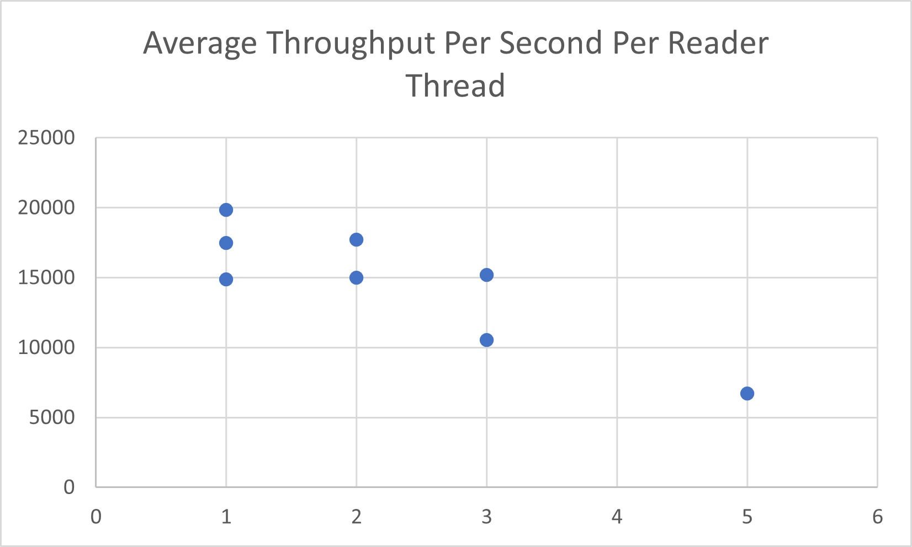

Throughput tests were completed on the following machine in Cantor 9341 (IP 10.72.84.33):

