1. Decompress the file and open it 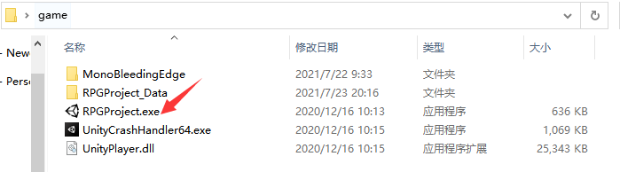
2. After opening the game, press F1 to hide the mouse and use WASD to control the movement of the character. The mouse controls the camera. Left-click normal attack right - click skills

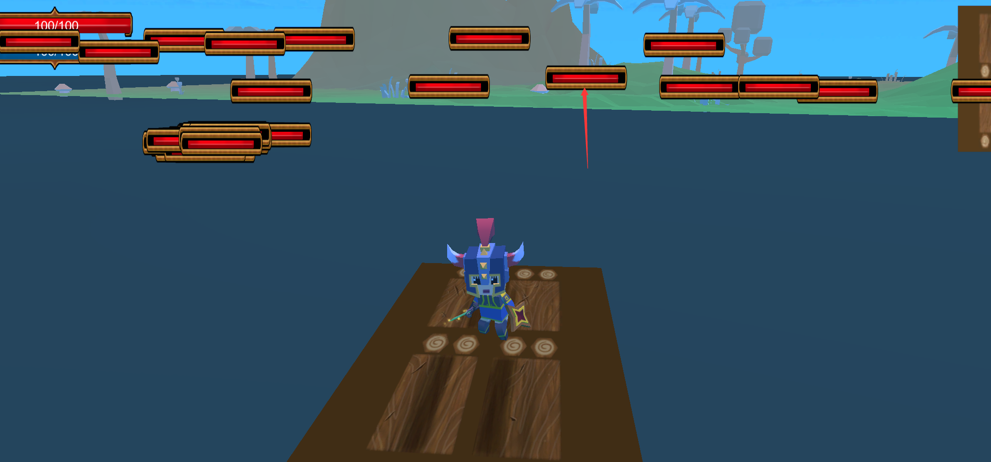

1. Go to the island and click on a small bee and enter the dungeon.

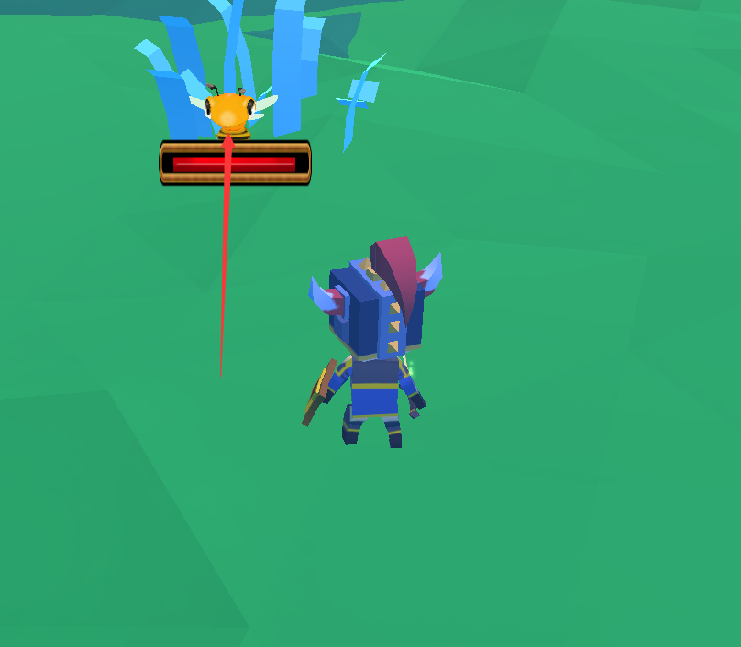

1. After entering the dungeon, you can accept tasks and buy equipment

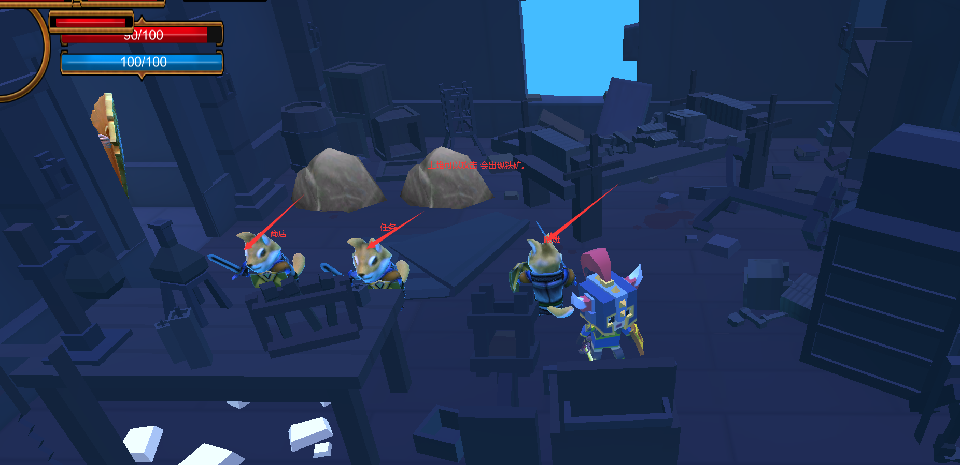

Click F1 again to call out the mouse, and click the left button to move the protagonist to show the automatic pathfinding function. When walking inside the castle, the monster will automatically attack the protagonist when it reaches a certain distance, which can show the function of the state machine.

The pet will automatically follow the attack to show the behavior tree function.