賠案內容
CLMM_FI_DTL
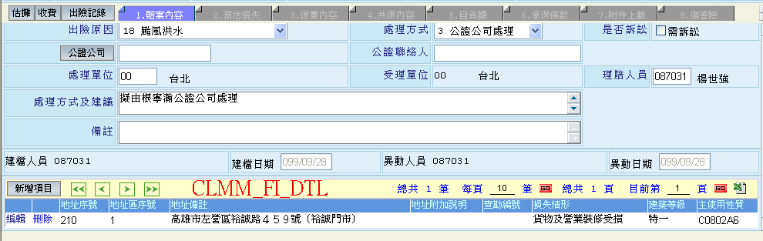
預估損失
CLMM_CM_APPDTL
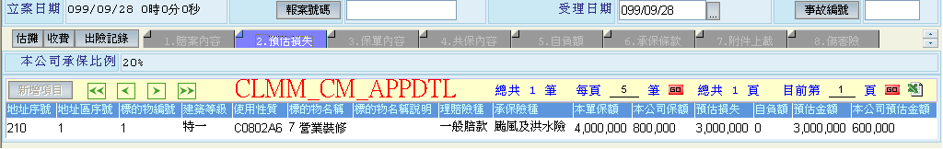
保單內容
PUBM_PN_MAIN
CLMM_CM_CLAIM
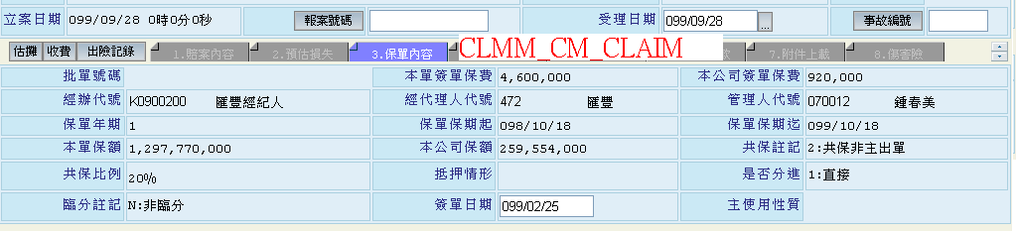
共保內容
PUBM_PN_SHAR
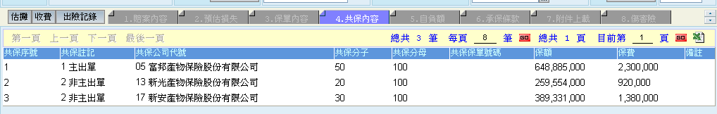
自負額
FIRM_PN_DEDUCT
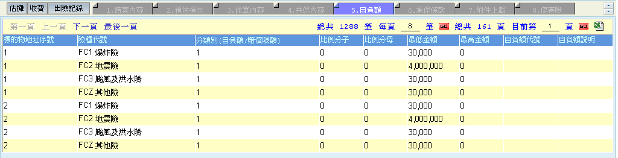
承保條款
PUBM_PN_TERMTXT
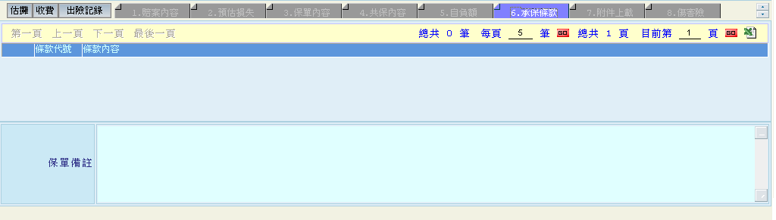
附件上載
CLMM_CM_ATTACHFILE (in CLMMasterDetailPage.vb)
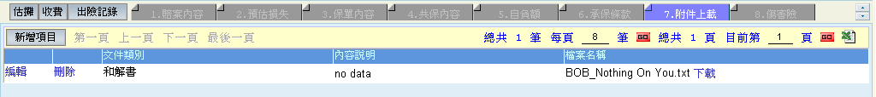
傷害險
CLMM_OBJ_ISSU (in CLMAppMasterDetailPage.vb)
