
TRIBHUVAN UNIVERSITY
Balkumari College
Chitwan, Nepal

Project Proposal on
MedDirect- EPharmacy Web Application
Submitted by
Ranjita MasbeKumal [1501.]
NishantThapa [1523.]
NiranjanBista [1835.]
Anima Bhandari [ 1803.]
Submitted to
Department of BICTE
[Bachelor in Information and Communication Technology in Education]
2077

ABSTRACT
We have proposed to make a MedDirect, which is an online Pharmacy web application. People are attracted to online shopping due to convenience. So, we have planned to bridge the gap between the pharmecutical shops and the coustomers. We have planned to conduct interview with the pharmacy shop owners and the Mrs. We have listed out the merits and demerits of online pharmacy in Nepal. The advantages of online pharmacies are privacy, avail great choice, lower prices and convenience mainly. Similarly ,the disadvantage include lack of physical evaluation in place ,some do not dispense drugs through licensed pharmacies, some online pharmacies do not adequately safeguards patient’s health, some do not adequately protect personal and financial information. In this pandemic period of Covid-19, the scope of online pharmacy plays vital role in today’s context. No doubt online pharmacy improves consumer convenience and access and this will give benefits to elderly patients suffering from chronic ailments because they need to visit pharmacy to buy medicines.
Keywords: Online, Pharma, Retail

Table of Contents
ABSTRACT ii
LIST OF FIGURE: 2
LIST OF TABLE: 2
CHAPTER I: INTRODUCTION 3
1.1 Overview: 3
1.2 : Problem Statement: 3
1.3: Scope of the Project: 3
1.4: Motivation………………………………………………………………..4
CHAPTER II: LITERATURE REVIEW 5
CHAPTER III: FEASIBILITY OF THE PROJECT 6
CHAPTER IV: METHODOLOGY 7
CHAPTER VI: TIME FRAMEWORK 12
5.1. Project Gantt Chart 12
EXPECTED OUTPUT 13
CONCLUSION: 14
REFERENCES: 15

LIST OF FIGURE:
Figure no 1 : SignUp Form……………………………………………………8
Figure no 2 : Proposed ER diagram of MedDirect……………………………9

LIST OF TABLE:
Table 1: Budgeting…………………………………………………………...11
Table 2: Gantt chart…………………………………………………………...12

CHAPTER I: INTRODUCTION

1.1 Overview:
‘MedDirect’, a web application which showcases the medicines and food supplements. It is a very good platform for the people who are unable to travel to the market to purchase drugs for themselves or their loved ones.

1.2 : Problem Statement:
It saves a lot of time and effort for patient/ consumers as they can conveniently purchase medicine. Customers now do not have to travel to market just to purchase medicines. It is a good deal for both the pharmacies and the normal people.

1.3: Scope of the Project
‘MedDirect’ – Epharmacy web application can impact several areas. Few major areas are as follows:
- Pharmacies who want to increase their market presence
- To save consumers time and provide conveniently purchase medicine.
- To provide reasonable price and privacy

1.4: Motivation
Our motivation for the MedDirect-Epharmacy web application came during the time of pandemic. There were not reliable business entities on the market who could supply the medicines to the COVID-19 patients. Our group saw this

problem and made a plan to solve that issue. So our web application solves this problem.

1.5: Objectives
We aim to achieve the following objectives:
- To solve the problems of inefficient market conditions, market monopoly and and reducing the middleman commission
- To supply quality products to the customer at reasonable price

CHAPTER II:LITERATURE REVIEW

‘MedDirect’ is an web application which focuses on delivering quality medicines to the customers. It showcases a large variety of medicines and food supplements. For our reference, we have looked upon the websites https://www.epharmacy.com.np/ and https://www.nepmeds.com.np/ for better adaptability to the market demands. These two websites are helping us to include all features that will make our website stand out in the market. We are working hard to make our project better suitable to the Nepali market.

CHAPTER III. FEASIBILITY STUDY

3.1 Technical
Since the ‘MedDirect’ is a web-based software platform, all
the devices with the internet can easily assess the system making it
technically feasible to use by all the people through smartphones,
computers or automation devices.

3.2 Social
In the age of digitalization, this system will be a milestone in the
societal values, where people could use technology at a local hierarchical
level. The user experience will be proven to advance where this system
contributes to make the world a better place.

3.3 Economical
We conducted a cost-benefit analysis of the given system. The
benefits outweigh the cost vaguely and a decision to design and further
documentation was carried out.

CHAPTER IV: METHODOLOGY

4.1 Software Development Model
For the development of this web application, we have chosen the Agile Development Development Process Model. In this model, we use an incremental model with small releases where each releases building on previous functionality. An iterative approach is taken and working software is delivered after each each iteration.
The phases in the Agile Model are:
1. Concept and Analysis :The problem is studied and analyzed. Different mathematical formulas and algorithms are prepared within the framework of the system description and concept.
2. Design and Requirements : The requirements are captured and documented. Based on the requirements, the design is prepared to address hardware and software aspects of a system define overall architecture.

3. Building and Prototyping
A running prototype is released through the methods of programming.

4. Evaluation, Testing, and Refining
The prototypes are constantly reviewed and improved by
integrating user feedback and evaluations. In order to incorporate
the additional requirements, the process is repeated until the
delivery of the final working project.

4.2 Our Project Model

‘MedDirect’ is a full functioning web-app consisting of the
following details:

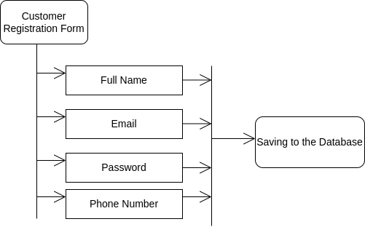
Figure 1: SignUp Form

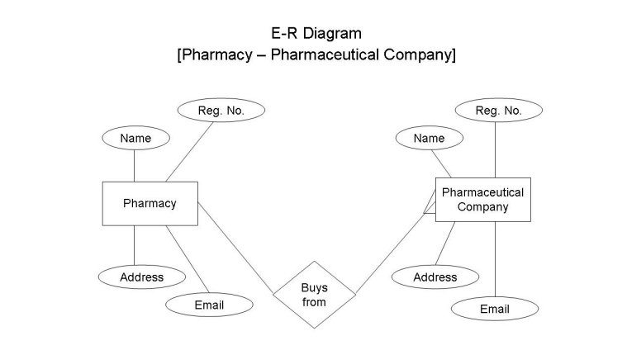
Figure 2: Proposed E-R Diagram of MedDirect

4.3 Development Tools

Our web-app is focused both on the backend and frontend. For these, we have used several programming languages, frameworks. The programming languages that we are using are as follows:

For frontend:

a. HTML5 and CSS

b. Bootstrap 5

c. Javascript( Scripting language)

For backend:

a. PHP

b. MySQL (DBMS)

With these sorts of languages, we will be using Visual Code Studio IDE for all of our development work.

CHAPTER V: COST ESTIMATION

Our budget for this project is about eight thousand and eight hundred under the following headings:

S.N | Process | Estimated Budget
1 | Feasibility Study | Rs 2,000
2 | Photocopy and Binding | Rs 800
3 | Consulting Experts | Rs 2000
4 | Miscellaneous | Rs 4000

Table 1 Budgeting

Week  Stages of project | 1 | 2 | 3 | 4 | 5 | 6 | 7 | 8 | 9 | 10 | 11 | 12 | 13
Selection of project
Selection of topic
Detailed analysis and study
Initial prototype
Mid term Defense
Implementation of system
Testing
Documentation of project work
Final Defense

Table 2 Gantt Chart

CHAPTER VI: TIME FRAMEWORK

EXPECTED OUTPUT

After the completion of our project, we have expected the web-page of E- Pharmacy will be more responsive, contains all the requirements and user friendly. The customer can view the medicines and food supplements and order them as per need. The ADMIN can control and view the product catalog. The customer can create a new account and do the shopping. The PROMO code can also be applied to get the discounts.

CONCLUSION

We are proposing to develop an e-commerce website for online pharmacy. After logging in, the available products/services in the system are listed to the user. Any medicine can be searched in the searchbox. The user can also filter out the medicines based on categories provided. Paging functionality for listing products/services has been implemented. After selecting a particular medicine,the user can update the quantity of theproduct. User can also update items in the cart,like removing items from the cart and updating the product’s quantity. The project also shows the history of purchases or saved lists for the user.After selecting the products,the user goes for the payment option and enters the billing details. In the billing section, promo code ordeal code can be applied,resulting in some discount for the final bill. For the admin part: The admin can view,delete and insert the products and category to the table. He/she can also view the users and their orders.

REFERENCES:

- (Economic Times ,2017)
- (Shankar et al. 2011)
- (Curranet al.(2011)
- (Ovaskainen ,2001)
- (Priyanka& Ashok,2016).
- https://www.clinicone.com.np/doctor-profile/
- https://www.1mg.com/drugs/dermi-5-cream-357049
- www.garvimedical.com

