Balkumari College
(Affiliated to Tribhuwan University)
Bharatpur- 11, Bhojad, Chitwan
[Subject Code:ICT.ED.485]
A MINOR PROJECT REPORT ON
“ ”
“(Nepal Rate E- Pharmacy)”

Submitted by
Ranjita MasbeKumal [1501.]
NishantThapa [1523.]
NiranjanBista [1835.]
Anima Bhandari [ 1803.]
Submitted to
Department of BICTE
[Bachelor in Information and Communication Technology in Education]
2077

DECLARATION

We declare that the work presented in this project entitled “Nepal Rate E-Pharmacy” is uniquely designed by us. We also confirm that; the report is only prepared for our academic requirement and not for any purpose. All sources of information have been specifically acknowledged by reference to the author(s) or institution(s).

……………………..
Date:……………….. BICTE
8thsemester students

RECOMMENDATIONS

This is to certify that the project work entitled “Nepal Rate E- Pharmacy” inChitwan submitted by BICTE students [Ranjita MasbeKumal ,Nishant Thapa , Anima Bhandari Niranjan Bista] has been carried out under my supervision . The entire work was based on the result of their primary field work and has not been submitted for any other academic degrees. I ,therefore, recommend this project to be accepted for the partial fulfillment of Bachelor of Information and Communication Technology from BalkumariCollege, Chitwan, Nepal.

……………………………
……………………………
Sunil Sharma
Professor
Department of BICTE
Balkumaricollege
Tribhuvan University Chitwan,Nepal
Date:……………………

TRIBHUVAN UNIVERSITY
BALKUMARI COLLEGE

BHARATPUR, CHITWAN,NEPAL

LETTER OF APPROVAL

On the recommendation of supervisor Sunil Sharma, ,Shree ParsadAryal this project entitled “Nepal Rate E-Pharmacy” in Chitwan at Balkumaricollege by BICTE students ,has been approved for the examination and submitted to Tribhuvan University in the partial fulfillment of requirements for Bachelor of Information and Communication Technology.

EXPERT COMMITTEE

…………………………. ………………………..
(Supervisor) Shree Prasad Aryal
Sunil Sharma, Head of department of BICTE
Professor Balkumaricollege
Department of BICTE Tribhuvan University
Balkumari College Chitwan ,Nepal
Tribhuvan University
Chitwan,Nepal

…………………………………… ………………………………….
(External Examiner) (Internal Examiner)
Date:………………………

ACKNOWLEDGEMENT

First of all, we offer our sincerest gratitude to the supervisor Mr.Sunil Sharma for guiding and correcting various documents for this project work with attention and care. He gave us his valuable time when necessary without feeling any difficulties.

We will be always thankful to Mr. Shree ParsadAryal (HOD , Department of BICTE) for providing administrative facilities and valuable suggestion and encouragement .His guidance helped us during the entire period of project work time. We would also like to thank to all faculty members of BICTE in Balkumaricollege for their kind support .

Finally, We are very thankful to all my family members and friends for their support ,encouragement, suggestion and genuine love that made our project work a success. We express our gratitude to all those who made this project come into existence.

We owe a great many thanks to great many people who helped and supported us during the course of this project work.

Ranjita MasbeKumal
NishantThapa
NiranjanBista
Anima Bhandari
Department of BICTE
Balkumaricollege
Chitwan, Nepal

ABSTRACT

The world is shifting towards the digital world. In present time, people mostly spend their time online. People have started to purchase goods and services from the internet. We know that the internet was the thing of the first world countries, but the internet has penetrated the gallies of Nepal too. We students of Balkumari college too wanted to do something for the public, so we have built this prototype website called “Meddirect”. It facilitates the customers to view the medical goods and purchase from the website. For this we did some market research, visited the pharmacies of Chitwan. The pros of the Meddirect are numerous. People do not have to get outside of the home to purchase medicines. The website facilitates them to choose and the customers will get medicine delivered at their homes. It will prove vital for old people and sick people as they cannot go to the market to buy essential medicines. You know, every aspect has its own cons. The database of most pharmacies is very poor. We had a very hard time putting stock list in our own website. Pharmacies of Chitwan district still use manual calculation of sales and stocks. Our website will help to boost online presence of retail pharmacies.

Keywords: Online, Pharma, Retail

Table of Contents
DECLARATION i
RECOMMENDATIONS ii
LETTER OF APPROVAL iii
ACKNOWLEDGEMENT iv
ABSTRACT v
LIST OF FIGURE: ii
LIST OF TABLE: iii
CHAPTER I: INTRODUCTION ii
1.1 BACKGROUND: ii
1.2 : Aims: iii
1.3: Objectives: iii
CHAPTER II: METHODOLOGY iv
CHAPTER III: STRUCTURE OF THE PROJECT 11
CHAPTER IV: SYSTEM DESIGN 13
CHAPTER VI: TIME FRAMEWORK 18
5.1. Project Gantt Chart 18
EXPECTED OUTPUT 19
Conclusion: 20
REFERENCES: 21

LIST OF FIGURE:
Figure no:3.1. Incremental development model
Figure no:. ER diagram

LIST OF TABLE:
Table 1: Summary of methodology
Table 2: Gantt chart

CHAPTER I: INTRODUCTION

1.1 BACKGROUND:
Digital Marketing is very popular now a day where in all the companies are promoting their business through digital technologies. Digital marketing is also popularly known as online marketing or internet marketing. Online medicine purchase is popular worldwide due to convenience. Asian healthcare market is also growing at good speed and presently both online and offline pharmacies are doing business. The global E-pharmacy market, led by North America and Europe,was approximately US$ 29.3 billion in 2014 and has been estimated to grow at a CAGR of 17.7% to reach a valuation of US$ 128 billion by 2023(FICCI,2016). Out of this market online pharmacies have less then 5% market share but the growth rate is double digit. We did some research on indian pharmacy market because there is no data on Nepalese pharmacy market but it is also booming. The Indian pharmacy market is huge ,estimated by industry to be around Rs 1.2 lakh core in size and out of that the online pharmacy market. (Economic Times,2017) The growth of online companies are imposing huge threat to these offline companies. As a result of this offline pharmacies are united together and on October 2015 the retailers shut their shops as a mark of protest against the online drug retail business.

According to (Shankar et al. 2011) now customers are using social media like Twitter, Facebook, Youtube, LinkedIn etc. and depend on them for taking marketing shopping decisions, thus promotion through these media has become important. Curran et al.(2011) wrote that social media sites such as Facebook is much better option than other advertising processes as it stores information of its users . According to (Ovaskainen ,2001) WHO is really concerned with internet sales which may bypass national drug regulatory authorities, allow medical products on the market which are unapproved, fraudulent, unsafe or ineffective even. George (2009) studied on internet pharmacies and recommended regulation approach on global basis. Increasing internet and smart phone users prove that Nepal have a bright future of online pharmacy, although this will bring few challenges with opportunity(Priyanka& Ashok,2016).

1.2 : Aims:
The aims of our project is to provide a user- friendly interface for consumers for easy buying process. It saves a lot of time and effort for patient/ consumers as they can conveniently purchase medicine. Our focus is to connect pharmacies and the consumers.

1.3: Objectives:
- To provide platform for pharmacies to showcase their products online.
- To save consumers time and provide conveniently purchase medicine.
- To provide reasonable price and privacy.

CHAPTER II: METHODOLOGY

Since, every project has its own aims and objectives that need to be fulfilled which motivated and lead us to fulfill our aim of carrying out the project. For achieving the goals, we use the mixed qualitative and quantitative method.

For our minor project, lots of work has to be done regarding the web pages. Webpage are an important part of the any organization because it is the main source to view the information of the medicine/drugs for the consumer service.

For this we performed, a review from which we generated the ideas.

- How the website should be look like?

- What sort of patient should we focus?

- What are the content that should be in the webpage?

Moreover, the reviews will help in finding the contents that are necessary for the web pages.

After the successful completion of reviewing the webpage we perform the interview. We did semi-structured interview because this type of interview helps the interviewee to share their ideas and provide us guidance about the basic and important content of the websites and enhancing the web range of the information. So, secondary we performed this interview in order to gather data and information for the webpage. We collected these information or data from review and by interviewing pharmacist, medical representative, and the public people for the informative, attractive and user friendly web pages.

The identified data and information was analyzed by the project coordinator in order to bring the required and important data and information.

The methodology we have mentioned is better on as it helps in finding the data and information required for website.

We divided the project into four phase. Each phase produces specific operation that will be used for analysis and conclusion.

Each phase is described below along with the specific operation produced by it.

Phase I:

In this phase, relevant data and information about webpage was collected by reviewing the existing web-page. As well as we viewed other webpages to gain the basic information for our webpages.

Phase II:

This phase is two folded:

- First to validate the findings of phase I. And determining the importance of those review of the websites.

- Secondly to identify additional information that are missed in phase-I. So, we conducted interview with the pharmacist ,MR and possible user of webpage.

This phase provided the project team the detailed idea of how the websites will be and what content are essential for the websites.

Phase III:

This is the main phase where we analyzed the finding of the phase-I and phase-II. Here, team members and team coordinator actively acted on choosing the required information for the web-page.

Phase IV:

In this phase all the information that has been gathered required for the web-page was implemented in real application. Then the team co-ordinate along with project team decided the tools for developing the web-page scripting language to make the page dynamic. Here we decide to use Bootstrap to develop the dynamic webpage for the customer services.

Table 1: Summary of methodology
Phase | Methodology
Phase-I | Review
Phase-II | Semi-structured interview
Phase-III | Gathering and analyzing the requirement
Phase-IV | Determining tools and scripting language to make
 | page dynamic

CHAPTER III: STRUCTURE OF THE PROJECT
Software engineering is an engineering discipline that is concerned with all aspects of software production from the early stages of system specification through to maintaining the system after it has gone into use.

Software engineering is the discipline whose aim are follows:

- Production of quality software

- Software that is delivered on time

- Cost within the budget

- Satisfies all requirements

A software process model is an abstract representation of a software process. Each process model (sometimes called process paradigms) represents a process from a particular perspective, and thus provides only partial information about that process.

These generic software process models are not definitive descriptions of software processes. Rather, they are abstractions of the process that can be used to explain different approaches to software development.

The process models are:

- The waterfall model

- Incremental development

In the project , we followed Incremental development model.

Outline description
Specification

Development

Validation
Initial version

Intermediate versions

Final version

Fig.3.1. Incremental developmentmodel

Incremental development has three important benefits compared to the waterfall model:

- The cost of accommodating changing customer requirements is reduced

- It is easier to get customer feedback on the development work that has been done.

- More rapid delivery and deployment of useful software to the customer is possible, even if all of the functionality has not been included.

Advantages :

- Results are obtained early and periodically.

- Parallel development can be planned.

- Progress can be measured.

- Risks are identified and resolved during iteration; and each iteration is an easily managed milestone.

Disadvantages:

- It is difficult to map requirements directly to different increments.

- An overhead in the model is rapid context switching between various activities.

- Each iteration is followed by an evaluation ensuring that user requirements have been met. This evaluation after each iteration is time consuming.

CHAPTER IV: SYSTEM DESIGN
In this phase the software’s overall structures are defined. In terms of client server, technology the number of tiers needed for the package architecture, database design, data structure design etc. are defined in this phase. The following are the essential approach taken during web portal designing:
- ER –Diagram

ER DAIGRAM
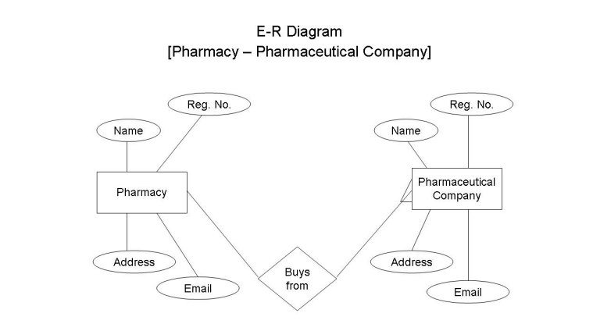

1.Screenshots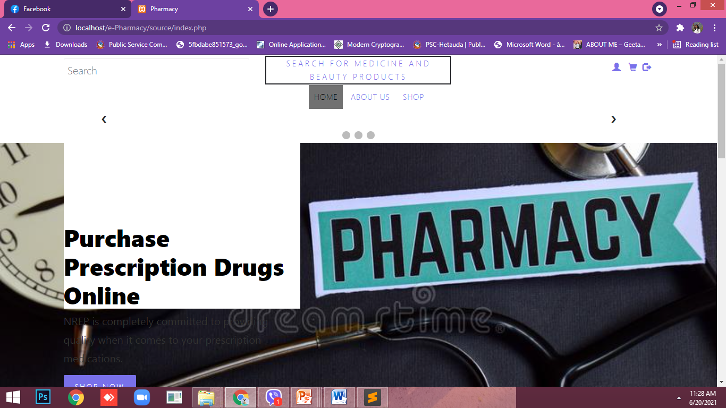Figure:4.1
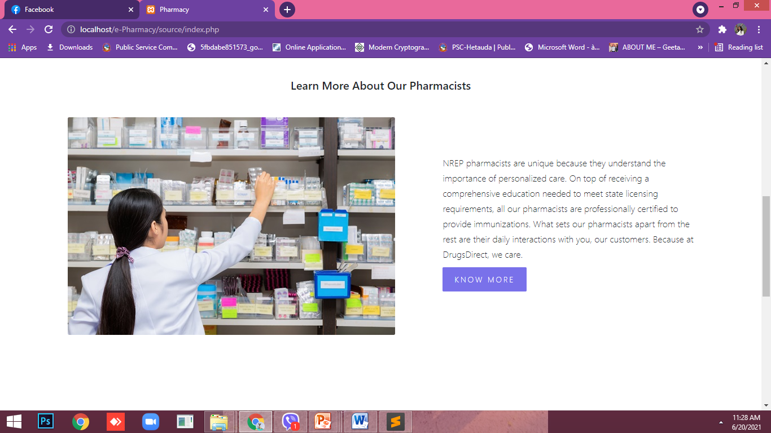

Figure:4.2

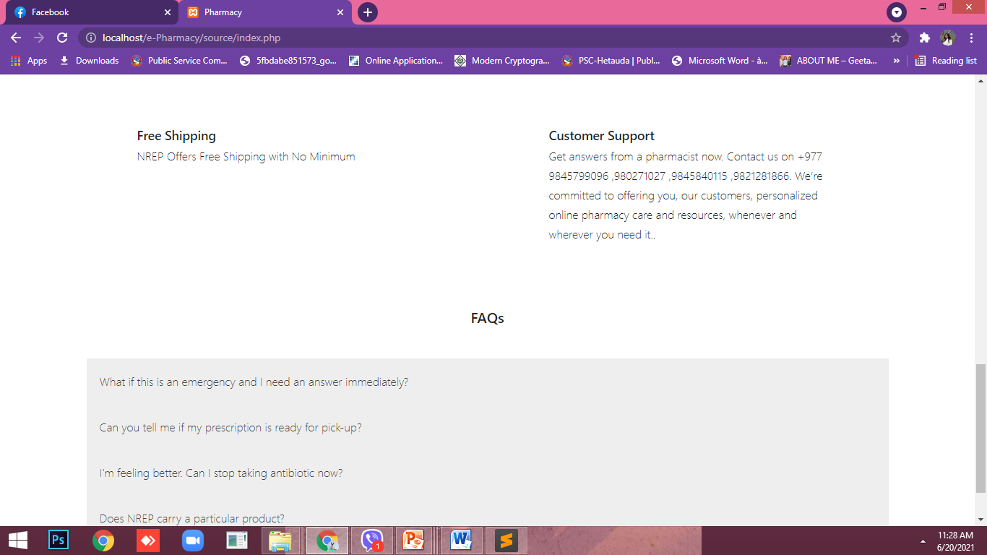

Figure:4.3

About us:
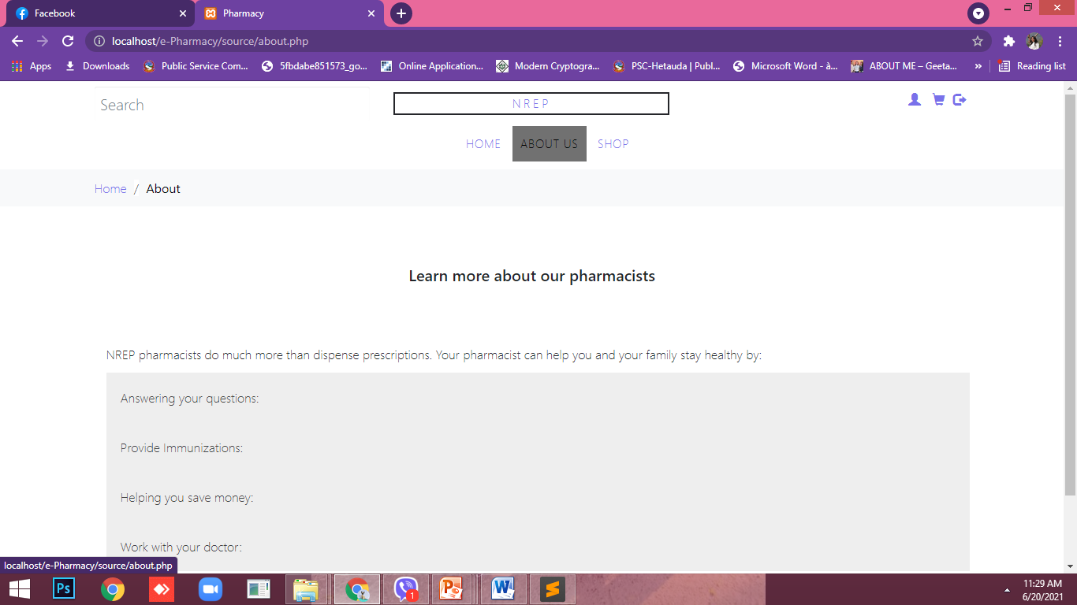

Figure:4.5

Shop now:
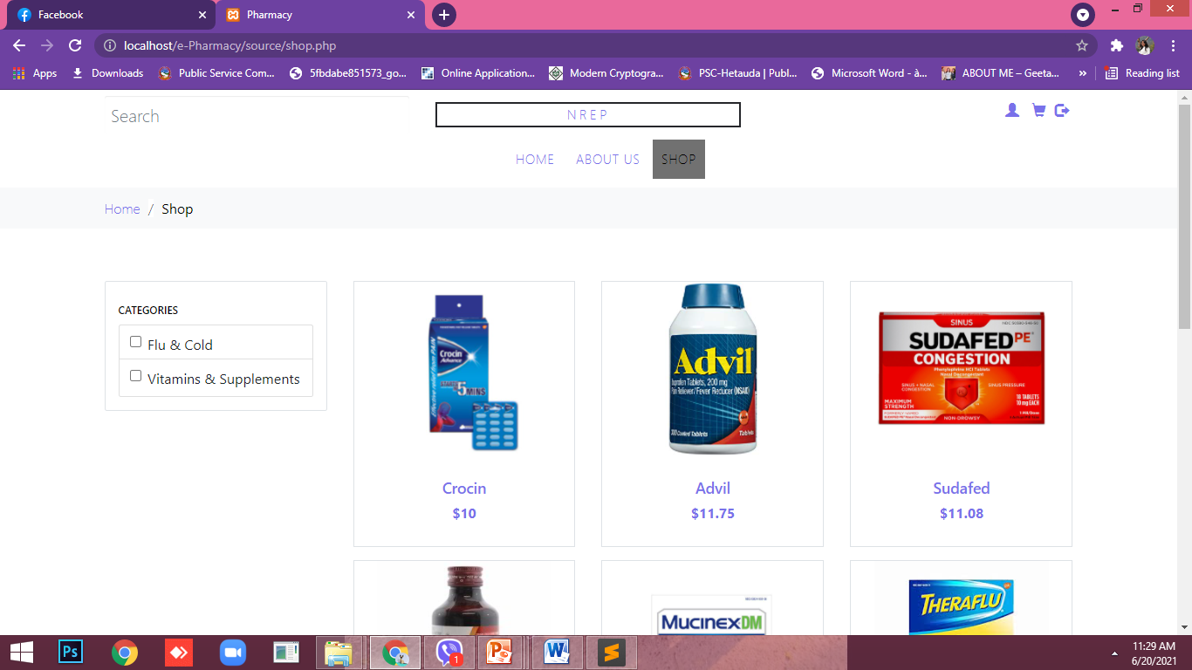

Figure:4.7
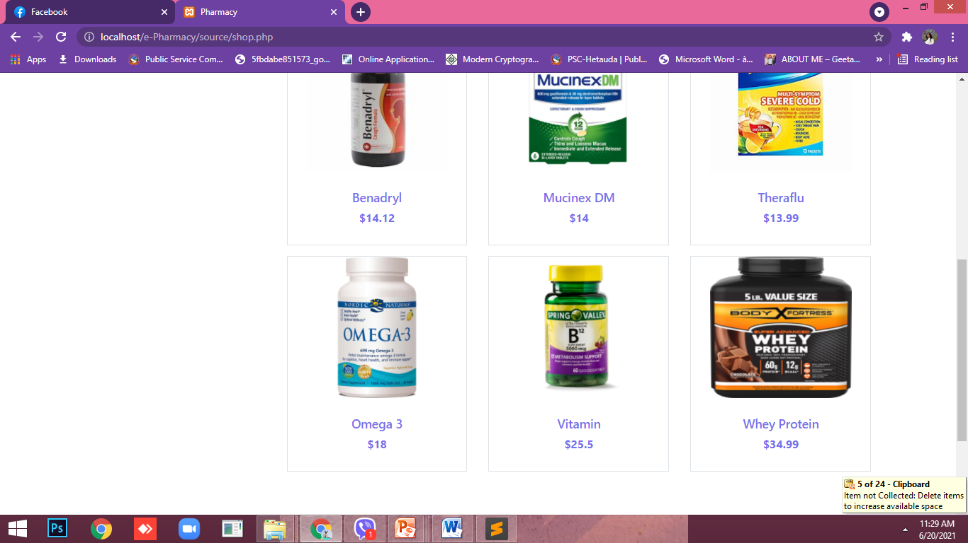

Log In page:
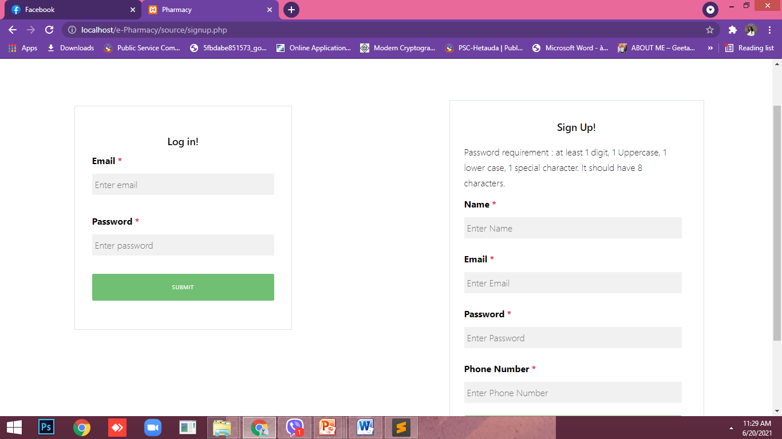
Figure:4.8

CHAPTER VI: TIME FRAMEWORK

5.1. Project Gantt Chart

A Gantt Chart is one of the most popular and useful ways of showing tasks (activities or events)

displayed against time. The Gantt chart of our project is given below:

Table 2: Gantt chart
Week  Stages of project | 1 | 2 | 3 | 4 | 5 | 6 | 7 | 8 | 9 | 10 | 11 | 12 | 13
Selection of project
Selection of topic
Detailed analysis and study
Initial prototype
Mid term Defense
Implementation of system
Testing
Documentation of project work
Final Defense

EXPECTED OUTPUT
After the completion of our project, we have expected the web-page of Meddirect will be more responsive, contains all the requirements and user friendly. We can have the all the required information about the medicine details about the authorized letter by doctor.

Conclusion:
We have developed an e-commerce website for online pharmacy.After logging in,the available products/services in the system are listed to the user. Any medicine can be searched in the searchbox. The user can also filter out the medicines based on categories provided.Paging functionality for listing products/services has been implemented.After selecting a particular medicine,the user can update the quantity of the product.User can also update items in the cart,like removing items from the cart and updating the product’s quantity. The project also shows the history of purchases or saved lists for the user.After selecting the products,the user goes for the payment option and enters the billing details.In the billing section,promocode or dealcode can be applied,resulting in some discount for the final bill due. For the admin part: The admin can view,delete and insert the products and category to the table.He/she can also view the users and their orders.

REFERENCES:
- (Economic Times ,2017)
- (Shankar et al. 2011)
- (Curranet al.(2011)
- (Ovaskainen ,2001)
- (Priyanka& Ashok,2016).
- https://www.clinicone.com.np/doctor-profile/
- https://www.1mg.com/drugs/dermi-5-cream-357049
- www.garvimedical.com

