CE444: Geotechnical Design

Homework Assignment #3

February 6th, 2026

To: Dr. Arash Khosravifar
From: Brandon Auyeung

Problem 1.
Watch the education video entitled: “An Introduction to Drilling and Sampling in Geotechnical Practice.” This video is available via YouTube at http://youtu.be/IGk1HI1NGug.
Take notes during the video and answer the following questions with bulleted answers.
- What are the common drilling methods?
- What method is best for drilling collapsing soil? Why?
- What method would be best for shallow holes (<25’) in cohesive soil?
- Explain how soil cuttings are brought to the surface for each method. Which method would be better for large, gravel sized particles?
- Under what circumstances must casing be used?
- What method is best for sampling rock?
- Explain how the standard penetration resistance, or N value, is determined? What is this a measure of?
- How is a thin-walled Shelby tube sample obtained?
- What is the objective of the piston-sampler?

Given:
“An Introduction to Drilling and Sampling in Geotechnical Practice” at http://youtu.be/IGk1HI1NGug.

Find:
- What are the common drilling methods?
- What method is best for drilling collapsing soil? Why?
- What method would be best for shallow holes (<25’) in cohesive soil?
- Explain how soil cuttings are brought to the surface for each method. Which method would be better for large, gravel sized particles?
- Under what circumstances must casing be used?
- What method is best for sampling rock?
- Explain how the standard penetration resistance, or N value, is determined? What is this a measure of?
- How is a thin-walled Shelby tube sample obtained?
- What is the objective of the piston-sampler?

Solution:
The answers to the questions are formatted in the “Results” section.

Results:
- Methods of drilling are all used to obtain subsurface samples
  - Solid Stem Continuous Flight Auger
  - Hollow Stem Continuous Flight Auger
  - Rotary Wash
  - Coring
- The Hollow Stem Continuous Flight Auger would be best, since the hollow stem walls allow for sampling to occur while providing walls of support to protect from the potential of collapsing soil. Rotary wash is also a good method to use.
- The Solid Stem Continuous Flight Auger is the best method to use here, since soils are likely not at risk of collapsing during drilling.
- For Solid Stem and Hollow Stem Continuous Flight Augers, the soil cuttings are brought up to the surface using the rotation of the auger’s screw. For Rotary Wash, the mud mixture is able to suspend and/or move the soil tailings up via a pump, where the soil tailings may then be separated from the slurry. Coring
- Casing is best used when sampling cohesionless or highly-erodible soils.
- Coring is the best method for sampling rock.
- The N-value is obtained by summing the number of hammer drops to penetrate the last two out of three successive 6” sections of a split-spoon sampler. This is a measure of a soils strength (?)
- Shelby tubes are attached to a drill rod and is then quickly advanced into the soil while being rotated. Once the sample is obtained, the Shelby tube is removed, trimmed, and seal with either wax or a O-ring cap. These are then transported to the lab with extreme caution.
- Piston-samplers are designed to ensure the initial soil sample does not plug or unexpectedly rise into a Shelby tube, which mitigates the risk of unrepresentative samples.

Problem 2.
List two advantages and two disadvantages of CPT over SPT.

Given:
SPT and CPT testing

Find:
Two advantages and disadvantages of both tests.

Soltuion:
The answers to the questions are formatted in the “Results” section.

Results:
SPT has the advantages that it obtains actual samples that may be used for visual classification and some lab tests, as well as being simpler to set up than CPT. SPT has the disadvantages that the test only obtains discrete, disturbed samples that the SPT test itself is user-dependent, which can increase uncertainty in results.
CPT has the advantages that is is able to measure many more quantities than SPT testing and is able to obtain a continuous sampling profile of the soil. CPT has the disadvantages that it is not able to capture a physical sample to run lab testing or visual inspection on and has more complexities in setup relative to SPT.

Problem 3.
What is the main indicator that a CPT is penetrating sand?

Given:
A CPT test.

Find:
How do you know when a CPT is penetrating sand?

Solution:
The answer to the questions are formatted in the “Results” section.

Results:
In the field, a good rule ot thumb is to check when the cone tip resistance, q_{c}, goes above 5 MPa. This indicates a switch from a non-sand layer (usually clay), to a sand layer since sands require more cone tip to fail.
Once data is obtained, one way to determine if the layer is a sandy layer is to determine if the I_{c} is less than 2.6. You may also plot the values of equivalent tip resistance, Q_{t}, with respect to equivalent sleeve friction, F_{r}.

Problem 4.
(Modified from Das) A soil profile is shown in figure below along with the energy corrected SPT blow counts in the clay layer. Use equation by Stroud (1975) (modified by Salgado 2008) to determine and plot the variation of undrained shear strength (Su) with depth. Plot Su values versus depth and propose Best Estimate (mean), Lower Bound (mean – 1 standard deviation) and Upper Bound (mean + 1 standard deviation) values for Su. Assume plastic index PI = 40.
Correct answer: Best Estimate (BE) Cu value (corresponding to average value) should be close to 17 kPa
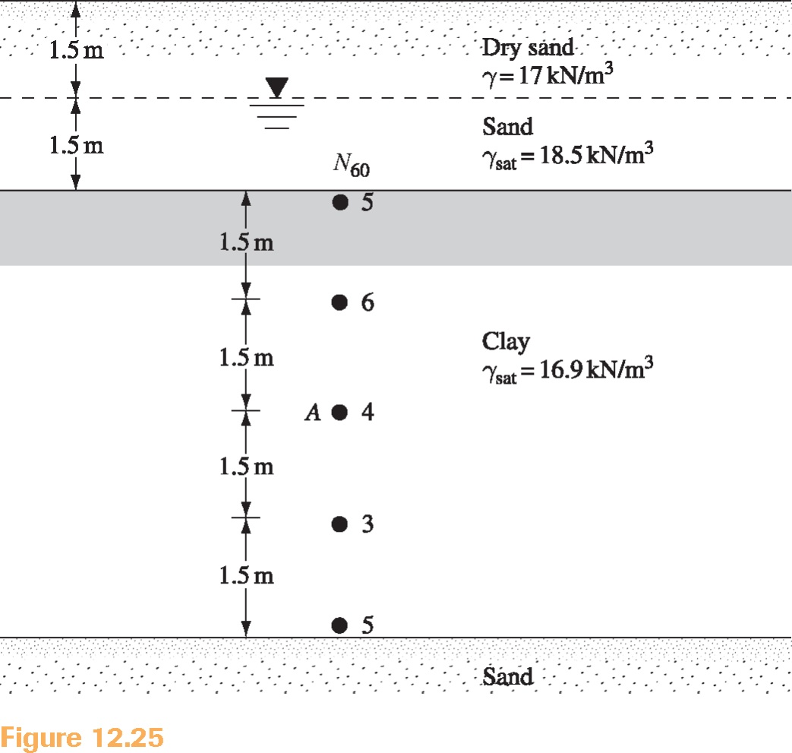

Given:
A soil profile is provided with parameters. The PI of the clay is assumed to be 40.
Figure G1. Given soil profile with N₆₀.

Find:
Use Stroud (1975) (modified by Salgado 2008) to determine and plot the variation of undrained shear strength (S_{u}) with depth. Plot S_{u} values versus depth and propose Best Estimate (μ), Lower Bound (μ-1σ) and Upper Bound (μ+1σ) values for S_{u.}

Solution:
Using the given N₆₀ values, it is known that S_{u} may be calculated with the following relationship.
P_{a} is known as 100 kPa (since it is equal to 1 atm). The value of f₁ may be found via Stroud, 1975, which is supplied as a modified version to us via Salgado 2008.
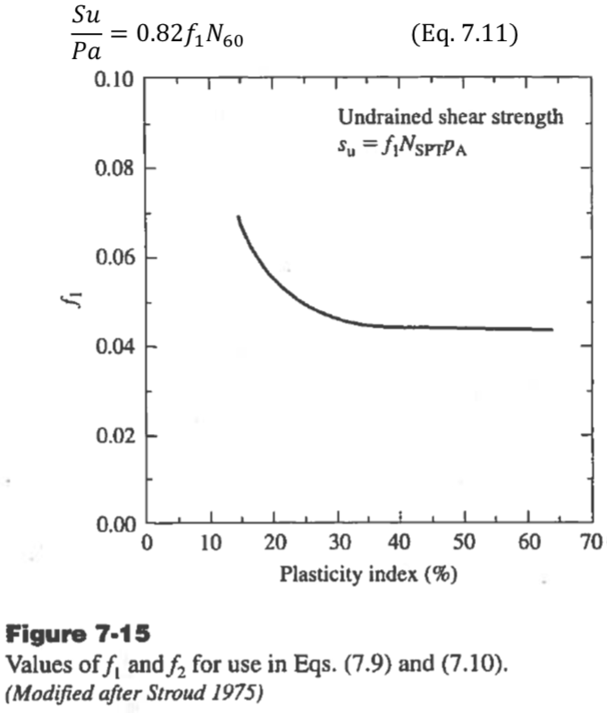
Figure S1. Stroud, 1975 (modified by Salgado, 2008).

Using the known PI value of 40, a f₁ value of 0.045 was obtained. This value was then used for calculations to obtain S_{u} from the N₆₀ values. A plot was then generated as shown in Figure R1.
The best estimate value (BE) was obtained by taking the mean of the S_{u} values. The Upper Bound was calculated by adding one standard deviation of S_{u} to the mean of S_{u.}. Similarly, the Lower Bound was calculated by subtracting one aatandard deviation of S_{u} to the mean of S_{u.}.

Results:
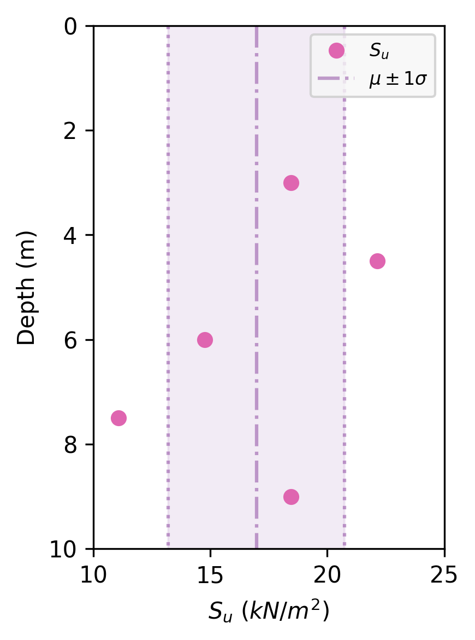
Figure R1. Values of S_{u} as depth increases. Best Estimate with ±1σ is included.

Depth [m] | S_{u} [kPa]
3 | 18.45
4.5 | 22.14
6 | 14.76
7.5 | 11.07
9 | 18.45
Table R1. S_{u} values with their associated depths.

The BE (i.e. μ of S_{u}) was found to be 16.97 kPa. The standard deviation (i.e. σ) of S_{u} was found to be 3.76 kPa. As such, μ-1σ was found to be 13.211 kPa and μ+1σ was found to be 20.37 kPa.

Problem 5.
The table below gives the energy-corrected SPT blow counts for a sandy dry soil deposit. Total unit weight is 16.5 kN/m³ from the ground surface down to 6 m depth and 18.5 kN/m³ below 6 m.
- Use the equation by Liao and Whitman (1986) to calculate (N1)60 and plot vs. depth.
- Use equations by Meyerhof (1957) and Skempton (1986), and Idriss and Boulanger (2003) to calculate relative density (Dr) and plot vs. depth. Use average constants for the Meyerhof (1957) equation. Note: Plot both relationships on same figure, use different symbols and add legend.
- Use the correlation by De Mello (1971) to find the peak friction angle (φ’p) and plot vs. depth.
- Break the soil profile into two sublayers and propose BE friction angle values (average) for each sublayer.
- Compare the idealized friction angle that you calculated from De Mello (1971) to those from Meyerhof (Table 4-3 in EPRI 1990) and comment on agreement/disagreement of the results.
Depth (m) | Total unit weight (kN/m³) | N₆₀
3.0 | 16.5 | 7
4.5 | 16.5 | 9
6.0 | 16.5 | 11
7.5 | 18.5 | 16
9.0 | 18.5 | 18
10.5 | 18.5 | 20
12 | 18.5 | 22
Correct answer: Idealized friction angle for Layer 1 between 0 and 6 m should be close to 33.3 degrees, and close to 36 degrees for the second layer between 6 and 12 m.

Given:
A sandy dry soil deposit the site. A table of N₆₀ and unit weight, γ, with respect to depth from surface is provided for this site.

Find:
- Use Liao & Whitman, 1986 to determine values of (N1)₆₀ and plot with respect to depth.
- Compare Meyerhof (1957) & Skempton (1986) to Idriss & Boulanger, 1957 to determine values of D_{R}. Plot both on the same graph with respect to depth.
- Use De Mello, 1971 to determine and plot with respect to depth.
- Break the soil profile into two sublayers and determine the BE of of each sublayer via averaging.
- Comment on the values obtained by De Mello, 1971 versus values from EPRI 1990 Table 4-3 by Meyerhof.

Solution:

Part A:
In order to calculate (N1)₆₀ , the vertical effective stress, σ_{v}’, must be obtained. This can be simplified since the soil deposit is ‘dry’ (i.e. we may assume no groundwater table).
With P_{a} equaling 100 kPa, Liao & Whitman, 1986 may then be used alongside the given N₆₀ values to obtain values of (N1)₆₀.
​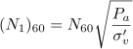
A plot of (N1)₆₀ with respect to depth may then be generated, as shown in Figure R2.

Part B:
Meyerhof (1957) & Skempton (1986) uses the following relationship to determine D_{R}.
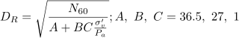
We can use the prior calculated σ_{v}’ and the provided N₆₀ to obtain D_{R} from Meyerhof (1957) & Skempton (1986). The newly calculated (N1)₆₀ may be used to calculate D_{R} via Idriss & Boulanger, 1986
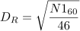
These D_{R} values can then be plotted together with respect to depth, as seen in Figure R3.

Part C:
De Mello, 1971 may be used to plot the values of (N1)₆₀ and the normalized vertical effective stress, . Again, the prior obtained vertical effective stress may be used here, with P_{a} equaling 100 kPa. When plotted on top of De Mello, 1971, as seen in Figure R4, a list of may be obtained and then plotted with respect to depth, as seen in Figure R5.

Part D:
The soil can be broken into Sublayer 1, from depths between 3 m and 6 m, and Sublayer 2, from depths below 6 m. The Best Estimate may be obtained by taking the average of in each sublayer.

Part E:
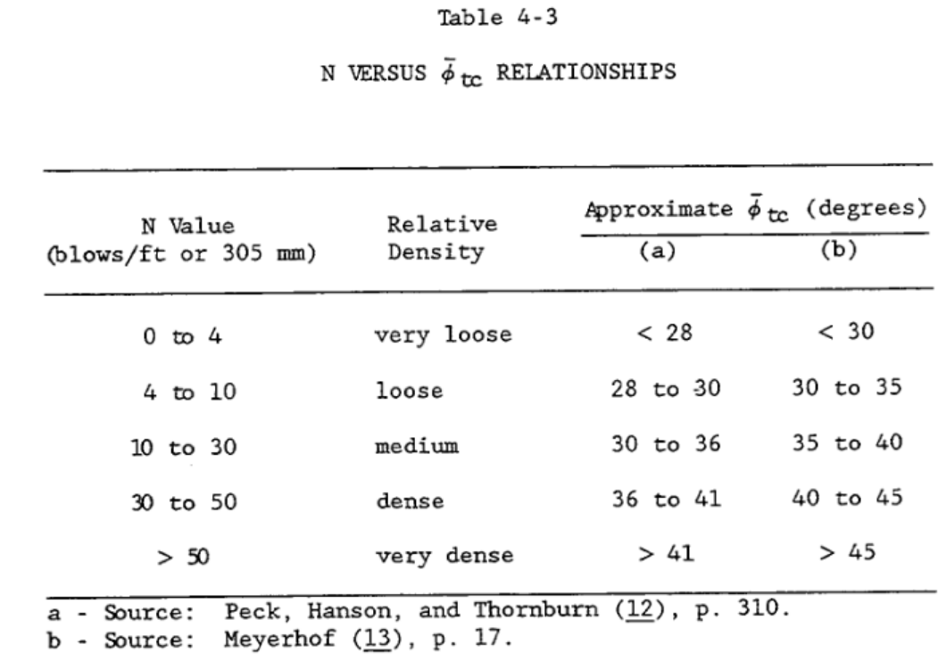
Table S1. Table 4-3 by Meyerhof found in EPRI 1990.
Table S1 is used to compare the calculated values to the values as expected by EPRI 1990.

Results:

Part a:
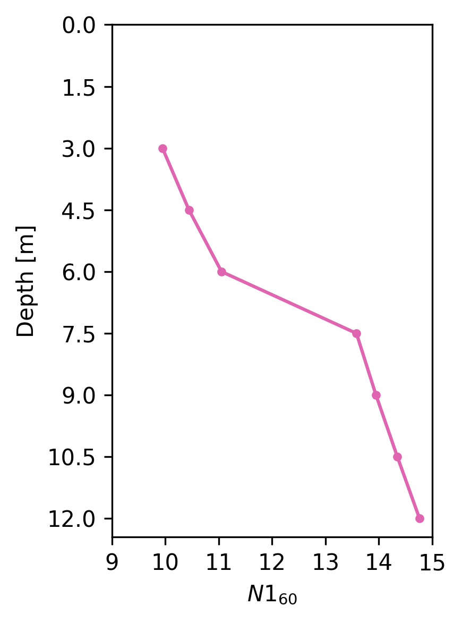
Figure R2. Plot of (N1)₆₀ with respect to depth.

Depth [m] | Vertical Effective Stress [kPa] | (N1)₆₀
3 | 46.5 | 9.95
4.5 | 74.25 | 10.44
6 | 99 | 11.06
7.5 | 138.75 | 13.58
9 | 166.5 | 13.95
10.5 | 194.25 | 14.35
12 | 222 | 14.77
Table R2. Vertical effective stress and (N1)₆₀ values with respect to depth.

Part B:

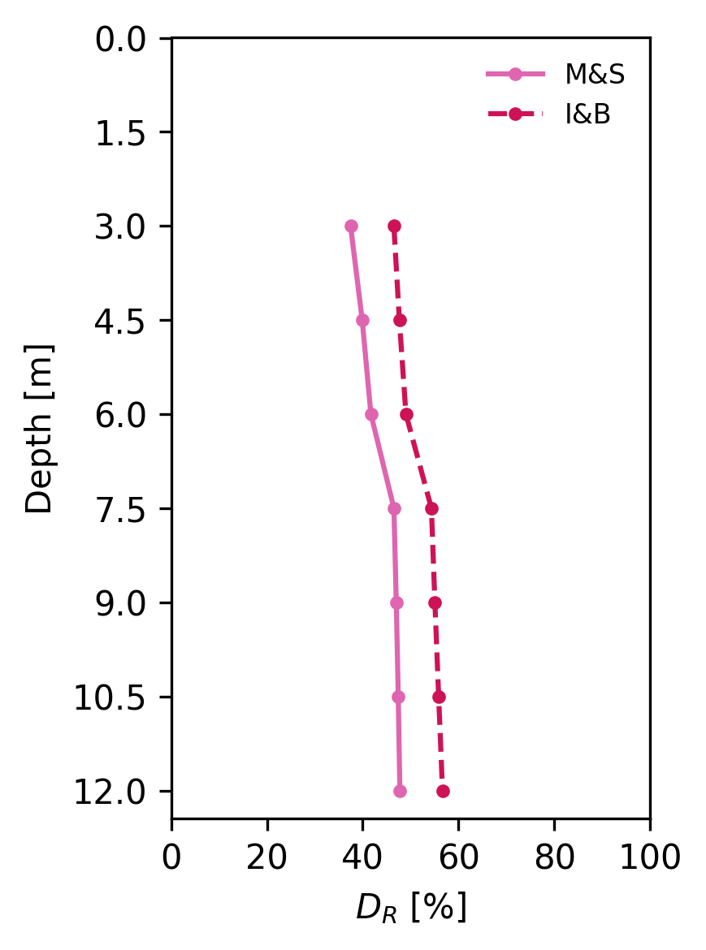
Figure R3. Plot of D_{R} with respect to depth.

Depth [m] | D_{R} via Meyerhof (1957) & Skempton (1986) [%] | D_{R} via Idriss & Boulanger, 1986 [%]
3 | 37.5 | 46.6
4.5 | 39.9 | 47.7
6 | 41.7 | 49
7.5 | 46.5 | 54.3
9 | 47.7 | 55.1
10.5 | 47.4 | 55.9
12 | 47.8 | 56.7
Table R3. D_{R} values with respect to depth using two methods.

Part C:
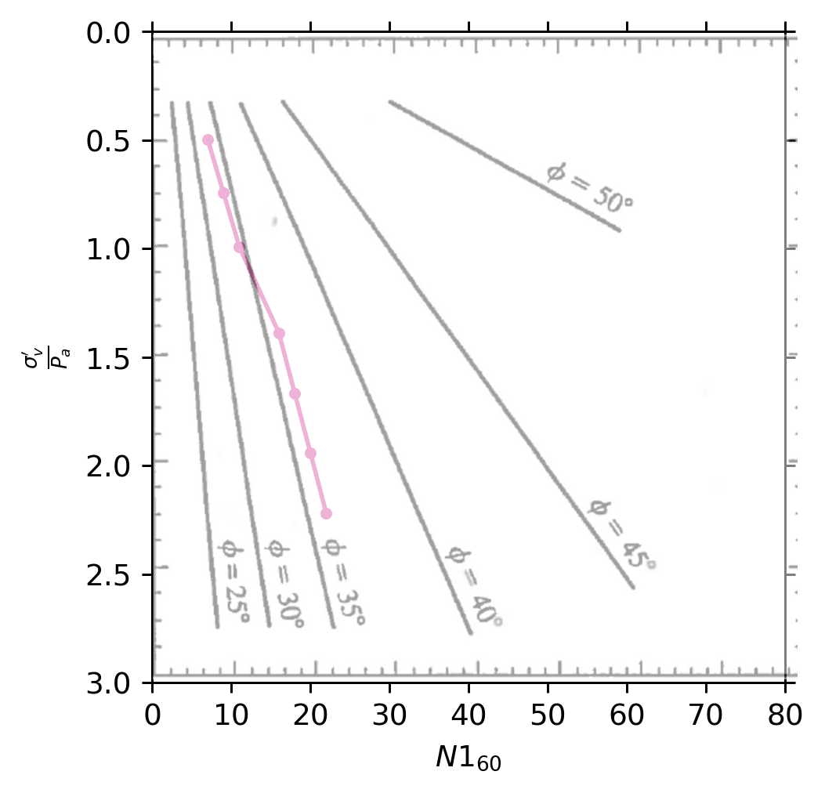Figure R4. Use of De Mello, 1971 to obtain values of .

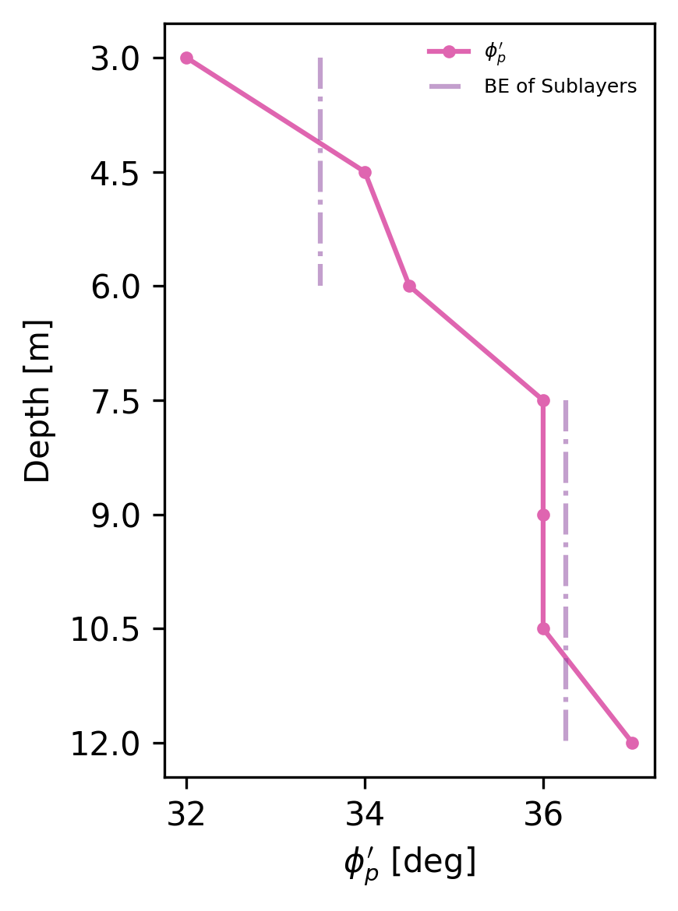
Figure R5. Plot of peak effective friction angle, with respect to depth.

Depth [m] | Normalized Vertical Effective Stress
3 | 0.495 | 32.0
4.5 | 0.743 | 34.0
6 | 0.990 | 34.5
7.5 | 1.388 | 36.0
9 | 1.665 | 36.0
10.5 | 1.923 | 36.0
12 | 2.220 | 37.0
Table R4. and with their respective depths.

Part D:
The BE of Sublayer 1 was found to be 33.5 degrees. The BE of Sublayer 1 was found to be 36.25 degress.

Part E:
The relative densities that we have calculated are found to be within the loose to medium category from EPRI 1990. EPRI 1990 expects a range of 30 degress to 40 degress which is is reflected in our calculations.

