

Maseeh College of Engineering and Computer Science
Department of Civil and Environmental Engineering

Post Office Box 751 503-725-4282 tel
Portland, Oregon 97207-0751 503-725-5950 fax

CE 444 Geotechnical Design

To: CE 444 Students Date: January 29, 2026
From: Arash Khosravifar

Subject: Homework Assignment #3 (due Feb 6 at 11:59 pm)

Problem 1. Watch the education video entitled: “An Introduction to Drilling and Sampling in Geotechnical Practice.” This video is available via YouTube at http://youtu.be/IGk1HI1NGug.

Take notes during the video and answer the following questions with bulleted answers.
- What are the common drilling methods?
- What method is best for drilling collapsing soil? Why?
- What method would be best for shallow holes (<25’) in cohesive soil?
- Explain how soil cuttings are brought to the surface for each method. Which method would be better for large, gravel sized particles?
- Under what circumstances must casing be used?
- What method is best for sampling rock?
- Explain how the standard penetration resistance, or N value, is determined? What is this a measure of?
- How is a thin-walled Shelby tube sample obtained?
- What is the objective of the piston-sampler?

Problem 2. List two advantages and two disadvantages of CPT over SPT.

Problem 3. What is the main indicator that a CPT is penetrating sand?

Problem 4. (Modified from Das) A soil profile is shown in figure below along with the energy corrected SPT blow counts in the clay layer. Use equation by Stroud (19975) (modified by Salgado 2008) to determine and plot the variation of undrained shear strength (Su) with depth. Plot Su values versus depth and propose Best Estimate (mean), Lower Bound (mean – 1 standard deviation) and Upper Bound (mean + 1 standard deviation) values for Su. Assume plastic index PI = 40.

Correct answer: Best Estimate (BE) Cu value (corresponding to average value) should be close to 17 kPa
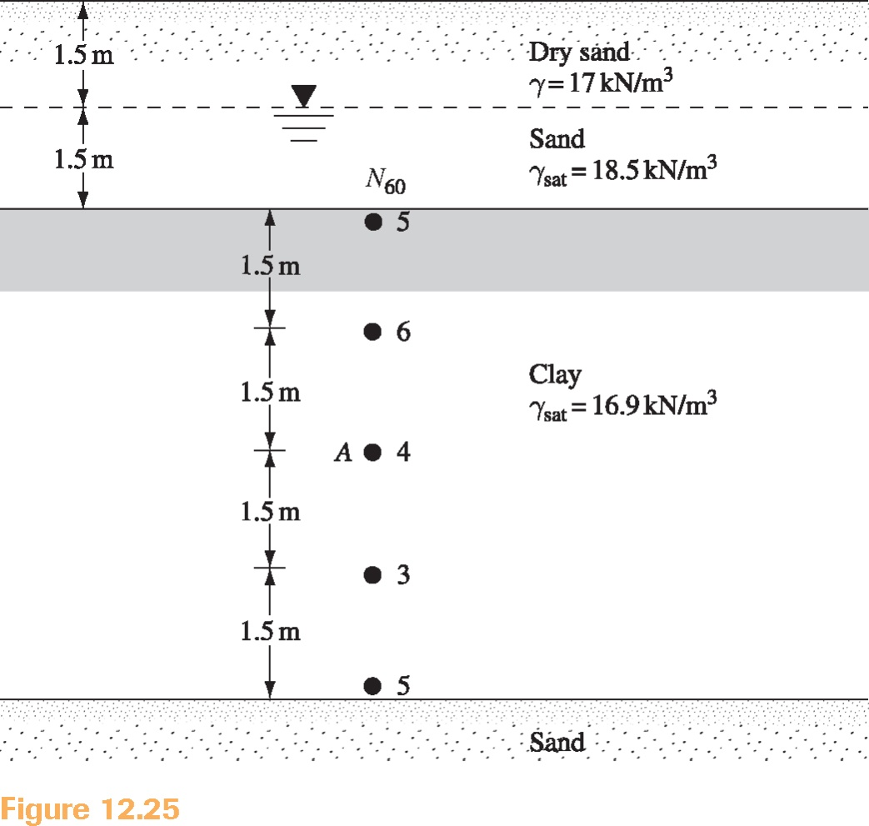

Problem 5. The table below gives the energy-corrected SPT blow counts for a sandy dry soil deposit. Total unit weight is 16.5 kN/m³ from the ground surface down to 6 m depth and 18.5 kN/m³ below 6 m.
- Use the equation by Liao and Whitman (1986) to calculate (N₁)₆₀ and plot vs. depth.
- Use equations by Meyerhof (1957) and Skempton (1986), and Idriss and Boulanger (2003) to calculate relative density (Dr) and plot vs. depth. Use average constants for the Meyerhof (1957) equation. Note: Plot both relationships on same figure, use different symbols and add legend.
- Use the correlation by De Mello (1971) to find the peak friction angle (φ’_{p}) and plot vs. depth.
- Break the soil profile into two sublayers and propose BE friction angle values (average) for each sublayer.
- Compare the idealized friction angle that you calculated from De Mello (1971) to those from Meyerhof (Table 4-3 in EPRI 1990) and comment on agreement/disagreement of the results.

Depth (m) | Total unit weight (kN/m³) | N₆₀
3.0 | 16.5 | 7
4.5 | 16.5 | 9
6.0 | 16.5 | 11
7.5 | 18.5 | 16
9.0 | 18.5 | 18
10.5 | 18.5 | 20
12 | 18.5 | 22

Correct answer: Idealized friction angle for Layer 1 between 0 and 6 m should be close to 33.3 degrees, and close to 36 degrees for the second layer between 6 and 12 m.

Problem 6. A CPT sounding for an LNG tank in Louisiana is provided in the attached file. Perform the following calculations and provided all required figures in one page (plots of qt, fs, sigma’vo, Ic, Dr, effective friction angle, Su, and OCR with depth)
- Convert input data to meter and kPa.
- Calculate total and effective vertical stress assuming water table at ground surface and total unit weight equal to 17 KN/m³ for the entire profile.
- Perform area correction on tip resistance assuming area ratio (a) is 0.59
- Calculate Ic based on Robertson (1990) and classify soil type into “Sand” or “Clay” based on Ic threshold of 2.6.
- Divide the soil profile to two sand layers and one clay layer. Show the layer boundaries with straight horizontal lines on the figures.
- Calculate relative density (Dr) for the “Sand” layers using correlations by Jamiolkowski (1985). Note: input NA() for “Clay” layers.
- Calculate effective friction angle (φ՛) for the “Sand” layers using correlations by Robertson and Campanella (1983).
- Calculate undrained shear strength (Su) for the “Clay” layer using Nk factor of 18.
- Calculate OCR for the “Clay” layer assuming (Su/σ’vo)_{N.C.} = 0.22
- Provide Best Estimate (BE) values for Dr, effective friction angle (φ՛), undrained shear strength (Su) and OCR for the three (3) idealized soil layers.

Correct answer: Use the table below to check your values.

