CE444: Geotechnical Design

Homework Assignment #4

February 15th, 2026

To: Dr. Arash Khosravifar
From: Brandon Auyeung

Problem 1.
A 6-story reinforced concrete frame structure is to be supported on a 1.2 m thick mat foundation. The building is rectangular with a width of 30 m and a length of 50 m. The total dead plus live load on the mat foundation is 125 MN (excluding weight of mat foundation). The building will have a basement and the top surface of the mat foundation will be 5.6 m below the existing ground surface. Concrete total unit weight is γc = 24 kN/m3. Calculate the total settlements immediately after construction and 30 years after construction.
Subsurface Investigation: Subsurface condition is shown in the following boring log performed at the center of the building plan. Ground water table was encountered at depth of 4.8 m. Competent bedrock was encountered at depth of 14.8 m. The energy ratio for the SPT tests was 50%, the hole diameter was 150 mm and the “standard sampler” was used. For applying rod length corrections, assume that the rod length is equal to the depth. Assume total unit weight (above and below GWT) of γ = 17 kN/m3 for the entire soil profile. Extract N values from the mid-depth of each SPT. Apply corrections to Nmeasured if needed proposed by Burland and Burbidge (1985). Convert N values to N60.
Hint: On application of silt and gravel correction factors to SPT N values when using the Burland and Burbidge (1985) method (Page 14 in Handout #2)
The boring log describes the 1st soil layer under the foundation (depth 6.8 m to 8.8 m) and the 3rd soil layer (depth 11.8 m to 14.8 m) as SAND with adjectives like "slightly" silty and gravelly. You can use your engineering judgment to decide if you should apply the silt correction factor. There is no one correct answer. The 2nd soil layer (depth 8.8 m to 11.8 m) is clearly described as SILT and it is below the water table, so you should apply the SILT correction factor (you will notice that since N_measured<15, you will end up using N=N_measured).
Correct answers:
• Total qb at the base of foundation =112.1 kPa
• Avg N60 over the depth of influence = 7.9
• Sand starts OC and ends NC
• Total settlement after 30 years, w = 6.9 cm

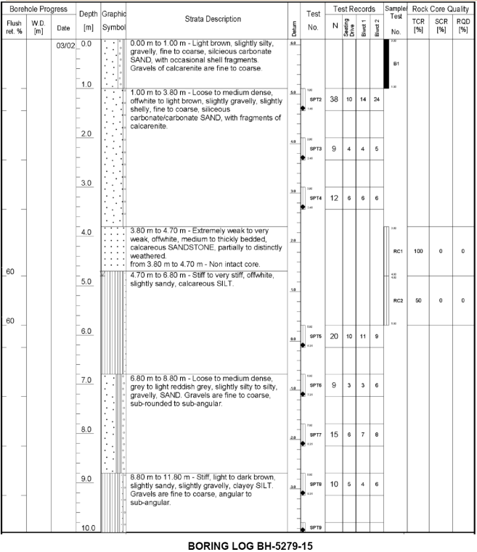

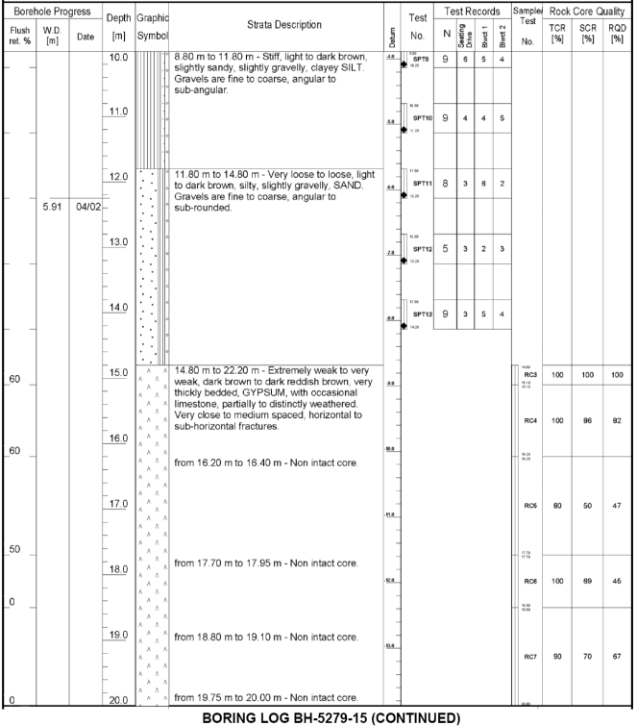

Given:
A 6-story RC frame structure is to be supported on a mat foundation 1.2 m thick. The structure is width 30 m and length 50 m. The DL+LL on the foundation is 125 MN. The building will have a basement and the top surface of the foundation is depth 5.6 m from ground surface.
Boring hole logs are given from 0 to 20 m of depth. The groundwater table was encountered at depth 4.8 m. Bedrock was hit at depth 14.8 m. The energy ratio for the SPTs was 50% with a borehole diameter of 150 mm. A ‘standard sampler’ was used. Additionally, assume the following:
- γ_{c} = 24 kN/m³
- Rod length is equal to depth
- γ = 17 kN/m³ regardless of saturation

Find:

Part A
Determine N₆₀ values from mid-depth of each SPT applying corrections via Burland & Burbidge (1985) and energy correction methods.

Part B
Determine the total settlements immediately after construction and 30 years after construction.

Solution:

Part A
Given that the top of the foundation is at 5.6 m and that the foundation is 1.2 m thick, it is assumed that soil above depth 6.8 m will be excavated. That means our first sublayer is in a sand that is considered ‘slightly silty to silty, gravelly’. The groundwater has already been encountered. In the sublayer from depths 6.8 m to 8.8 m (also known as Sublayer 1) and the sublayer from depths 11.8 m to 14.8 m (also known as Sublayer 3), the Burland & Burbidge (1985) correction will not be used. In the sublayer from depths 8.8 m to 11.8 m (also known as Sublayer 2) the Burland & Burbidge (1985) will be used. The Burland & Burbidge (1985) correction is as follows.
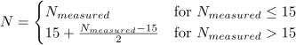
The mid-depth SPTs for each sublayer is SPT7 for Sublayer 1, SPT9 for Sublayer 2, and SPT12 for Sublayer 3. No other sublayers after Sublayer 3 have SPT data, so Sublayer 3 is our final considered sublayer.
Multiple factors are required to get N₆₀. To get the energy correction factor, C_{h}, the following relationship is used.
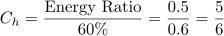
Assuming the rod length is equal to depth, the following relationship is used to get the rod length correction factor, C_{r}.
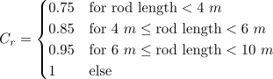
Since a standard sampler was used, the sampler correction factor, C_{s} is equal to 1. The borehole diameter correction factor, C_{d} is known to be 1.05 for borehole diameters equal to 150 mm.
These correction factors and the gathered N values can be used to obtain N₆₀ using the following relationship.
N₆₀ values, the factors, and SPTs used are then tabulated in Table R1.

Part B
To start this problem, it is important to define parameters of the foundation. This is done in Table S1.
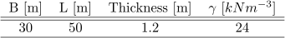
Table S1. Foundation parameters.
The top of the foundation is located at depth 5.6 meters. This means that a total of 5.6 m plus 1.2 meters of soil will be removed, putting the bottom of the foundation at depth 6.8 m. The stiff layer is gypsum is encountered at depth 14.8 m, making the value of H equal to 14.8 m minus 6.8 m, equaling 8.0 meters.
The value of q_{b} is found by summing the stress from the point load and the stress from the self weight of the foundation. This results in the below calculation.

In order to define soil parameters, it is important to calculate the depth of influence. Keeping units in meters allows for the reference length, L_{R}, to be equal to 1 meter. The depth of influence, z_{f0}, is calculated in the following relationship.
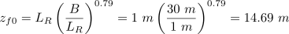
Now that the depth of influence is calculated, the averaged value of N₆₀ across the depth of influence (i.e. the value of ) can be obtained. By repeating the analysis found for Part A for all SPTs in the depth of influence, the value of can be obtained.
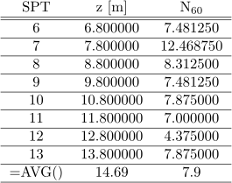
Table S2. Obtaining
Now that is found, we can use the given information to begin calculating the value of the the many factors involved.
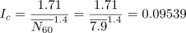
Compressibility Index Eqn.

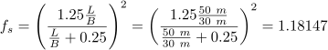
Shape Factor Eqn.

Layer Thickness Factor Eqn.

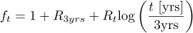 Time Factor Eqn.
Note:
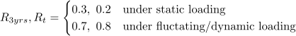
For both cases, I_{c}, f_{s}, and f_{L} are equal. The loading is static. Therefore, in the case of immediate settlement, f_{t} is equal to 1. On the other hand, in the case where 30 years of settlement are considered, f_{t} is equal to 1.5.
Before settlement may be calculated, it is important to determine what case the settlement falls under.
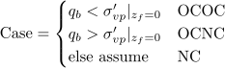
The preconsolidation stress at the bottom of the footing, (which may also be called as ), is equal to the vertical effective stress of the excavated soil. That soil is assumed to have been the only load on the site, meaning it’s effective stress is the only weight the soil at that depth has felt. The value of is found with the following relationship.
Based on the values obtained from calculation, this foundation is an OCNC case. OCNC settlement cases follow the below relationship for settlement. Values for settlement under time 0 (i.e. immediate settlement) and 30 years are then calculated.
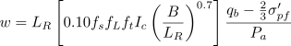

Results:

Part A
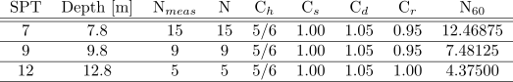
Table R1. Tabulated results for mid-depth N₆₀ and the factors for obtaining N₆₀.

Part B
The immediate settlement is equal to 0.047 m (i.e. 4.7 cm). The settlement in 30 years is equal to 0.079 m (i.e. 7.9 cm).

