

Maseeh College of Engineering and Computer Science
Department of Civil and Environmental Engineering

Post Office Box 751 503-725-4282 tel
Portland, Oregon 97207-0751 503-725-5950 fax

CE 444 Geotechnical Design

To: CE 444 Students Date: February 10, 2026
From: Arash Khosravifar

Subject: Homework Assignment #4. Due dates: Feb 15th

Problem 1. A 6-story reinforced concrete frame structure is to be supported on a 1.2 m thick mat foundation. The building is rectangular with a width of 30 m and a length of 50 m. The total dead plus live load on the mat foundation is 125 MN (excluding weight of mat foundation). The building will have a basement and the top surface of the mat foundation will be 5.6 m below the existing ground surface. Concrete total unit weight is γ_{c} = 24 kN/m³. Calculate the total settlements immediately after construction and 30 years after construction.

Subsurface Investigation: Subsurface condition is shown in the following boring log performed at the center of the building plan. Ground water table was encountered at depth of 4.8 m. Competent bedrock was encountered at depth of 14.8 m. The energy ratio for the SPT tests was 50%, the hole diameter was 150 mm and the “standard sampler” was used. For applying rod length corrections, assume that the rod length is equal to the depth. Assume total unit weight (above and below GWT) of γ = 17 kN/m³ for the entire soil profile. Extract N values from the mid-depth of each SPT. Apply corrections to N_{measured} if needed proposed by Burland and Burbidge (1985). Convert N values to N₆₀.

Hint: On application of silt and gravel correction factors to SPT N values when using the Burland and Burbidge (1985) method (Page 14 in Handout #2)
The boring log describes the 1st soil layer under the foundation (depth 6.8 m to 8.8 m) and the 3rd soil layer (depth 11.8 m to 14.8 m) as SAND with adjectives like "slightly" silty and gravelly. You can use your engineering judgment to decide if you should apply the silt correction factor. There is no one correct answer. The 2nd soil layer (depth 8.8 m to 11.8 m) is clearly described as SILT and it is below the water table, so you should apply the SILT correction factor (you will notice that since N_measured<15, you will end up using N=N_measured).

Correct answers:
- Total qb at the base of foundation =112.1 kPa
- Avg N60 over the depth of influence = 7.9
- Sand starts OC and ends NC
- Total settlement after 30 years, w = 6.9 cm

Problem 2. A uniform bearing pressure of 250 kPa is applied at the bottom of an 8 m deep basement excavation that is 30 m wide and 100 m long. Estimate (a) net immediate settlements using Janbu et al. (1956), (b) net consolidation settlement, (c) sum of immediate and consolidation settlements due to net load.

- Use correlations by Duncan and Buchignani (EPRI 1990 Figure 5-6) to estimate elastic soil modulus (Es).
- For calculating the consolidation settlement, break the clay layer into a number of sublayers (to be consistent let’s all use 4 sublayers). Calculate the induced stress (Δσ_{v}) in the middle of each sublayer using the approximate 2:1 method. Apply the correction factor for 3D consolidation assuming Skempton A value of 0.4 at failure.
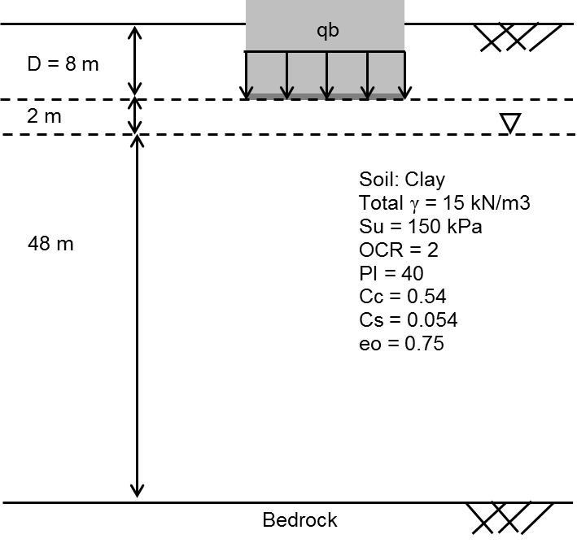

Hints:
- When calculating the consolidation settlement in clay, make sure to only consider the saturated portion of the clay layer, i.e. ranging from 10 m to 58 m depth.
- Note that Zf is the depth from the base of the foundation.
- When calculating alfa to apply 3D adjustment for consolidation settlement, you may simply use the value corresponding to the strip footing in Table 9-4 in Salgado (i.e. alpha=0.3). You may choose a slightly different value if you use interpolation.

Correct answers:
- K = 400 but other values could be correct (in calculating Eu)
- q_{b}^{net} = 130 kPa
- The first row of the table for consolidation settlement calculation is copied below:

