

Maseeh College of Engineering and Computer Science
Department of Civil and Environmental Engineering

Post Office Box 751 503-725-4282 tel
Portland, Oregon 97207-0751 503-725-5950 fax

CE 444 Geotechnical Design

To: CE 444 Students Date: February 26, 2026
From: Arash Khosravifar

Subject: Homework Assignment #5 (Due March 6th, 11:59 p.m.)

Problem 1. A shallow square footing is being considered as a foundation option to support both gravity and seismic loads for a marquee sign. The footing width is 4-by-4 meters and the embedment depth D = 1.5 meters. The soil deposit includes a saturated clay with undrained shear strength S_{u} = 50 kPa and total unit weight of γ = 17 kN/m3. The water table is very deep. The mass of the marquee sign is approximately m = 100 metric ton (100 Mg). Assume pinned connection between column and foundation (i.e. no bending moment transferred to the foundation). Find (a) the limit net bearing capacity (q_{bL}^{net}) and (b) factor of safety (FS).

Note 1: Estimate the horizontal load (seismic) using Q_{h} = m*S_{a} where m is the structure mass and S_{a} is the spectral acceleration from an earthquake. To estimate spectral acceleration (S_{a}) we use the online design tool by USGS. Unfortunately, this service is no longer available for free. So, I have attached the USGS report that was performed last year for a site located at the Engineering Building at PSU. For your information. this report was created using the following steps:
- Go to USGS website and find U.S. Seismic Design Maps application:
http://earthquake.usgs.gov/designmaps/us/application.php
- Use the following input parameters in the application:
  - Select 2010 ASCE 7
  - Select Site Class D “Stiff Soil”
  - Select Risk Category I, II or III
  - Set site latitude and longitude to the Engineering Building at PSU

In the summary report find S_{D1} which is the design spectral acceleration for a structure with fundamental period of 1 second. Assuming that the marquee sign has a fundamental period of approximately 1 second, use S_{a} = S_{D1} to calculate seismic (horizontal) Q_{h} = m*S_{a}. Note that S_{D1} reported in the summary report needs to be multiplied by “g”.

Note 2: In calculating the inclination factor ignore the limitation on Qh/Qv ≤ 0.4.

Note 3:
The structure mass, m=100 Mg = 1e5 kg
The structure weight (vertical), Qv = m*g = (1e5 kg)*(9.81 m/s2) = 9.81e5 N = 981 kN
The seismic load (horizontal), Qh = m*Sa = (1e5 kg)*(0.447*9.81 m/s2) = 4.385e5 N = 438.5 kN

Correct answer: FOS=3.8

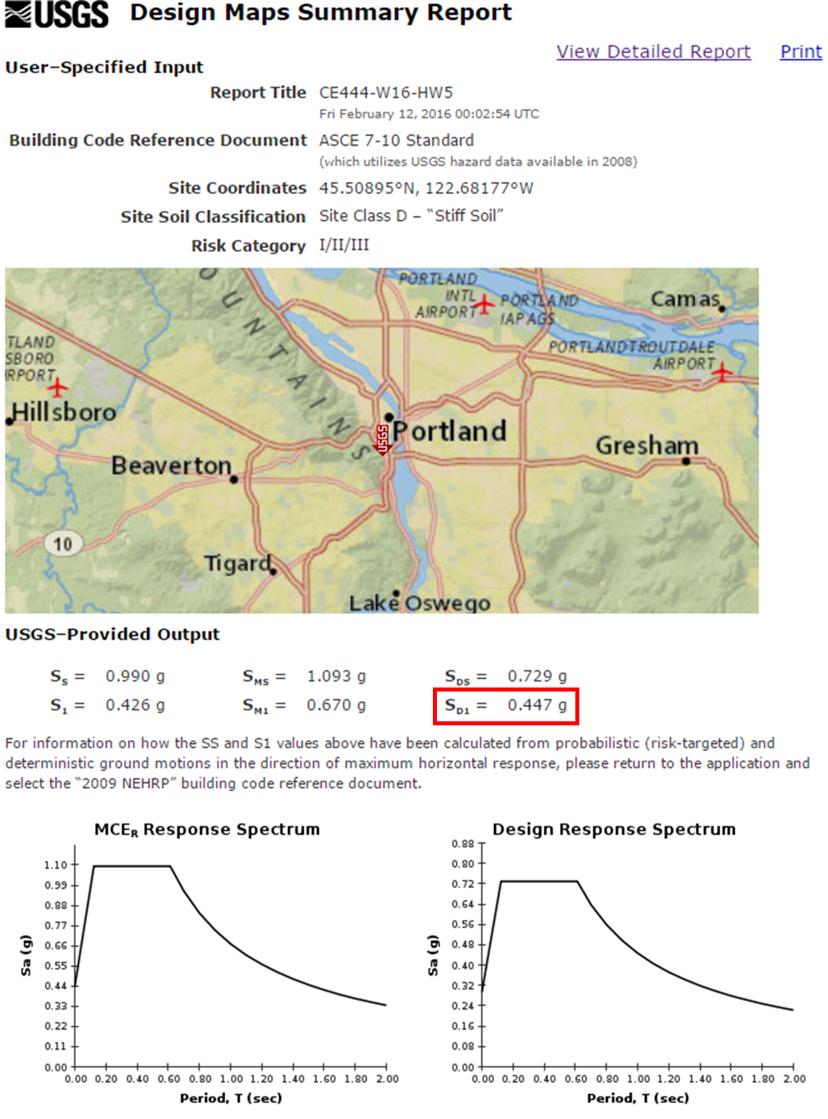
Problem 2. A rectangular footing of width B and length 2B will need to support a vertical dead plus live load of 1.7 MN (including the expected weight of the foundation) with a factor of safety against bearing failure of 2.5. The footing base will be placed 1.4 m below the ground surface in a deep deposit of sand. The water table is at a depth of 20 m. The soil's total unit weight above the water table is 18 kN/m3 and below the water table is 20 kN/m3. Prepare a spreadsheet that computes the minimum footing width (B) required to provide adequate safety against bearing failure, and plot B versus the effective friction angle (φ′) of the sand (for φ′ values of 30° to 45°).

Hint: Different approaches can be used to find the minimum footing width. One approach is to manually iterate by changing the footing width B until the required FS is obtained. A second approach is to use "goal seek" in Excel; You specify that the FS should be set equal to 2.5 by changing the footing width, B, and then "goal seek" performs the iterations for you. The third approach is to set up the iteration using circular references (attached file): There are two entries for footing width (B); the first entry is a trial B that is used in all the bearing capacity calculations, after which a second "new trial B" is computed. I then set the first B equal to the latter B. At this point, Excel may show an error message that you have a circular reference. To fix that, go to "Options", click on the "calculations" tab, and enable "Iterations". Excel will now perform the iterative computations to converge FS and Target FS.

Correct answer: For friction angle of 45 degree, you should be calculating a foundation width of 0.47 m.

Problem 3. Square footings of width B will support columns for an elevated bridge that crosses over a park that periodically floods during winter. The footings will be embedded a depth D_{f} in a deep deposit of medium-dense gravelly sand having an effective friction angle of 35 degrees. The water level can rise to about 5 feet over the ground surface. The unit weight of the gravelly sand is about 128 pcf when saturated. The design dead plus live loads imposed on each footing are a vertical load of 320 kips (along the centerline of the footing), a horizontal load of 60 kips (at the column base), and an overturning moment of 180 kip⋅ft (in one direction only). Determine the minimum footing width B required to provide a factor of safety against bearing failure of 3.0 for embedment depths (D_{f}) ranging from 1 to 6 feet, and plot the minimum B versus D_{f}. Perform all calculations in SI units.

Hint: There are various methods to account for the effect of bending moment on q_net. The approach that we use includes the following steps:
1. Calculate B_eff = B - 2 * ML/Qv and L_eff = L - 2 * MB/Qv
2. Use previous equations, just replace B with B_eff and L with L_eff. That includes how to calculate q_net:
q_net = Qv/(B_eff*L_eff) - qo

Correct answer: For the footing embedment of 6 ft (1.83 m), you should be calculating a footing width of 2.2 m.

