CE444: Geotechnical Design

Homework Assignment #5

February 6th, 2026

To: Dr. Arash Khosravifar
From: Brandon Auyeung

Problem 1.
A shallow square footing is being considered as a foundation option to support both gravity and seismic loads for a marquee sign. The footing width is 4-by-4 meters and the embedment depth D = 1.5 meters. The soil deposit includes a saturated clay with undrained shear strength Su = 50 kPa and total unit weight of γ = 17 kN/m3. The water table is very deep. The mass of the marquee sign is approximately m = 100 metric ton (100 Mg). Assume pinned connection between column and foundation (i.e. no bending moment transferred to the foundation).

Find:

Part A
​Determine .

Part B
Determine factor of safety, FS.

Solution:

Part A

Problem 2.

Given:
A rectangular footing of width B and length 2B will need to support a vertical dead plus live load of 1.7 MN (including the expected weight of the foundation) with a factor of safety against bearing failure of 2.5. The footing base will be placed 1.4 m below the ground surface in a deep deposit of sand. The water table is at a depth of 20 m. The soil's total unit weight above the water table is 18 kN/m3 and below the water table is 20 kN/m3.

Find:

Part A
Prepare a spreadsheet that computes the minimum footing width (B) required to provide adequate safety against bearing failure

Part B
Plot B versus the effective friction angle of the sand (for values of 30° to 45°).

Solution:
Constant values of γ = 18 kNm⁻³, D = 1.4 m, q₀ = γD = 25.2 kPa, and F.S. = 2 were used.
The following equations were used to calculate the factors in Table 1.
as given by the problem statement
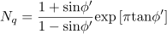
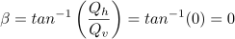
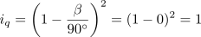
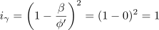

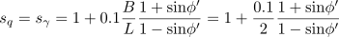

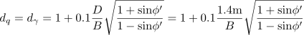

These factors are able to be used to calculate the demand, capacity, and the factor of safety relationship.
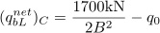 Capacity

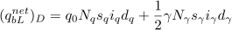 Demand

By setting all variables in the above equation(s) in terms of B and , the Sympy module in Python can solve the above expression for B for each given value of from 30 degrees to 45 degrees.

Part A
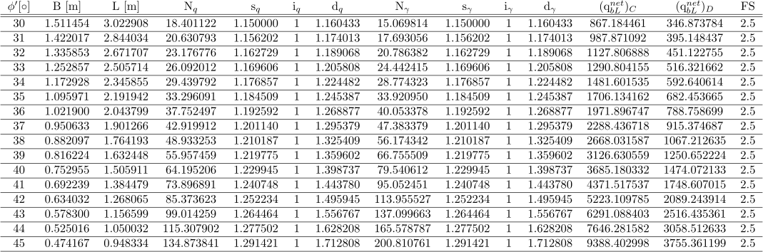
Table 1. Prepared spreadsheet of values used to find B given a FS = 2.5 and a variable effective friction angle of sands.

Part B
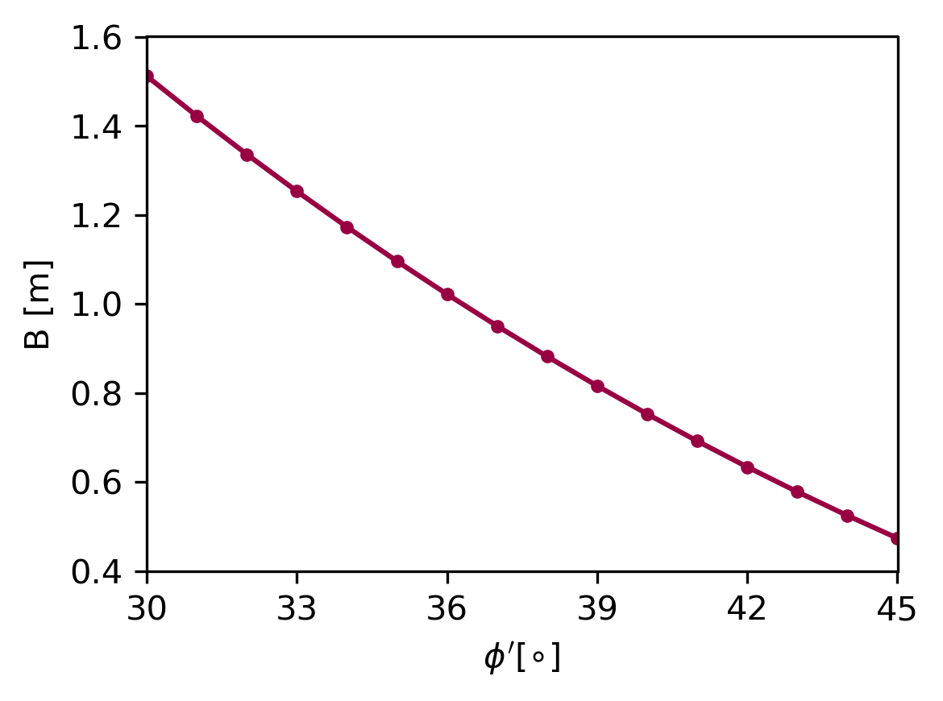
Figure 1. Required foundation width to achieve a 2.5 factor of safety with respect to effective friction angle of sand.

