

Maseeh College of Engineering and Computer Science
Department of Civil and Environmental Engineering

Post Office Box 751 503-725-4282 tel
Portland, Oregon 97207-0751 503-725-5950 fax

CE 444 Geotechnical Design

To: CE 444 Students Date: March 6, 2026
From: Arash Khosravifar

Subject: Homework Assignment #6 (Due March 13, 11:59 p.m.)

Problem 1. Axial Load on Piles
A single pile foundation is being considered to support a structure with a weight of 1.8 MN. The site investigation program includes one CPT performed at the center of the site (attached file). The type of piles readily available at the site is driven RC concrete piles with a circular cross section and a diameter of 2 feet (0.61 meter). Assuming a factor of safety (FS) of 4 find the required length of pile knowing that at least 12 meters of pile is needed to provide stability against lateral loads. Follow the following steps and assumptions:
- Analyze CPT data using the spreadsheet that you developed in Homework 3. Assume water table is at ground surface. Total unit weight is 17 kN/m³. CPT tip resistance is already area-corrected. Calculate soil behavior index (Ic) using Robertson (1990). Classify the soil type to either Sand or Clay based on Ic threshold of 2.6. Estimate effective friction angle in sand using correlations by Robertson and Campanella (1983). Estimate undrained shear strength in clay using Nk factor of 15.
- Develop idealized soil profile and fill out table below. Develop “design” soil properties by averaging friction angle and shear strength in each soil layer.
- Calculate skin friction (qs) and end bearing (qp) for each data point in the CPT file based on whether that data point corresponds to Clay or Sand. Get an estimate of friction angle between concrete pile and soil (δ) using AASHTO LRFD (2014) Table 3.11.5.3-1 (attached). Use your engineering judgment in selecting the right value from table. Use the “design” soil properties in your calculation (i.e. the average values in table below). Calculate resistance Qs and Qp profiles.
- Find allowable resistance (Qall) and determine required length of pile.
In your submittal, include: table below, individual figures for skin friction (qs) profile (versus depth), qp profile, Qall profile (in all figures show the soil layers with straight lines and label soil layers as Sand or Clay), total required pile length, and comment on the comparison of qs and qp in sand versus clay layers.
Sublayer | Type (Sand/Clay) | Top Depth (m) | Bottom Depth (m) | Avg φ' (Deg) | N*q | Avg Cu (kPa) | K | α

1
2
3
4
5
6

Hints:
In Column AF you will need to simply extract the qs that is already calculated for sand and clay. Here is how you can formulate Cell AF3 in your spreadsheet:
=IF(Q3="Sand",Y3,IF(Q3="Clay",AC3))

In Column AG you will need to multiply qs by the tributary area to get the side friction:
ΔQs = qs * Area = qs * (perimeter * delta_L)
delta_L = depth difference between each row = 0.152 m.
perimeter = 3.14*diameter
ΔQs is the side friction (in kN) between two consecutive rows and it can be calculated by averaging qs between two consecutive rows. For example, Cell AG4 can be formulated in the spreadsheet as following:
=AVERAGE(AF3:AF4)*$AG$1*(E4-E3)

In Column AH you will need to sum all the side frictions (ΔQs) from the ground surface to each corresponding depth. For example, here is how you may formulate Cell AH8 in your spreadsheet:
=SUM($AG$3:AG8)
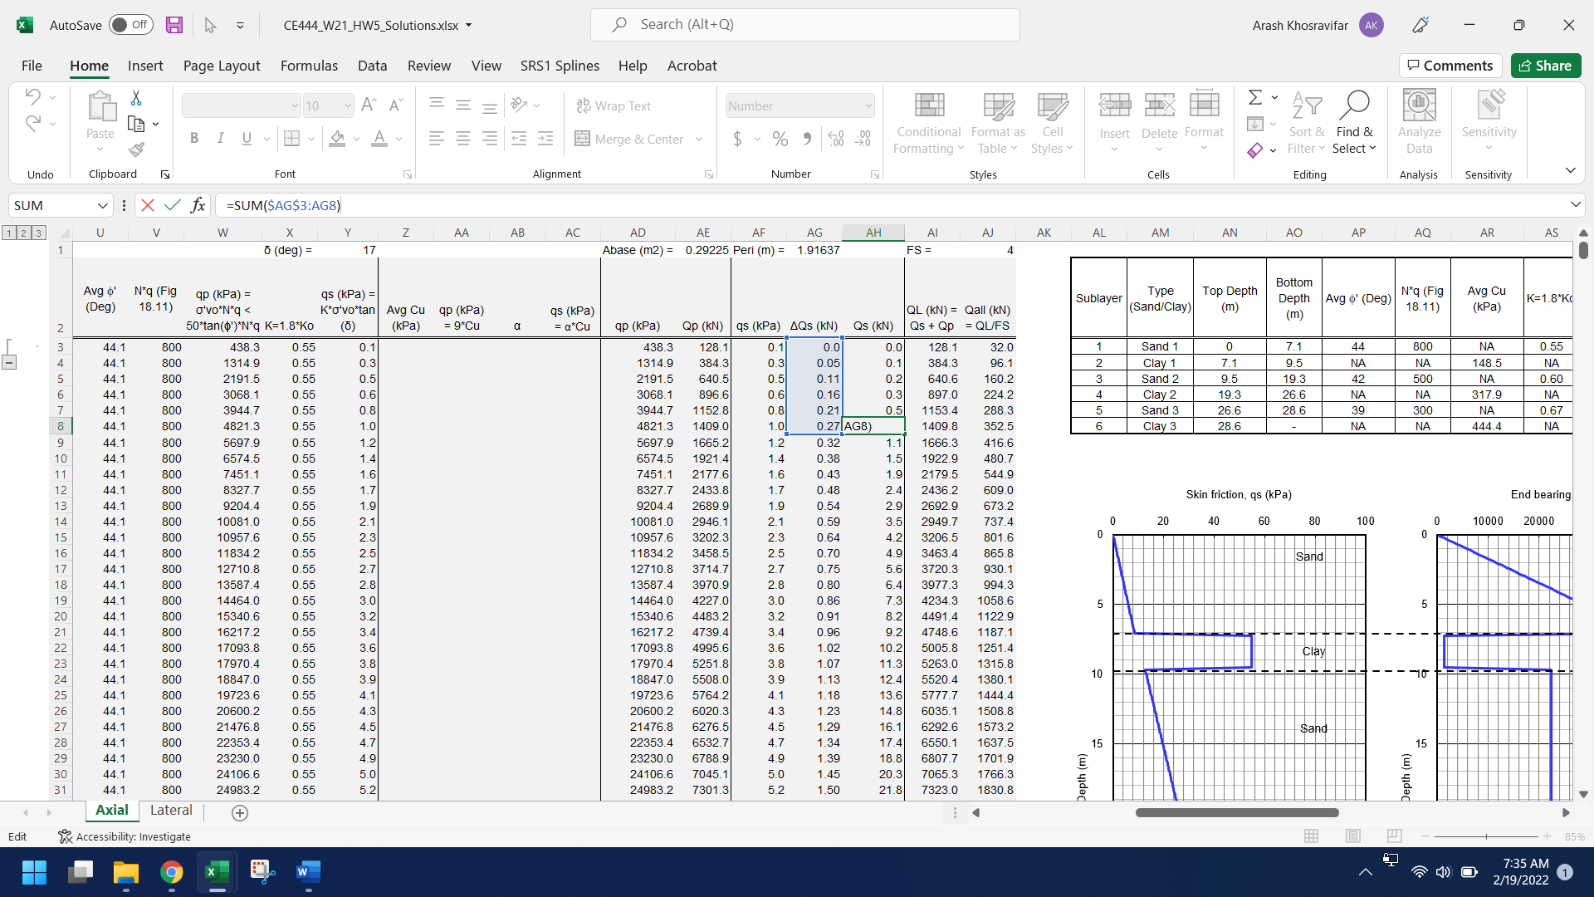

- The PWP (u2) in the CPT profile (Column D) is the porewater pressure measured by the sensor behind the tip of the CPT. This measurement is sometimes faulty due to improper saturation of the sensor by the CPT operator. Therefore, it is not uncommon in practice to set this measurement to zero as done in this case. Note that this column is different from the Hydrostatic PWP (Column J) which you will need to calculate based on the location of the water table (assumed to be at ground surface in this case).

- The header for N*q (Columns V and AQ) refers to the figure in Page 6 of Handout #4. The textbook does not have this figure.

- Note that you will have to first use the CPT data (Columns A to T) to fill out the summary Table in Columns AL to AT, Rows 2 to 8. Here you will get average values for phi', N*q, Cu and alfa for each one of the six sublayers. Then you will use these average values in Columns U to AJ for the pile analysis. For example, you will need to use one (average) value for N*q for each sublayer that is characterized as sand (there are three sand sublayers) rather than calculating N*q for every single data point.

- The average Cu for two sublayers (Clay 2 and Clay 3) will be >300 kPa. That means that you will need to extrapolate the figure for alfa versus Cu. Approximate extrapolation is adequate in this case.

Problem 2. Lateral Load on Piles
In this problem we will practice how to perform lateral load analysis on piles using the Beam-on-Nonlinear-Winkler Foundation (BNWF) method, also known as the p-y approach. There are many commercial and non-commercial software packages available for lateral load analysis of piles, e.g. Lpile by Ensoft, PB-MultiPier, DFSAP, RSPile by Rocscience, and OpenSees, to name a few. In this problem we will use Lpile Student Version to solve the problem, but any other lateral pile analysis software can be sued too.

Running Lpile: Download the zip file on Canvas and unzip it on a local drive. The program doesn’t need installation. You should be able to start the program by double clicking on LPILESSudent.exe. There are user manual documentation and example files in the zip folder too.

Create the model: Follow these steps to create a model and save the file as “HW5_Sand” for future references.
- First, change the unit system to SI from Options/Units.
- Define the pile properties from Data/Pile Properties using the following data:
  - Let’s model a pile that is 20 m long.
  - Keep the default number of increments, i.e. 100.
  - Let’s keep the pile head at ground surface.
  - Let’s keep this example simple, i.e. no ground slope, and no batter angle.
  - The pile that you will be modeling will be a steel pipe pile with an outer diameter of 0.6 m and a wall thickness of 0.025 m. The elastic modulus of steel can be assumed as 200 GPa. Calculate the section properties (Dia, Area, I, and E). Double check your answers with your classmates. These input parameters, though simple, can be easily miscalculated and will significantly affect your results.
- Define the loading type from Data/Loading Type: Let’s keep the loading type as “Static”.
- Define the loads to be applied at pile head from Data/ Boundary Conditions and Loading. Lpile gives you five options to define the loads at pile head. To start with, let’s apply a shear load of 200 kN and a zero moment at pile head (this is the first option in the drop-down menu. In this case, Condition 1 will be 200 and Condition 2 will be 0. Specifying an axial load will account for the p-delta effect. So, let’s add a 500 kN axial load too.
- Define the soil properties from Data/Soil Layers. Lpile discretizes the pile into 100 increments (101 nodes) and models the soil as individual soil springs (also called p-y springs) attached to the pile nodes. That means that Lpile internally creates 101 p-y springs along the pile based on the soil properties that you will assign in this window. The drop-down menu gives you several p-y options for sand, several p-y options for clay, and couple p-y options for rock. In the first analysis we will assume that the subsurface is uniformly sand. You will notice that there are three options to model sand: Sand (Reese), API Sand, and Liquefiable Sand. These are different types of p-y springs that have been proposed by different codes and guidelines to model sand.
  - In this problem we will use “API Sand (O’Neill)” which is allowed by many design codes including API (American Petroleum Institute) and AASHTO. Since we only have one layer, the depth of top of the layer should be 0 m and the depth of bottom of the layer should be equal to the length of the pile, i.e. 20 m.
  - In the same window, Click on “API Sand” under the Properties of Layer. This opens a new window where you can define the properties of the sand layer at the top and bottom of the layer. For a uniform sand layer, such as the one that we are analyzing here, the top and bottom properties are the same.
    - Let’s assume that the total unit weight is 17 kN/m3 and the ground water is at ground surface. That means that you have to input 7.19 kN/m3 (17 – 9.81 = 7.19) for the effective unit weight.
    - Let’s assume that the friction angle of sand is 35 degrees.
    - The p-y Modulus (k) is a parameter that defines the stiffness of the p-y relationship. If you leave it as zero, Lpile internally calculates this value based on API recommendations.
- Run the analysis from Computation/Run Analysis. You should get a message that says: “the analysis was completed without errors”. This analysis should take a fraction of a second. This computational effectiveness, and the fact that software packages like Lpile are cheap and readily available for many geotechnical firms, is the reason why the p-y solution method has effectively replaced the closed-form solutions and charts that used to be used in the past when these computer software packages were not available.
- Results. You can pull up the results from Graphics/Lateral Deflection vs. Depth, Bending Moment vs. Depth, Shear Force vs. Depth, and Mobilized Soil Reaction vs. Depth. Click to open all the four graphics and move them to be able to see four windows side-by-side: deflection, soil reaction (or p), shear, and moment.
  - The following items do not need to be included in your report. Take some time to understand if the results make sense.
    - Lateral deflection plot: How much deformation do you get at the pile head? What is the approximate depth below which the deflections are negligible?
    - Mobilized soil reaction plot: Do the positive and negative soil reactions correspond to the negative and positive pile deflections, and why? What is the approximate depth below which the soil does not feel the shear force at pile head?
    - Shear force plot: What is the shear force at pile head? Is it a coincidence that this shear force is equal to boundary condition that you specified earlier? Does the point where the slope of shear is maximum correspond to the maximum soil reaction, and why? What is the approximate depth below which the shear force is negligible?
    - Bending moment plot: What is the moment at pile head? Is it a coincidence that this moment is equal to the boundary condition that you specified earlier? Where does the maximum moment develop in the pile? Does the point where the slope of moment is maximum correspond to the maximum shear force, and why? What is the approximate depth below which the moments are negligible?
  - The following items should be included in your report:
    - The four plots of deflection, soil reaction, shear, and moment with depth. You can take a snapshot and include it in your report or use the output file to extract digital data and plot them in excel. If you are taking a snapshot, your plots in your report should be legible.
    - Fill out the following table and include in your report:
Boundary conditions at pile head | Maximum lateral deflection (m) | Maximum shear force (kN) | Maximum bending moment (kN-m)
V =
M =
Axial force =

- In the next analysis, we will try to investigate what would have happened if the pile head was fixed against rotation. You can go back to the Boundary Conditions and Loading window, and add a row (keep the previous loading conditions). From the drop-down menu for the new row select Shear and Slope. Set the shear to be same as before, i.e. 200 kN, and set the slope to 0. This will fix the pile head against rotation. Keep the axial load as 500 kN. Run the analysis and open the four results windows where both analyses (Case 1 with free pile head and Case 2 with fixed pile head) are plotted. Answer the following questions:
  - No need to be included in your report.
    - Did the displacement decrease or increase in a fixed pile head compared to the free pile head?
    - Does the shear force at pile head still start from 200 kN, and why?
    - How did the bending moment at pile head change in the fixed head analysis?
  - Include the following in your report:
    - Four side-by-side plots of deflection, soil reaction, shear force, and bending moment with depth. Each plot should include both free-head and fixed-head cases.
    - Fill out the following table and include in your report:
Boundary conditions at pile head | Maximum lateral deflection (m) | Maximum shear force (kN) | Maximum bending moment (kN-m)
V =
Rotation =
Axial force =

- In this analysis we will develop the pile-head force-deflection curve, also known as the pushover curve. This can be done by pushing the pile head to a target displacement in a number of increments and recording the shear force at pile head at each increment. Go back to the Boundary Conditions and Loading window. Delete the second row that you had added in the previous analysis. Add additional rows to have a total of 10 load conditions. Change all load condition types to Displacement and Moment. Change Condition 1 (pile head displacement to range from 0 m to 0.09 m in increments of 0.01 m. Apply no moment at pile head (leave all Condition 2’s as zero). Apply 500 kN axial load for all load conditions. Run the analysis and open the four results windows and answer the following questions:
  - No need to be included in the report
    - Do the pile head deflections match what you specified in the loads section?
    - Does the shear force at pile head increase with increasing pile head displacements? What is the maximum shear force along the pile? Is it still at pile head or did it migrate to deeper locations?
    - Does the maximum moment in the pile increase with increasing pile head displacements?
    - In all these cases, does the depth below which the pile demands (deflection, V, and M) are negligible change?
  - Include the following in your report:
    - From the Graphics menu open the Load vs. Top Deflection window. This plot is called the pile-head force-displacement or the pushover curve. Include this figure in your report.
    - Calculate and report the pile lateral stiffness (in kN/m), which is the slope of the initial portion of the pushover curve.
- In this analysis, we will investigate sand vs. clay sites. Make a copy of the current file and save it as “HW5_Clay”. Make the following changes to the new file.
  - Go back to Data/Soil Layers and from the drop-down menu change the soil type to clay. As you can see there are several options available for clay. We are going to use Soft Clay (Matlock) which is one of the most common p-y curves developed for clay sites. Click on the Properties of Layer on the right column which opens a window to input soil properties:
    - Input the same effective unit weight as the previous case, i.e. 7.19 kN/m3. This assumes that the ground water table is at the ground surface.
    - Assign an undrained cohesion for clay. This is the same as Su, undrained shear strength. Let’s use 50 kPa.
    - The strain factor, E50 is a parameter that defines the stiffness of the p-y curve. Let’s leave it as zero to have Lpile calculate this parameter internally.
  - Go back to the Boundary Conditions and Loading menu and delete all the additional load conditions that you had to add to develop the pushover curve in the previous analysis. Leave one load condition and change it to Shear and Moment. Let’s apply exact same loads that we applied in the first analysis for the sand site, i.e. shear load of 200 kN, zero moment, and an axial load of 500 kN.
  - Run the analysis and pull up the four results plot windows (deflection, soil reaction, shear and moment with depth). Answer the following questions:
  - No need to be included in the report:
    - Does the pile head displacement increase in the clay site compared to sand site? How about other demands, i.e. shear force and bending moment?
  - Include in your report:
    - Four side-by-side plots of deflection, soil reaction, shear force and bending moment with depth.
    - Fill out the following table and include in your report:
Boundary conditions at pile head | Maximum lateral deflection (m) | Maximum shear force (kN) | Maximum bending moment (kN-m)
V =
M =
Axial force =

