CE444: Geotechnical Design

Homework Assignment #6

March 13th, 2026

To: Dr. Arash Khosravifar
From: Brandon Auyeung

Problem 1.

Given:
A single pile foundation is being considered to support a structure with a weight of 1.8 MN. The site investigation program includes one CPT performed at the center of the site (attached file). The type of piles readily available at the site is driven RC concrete piles with a circular cross section and a diameter of 2 feet (0.61 meter). Assuming a factor of safety (FS) of 4 find the required length of pile knowing that at least 12 meters of pile is needed to provide stability against lateral loads. Follow the following steps and assumptions:
Analyze CPT data using the spreadsheet that you developed in Homework 3. Assume water table is at ground surface. Total unit weight is 17 kN/m3. CPT tip resistance is already area-corrected. Calculate soil behavior index (I_{c}) using Robertson (1990). Classify the soil type to either Sand or Clay based on Ic threshold of 2.6. Estimate effective friction angle in sand using correlations by Robertson and Campanella (1983). Estimate undrained shear strength in clay using Nk factor of 15.
Develop idealized soil profile and fill out table below. Develop “design” soil properties by averaging friction angle and shear strength in each soil layer.

Find:
Calculate skin friction (q_{s}) and end bearing (q_{p}) for each data point in the CPT file based on whether that data point corresponds to Clay or Sand. Get an estimate of friction angle between concrete pile and soil (δ) using AASHTO LRFD (2014) Table 3.11.5.3-1 (attached). Use your engineering judgment in selecting the right value from table. Use the “design” soil properties in your calculation. Calculate resistance Q_{s} and Q_{p} profiles. Find allowable resistance (Q_{all}) and determine required length of pile.
In your submittal, include: table below, individual figures for skin friction (q_{s}) profile (versus depth), q_{p} profile, Q_{all} profile (in all figures show the soil layers with straight lines and label soil layers as Sand or Clay), total required pile length, and comment on the comparison of q_{s} and q_{p} in sand versus clay layers.
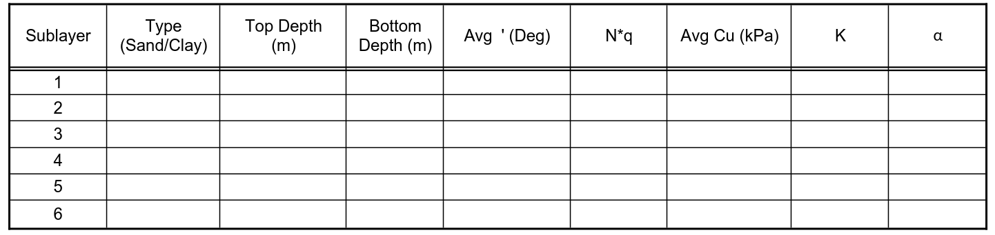

Solution:
CPT data was analyzed to generate the following CPT profiles depicted in Figures 2 and 3. The average and S_{u} were collected from each sublayer. The value of N_{q}* was obtained using the figure generated by Meyerhof in Figure 1.
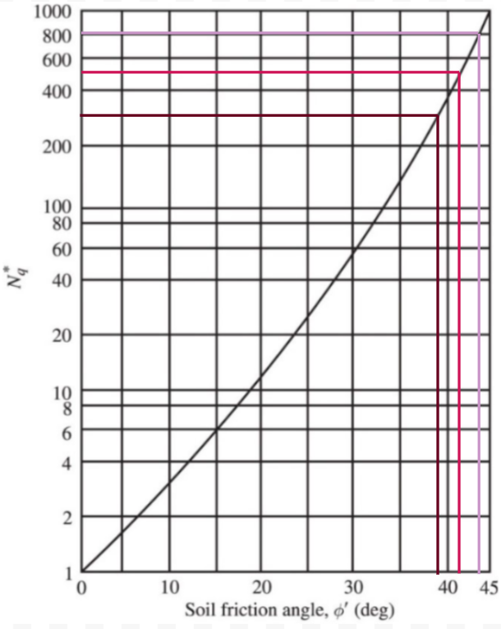
Figure 1. Selection of N_{q}* based on extracted .
The value of K was determined using the below equation.
Driven Pile

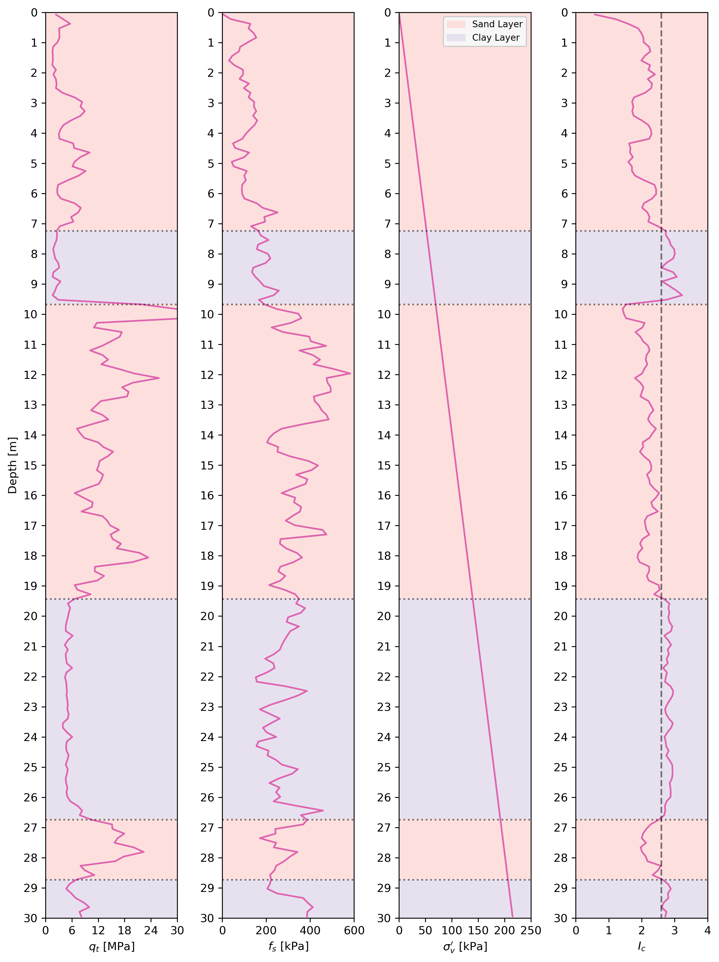
Figure 2. Tip resistance, sleeve friction, vertical effective stress, and I_{c} values of the profile.
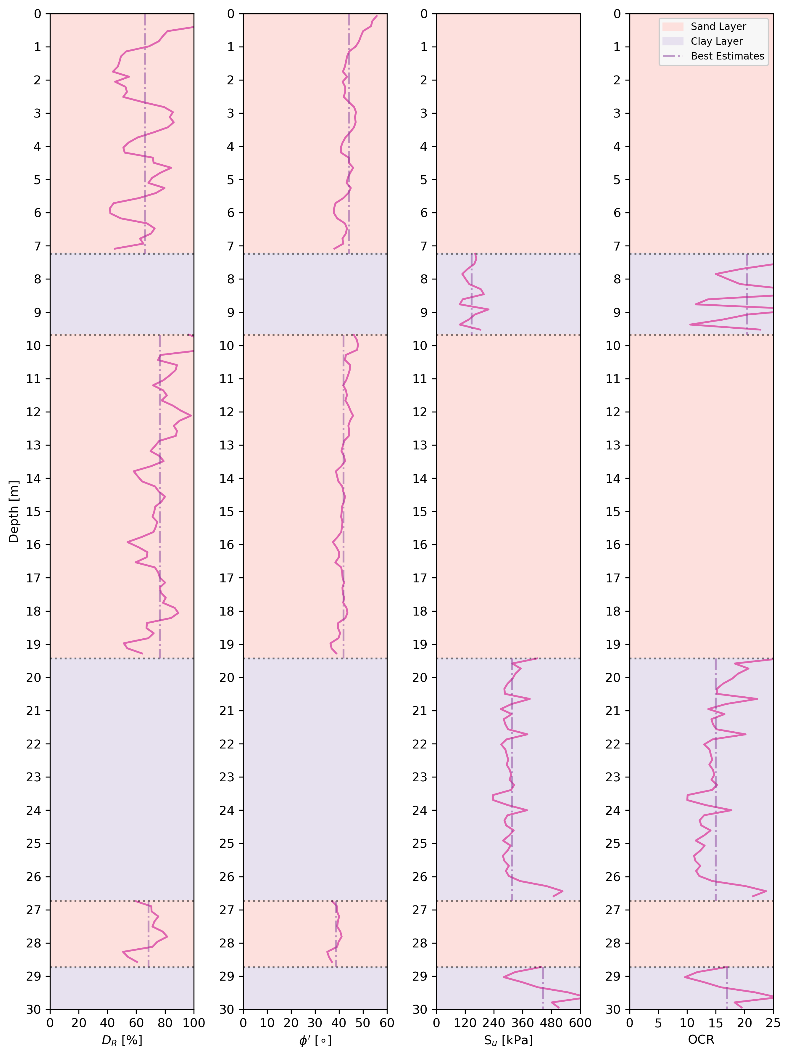
Figure 3. Relative density, friction angle, S_{U}, and OCR of the soil profile.
The value of α was obtained from the figure generated by Das B.M. as shown in Figure 4. Extrapolation was required due to S_{u} values extracted being higher than graph axis limits.
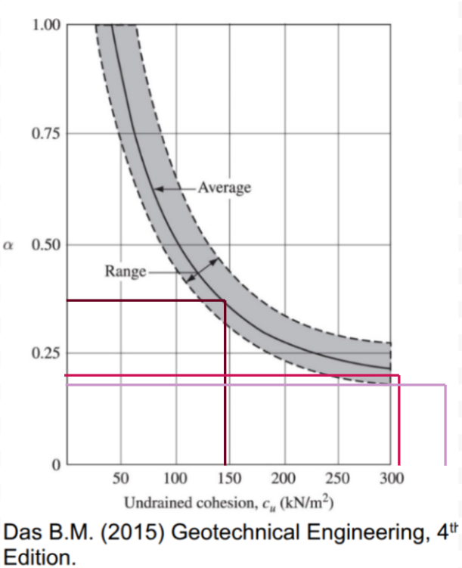
Figure 4. Selection of α based on extracted S_{u} with extrapolation.
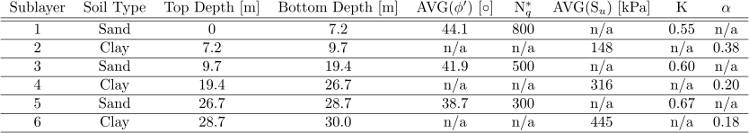
Table 1. Design values for soil profile.
Using these design values, the values of q_{p} and q_{s} can be obtained.

Sand
δ obtained from AASHTO LRFD (2014) Table 3.11.5.3-1
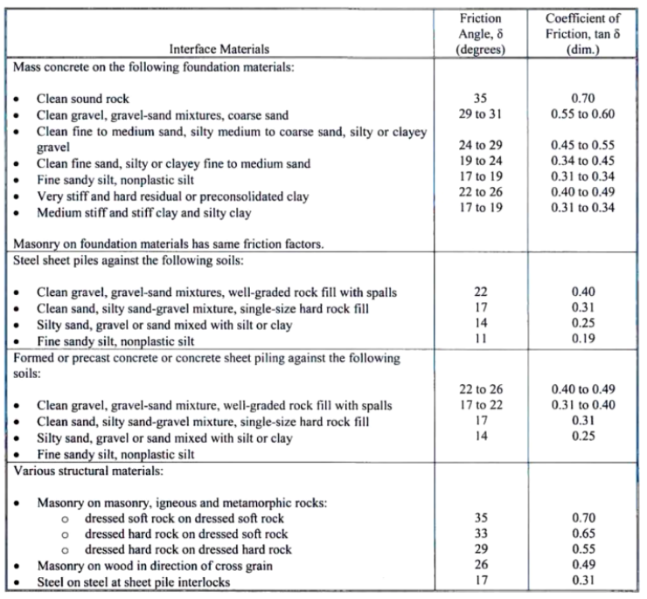
Table 2. AASHTO LRFD (2014) Table 3.11.5.3-1.

Clay
The value of Q_{p} and Q_{s} were obtained as follows.
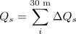
The values of Q_{L} and Q_{all} were obtained as follows.
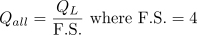
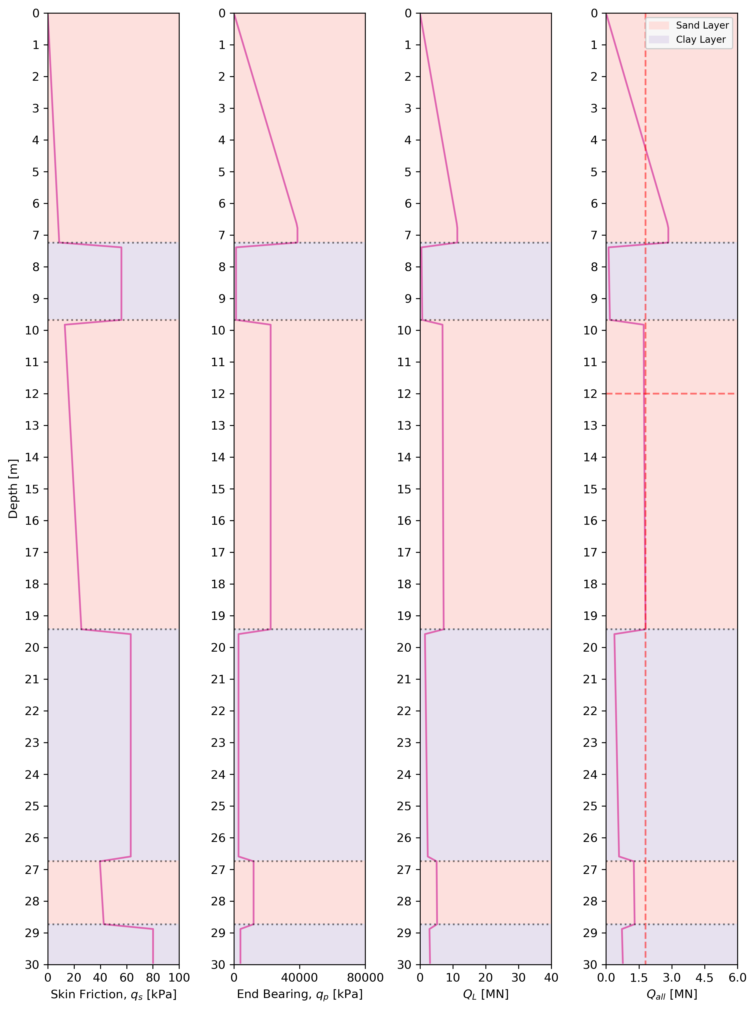
Figure 5. q_{s}, q_{p}, Q_{L} and Q_{all} profiles.
The required pile length must be longer than 12 meters and must have an allowable capacity of 1.8 MN. Therefore, the pile length must be 19 meters.
In the sand layer, the end bearing pressure is much greater than the skin friction pressure. This is because sand’s cohesionless properties do not provide much sticking friction to the pile, while the stress-dependent behavior of sand allows intergranular resistance to mobilize.
In the clay layer, the skin friction pressure is much greater than the end bearing pressure. This is because clay has cohesion, allowing it to stick to the pile, while the softer clay cannot provide high end bearing capacity.

Problem 2.

Given:
In this problem we will practice how to perform lateral load analysis on piles using the Beam-on-Nonlinear-Winkler Foundation (BNWF) method, also known as the p-y approach. There are many commercial and non-commercial software packages available for lateral load analysis of piles, e.g. Lpile by Ensoft, PB-MultiPier, DFSAP, RSPile by Rocscience, and OpenSees, to name a few. In this problem we will use Lpile Student Version to solve the problem, but any other lateral pile analysis software can be used too.

Find:
Follow instructions to run multiple pile tests. Answer the following based on each simulation.

Test One
The four plots of deflection, soil reaction, shear, and moment with depth. You can take a snapshot and include it in your report or use the output file to extract digital data and plot them in excel. If you are taking a snapshot, your plots in your report should be legible. Fill out the following table and include in your report:
Boundary conditions at pile head | Maximum lateral deflection (m) | Maximum shear force (kN) | Maximum bending moment (kN-m)
V =
M =
Axial force =

Test Two
From the Graphics menu open the Load vs. Top Deflection window. This plot is called the pile-head force-displacement or the pushover curve. Include this figure in your report. Calculate and report the pile lateral stiffness (in kN/m), which is the slope of the initial portion of the pushover curve.

Test Three
The four plots of deflection, soil reaction, shear, and moment with depth. You can take a snapshot and include it in your report or use the output file to extract digital data and plot them in excel. If you are taking a snapshot, your plots in your report should be legible. Fill out the following table and include in your report:
Boundary conditions at pile head | Maximum lateral deflection (m) | Maximum shear force (kN) | Maximum bending moment (kN-m)
V =
M =
Axial force =

Solution:

Test One
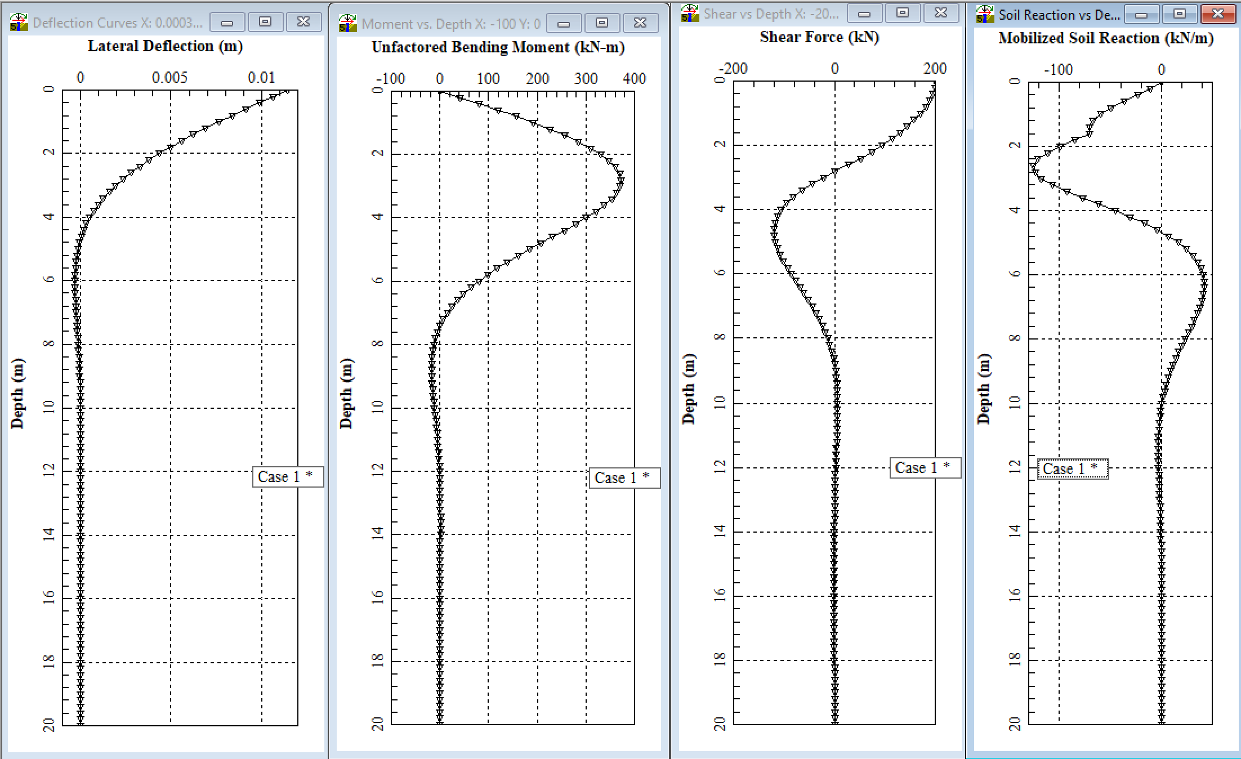Figure 6. Curves generated from Test One on sand.

Boundary conditions at pile head | Maximum lateral deflection (m) | Maximum shear force (kN) | Maximum bending moment (kN-m)
V = 200 kN  M = 0  Axial force = 500 kN | 0.11417 | 200 | 372.2
Table 3. Results from Test One.

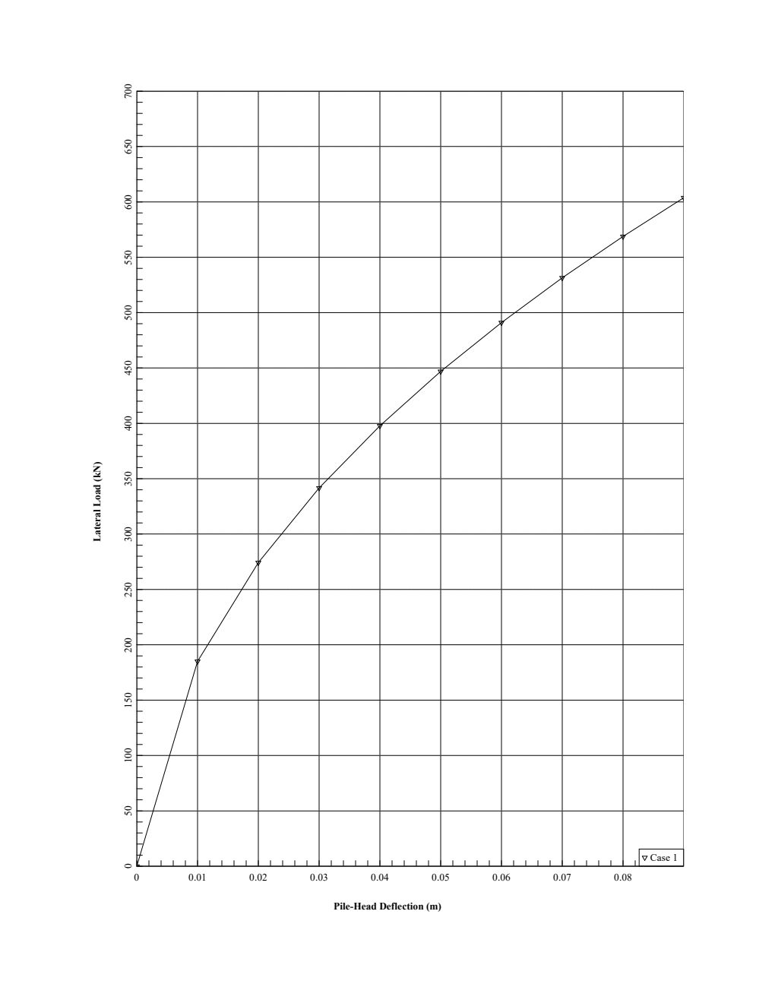
Test Two
Figure 7. Pushover curve generated from Test Two.

Test Three
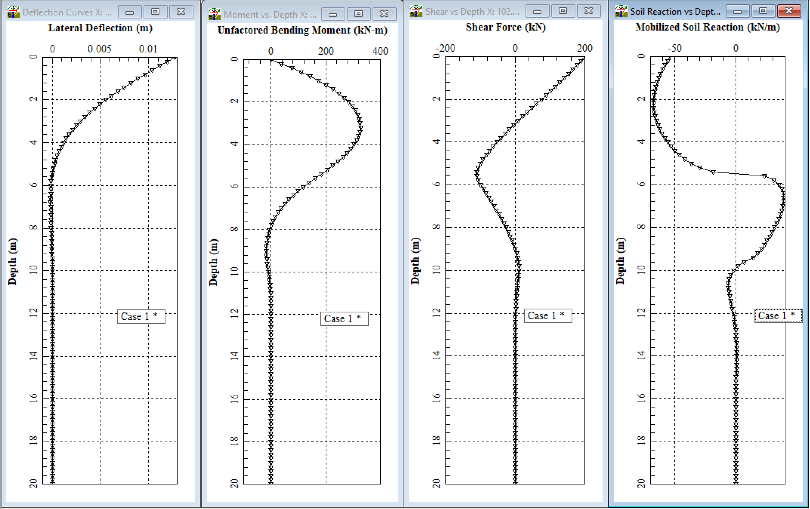
Figure 8. Curves generated from Test Three on clay.

Boundary conditions at pile head | Maximum lateral deflection (m) | Maximum shear force (kN) | Maximum bending moment (kN-m)
V = 200 kN  M = 0  Axial force = 500 kN | 0.12758 | 200 | 372.3
Table 3. Results from Test Three.

