CE543: Introduction to Geotechnical Earthquake Engineering

Homework Assignment #2

January 23rd, 2026

To: Arash Khosravifar, PhD
From: Brandon Auyeung

Problem 1.
In this question, we will investigate the differences in ground motions at a soil site and a rock site located close to each other near Gilroy, California. The Gilroy 1 site is a rock site, and it is located about 2 km west of Gilroy 2, a soil site. Strong ground motion instruments at these two sites recorded the 1979 Coyote Lake Earthquake, the 1984 Morgan Hill Earthquake, and the 1989 Loma Prieta Earthquake.
Locate the "PEER Ground Motion Database" website by the Pacific Earthquake Engineering Research (PEER). From this page, or using a general web search, find the "NGA-West2" where NGA stands for Next Generation Attenuation. At the NGA-West 2 website, find the Databases tab and download the “NGA-West2 Flatfile” compressed file (527 MB). There are 11 files inside the compressed file that report pseudo-spectral accelerations for damping ratios ranging from 0.5% to 30%. Locate the one corresponding to 5% damping (also uploaded on Canvas). This Excel spreadsheet has a wealth of information regarding available strong ground motion records. Locate the Final Products tab and download the “PEER 2013/03 PEER NGA-West2 Database” report (PDF file, 6 MB), where you can find the explanation for all the headings in the flatfile under Appendix D of the report.
(a) For each of the above three earthquakes, summarize the fault name, the earthquake moment magnitude, fault rupture length, and fault mechanism. Plot the combinations of magnitude and fault rupture length on the graph by Wells and Coppersmith (1994) as given in the course notes. How do these earthquakes compare to the median relation in this correlation – are they above or below the mean relation, and are they within the scatter of the data?
(b) For both sites, list the peak horizontal acceleration and peak horizontal velocity recorded during these earthquakes. Note that the "peak" value that you obtain from the flatfile is actually the geometric mean of the peak values from the two orthogonal horizontal directions. Plot the peak horizontal acceleration at Gilroy 2 versus peak horizontal acceleration at Gilroy 1. Make the same plot for peak velocity. How do the motions at the soil site compare to those at the rock site?
(c) Determine the ratio of the pseudo spectral accelerations (5% damping) for the horizontal motions at Gilroy 2 (soil) versus at Gilroy 1 (rock). Determine these ratios for each of the three earthquakes, and plot them versus period. Plot all three earthquakes on one graph. Make the "period" axis to be in logarithmic scale (0.01 to 10 sec), and the spectral ratios in arithmetic scale. How do the spectral accelerations on soil compare to those on rock? At what periods are the differences greatest? Do the differences vary with earthquakes? If you see any differences between ratios for these earthquakes, explain why they are different. Can you relate your observations to the plots from (b)?
(d) Suppose a water tower that acts as a linear-elastic single-degree-of-freedom structure with 5% damping was located at the Gilroy 2 station during the 1984 Morgan Hill earthquake. The tower's superstructure weighs 60 kN, and its natural period is 1.0 second. Using the pseudo spectral accelerations obtained from the NGA flatfile, estimate the tower's peak horizontal base shear force during this earthquake. Estimate the peak horizontal displacement of the superstructure relative to its base under this peak loading.
Hint for Problem 1c:
The pseudo spectral accelerations (PSA) are listed in the NGA flatfile in columns EE to IK. This is explained in Appendix D of the PEER report (except below). The headings of these columns specify the periods. For example, the heading for Column EE is "T0.010S" which means T=0.01 sec. To be able to plot PSA vs T you will have to delete "T" and "S" from the headings. You can either do that manually (for 111 columns) or use the Convert Text to Columns Wizard in Excel. You can find those period values in “Periods.xlsx” uploaded on Canvas. Feel free to come to the office hours if you want to learn how to do this data manipulation in Excel.


Given:
It is known that Gilroy 1 is a rock site and 2 km away is Gilroy 2, a soil site which is. Strong ground motions from the 1979 Coyote Lake Earthquake, the 1984 Morgan Hill Earthquake, and the 1989 Loma Prieta Earthquake can be found "PEER Ground Motion Database" website. Use the “NGA-West2 Flatfile” compressed file(s) that contain the PS_{a} with 5% damping and the “PEER 2013/03 PEER NGA-West2 Database” report to answer the following.

Find:
- For each of the above three earthquakes, summarize the fault name, the earthquake moment magnitude, fault rupture length, and fault mechanism. Plot the combinations of magnitude and fault rupture length on the graph by Wells and Coppersmith (1994) as given in the course notes. How do these earthquakes compare to the median relation in this correlation – are they above or below the mean relation, and are they within the scatter of the data?

- For both sites, list the peak horizontal acceleration and peak horizontal velocity recorded during these earthquakes. Note that the "peak" value that you obtain from the flatfile is actually the geometric mean of the peak values from the two orthogonal horizontal directions. Plot the peak horizontal acceleration at Gilroy 2 versus peak horizontal acceleration at Gilroy 1. Make the same plot for peak velocity. How do the motions at the soil site compare to those at the rock site?
- Determine the ratio of the pseudo spectral accelerations (5% damping) for the horizontal motions at Gilroy 2 (soil) versus at Gilroy 1 (rock). Determine these ratios for each of the three earthquakes, and plot them versus period. Plot all three earthquakes on one graph. Make the "period" axis to be in logarithmic scale (0.01 to 10 sec), and the spectral ratios in arithmetic scale. How do the spectral accelerations on soil compare to those on rock? At what periods are the differences greatest? Do the differences vary with earthquakes? If you see any differences between ratios for these earthquakes, explain why they are different. Can you relate your observations to the plots from (b)?
- Suppose a water tower that acts as a linear-elastic single-degree-of-freedom structure with 5% damping was located at the Gilroy 2 station during the 1984 Morgan Hill earthquake. The tower's superstructure weighs 60 kN, and its natural period is 1.0 second. Using the pseudo spectral accelerations obtained from the NGA flatfile, estimate the tower's peak horizontal base shear force during this earthquake. Estimate the peak horizontal displacement of the superstructure relative to its base under this peak loading.

Solution:

Part a):
The file we are given may be filtered so that only earthquakes (which may be referenced to as “EQs” from now on) named “Coyote Lake”, “Morgan Hill”, or “Loma Prieta” may be displayed. From there, we are interested in data from Gilroy Array #1 and Gilroy Array #2. This filter simplifies the number of entries we need to look at to obtain our information.
It is relatively straightforward to obtain the fault name, moment-magnitude, and rupture length for each earthquake. The fault mechanism of may be obtained by looking at the “Mechanism Based on Rake Angle” column. This column provides a number which can be then translated to a fault mechanism via the “PEER 2013/03 PEER NGA-West2 Database” report. For the Coyote Late and Morgan Hill EQs, a 0 is listed. For the Loma Prieta EQ, a 3 is listed. Appendix D from the report may be referred to determine the mechanism of the rupture.
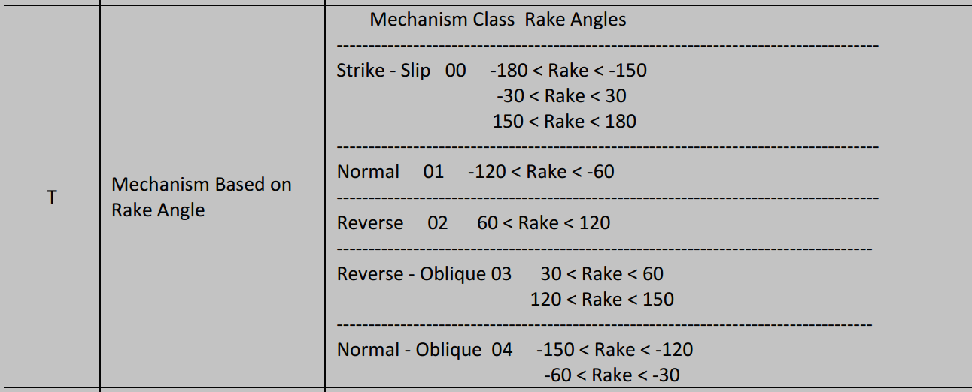
Figure S1. Mechanism of rupture taken from Appendix D of “PEER 2013/03 PEER NGA-West2 Database” report.
We are now able to plot the data obtained from the PEER Ground Motion Data with the models provided by Wells & Coppersmith, 1994.
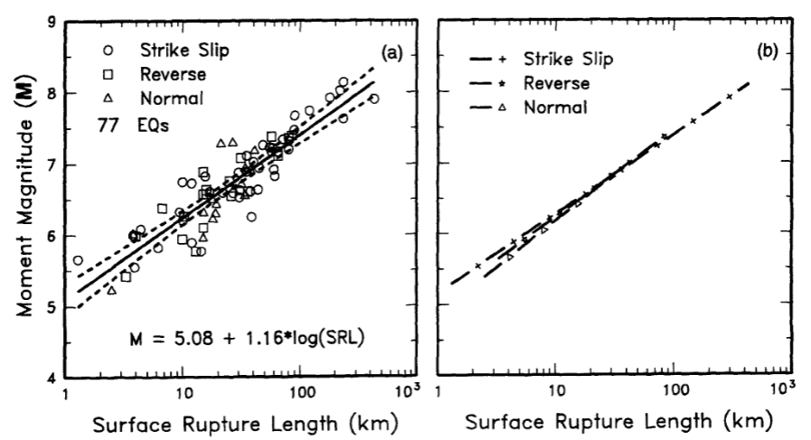
Figure S2. Moment-magnitude as a function of surface rupture length (SRL) in km from Wells & Copperfield, 1994. Dashed lines describe the 95% Confidence Interval (CI) of the model.

Part b):
Based on Figure 2, we may find a relationship between moment-magnitude and surface rupture length. This is plotted with the database’s information, as found in Figure R1.
$$M_{w}=a+blog\left(SRL \left[km\right]\right)=5.08+1.16log\left(SRL\right)$$
The peal ground acceleration (PGA) and peak ground velocity (PGS) are found on in columns EB and EC of the Excel file. As described in the “Given” section, these are geometric means of the PGA and PGV in two orthogonal horizontal directions.
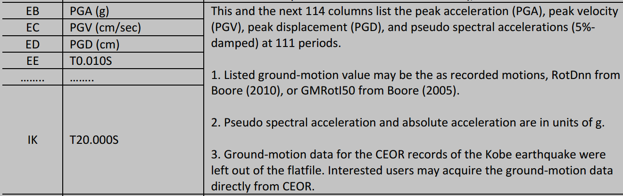
Figure S3. PGA, PSV, PSD, and PS_{a} as a function of structural period taken from Appendix D of “PEER 2013/03 PEER NGA-West2 Database” report.
This information can then be used to create the plots shown in Figure R2 and Figure R3.

Part c):
The S_{a} from each EQ may be used to determine the spectral ratio, S/R, via the following relationship.
$$S/R\left(EQ,T\right)=\frac{S_{a_{soil}}\left(EQ,T\right)}{S_{a_{rock}}\left(EQ, T\right)}$$
The above relationship may be interpreted as such: the spectral ratio for a given earthquake and structural period is equal to the quotient of the spectral acceleration (or psudo-spectral acceleration) for a soil site and the spectral acceleration (or psudo-spectral acceleration) for a rock site for the same given earthquake and structural period.
The S/R is calculated for all EQs and plotted against structural periods ranging from [0, 10] seconds as required in “c)” of the “Find” section. The results of this plotting is shown in Figure R4.

Part d):
The structure’s natural period, T = 1.0 sec, on Gilroy 2 under the Morgan Hill EQ corresponds to the S_{a}(T = 1.0 sec, EQ = Morgan Hill, Site = Gilroy 2, a soil site). This is directly found in the flatfile as a value of 0.08360343, in Gs. Given the W = 60 kN weight of the structure, base shear can be calculated as follows.
$$V=\frac{W}{g}S_{a}g=WS_{a}=60 kN ×0.08360343$$
The maximum displacement of the structure can be found using the relationship below.
$$S_{d}=\frac{S_{a}\left[m/s^{2}\right]}{ω_{n}^{2}}=\frac{S_{a}g}{{\left(\frac{2π}{T}\right)}^{2}}=\frac{0.08360343\left(9.81m/s^{2}\right)}{{\left(\frac{2π}{1s}\right)}^{2}}$$

Discussion:
This is where the flatfile for NGA-West2 was downloaded: https://peer.berkeley.edu/research/databases/databases. The filename used was Updated_NGA_West2_Flatfile_RotD50_d050_public_version.xlsx". The .pdf report was found here: https://peer.berkeley.edu/publications/2013-03.

Results:
- The answers are formatted below.
Earthquake | Fault Name | Moment-magnitude | Fault Mechanism | Rupture Length
Coyote Lake | Calaveras fault south | 5.74 | Strike-slip | 6.6 km
Morgan Hills | Calaveras fault south | 6.19 | Strike-slip | 27.0 km
Loma Prieta | San Andreas-Santa Cruz | 6.93 | Reverse | 40.0 km
Table R1. Answers for part 1 regarding EQ parameters.
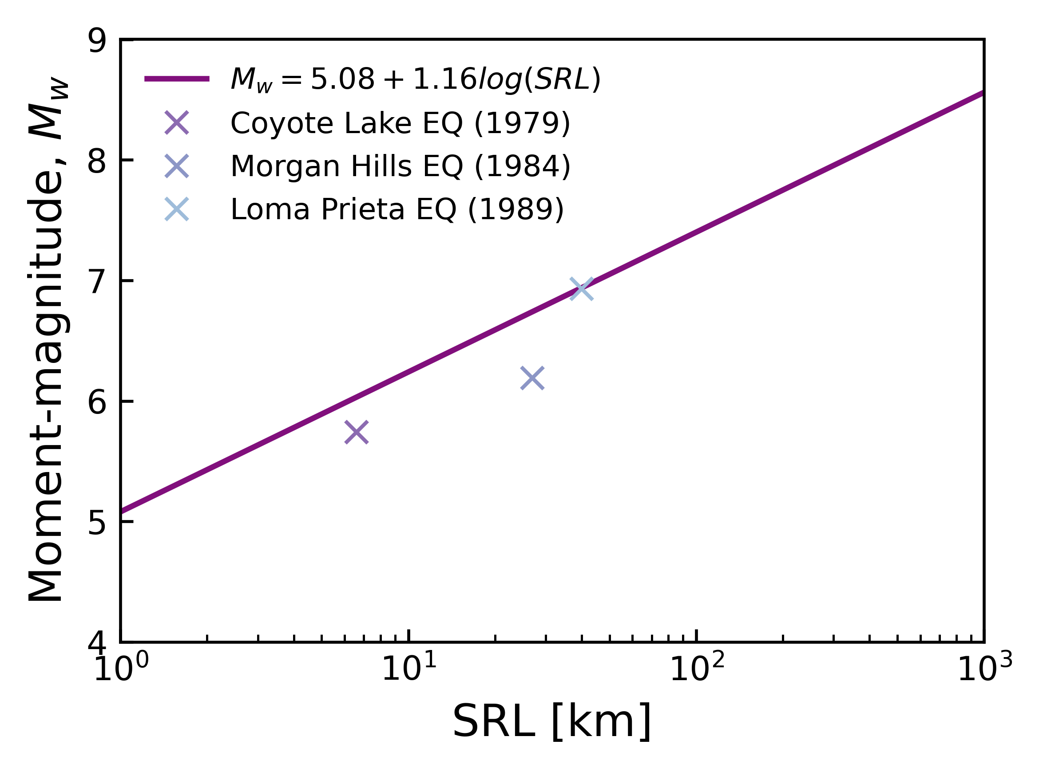
Figure R1 GEER Data for various EQs plotted with Wells & Copperfield, 1994 model for moment-magnitude as a function of surface rupture length in km.
The Loma Prieta EQ (1989) is well represented by the model. The model overestimates (i.e. is below the model mean) the moment-magnitude of the Coyote Lake EQ (1979) and the Morgan Hills EQ (1984). The spread of moment-magnitudes is still within reason. Both overestimated EQs are non-reverse fault mechanisms.
- The answers are formatted below.
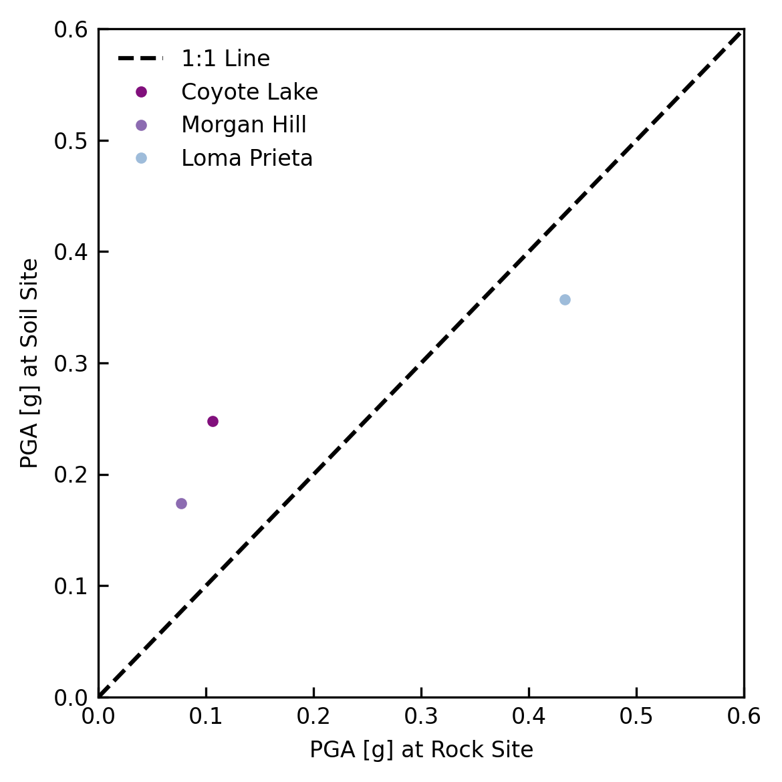
Figure R2 PGA data for multiple EQs on a rock site (Gilroy 1) and on a soil site (Gilroy 2).
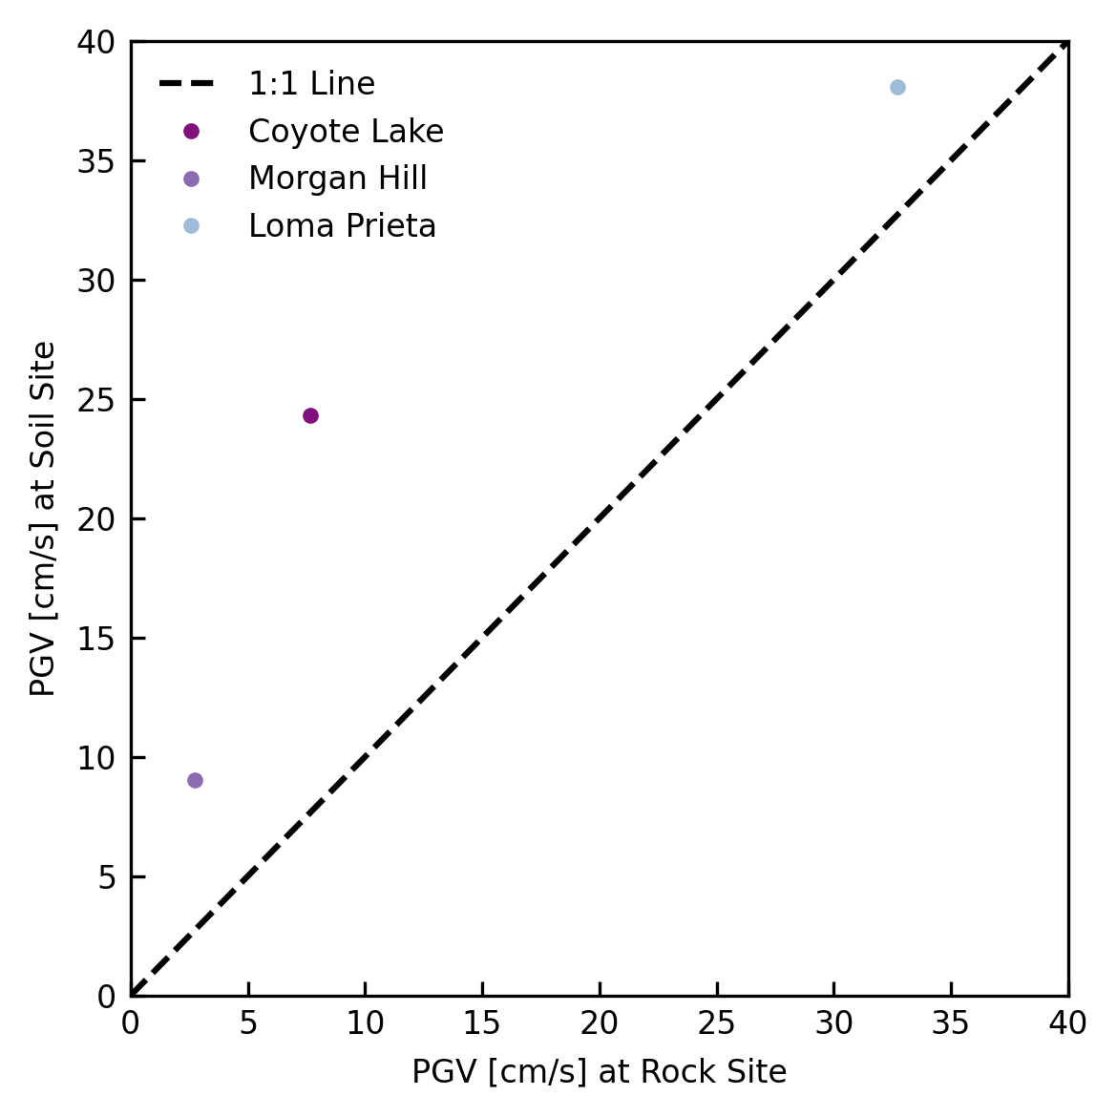
Figure R3. PGV data for multiple EQs on a rock site (Gilroy 1) and on a soil site (Gilroy 2).
As observed in Figure R2, the PGA on soil sites is amplified across the Coyote Lake and Morgan Hill, the two lower magnitude EQs. On the other hand, the PGA on soil sites is de-amplified during the Loma Prieta; the PGA on the rock site is higher than the PGA on the soil site for the Loma Prieta. The higher magnitude of the Loma Prieta, and the non-linearity of soil likely caused the soil to soften. With the higher magnitude EQs, greater shear strain is experienced, and thus a lower shear modulus, leading to soil being able to act as a fuse/base isolator.
- The answers are formatted below.
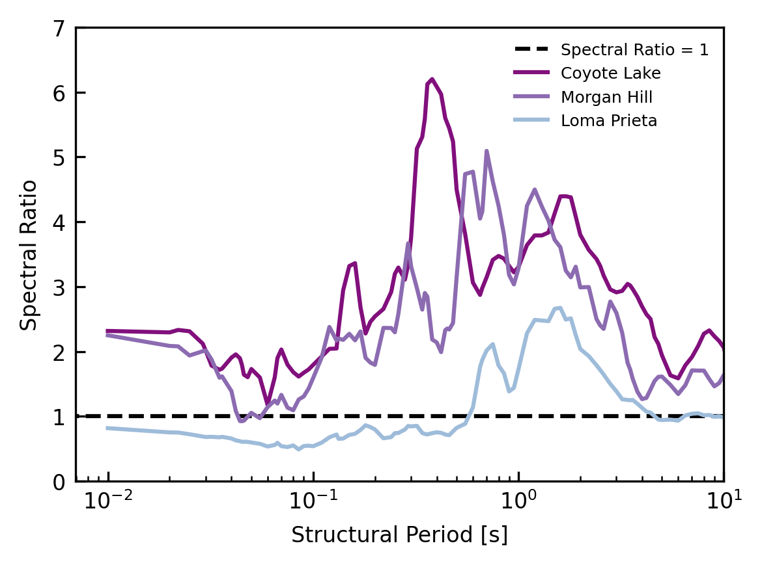
Figure R4. Spectral ratios across a range of structural periods for a variety of EQs.

The Loma Prieta EQ has Spectral Ratios, S/Rs, that are frequently below 1, whereas the Coyote Lake and Morgan Hill EQ’s have S/Rs that rarely go below 1. When S/R > 1, this means that soil is able to amplify the ground motions that are occurring. This is also seen from Figure R2; the PGA on the soil site for Coyote Lake and Morgan Hill are higher than on the rock site. On the other hand, when S/R < 1, the soil is able to de-amplify the ground motions. This can also be observed from Figure R2; the PGA on the rock site is higher than that of the soil site for the Loma Prieta EQ.

d) The base shear of caused by these conditions is 5.016 kN. The estimated maximum displacement of the building relative to the base is 0.0208 m (i.e. 2.08 cm).

Appendix:
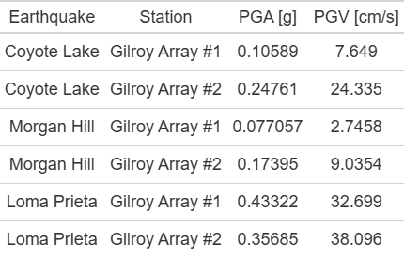
Table A1. EQ data used to create Figure R2 and Figure R3.

