

Maseeh College of Engineering and Computer Science
Department of Civil and Environmental Engineering

Post Office Box 751 503-725-4282 tel
Portland, Oregon 97207-0751 503-725-5950 fax

CE443(543) Introduction to Seismology and Site Evaluation

To: CE443(543) Students Date: January 29, 2026
From: Arash Khosravifar

Subject: Homework Assignment #4 (Due Feb 6 at 11:59 p.m.)

Problem 1:
In this problem we will develop design spectra (MCE_{R} and DE) per ASCE 7-10. The ASCE online hazard tool can be accessed using this link: https://ascehazardtool.org/ However, this tool occasionally becomes unavailable; therefore, I am providing you with the seismic parameters for the Engineering Building at PSU in Table 1.

Table 1. ASCE 7-10 Seismic Parameters for the Engineering Building at PSU
Site Class | B | D
S_{S} (g) | 0.99 | 0.99
S₁ (g) | 0.426 | 0.426
S_{MS} (g) | 0.99 | 1.093
S_{M1} (g) | 0.426 | 0.671
S_{DS} (g) | 0.66 | 0.729
S_{D1} (g) | 0.284 | 0.447
Fa | 1 | 1.104
Fv | 1 | 1.574
T_{L} (s) | 16 | 16
T₀ (s) | 0.086 | 0.123
T_{S} (s) | 0.430 | 0.613
PGA_{M} (g) | 0.428 | 0.459

- Develop MCE_{R} and DE spectra for both site classes for periods ranging from 0.01 s to 10 s. Make sure that T₀ and T_{S} are included in the range of periods. Plot all four curves on one plot with logarithmic horizontal axis. Make use of different symbols and line types, and label the series clearly. Between the two site classes, which spectra plot higher?
- Now let’s compare the results of MCE_{R} and DE spectra per ASCE 7-10 with the DSHA spectra that you developed for a Cascadia Subduction Zone (CSZ) event in the previous homework using the CSZ online tool (developed by Dr. Dusicka at PSU: http://csz.cee.pdx.edu/ ). Make a plot that includes MCE_{R} and DE for Site Class B and CSZ for Vs = 760 m/s. Comment on the comparisons, e.g. which curve plots higher/lower, are there periods where one curve is higher/lower than the others?

Hint: Your final graph for Part (a) should look like the figure below:
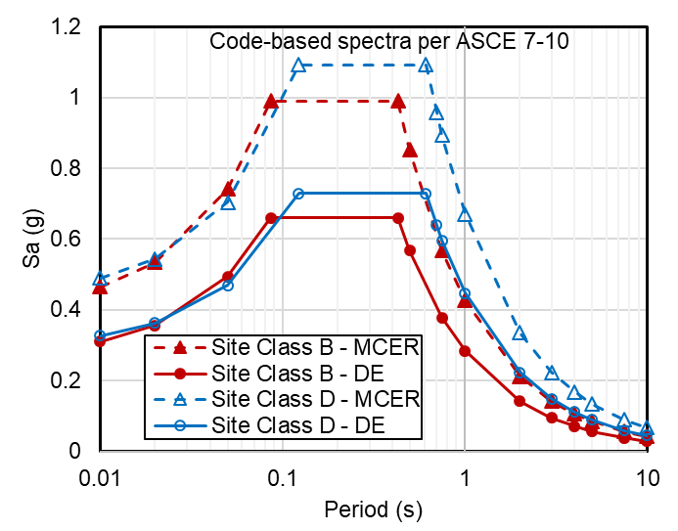

Problem 2:
In this problem we will examine the changes that happen to ground motions as they pass through liquefied soils. A centrifuge test was performed on a pile-supported wharf by Dickenson, McCullough, Schlechter and co-workers at UC Davis large centrifuge in 2000. The objective of this test was to study the seismic performance of marginal wharves in earthquakes. A cross section of this test is shown in figure below. The test was instrumented with numerous sensors including accelerometers, displacement transducers, pore-water-pressure transducers, strain gauges, etc. A centrifuge model of this size can take up to 6 months to design and 2 months to construct. You can find the full data report along with photos of the physical model building here:
https://cgm.engr.ucdavis.edu/library/data-reports/ (search for test NJM02).

In this problem we will analyze a subset of centrifuge data to study how the frequency content of motions change as they pass through a liquefied soil layer. To do this, we will use time histories of accelerations recorded in an array shown with a red box on the cross section below. Three accelerometers are embedded in liquefied soil. The acceleration time histories are provided in the attached spreadsheet. You can visually see the difference between motions if you plot all accelerations vs. time. However, to investigate the change in frequency contents, you will have to calculate the spectral acceleration (Sa) of each time history and plot them all on one graph. There are many commercial or free tools to calculate spectral acceleration for a given time history. You can use the attached Matlab script and modify it to be able to read data from the excel file and calculate Sa for 5% damping.
- Plot the spectral acceleration for all motions on one graph.
- Comment on any change you notice as motions propagate through different layers of soil (e.g. any change in PGA).
- Estimate the natural period (Tn) of the soil profile from the calculated Sa. Hint: motions get amplified at the natural period of the soil profile. You need to compute the ratio of Sa at the top of the soil profile to the bottom of the soil profile (i.e. amplification ratio) and plot this ratio versus period. Then find the period at which maximum amplification occurs.

Hint: Instructions for using the Matlab script to calculate Sa:
You will have to run the script in “calc_spectra.m”. Open the file in Matlab and click on Run (or press F5). When Matlab reaches the following command, it will read the acceleration time history in Column C of the Excel file which corresponds to the “Average Base Acceleration”.
acc = xlsread('Centrifuge_acc_NJM02.xlsx','Acc','C3:C2002');
Once the run is completed, the spectral accelerations are stored in a variable called “psa”. You should now copy the values in “psa” and “periods” variables from Matlab and paste them in Excel for plotting. To copy these variables in Matlab, you will have to double click on the variable in the “Workspace” and then simply select and copy the data.
Once you have processed the Base Accelerations, you will have to modify the above command to read the values in Column D (modify the command to read D3:D2002) and repeat the process. The last column to process is Column H.
Note: Make sure that all the relevant files (two .m files and the input Excel file) are in the same folder when running Matlab.
