CE543: Introduction to Geotechnical Earthquake Design

Homework Assignment #5

February 20th, 2026

To: Dr. Arash Khosravifar
From: Brandon Auyeung

Problem 1.
Consider the isotropically consolidated drained triaxial compression tests for specimens with an initial relative density of 100% by Lee and Seed (1967) in Figure 9 of the Monograph (Idriss and Boulanger, 2008; copied below).
(a) Plot the peak effective friction angle versus effective confining stress (σ3c'). Above what effective confining stress does the peak effective friction angle become approximately constant for these specimens (i.e., equal to the constant volume friction angle)?
(b) On one figure, plot the Mohr circles at peak deviator stress for effective confining stresses of about 100, 290, and 1000 kPa. Draw a Mohr Coulomb failure surface to fit these test results (not as a straight line, but as an appropriately curved surface).
(c) Compute the final void ratio for both specimens (DR=100% and 38%) and all confining effectives stresses (σ3c') on Figure 9, assuming that the reported volumetric strains are uniform throughout the specimens. Assume emin = 0.61 and emax = 1.03 for this sand. On one figure, plot the final void ratio versus initial confining stress. Do the computed void ratios converge to the same "critical state" void ratio at large strains? If not, explain why.
(d) Estimate the peak deviatoric stress that can be carried by a specimen with a relative density of 100% tested in ICD triaxial compression with an effective confining stress of 500 kPa (you can interpolate the data in the top left plot on Figure 9).
(e) If a specimen at DR=100% with an effective consolidation stress of 300 kPa was tested in undrained compression, would the pore water pressure be expected to increase or decrease? Would this sample be initially dense or loose of critical state? Explain your reasoning.
Hints:
Part (a): The peak effective friction angle for this sand should plateau at about 33 degrees at large effective stresses (larger than ~40 atm)
Part (c): For example, at confining stress of 116 atm, the loose sample (Dr=38%) has an initial void ratio of eo=0.87, final volumetric strain of εvol=-15.7%, and final void ratio of ef=0.576.
Part (d): qpeak = Δσd,peak = 1750 kPa
Part (e): dense of critical expected to dilate.
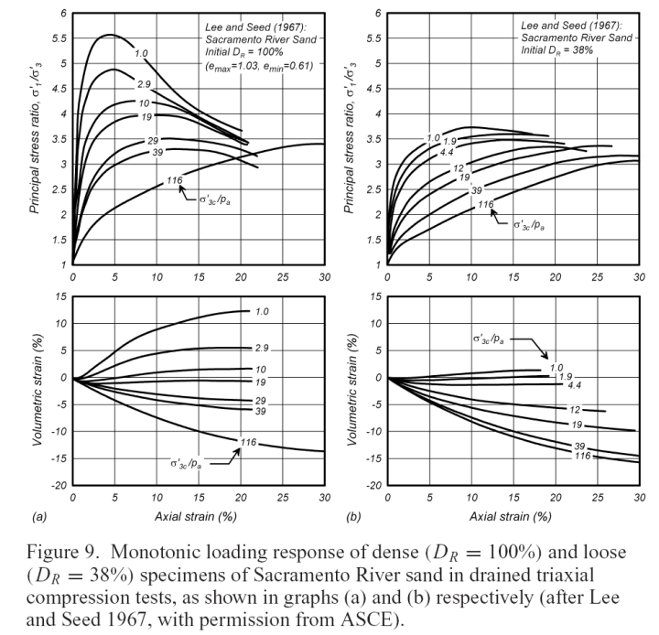

Given:
Figure 9 from Lee & Seed (1967), considering the D_{R} = 100% sample.

Find:

Part A
Plot the peak effective friction angle versus effective confining stress (σ3c'). Above what effective confining stress does the peak effective friction angle become approximately constant for these specimens (i.e., equal to the constant volume friction angle)?

Part B
On one figure, plot the Mohr circles at peak deviator stress for effective confining stresses of about 100, 290, and 1000 kPa. Draw a Mohr Coulomb failure surface to fit these test results (not as a straight line, but as an appropriately curved surface)?

Part C
Compute the final void ratio for both specimens (DR=100% and 38%) and all confining effective stresses (σ3c') on Figure 9, assuming that the reported volumetric strains are uniform throughout the specimens. Assume emin = 0.61 and emax = 1.03 for this sand. On one figure, plot the final void ratio versus initial confining stress. Do the computed void ratios converge to the same "critical state" void ratio at large strains? If not, explain why?

Part D
Estimate the peak deviatoric stress that can be carried by a specimen with a relative density of 100% tested in ICD triaxial compression with an effective confining stress of 500 kPa (you can interpolate the data in the top left plot on Figure 9).

Part E
If a specimen at DR=100% with an effective consolidation stress of 300 kPa was tested in undrained compression, would the pore water pressure be expected to increase or decrease? Would this sample be initially dense or loose of critical state? Explain your reasoning.

Solution:

Part A
The peak effective friction angle, , is related to the maximum flow number, N_{max} using the following relationship.
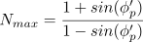
From the given figure, the maximum flow numbers per each series of confining stress can be collected. These values of N_{max} can then be tabulated with their values of .
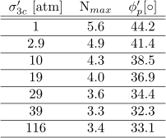
Table S1. Values of cell pressure, max flow number, and peak effective friction angle.
A figure can then be generated of with respect to , as seen in Figure R1 where the constant volume friction angle is where the relationship between the two variables begins to ‘flatten’.

Part B
The value of was found from Part A and can be multiplied by 100 kPa/atm to convert all values into the kPa space. The value of the major principal stress at peak is found using the following relationship.
The peak deviatoric stress can then be found by subtracting the minor principal stress from the major principal stress.

Mohr’s circles can then be generated for the listed confining pressures using the following relationships.
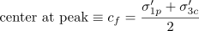
With no cohesion, a quadratic line can be fit through the points of failure on the Mohr’s circle stresses to obtain an approximated Mohr-Coulomb Failure Criterion.
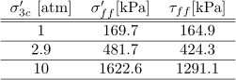
Table S2. Value on the Mohr-Coulomb Failure Criterion used for quadratic regression.
Using the tabulated values in Table S2 and the origin, a quadratic regression can be used to make an estimate for a curved Mohr-Coulomb Failure Criterion. This regression assumes that stress units are in kPa.
The Mohr’s circles, the failure points along those circles, and the Mohr-Coulomb Failure Criterion can be plotted together as seen in Figure S2.

Part C
The initial void ratio, , can be obtained using the following relationship.
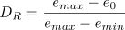
Using the known values of e_{min} and e_{max} as given by the problem statement, the intial void ratios for the loose (i.e. D_{R} = 38% = 0.38) and dense (i.e. D_{R} = 100% = 1) are found to be 0.87 and 0.61 respectively.
The change in volumetric strain, , can be obtained from the bottom graphs of Figure 9 for both loose and dense samples. or is related to the change in void ratio, in the following relationship.
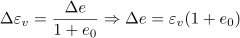

The final void ratio, can then be obtained from the following relationship.

The values are then tabulated for the loose and dense values, as seen in Tables S2 and S3. Once obtained, the values of final void ratio can be plotted with respect to .

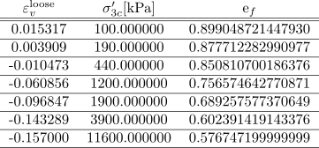
Table S2. Loose sample volumetric strains and final void ratios.

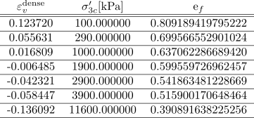
Table S3. Dense sample volumetric strains and final void ratios.

Part D
The answer to this question is formatted in the Results section.

Part E
The answer to this question is formatted in the Results section.

Results:

Part A
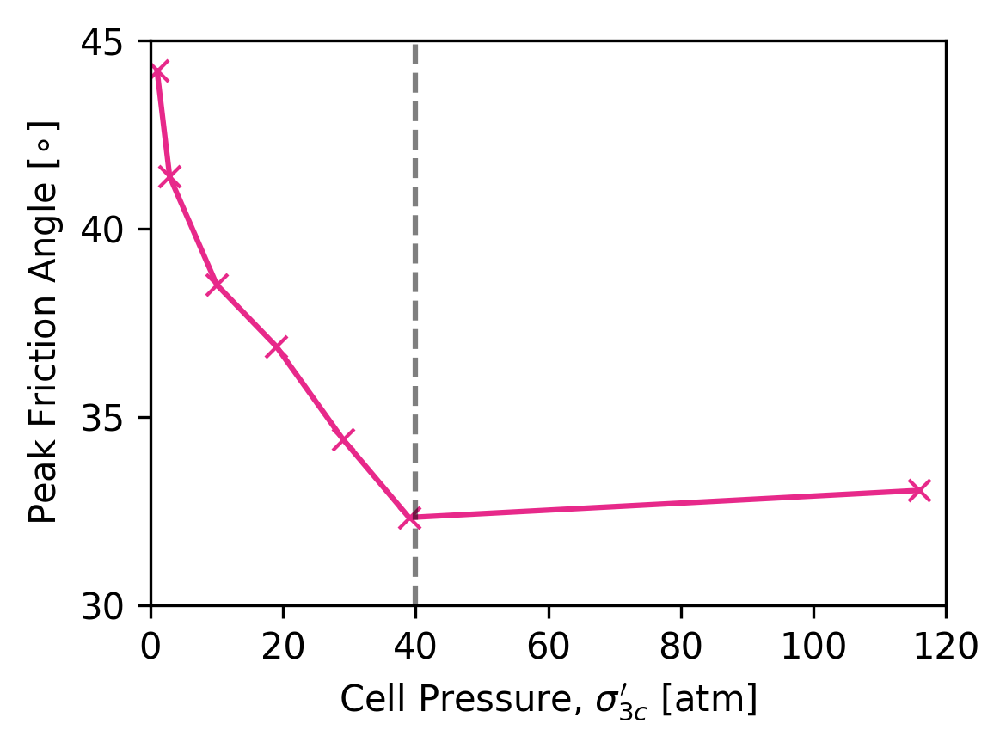
Figure R1. Peak effective friction angle plotted with respect to cell pressure.
The constant volume friction angle is around 33 degrees at a confining pressure of 40 atm.

Part B
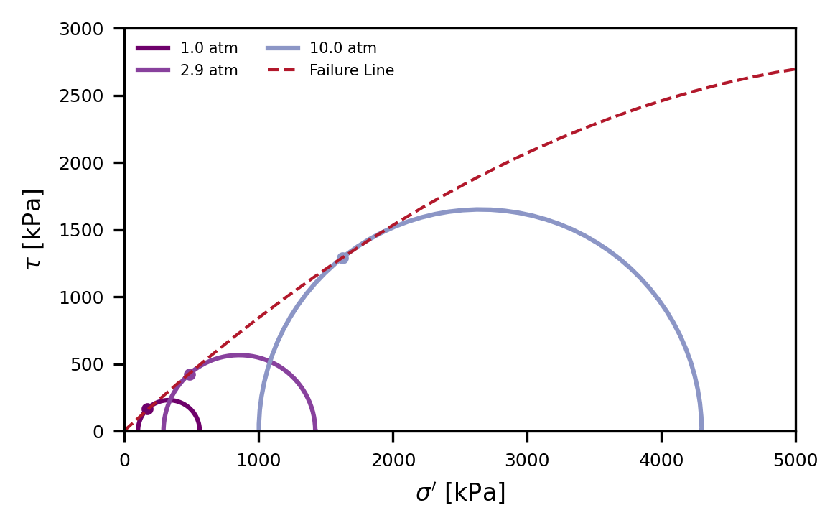
Figure R2. Mohr’s circles at peak deviatoric stress with curved Mohr-Coulomb Failure Criterion line.

Part C
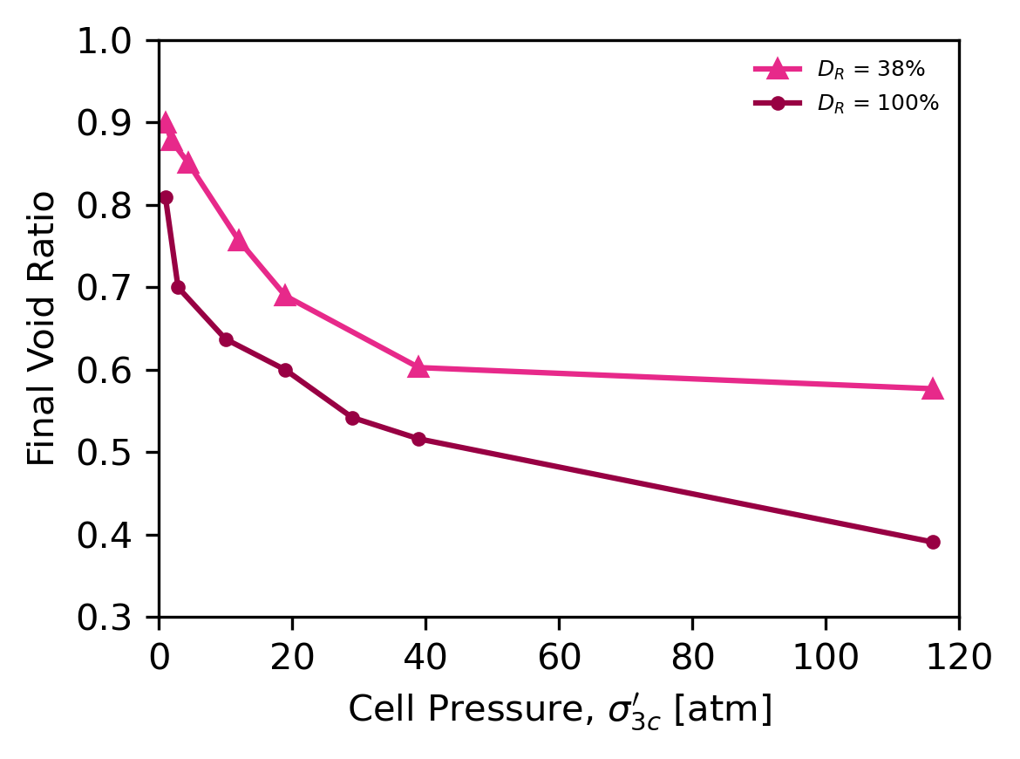
Figure R3. Final void ratio plotted with respect to cell pressure for loose and dense samples.
The samples do not appear to converge to the ‘critical state’ of the soil. This is likely due to limitations within the lab regarding the measurement of local void ratio within the shear band.

Part D
Interpolating the graph in Figure 9, a value of 500 kPa (i.e. 5 atm) confining stress provides a value of around 4.5 for N_{max}. This confining stress and flow number can be multiplied to obtain a value of peak major principal stress equal to 2250 kPa. Lastly, subtracting the peak major principal stress from the confining stress computes a peak deviatoric stress equal to appropriately 1750 kPa.

Part E
In a TX ICD in D_{R} = 100%, = 300 kPa, then according to the bottom left graph, the soil will have a positive which implies dilative tendencies. If a TX ICU is preformed on this sample with these initial conditions, the dilative behavior of this soil would result in negative pore water pressure, due to suction from attempts of the sample to expand.

Problem 2.
Consider the undrained triaxial compression test result for specimen B of Toyoura sand in Figure 12 (Ishihara 1993) of the Monograph:
(a) What is the constant volume (or critical state) effective friction angle, φcv'?
(b) On a single figure, plot the Mohr circles for the specimen at the following times: (i) the end of consolidation, (ii) at phase transformation (i.e., the transition from incrementally contractive to incrementally dilative behavior), and (iii) at critical state.
(c) Determine the excess pore pressure (Δu) at point Q.
Hints:
Part (a): 30.9 degrees
Part (c): 71 kPa

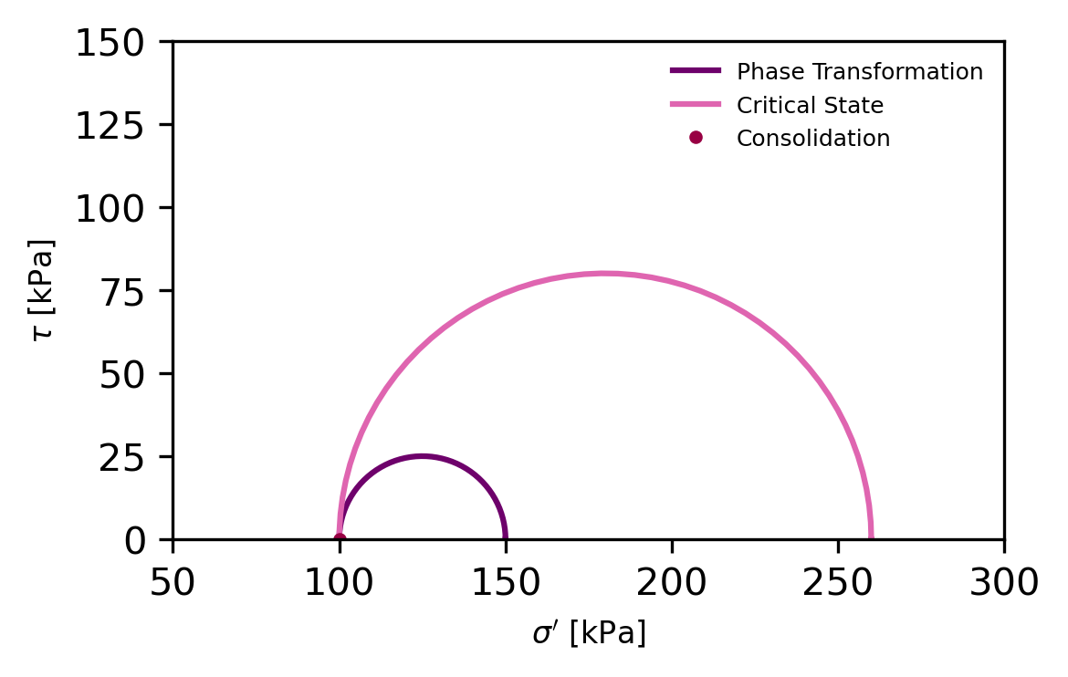
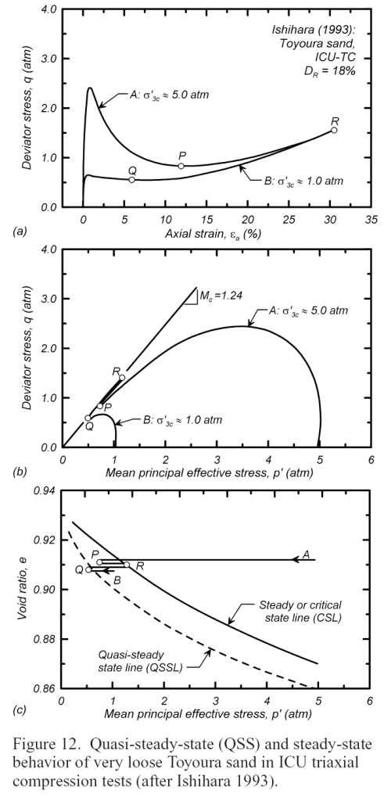

Problem 3.
Consider the undrained triaxial compression test data for Toyoura sand summarized in Figure 12 of the Monograph.
(a) For a specimen that was isotropically consolidated at an effective confining stress of 200 kPa and an initial void ratio of 0.920, and then tested in undrained compression, estimate the critical state values for the following quantities: σ3', σ1', Δu, ru, p' and q.
(b) For a specimen that was isotropically consolidated at an effective confining stress of 200 kPa and an initial void ratio of 0.880, and then tested in undrained compression, estimate the critical state values for the following quantities: σ3', σ1', Δu, ru, p', and q.
(c) If the specimens in (a) and (b) had been loaded in drained triaxial compression, would they have been contractive, dilative, or not changed volume at all? Would they be stronger in drained or undrained loading?
Hints:
Part (a): Δu = 164 kPa
Part (b): Δu = -29 kPa
Part (c): Sample B is dense of critical, dilative, negative PWP in undrained, stronger in undrained compared to drained.

