CE543: Introduction to Geotechnical Earthquake Engineering

Homework Assignment #5

March 10th, 2026

To: Dr. Arash Khosravifar
From: Brandon Auyeung

Problem 1.
A series of undrained cyclic simple shear tests were performed on K_{o}-consolidated specimens of saturated sand at a relative density of 50%. The cyclic loading consisted of uniform sinusoidal shear loads. Tests were performed at three different initial vertical effective consolidation stresses, with the results tabulated below.

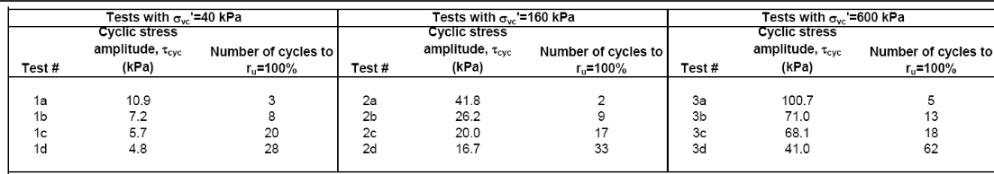
Find:

Part A
Estimate the cyclic shear stress that would be required to trigger r_{u}=100% in 15 uniform undrained loading cycles for a specimen of this sand having an initial vertical consolidation stress of 450 kPa.

Part B
For the cyclic resistance ratio (CRR) defined as the cyclic stress ratio that triggers ru=100% in 15 uniform cycles of loading, determine the value of K_{σ} for an effective consolidation stress of 450 kPa.

Solution:

Part A
The CSR can be obtained by dividing the τ_{cyc} value by the effective consolidation stress that is used to consolidate the sample.
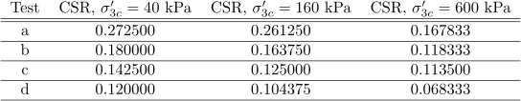
Table 1. Values of CSR per test letter.
The values of CSR can be fit to a power fit with the number of cycles to failure (i.e. N to failure) as the independent values (i.e. CSR = αN^{β}).

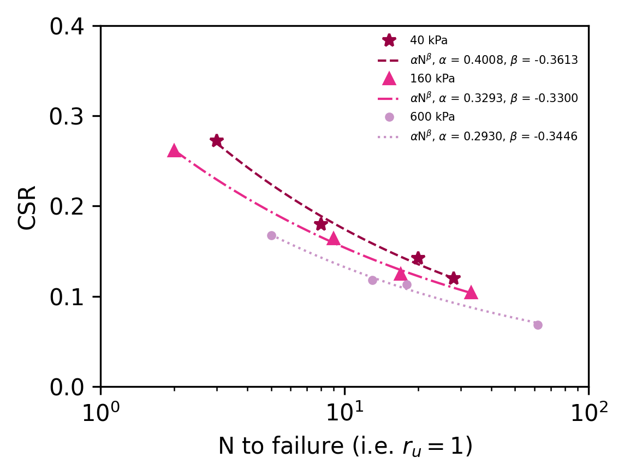
Figure 1. CSR plotted with respect to N to failure, along with power fit model on different effective consolidation stresses.
The CSR at N = 15 for σ_{3c}’ = 450 kPa is between the power fits of CSR at N = 15 for σ_{3c}’ = 160 kPa and CSR at N = 15 for σ_{3c}’ = 600 kPa. Linear interpolation can be used to determine the value of CSR at N = 15 for σ_{3c}’ = 450 kPa and thus the value of τ_{cyc} at N = 15 for σ_{3c}’ = 450 kPa.
Linear Interpolation

Part B
The value of K_{σ} requires the CRR at 1 atm (i.e. 100 kPa). This value can be found via linear interpolation between the power fits.
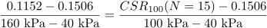 Linear Interpolation

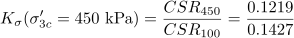

Problem 2.

Given:
The soil profile at a level site consists of a 3-m thick layer of sandy clay, overlaying an 8-m thick layer of loose sand, overlaying stiff gravelly clays that extend to depths greater than 20 m. The water table is at a depth of 2 m and the ground water is initially hydrostatic. The total unit weight of the upper sandy clay, above or below the water table, is 18 kN/m³. The total unit weight of the loose sand layer is 20 kN/m³. The coefficient of lateral earth pressure at rest (K_{o}) in the loose sand is estimated to be 0.5. Two open standpipe piezometers were installed that had small enough slotted intervals that they provide essentially point measurements of ground water conditions: Piezometer A has its slotted interval at a depth of about 4 m, while Piezometer B has its slotted interval at a depth of about 10m.

Find:

Part A
For the initial conditions, determine: (i) where the water levels (relative to the ground surface) would be in both piezometers, and (ii) the average hydraulic gradient between the slotted intervals of the two piezometers.

Part B
For the initial conditions, determine the total horizontal stress at the depth of the slotted interval for Piezometer B.

Part C
Suppose an earthquake causes liquefaction (100% excess pore pressure ratio) in the loose sand layer. Determine: (i) where the water levels (relative to the ground surface) would be in both piezometers if they had sufficiently tall "riser" sections – i.e., portions that extend above ground, and (ii) the average hydraulic gradient between the depths of the slotted intervals for the two piezometers.

Part D
For the conditions given in (c), determine the total horizontal stress at the depth of the slotted interval for Piezometer B if the value of Ko is unaffected.

Solution:

Part A
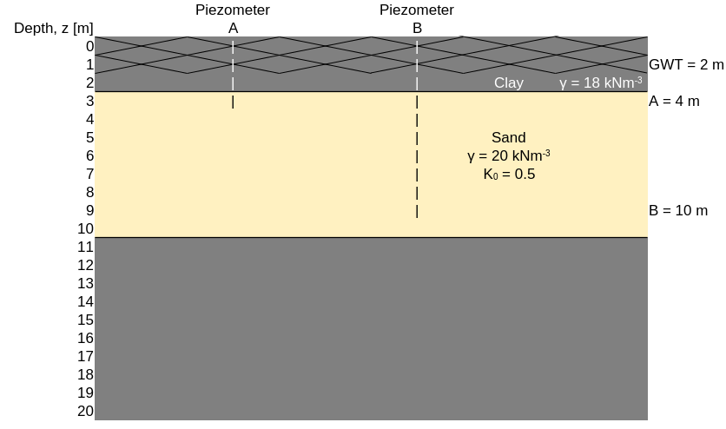
Figure 2. Rough sketch of Problem 2.

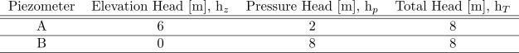
Table 2. Hydrostatic head on piezometers using bottom of piezometer B as the datum.

The water levels in the piezometers will be where the groundwater table is (i.e. z = 2 m).
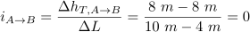

Part B

Part C
Liquefaction can only occur in the loose sand layer. When liquefaction occurs, the pressure ratio, r_{u}, is equal to one (i.e. Δu = σ_{v0}’).
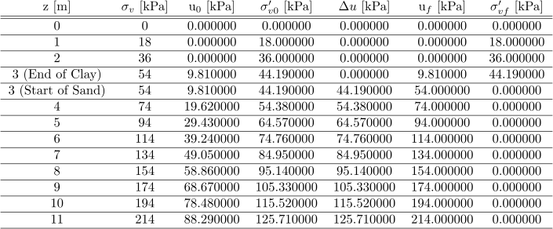
Table 3. Values of stresses and pore water pressures at depths.
The hydraulic gradient and be calculated by obtaining the total heads after liquefaction at the two piezometers. The datum of ground surface will be used here.

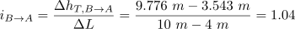 Liquefaction has occurred.

Water is expected to rise to the surface of the ground within the piezometers (i.e. z = 0 m).

Part D
No effective stress in liquefied layer.

Problem 3.

Given:
Square footings of width B will support columns for an elevated bridge that crosses over a The liquefaction resistance of a clean, poorly graded sand (SP) deposit was evaluated using cyclic triaxial testing of undisturbed samples obtained using frozen sampling techniques. The sand deposit extends from the ground surface to a depth of 10 m. The water table is at a depth of 2 m, and ground water conditions are initially hydrostatic. The sand is normally consolidated with an estimated coefficient of earth pressure at rest of 0.45. Isotropically consolidated undrained cyclic triaxial tests were performed on samples from a depth of 5 m with the results presented below.
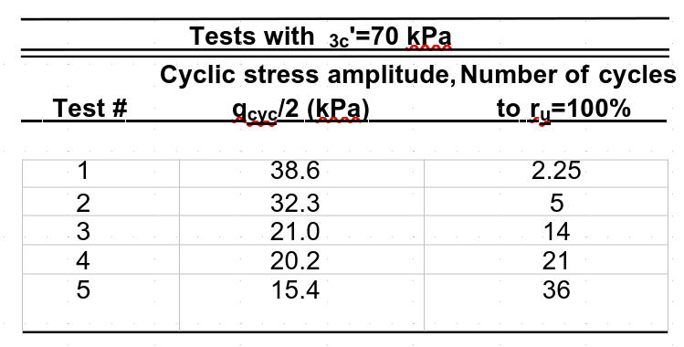

Find:

Part A
For the initial conditions, estimate the vertical effective stress at a depth of 5 m.

Part B
Suppose the site was shaken by an earthquake, with each direction of horizontal shaking producing cyclic shear stresses at a depth of 5 m that are equivalent to about 10 uniform cycles at a cyclic stress ratio of 0.14. Assuming the sand is essentially undrained during shaking, and using the mid-range of the r_{u} versus FS_{liq} relation by Marcuson and Hynes (1989) (Figure 31 below from the textbook), estimate the vertical effective stress at that depth.
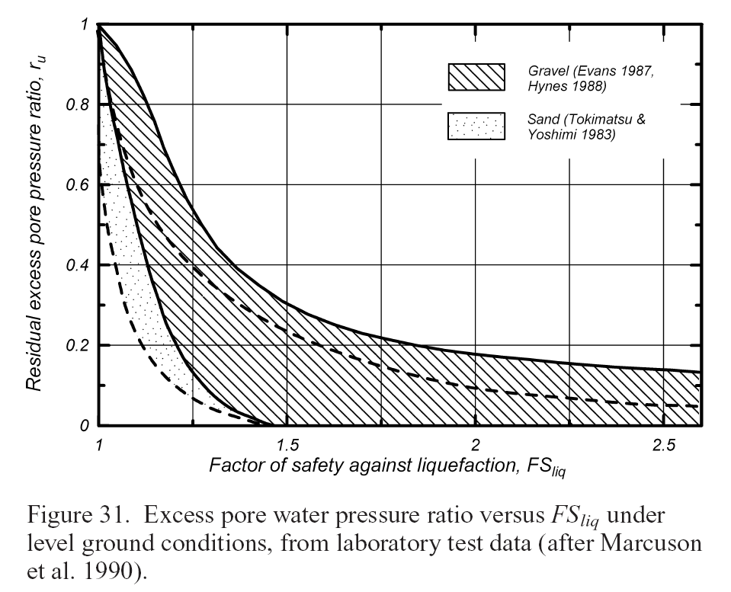

Part C
Repeat part (b) for an earthquake that causes about the same number of loading cycles but with amplitudes that are about twice as large.

Solution:

Part A
We assume sand to have a unit weight of 20 kNm⁻³.

Part B
The CSR of the soil can be obtained by dividing the τ_{cyc} values (which are equal to 0.5q_{cyc}) by σ_{vc}’ used to consolidate, this value being 70 kPa.
The CSR values obtained can be translated into in-situ field shaking with the following equation.
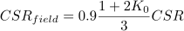
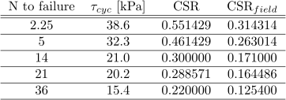
Table 4. CSR values.

Power fits can be obtained on both CSR values and graphed as seen below.
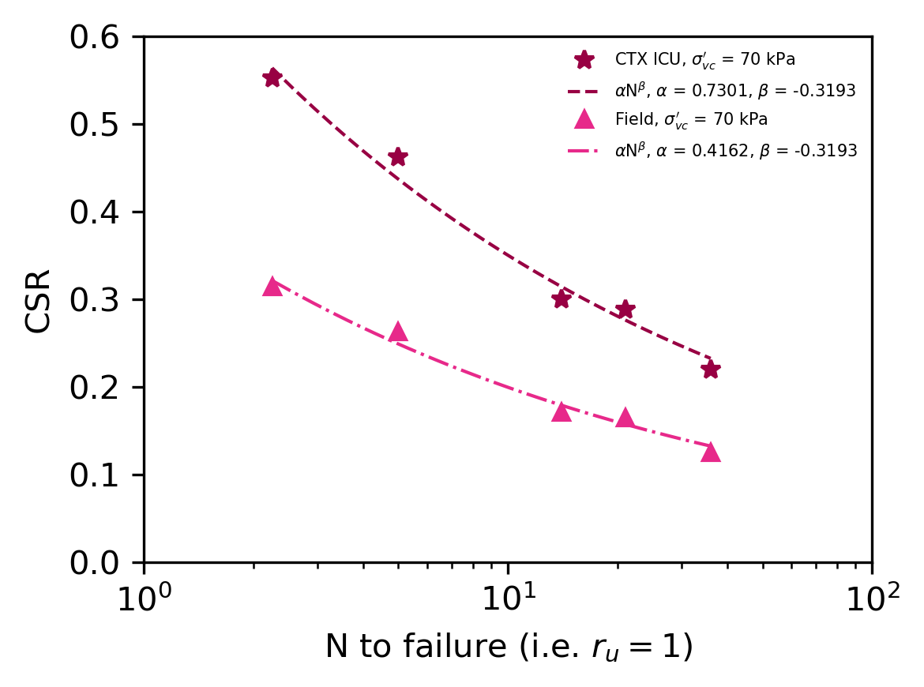
Figure 3. CSR values and power fits for CTX ICU and field shaking.
The CSR of 0.14 due to an EQ corresponds to ten uniform cycles (i.e. N = 10). Therefore, the CRR is the soil’s in-situ capacity at N = 10.
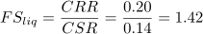
Via Marcuson and Hynes (1989), a r_{u} value of 0.14 can be obtained. The r_{u} can be used to obtain the values necessary to calculate the vertical effective stress during shaking.
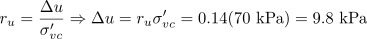

Part C
Because the amplitude has doubled with no change in number of cycles, the CSR can also be doubled. The new CSR is equal to twice of 0.14 (i.e. 0.28). The CSR is now greater than the CRR. This means the soil has liquefied, resulting in an r_{u} equal to 1.
Therefore, the vertical effective stress after doubling the EQ amplitude is 0, since the soil is liquefied.

