

Maseeh College of Engineering and Computer Science
Department of Civil and Environmental Engineering

Post Office Box 751 503-725-4282 tel
Portland, Oregon 97207-0751 503-725-5950 fax

CE443(543) Introduction to Seismology and Site Evaluation

To: CE443(543) Students Date: March 26, 2026
From: Arash Khosravifar

Subject: Homework Assignment #6 (Due March 6th at 11:59 p.m.)

Problem 1: A series of undrained cyclic simple shear tests were performed on Ko-consolidated specimens of saturated sand at a relative density of 50%. The cyclic loading consisted of uniform sinusoidal shear loads. Tests
were performed at three different initial vertical effective consolidation stresses, with the results tabulated below.

(a) Estimate the cyclic shear stress that would be required to trigger ru=100% in 15 uniform undrained loading cycles for a specimen of this sand having an initial vertical consolidation stress of 450 kPa.

(b) For the cyclic resistance ratio (CRR) defined as the cyclic stress ratio that triggers ru=100% in 15 uniform cycles of loading, determine the value of Kσ for an effective consolidation stress of 450 kPa.

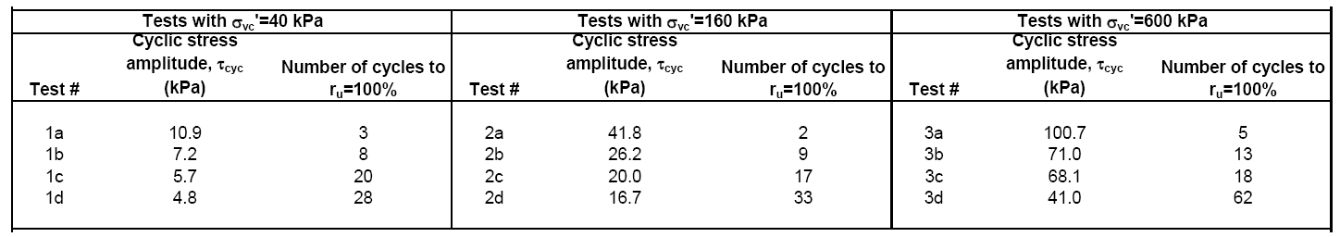

Correct answers:
- Cyclic shear stress = 54 kPa
- K_sigma = 0.86

Problem 2:
The soil profile at a level site consists of a 3-m thick layer of sandy clay, overlaying an 8-m thick layer of loose sand, overlaying stiff gravelly clays that extend to depths greater than 20 m. The water table is at a depth of 2 m and the ground water is initially hydrostatic. The total unit weight of the upper sandy clay, above or below the water table, is 18 kN/m3. The total unit weight of the loose sand layer is 20 kN/m3. The coefficient of lateral earth pressure at rest (Ko) in the loose sand is estimated to be 0.5. Two open standpipe piezometers were installed that had small enough slotted intervals that they provide essentially point measurements of ground water conditions: Piezometer A has its slotted interval at a depth of about 4 m, while Piezometer B has its slotted interval at a depth of about 10m.

- For the initial conditions, determine: (i) where the water levels (relative to the ground surface) would be in both piezometers, and (ii) the average hydraulic gradient between the slotted intervals of the two piezometers.
- For the initial conditions, determine the total horizontal stress at the depth of the slotted interval for Piezometer B.
- Suppose an earthquake causes liquefaction (100% excess pore pressure ratio) in the loose sand layer. Determine: (i) where the water levels (relative to the ground surface) would be in both piezometers if they had sufficiently tall "riser" sections – i.e., portions that extend above ground, and (ii) the average hydraulic gradient between the depths of the slotted intervals for the two piezometers.
- For the conditions given in (c), determine the total horizontal stress at the depth of the slotted interval for Piezometer B if the value of Ko is unaffected.

Correct answers:
- i_{A-B}=0
- σ_{h0} = 136 kPa
- i_{B-A} = 1.03
- σ_{h} = 194 kPa

Problem 3:
The liquefaction resistance of a clean, poorly graded sand (SP) deposit was evaluated using cyclic triaxial testing of undisturbed samples obtained using frozen sampling techniques. The sand deposit extends from the ground surface to a depth of 10 m. The water table is at a depth of 2 m, and ground water conditions are initially hydrostatic. The sand is normally consolidated with an estimated coefficient of earth pressure at rest of 0.45. Isotropically consolidated undrained cyclic triaxial tests were performed on samples from a depth of 5 m with the results presented below.

Tests with σ3c'=70 kPa

Cyclic stress amplitude, Number of cycles
Test # qcyc/2 (kPa) to ru=100%

1 | 38.6 | 2.25
2 | 32.3 | 5
3 | 21.0 | 14
4 | 20.2 | 21
5 | 15.4 | 36

- For the initial conditions, estimate the vertical effective stress at a depth of 5 m.
- Suppose the site was shaken by an earthquake, with each direction of horizontal shaking producing cyclic shear stresses at a depth of 5 m that are equivalent to about 10 uniform cycles at a cyclic stress ratio (τhv,cyc/σvc') of 0.14. Assuming the sand is essentially undrained during shaking, and using the mid-range of the ru versus FSL relation by Marcuson and Hynes (1989) (Figure 31 below from the textbook), estimate the vertical effective stress at that depth.
- Repeat part (b) for an earthquake that causes about the same number of loading cycles but with amplitudes that are about twice as large.

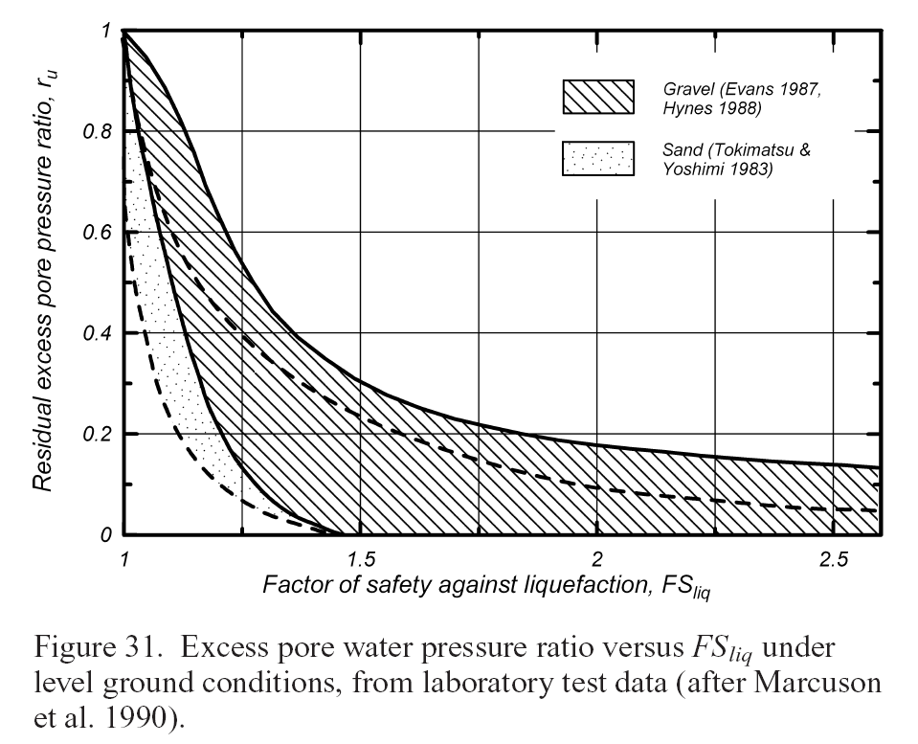

Hints for Problem 3:
Factor of safety against liquefaction (FS_L) is calculated by dividing resistance (CRR) with demand (CSR):
FS_L = CRR/CSR

To get CRR you will need to use the test data to develop CSR versus N and extract the CSR at the number of cycles that corresponds to your earthquake loading (i.e., N=10). Note that to get CSR in the above figure you will need to use the Triaxial test data to calculate CSR_TX and then multiply it by two factors to convert it to 2D simple shear loading in the field. These two factors include:
- 0.9 for bi-directional loading
- (1+2Ko)/3 to convert from Triaxial loading conditions to 2D simple shear loading conditions which is more representative of earthquake loading.

Note that CSR_TX = (q_cyc/2)/sigma’3c

Your CSR versus N plot should look like the figure below:

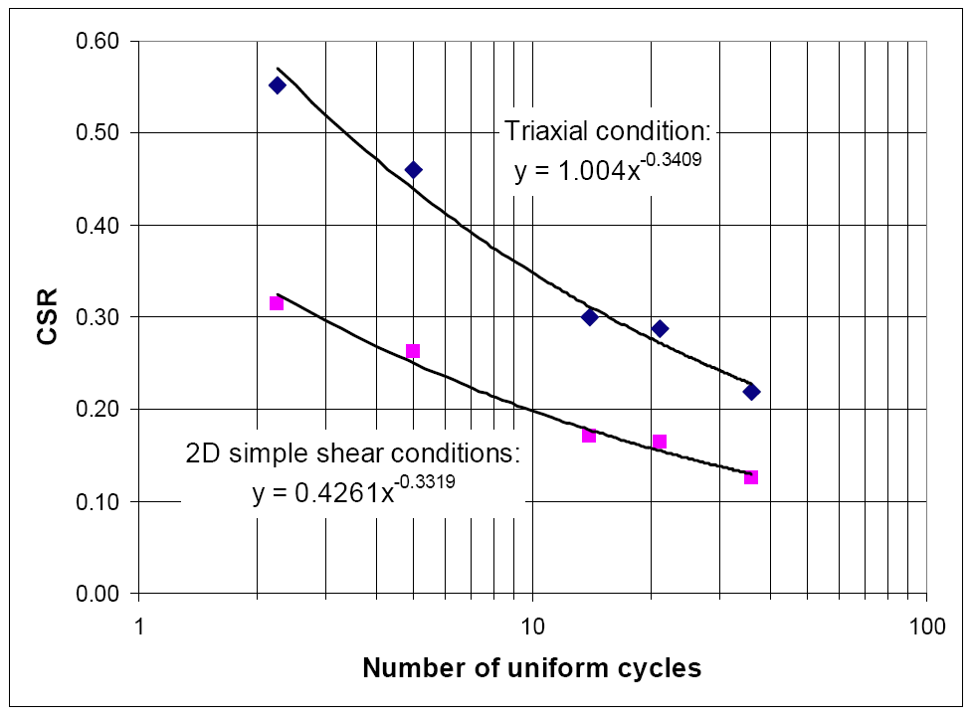

Now you can extract the resistance (CRR) at the corresponding number of equivalent loading cycles in the earthquake (i.e., N=10) using the 2D simple shear conditions relationship in the figure above which gives CRR = ~0.20

The demand (CSR) is given in the problem statement which is CSR = 0.14, so now you can calculate FS_L = CRR/CSR = (0.20)/(0.14) = 1.43.

The excess pore pressure ratio can now be estimated using the following graph from Marcuson and Hynes (1989). Using the mid-range of the hatched zone for “sand” gives a ru≈0.14;

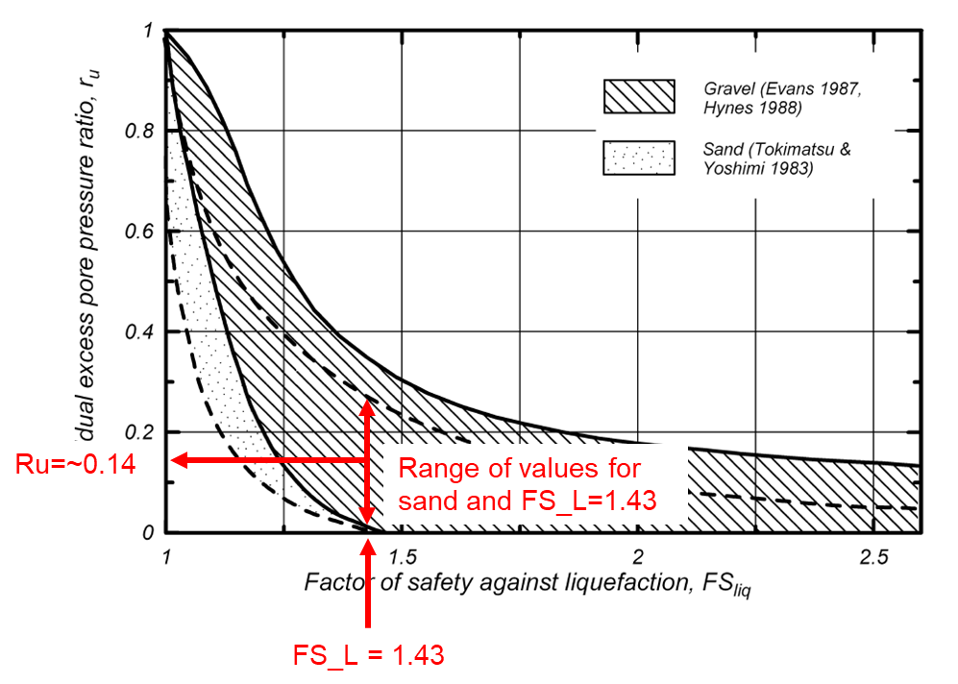
Note that for part (d) CSR will be doubled so FS_L = (0.20)/(0.28) = 0.71. When FS_L<1, liquefaction is fully triggered which means Ru=1.0. You may notice that in the above figure, the FS_L on the horizontal axis is greater than 1.0 and for FS_L<1 the Ru values are all 1.0.

