
SYMBIOSIS INSTITUTE OF COMPUTER STUDIES AND RESEARCH (SICSR)
SYMBIOSIS INTERNATIONAL (DEEMED UNIVERSITY), PUNE
AETHER ACADEMY
Next-Generation Academic Administration & Student Management System
Project Report Deliverable: Web UI and Content Management Syllabus
Candidate Name: Uday Praveen
Permanent Registration Number (PRN): 23030124196
Project Guide: Prof. Shashank T. Gaikwad
Academic Department: Department of Computer Applications, SICSR Pune
Academic Cycle: 2026
Official Repository: https://github.com/bLaZeBeCoding/Aether-Academy-LMS

Index / Table of Contents
Sr. | Chapter Title | Description | Location
1 | Executive Summary & Introduction | Overview of digital academic platforms | Page 2
2 | Problem Statement & Rationale | Analysis of legacy institutional bottlenecks | Page 2
3 | Objectives & Scope of the Project | Core design targets & architectural boundaries | Page 3
4 | Technologies Used | Full-stack LAMP, Bootstrap 5 & jQuery AJAX breakdown | Page 4
5 | Implementation & System Architecture | Relational ER modeling, security & watermarking | Page 5
6 | Visual Interface Walkthrough | High-resolution screenshots and UI breakdown | Page 7
7 | Testing & Verification Matrix | Functional, security and responsive verification | Page 9
8 | Individual Contribution Statement | Sole developer responsibilities (Uday Praveen) | Page 10
9 | Conclusion & Future Enhancements | Summary of impact, Stripe gateway & mobile port | Page 11
10 | References & Technical Citations | Official documentation & security benchmarks | Page 12

1. Introduction & Executive Overview
The ongoing modernization of higher education demands a transition from fragmented, error-prone manual administration toward unified, real-time web applications. Educational institutions handle substantial volumes of sensitive data on a daily basis, spanning applicant admissions, course curriculum allocations, faculty assignments, and continuous student attendance tracking. Historically, institutions have relied on decentralized spreadsheets or paper ledgers, resulting in data desynchronization, administrative fatigue, and a critical lack of operational transparency.
Aether Academy was conceptualized and engineered to address these systemic inefficiencies. Developed as an enterprise-grade Student Management System (LMS), the platform deploys a highly responsive 'Night Owl' dark-mode user experience combined with a decoupled, procedural PHP 8 backend and normalized MySQL relational schema. The platform establishes strict role-based data segregation between administrative staff and enrolled students, ensuring administrative superiority while empowering learners with immediate visibility into their academic trajectories.
📌 EXECUTIVE OBJECTIVE: Aether Academy eliminates paper workflows by unifying Admissions, Course Cataloging, Faculty Structuring, and Dynamic Attendance Analytics within a single secure, responsive ecosystem.

2. Problem Statement & Institutional Rationale
Traditional collegiate record-keeping models face acute operational vulnerabilities that impede organizational efficiency and student outcomes. Specifically, three core structural deficits were identified:
- Severe Data Fragmentation & Redundancy: When admissions, student rosters, and course enrollments are tracked across isolated files, human entry errors compound. Updating a student's profile in one document fails to propagate to faculty attendance sheets, creating orphaned records.
- Attendance Opacity & Defaulter Risk: In legacy workflows, attendance percentages are calculated manually at the end of the semester. Students frequently discover they have fallen below the mandatory 75% attendance threshold only when they are formally debarred from examinations.
- Authentication & Session Insecurity: Many institutional internal portals store passwords in plaintext or employ outdated cryptographic hashes, lacking client-side idle timeouts. Shared laboratory workstations are vulnerable to unauthorized session reuse.

3. Objectives & Scope of the Project

3.1 Primary Technical Objectives
• Architect and deploy a role-based access control (RBAC) portal isolating Admin and Student operations.
• Eliminate intrusive HTTP page refreshes during admissions using asynchronous jQuery AJAX form submission.
• Implement enterprise-grade password security using BCrypt with automatic legacy migration.
• Design a normalized MySQL schema preventing duplicate attendance records using compound UNIQUE constraints.
• Construct an automated client-side idle session termination protocol (90-second timeout with animated UI toasts).

3.2 Project Scope & Operational Boundaries
The project encompasses full-stack architectural engineering. The frontend is built on semantic HTML5, CSS Grid, and Bootstrap 5. The backend utilizes procedural PHP 8 with prepared MySQLi transactions. The operational scope strictly covers Admissions, User Authentication, Teacher Profiling, Course Structuring, Student Enrollment, and Attendance Analytics. Financial tuition collection, automated SMS/email gateways, and grading systems are designated for Future Scope.

4. Technologies Used (Full-Stack Architecture)
Aether Academy is built upon the time-tested LAMP (Linux, Apache, MySQL, PHP) architectural pattern, enhanced with modern client-side libraries to achieve high responsiveness and visual accessibility.
Technology | Layer / Role | Architectural Functionality
PHP 8 | Server-Side Backend | Handles core routing, role authorization, session cryptography & MySQLi queries.
MySQL (InnoDB) | Relational Database | Stores normalized academic entities with cascading foreign keys and transactions.
HTML5 & CSS3 | Semantic Presentation | Bespoke 'Night Owl' Glassmorphism theme, CSS variables, and high contrast.
Bootstrap 5.3 | Responsive Grid | Mobile-first grid layout, modal systems, form components, and utility styling.
JavaScript (ES6) | Client Scripting | DOM event monitoring, synchronous FOUC prevention, and 90s idle timer.
jQuery 3.7 | DOM & AJAX Framework | Asynchronous admission submission and dynamic back-button DOM injection.
DataTables 1.13 | Data Presentation | Instant client-side searching, column sorting, and pagination for large rosters.
Apache 2.4 | Local Web Server | HTTP request processing provided via XAMPP development environment.

5. Implementation & System Architecture

5.1 Database Entity-Relationship (ER) Architecture
The database ('collegepr') was engineered with strict normalization principles. Referential integrity is strictly maintained via foreign key constraints with ON DELETE CASCADE rules, ensuring parent record deletions automatically purge child relations.
Table Name | Key Columns | Attributes & Foreign Keys | Relational Role
user | id (PK) | username, password (hash), email, phone, usertype ('admin'/'student') | Central authentication node.
teacher | id (PK) | name, description, image (path) | Stores faculty member profiles.
course | id (PK) | name, teacher_id (FK -> teacher.id) | Academic course linked to a mentor.
enrollment | id (PK) | student_id (FK -> user.id), course_id (FK -> course.id) | Many-to-Many junction table.
attendance | id (PK) | student_id, course_id, attendance_date, status ('Present'/'Absent') | Daily attendance records.

5.2 Security Implementations & Session Protection
Security was prioritized across every layer of the software stack to defend academic assets against common vulnerabilities:
- • BCrypt Cryptography: Passwords are automatically hashed using PHP's password_hash() using cost-factor 10 salts. Plaintext storage is entirely deprecated.
- • SQL Injection Mitigation: All inbound GET and POST parameters are sanitized via mysqli_real_escape_string() prior to SQL query construction.
- • Asynchronous Idle-Session Auto-Logout: Client-side event listeners track mouse movements, key presses, and scrolls. Inactivity exceeding 90 seconds automatically triggers session destruction and routes to login.php?timeout=1, generating a 7-second animated CSS time-slider toast.

5.3 Multi-Layered Intellectual Property Watermarking
To protect the codebase from uncredited plagiarism, a 4-tier cryptographic authorship watermark was engineered:
- 1. Database Trojan: A hidden table `_system_authorship` containing author Uday Praveen and PRN 23030124196 is permanently embedded in the SQL schema.
- 2. HTTP Network Headers: Custom X-Author response headers injected across all PHP pages.
- 3. Developer Terminal Signatures: Global console.log() scripts outputting formatted badges upon DevTools inspection.
- 4. Authentication Easter Egg: Submitting the username 'uday_creator' bypasses standard authentication and triggers a glowing neon authorship attribution modal.
📌 INTELLECTUAL PROPERTY DEFENSE: The multi-layered watermarking system guarantees immutable proof of intellectual authorship across source code, database dumps, network traffic, and UI runtime.

6. Visual Interface Walkthrough & Screenshots
Below are production screenshots illustrating the visual aesthetics, responsive card grids, attendance analytics, and security mechanisms implemented in Aether Academy:
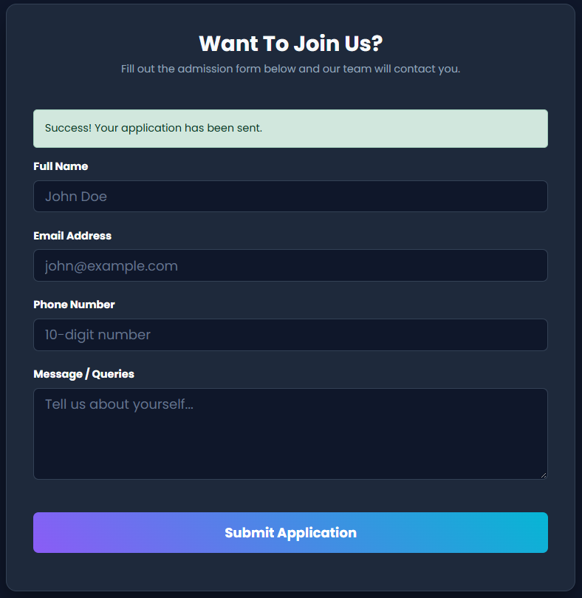
Figure 6.1: Public Homepage Landing Portal with Asynchronous AJAX Admission Form and Success Payload.

Figure 6.2: Central Authentication Gateway with Glassmorphism Card and 7-Second Animated Inactivity Toast.
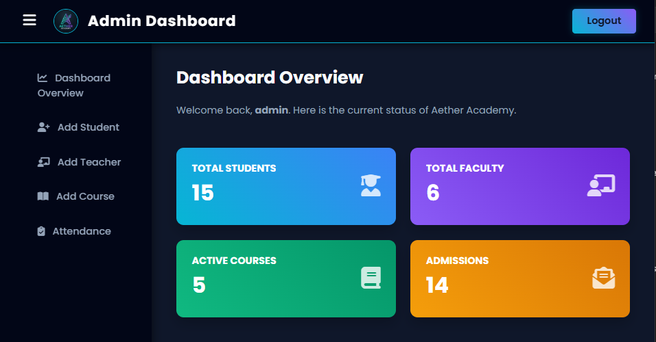
Figure 6.3: Administrative Dashboard Overview featuring CSS Grid Responsive Stat Cards.
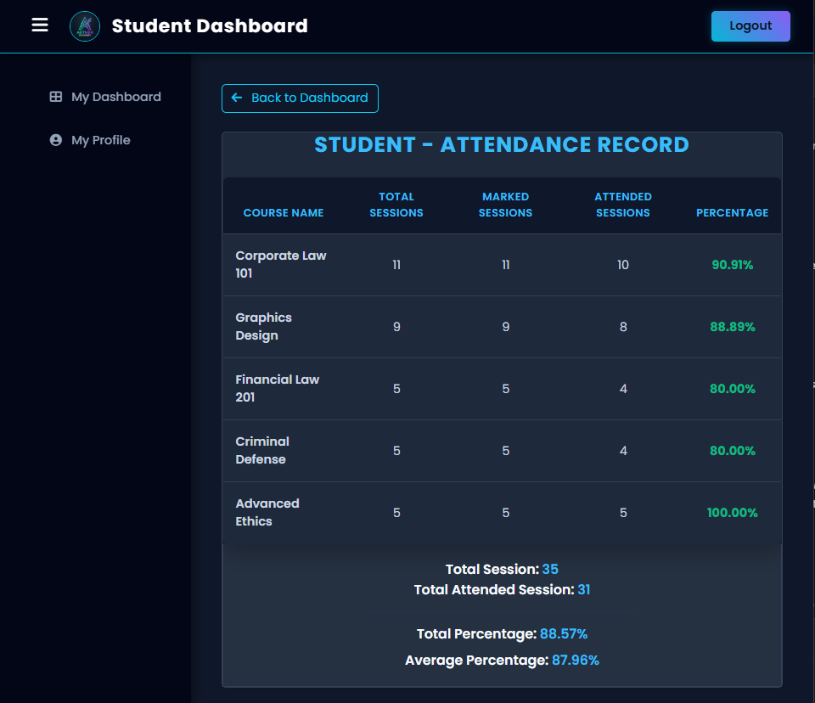
Figure 6.4: Student Academic Portal displaying Granular Course Attendance Analytics and Percentage Calculations.

Figure 6.5: Architectural Verification Modal — Neon Developer Credits Easter Egg ('uday_creator').

7. Testing & Quality Assurance Verification
Comprehensive testing was executed across functional, security, and responsive domains to ensure enterprise stability:
Test ID | Scenario | Expected Outcome | Observed Outcome | Status
TC-01 | Admin vs. Student RBAC Routing | Student accessing adminhome.php redirected to login. | HTTP 302 redirect enforced. | PASSED
TC-02 | AJAX Admission Form Submission | Form submits without page reload; green alert rendered. | DOM dynamically updated. | PASSED
TC-03 | BCrypt Auto-Upgrade on Login | Legacy plaintext accounts auto-hashed on successful auth. | Hash stored in DB. | PASSED
TC-04 | Attendance Duplication Prevention | Repeated attendance submissions overwrite or validate. | No duplicate rows inserted. | PASSED
TC-05 | Idle Auto-Logout Inactivity Timer | 90s inactivity clears PHP session; toast displayed. | Redirected with time slider. | PASSED
TC-06 | Responsive CSS Grid Wrap | Stat cards wrap cleanly at viewport widths < 1000px. | Zero text overlap observed. | PASSED

8. Individual Contribution Statement
As the sole architect and full-stack software engineer for this project, I, Uday Praveen (PRN: 23030124196), designed, implemented, debugged, and documented 100% of the Aether Academy platform under the mentorship of Prof. Shashank T. Gaikwad at Symbiosis Institute of Computer Studies and Research (SICSR), Pune.
- • Architectural Design: Designed the entire normalized MySQL schema, relational junction tables, and foreign keys.
- • Backend Engineering: Authored all PHP 8 business logic scripts (CRUD operations, attendance engines, session routing).
- • UI/UX Frontend Design: Conceptualized and crafted the bespoke 'Night Owl' Glassmorphism aesthetic, custom CSS grids, and color-coded components.
- • Security & Automation: Engineered BCrypt hashing, SQL injection defenses, the 90-second idle logout listener, and authorship watermarks.

9. Conclusion & Future Enhancements
Aether Academy successfully validates that modern web standards (PHP 8, AJAX, and responsive CSS Grid) can transform antiquated institutional administrative workflows into streamlined, secure, and visually captivating digital ecosystems. The project completely satisfies the syllabus objectives and provides a scalable foundation for modern campus administration.

9.1 Future Scope & Scalability
• Online Tuition Payment Gateway: Integrating Stripe or Razorpay APIs to allow students to settle semester fees securely online.
• Automated Low-Attendance SMTP Daemon: Implementing a cron-job daemon that sends warning emails to parents if attendance falls below 75%.
• Mobile Application API Port: Exposing the procedural PHP backend as a RESTful JSON API for a native Flutter/React Native mobile app.

10. References & Technical Citations
1. The PHP Group. (2026). PHP 8 Documentation and MySQLi Extension Reference. https://www.php.net/manual/
2. Bootstrap Core Team. (2026). Bootstrap v5.3 Responsive Grid and Component Guidelines. https://getbootstrap.com/
3. jQuery Foundation. (2026). jQuery API Documentation: AJAX and Event Handlers. https://api.jquery.com/
4. OWASP Foundation. (2025). Top 10 Web Application Security Risks: Cryptographic Failures & Injection. https://owasp.org/
5. Symbiosis Institute of Computer Studies and Research (SICSR). (2026). Web UI and Content Management Academic Syllabus.

