**Clarifai registration**

**Added 10.08.2018.**

1. Go to: <https://clarifai.com/>

and press “LOG IN” button.

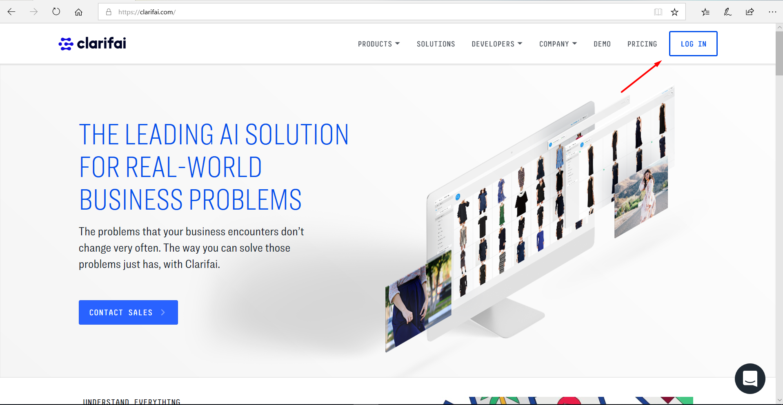

2. In next page press the link “Sign up now”.

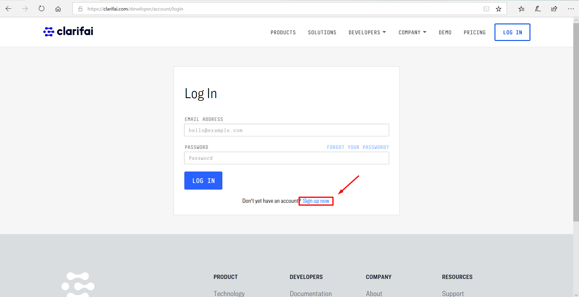

3. Fill the all required fields.

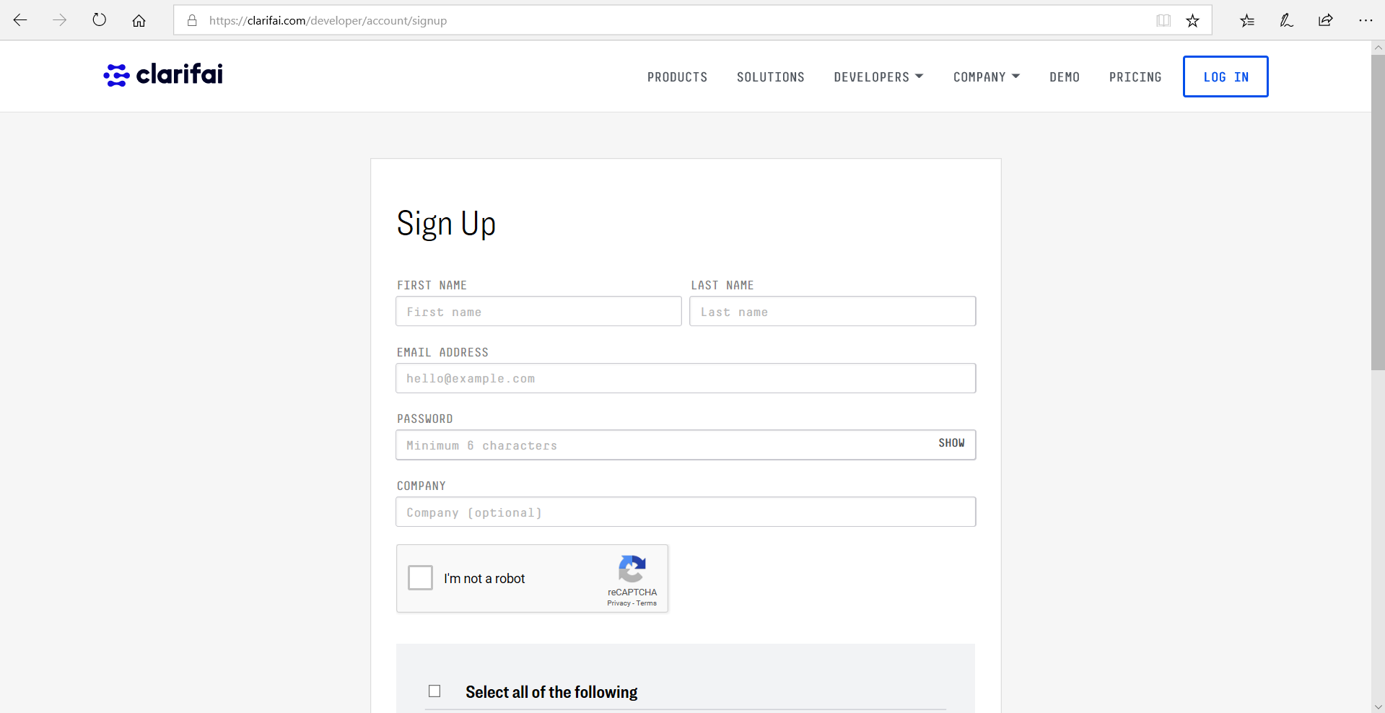

4. Press “SIGN UP” button.

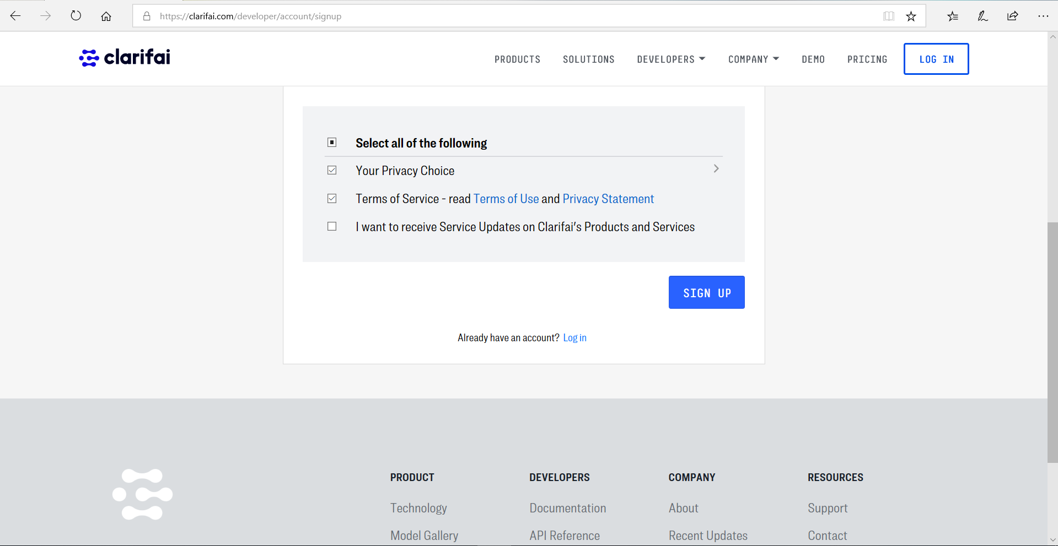

5. You’ve been referred to next page.

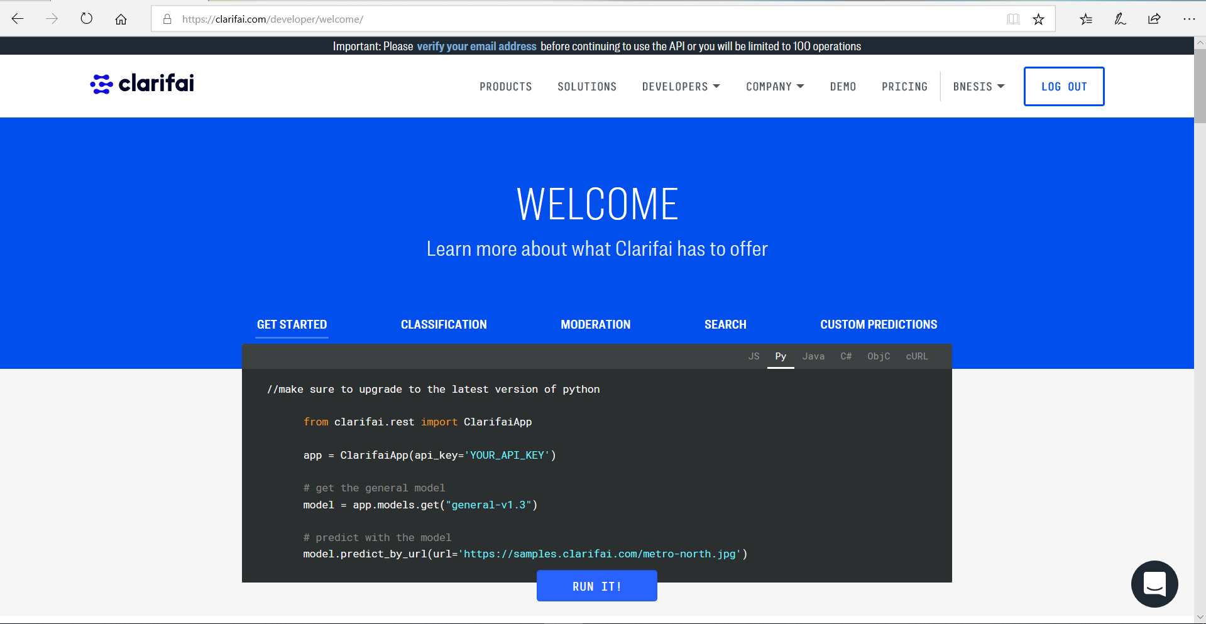Note. For getting “Community Plan” you must verify your e-mail address.  
  
6. Go to your account, then select applications and press “CREATE NEW APPLICATION” button.

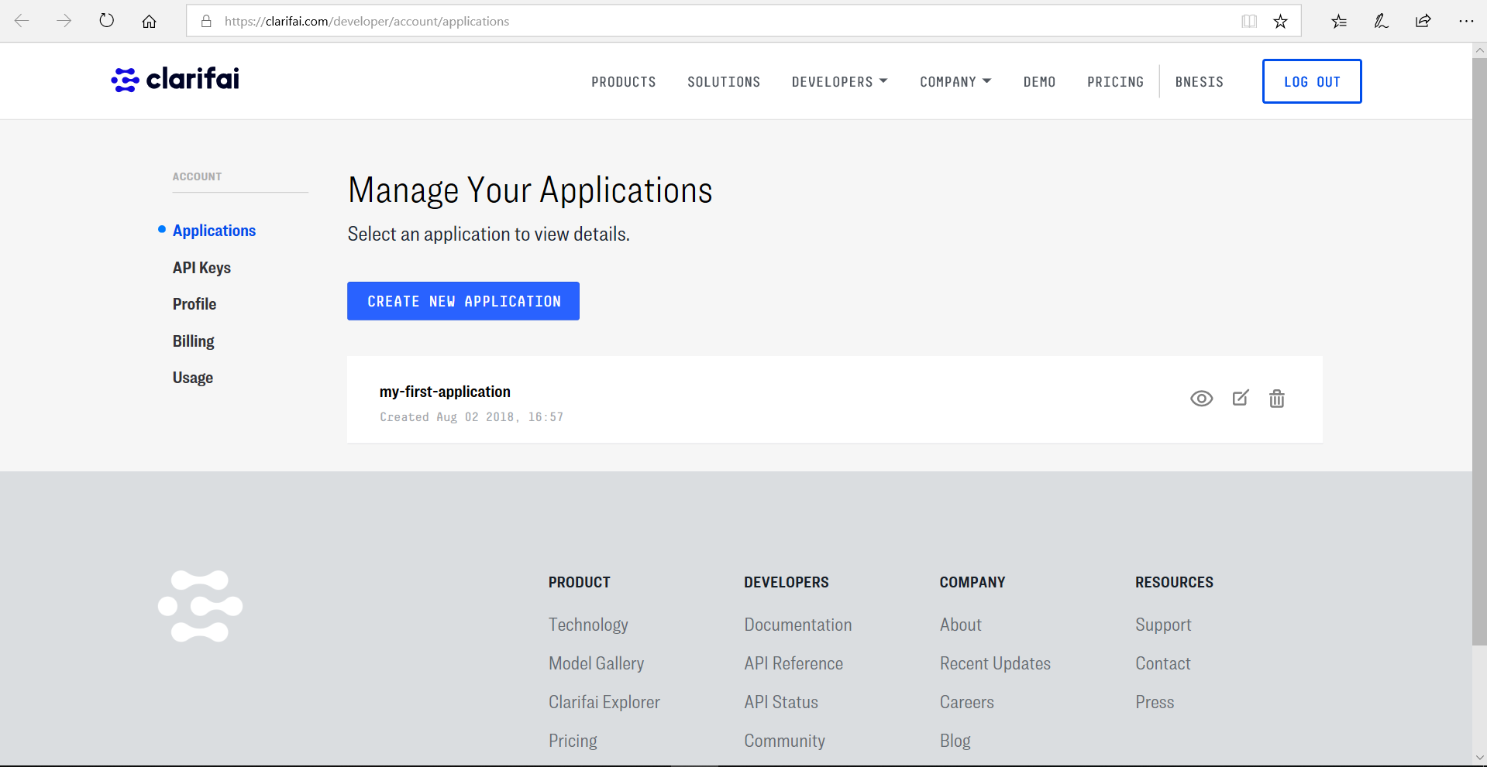

7. Fill a field “APP NAME” and press “CREATE APP” button.

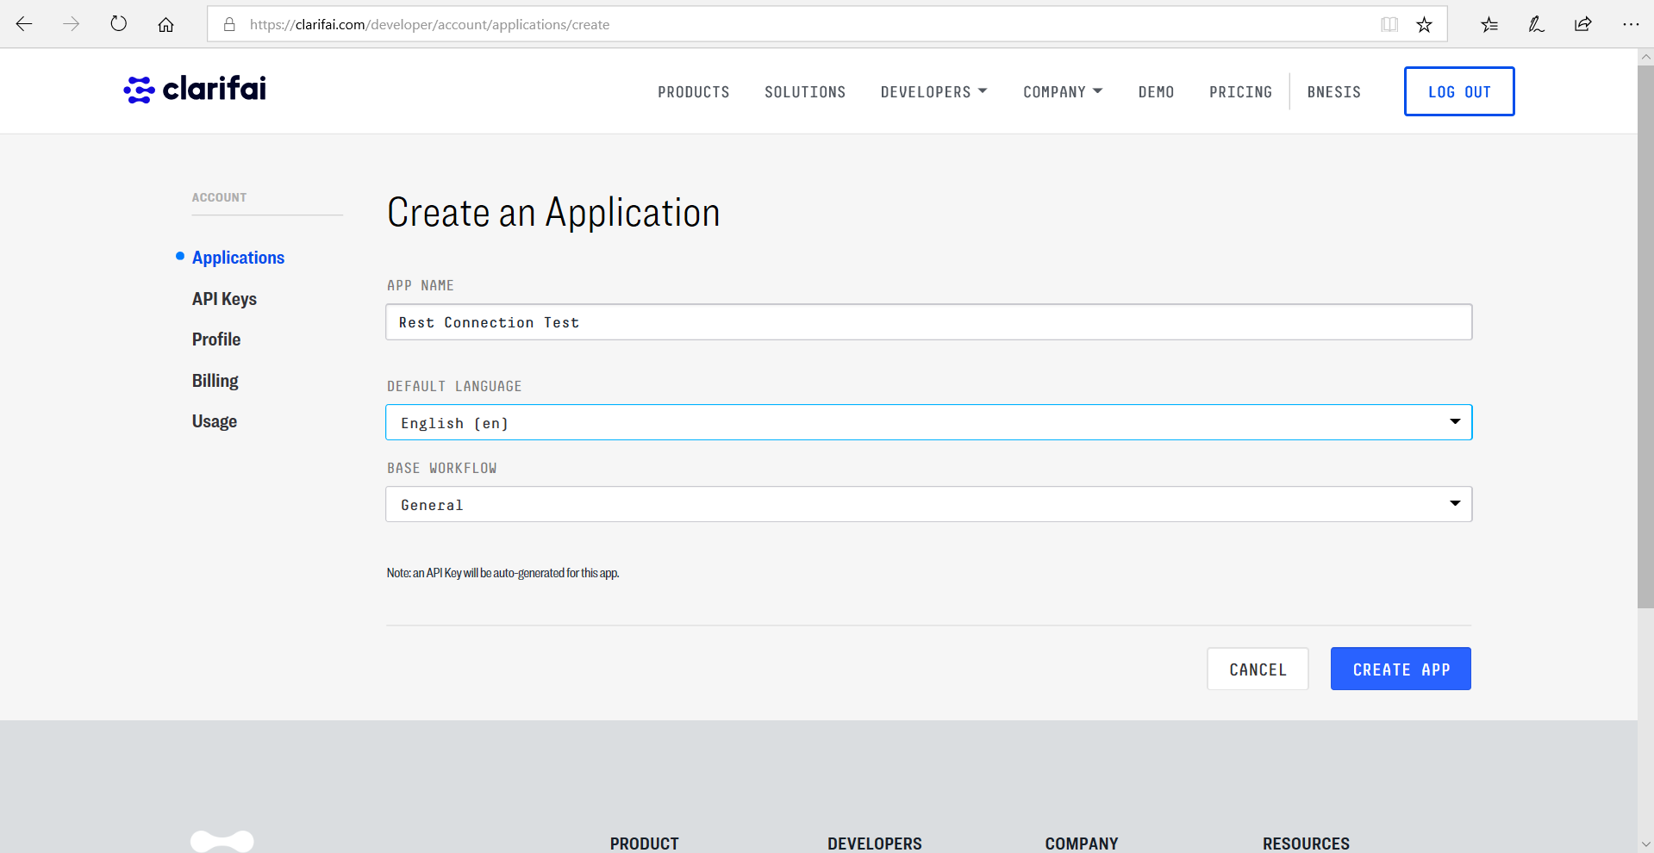

8. After APP creating go to “API Keys”.

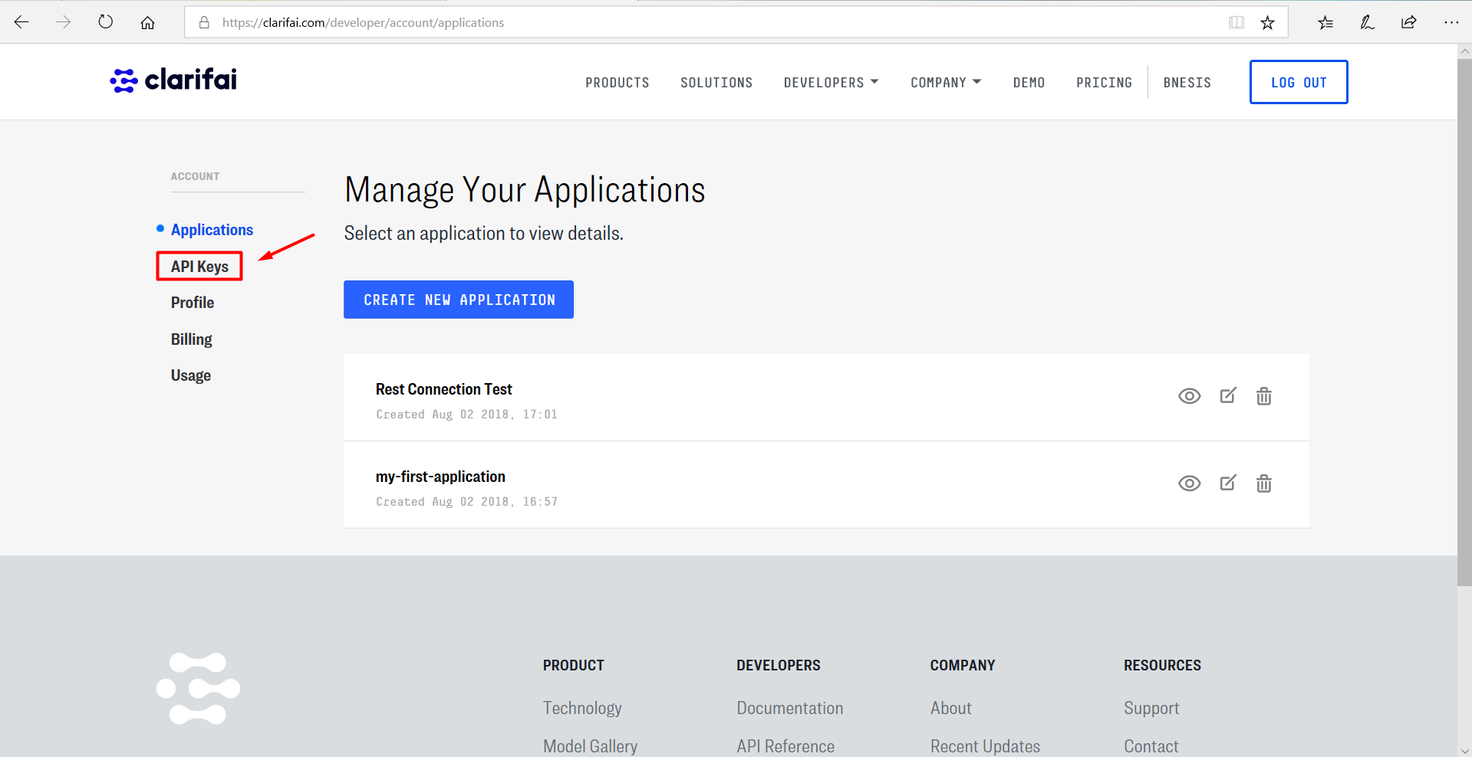

9. Copy your API Key to your App.

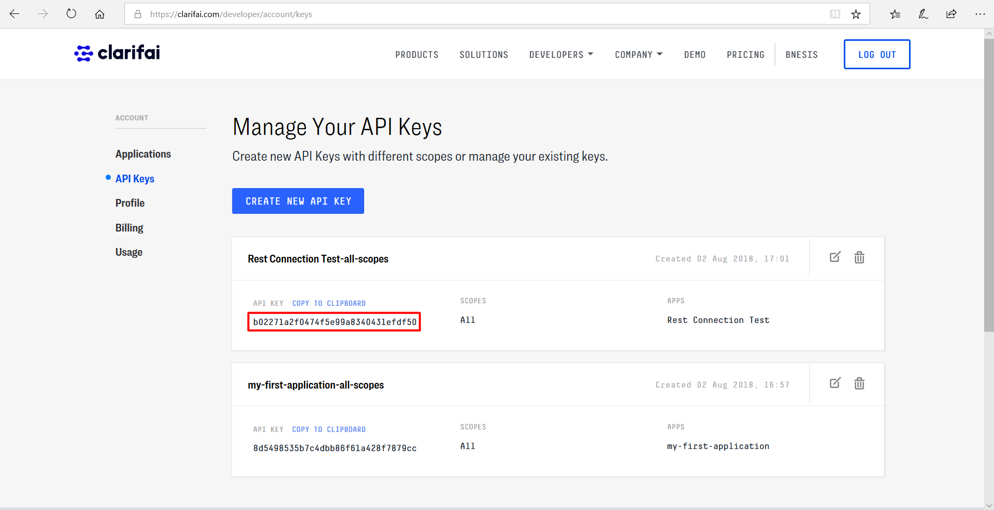

**Good Luck!**