**DHL EXPRESS APP Registration (Public)**

For creating public APP you need to contact with [xmlrequests@dhl.com](mailto:xmlrequests@dhl.com) along with you full Account details like account number, address, region etc.

**DHL EXPRESS APP Registration (SANDBOX)**

1. Go to: <https://xmlportal.dhl.com/login>

And click on “Register Now”.

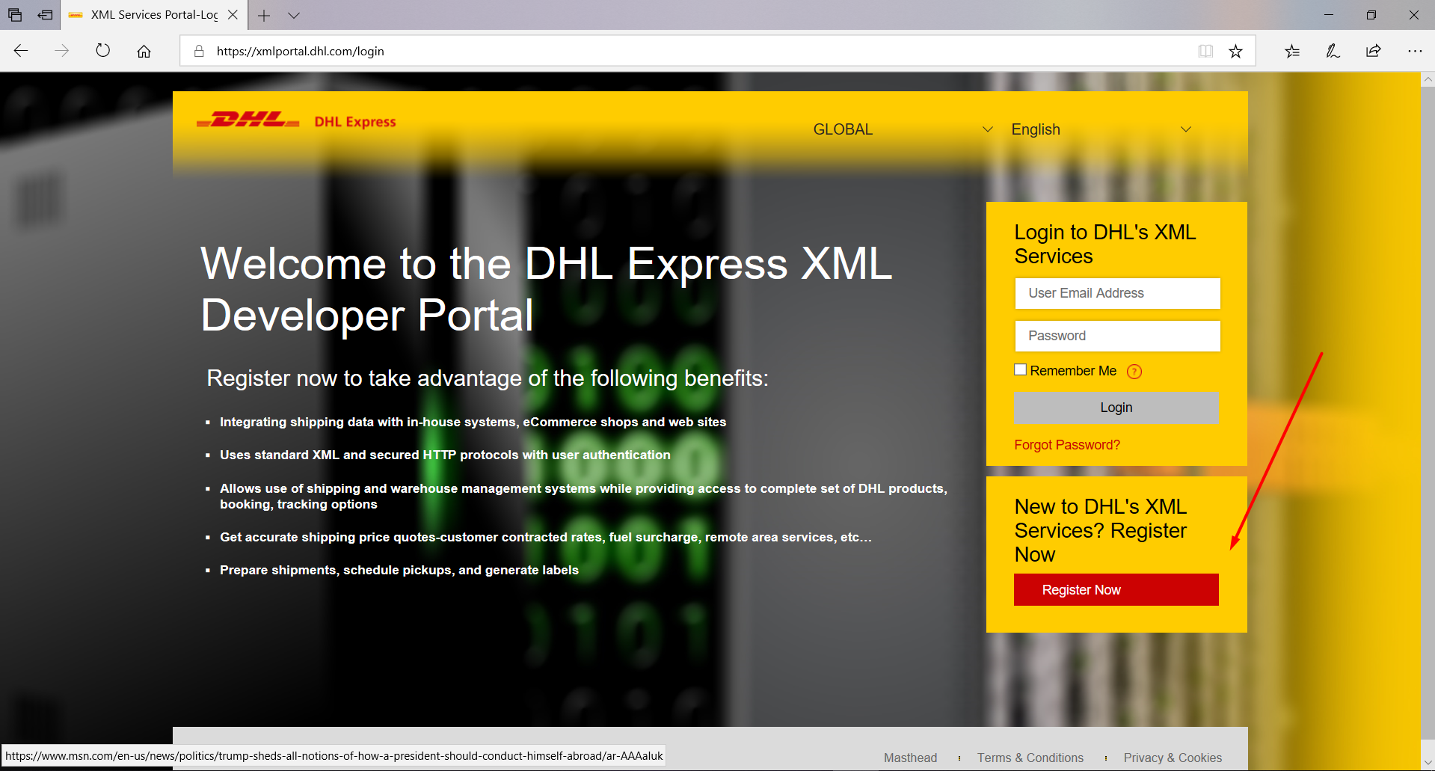

2. Fill all fields.

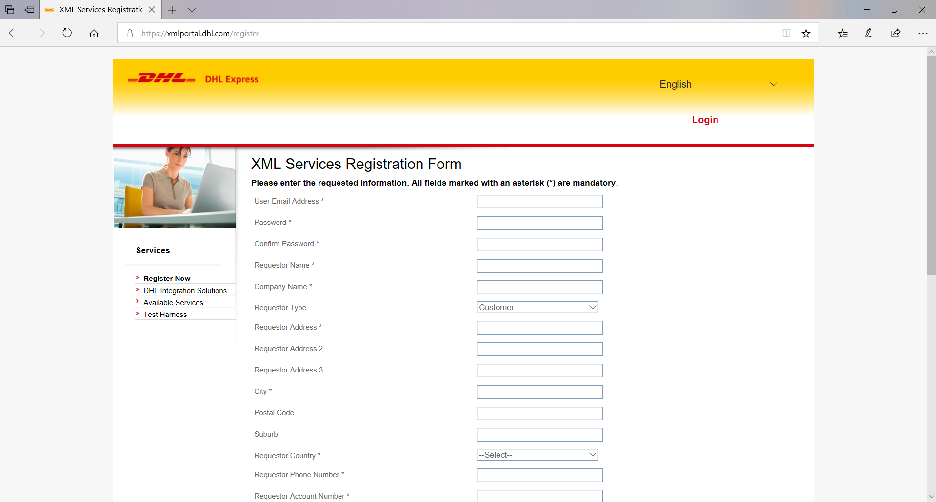

Note: In “Requestor Services” only checked “service” will worked:

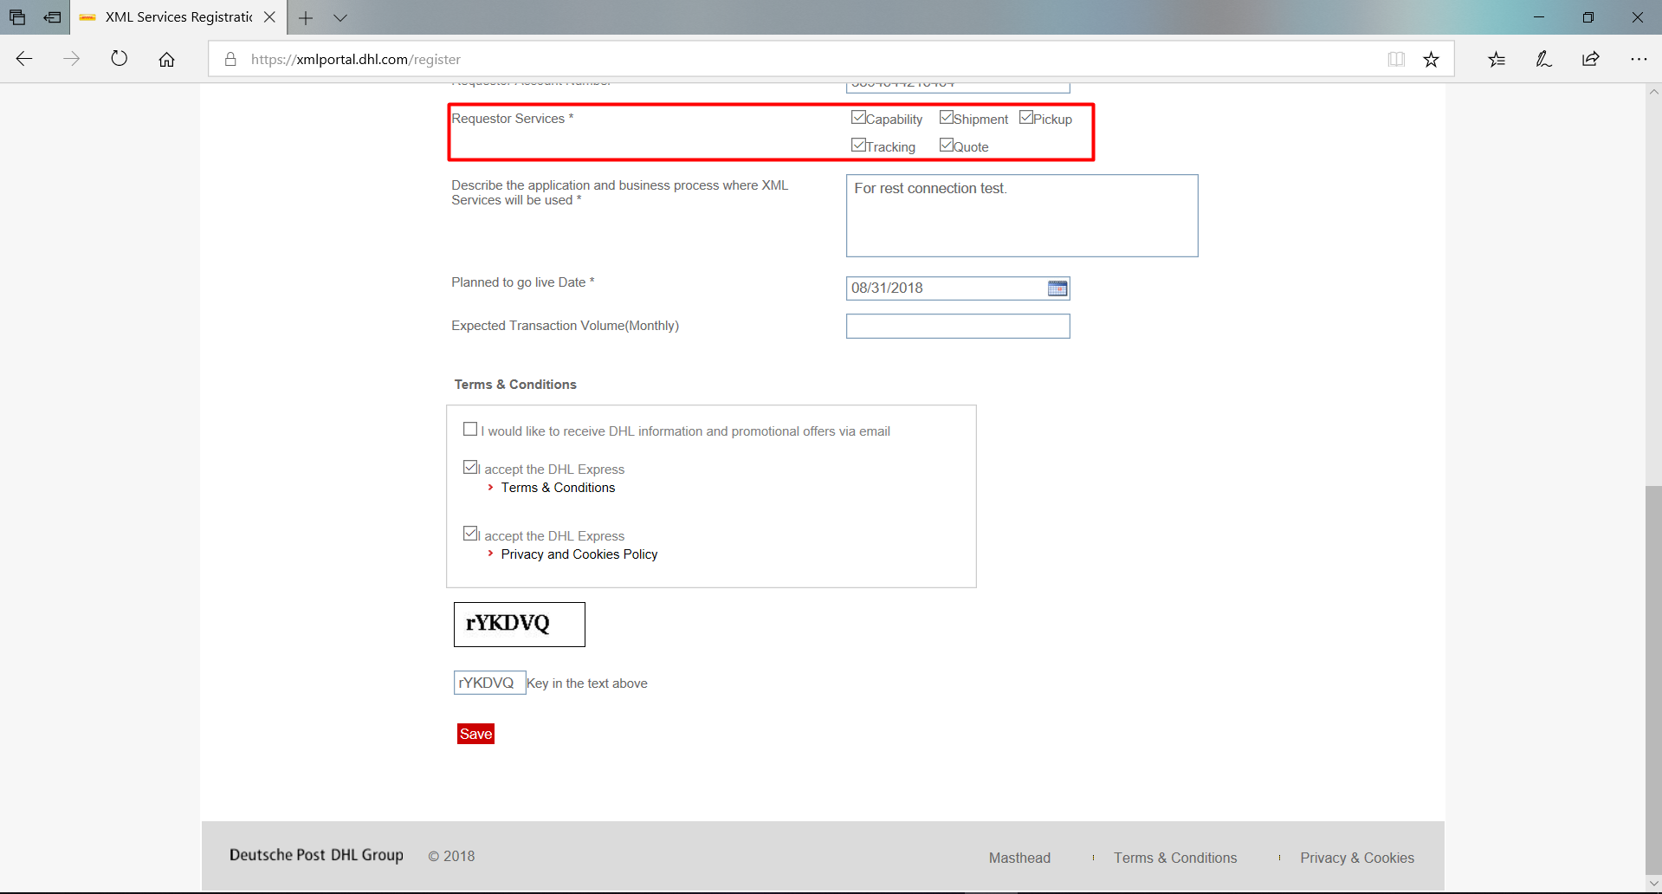

3. After click on “Save” will redirect to success page registration:

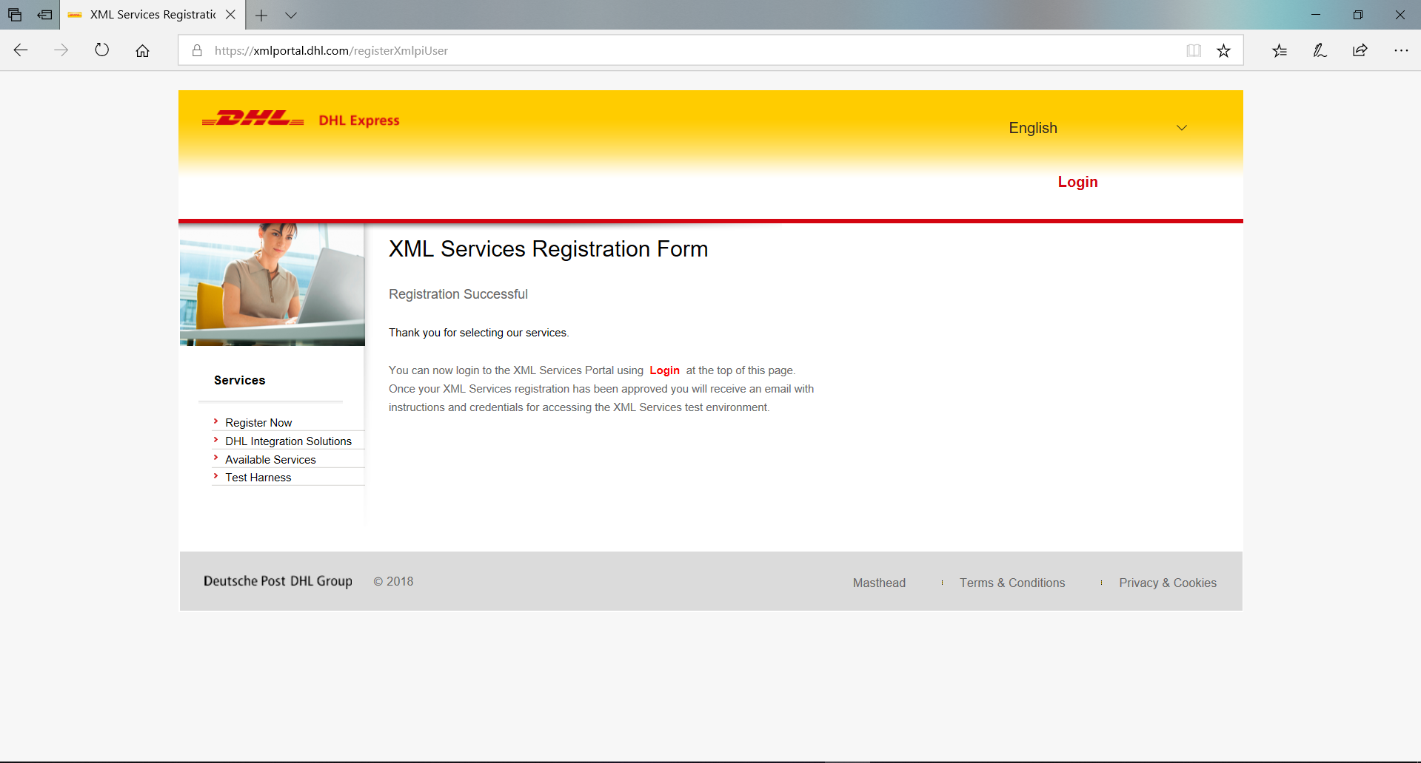

4. Login to your account and click on the “XML Services Status”:

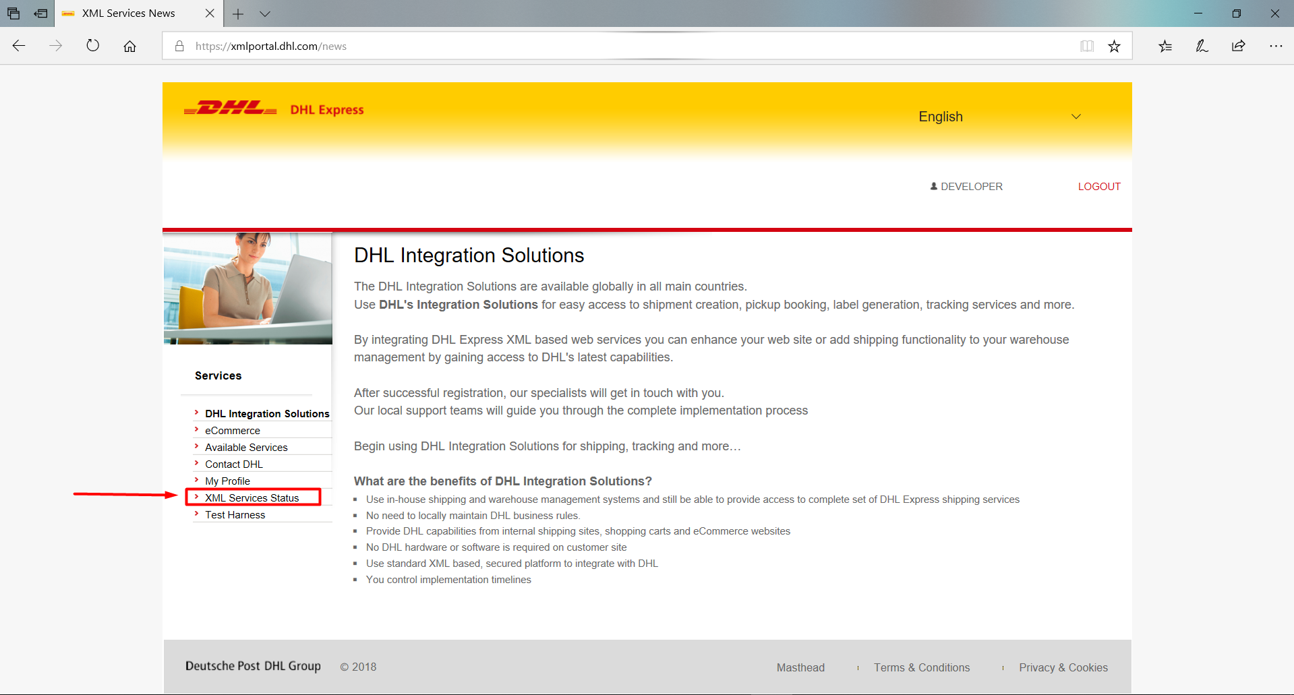

5. Service status must be approved.

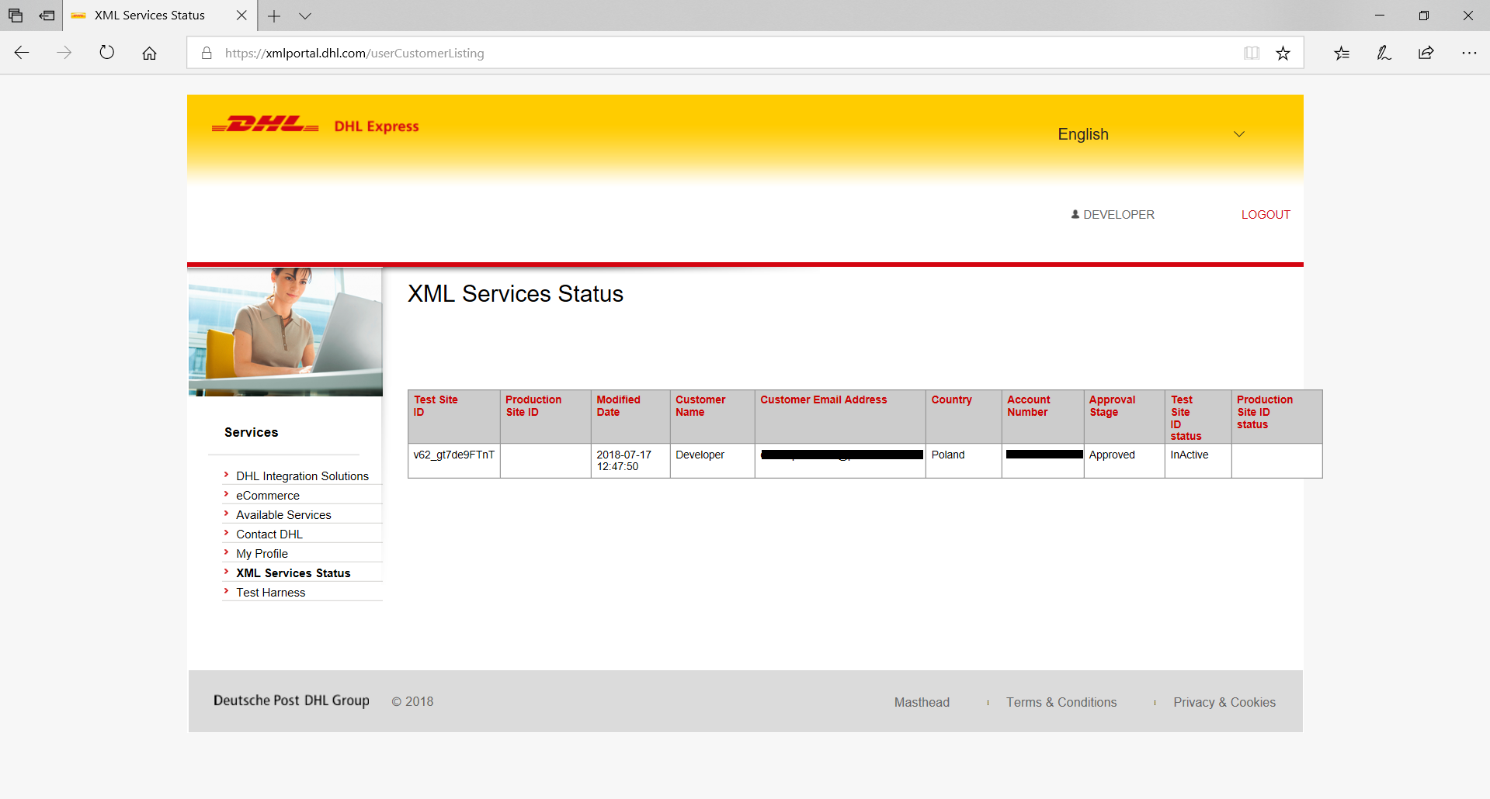Note: Service will approved in 24 hours, if still not approved please contact DHL.

6. Go to your e-mail (Example: protonmail):

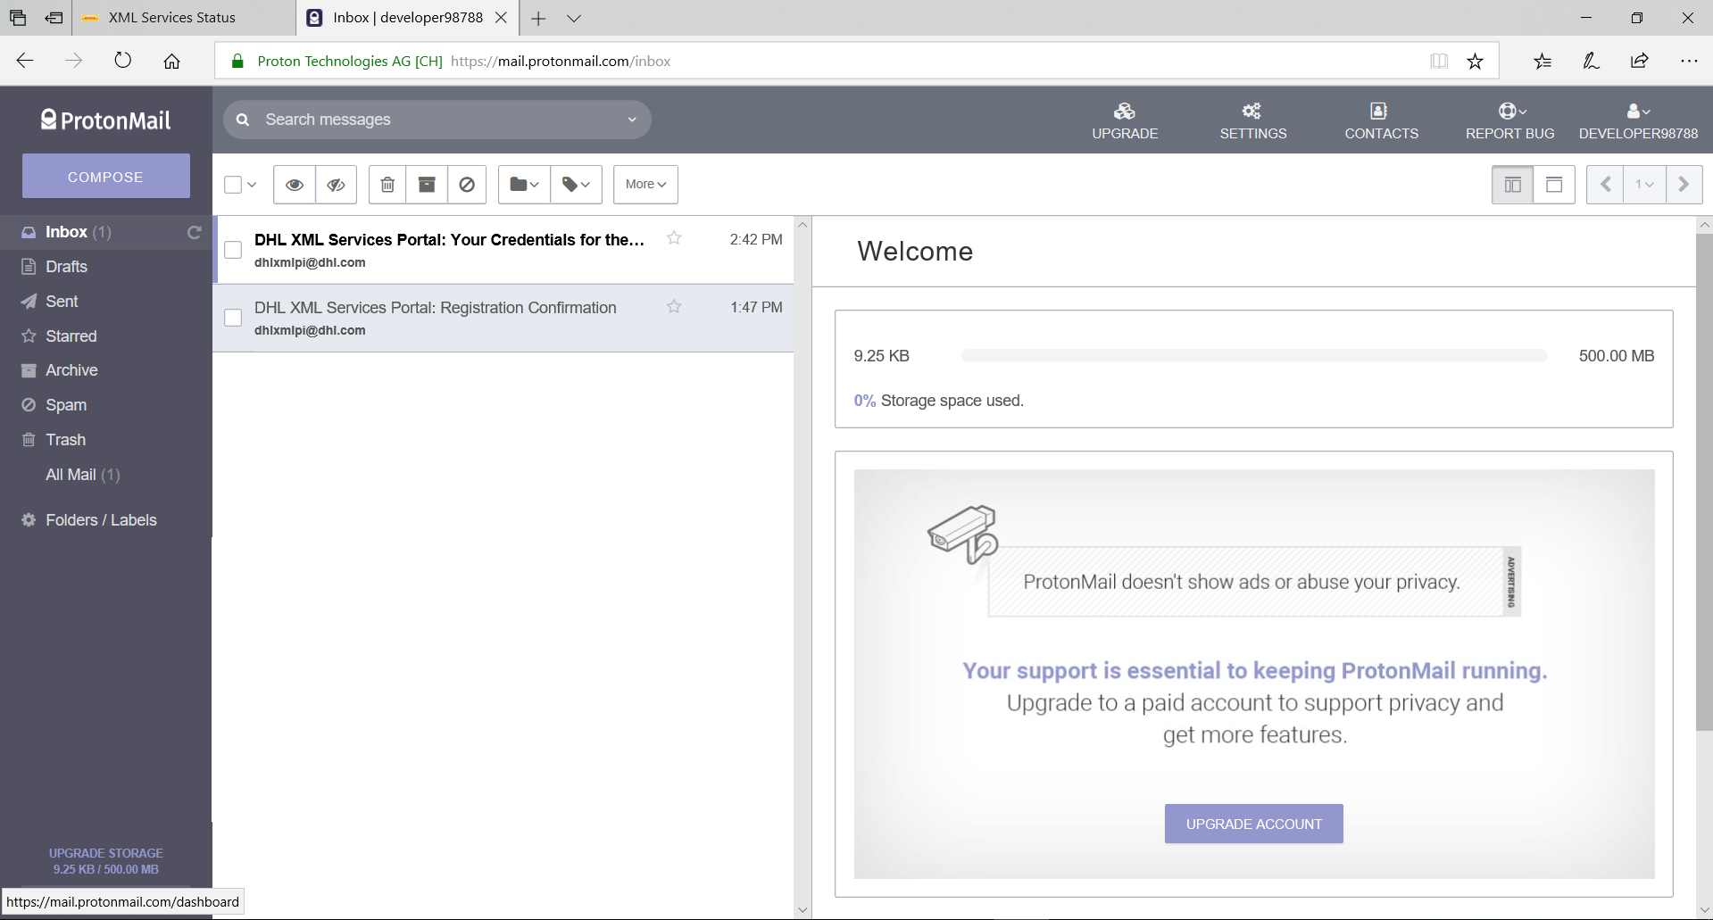Find “DHL XML Services Portal: Your Credentials”.

7.Copy Site ID and Password to your app:

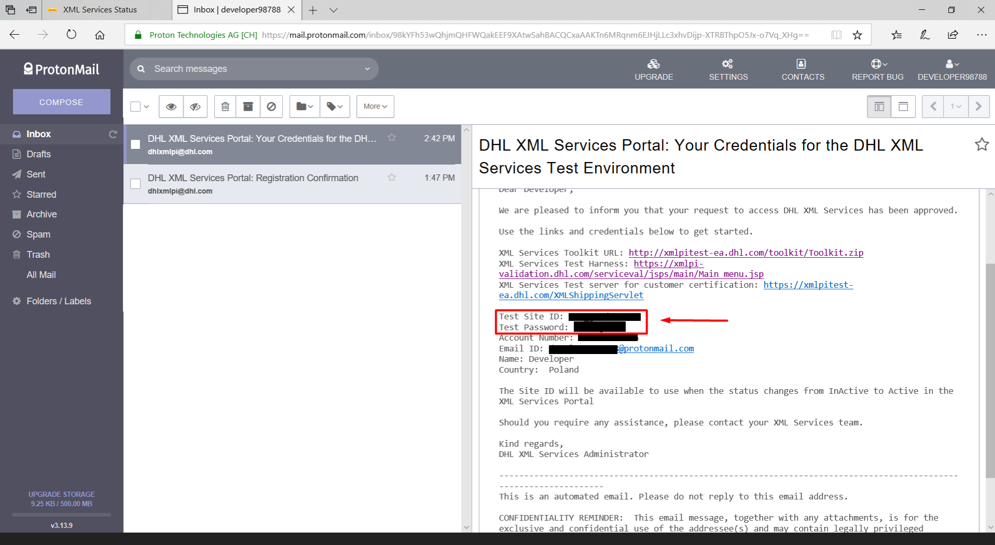

Good Luck!