Predictbgl registration

Added 07.08.2018.

1. Go to: <https://predictbgl.com/>

And press “Signup” button.

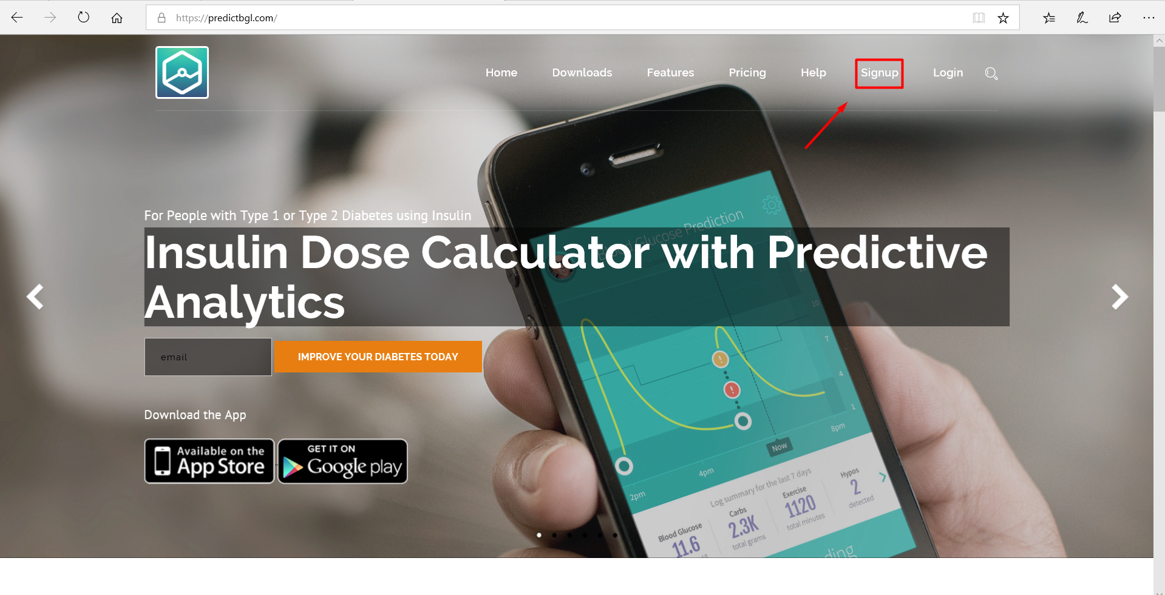

2. Write e-mail and press “START NOW”.

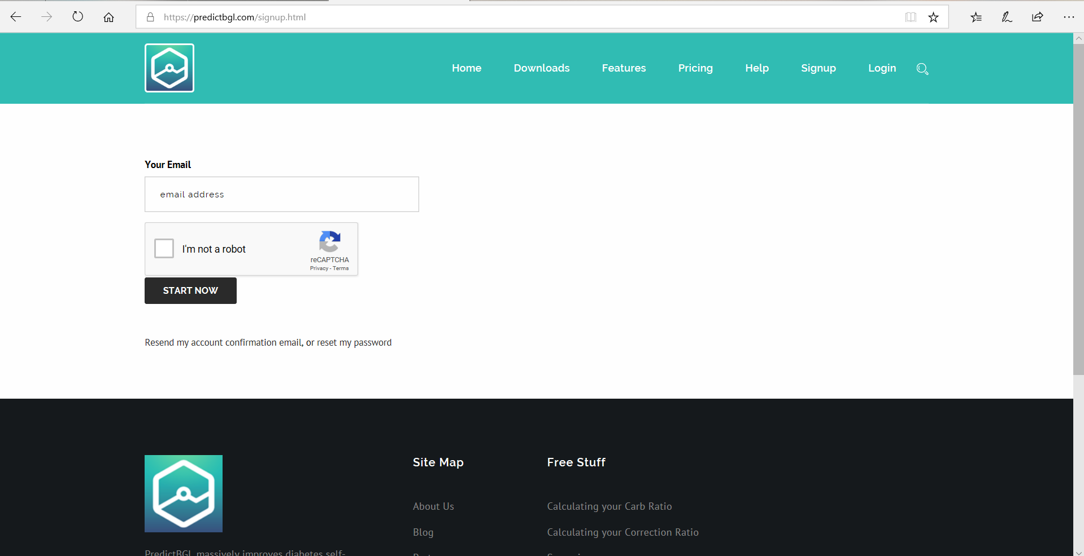

3. Fill the field and press “DONE”.

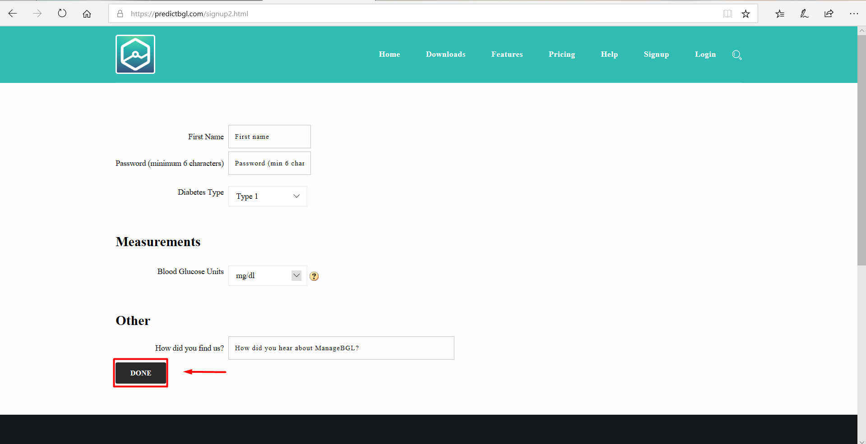

4. After registration will be seen next page.

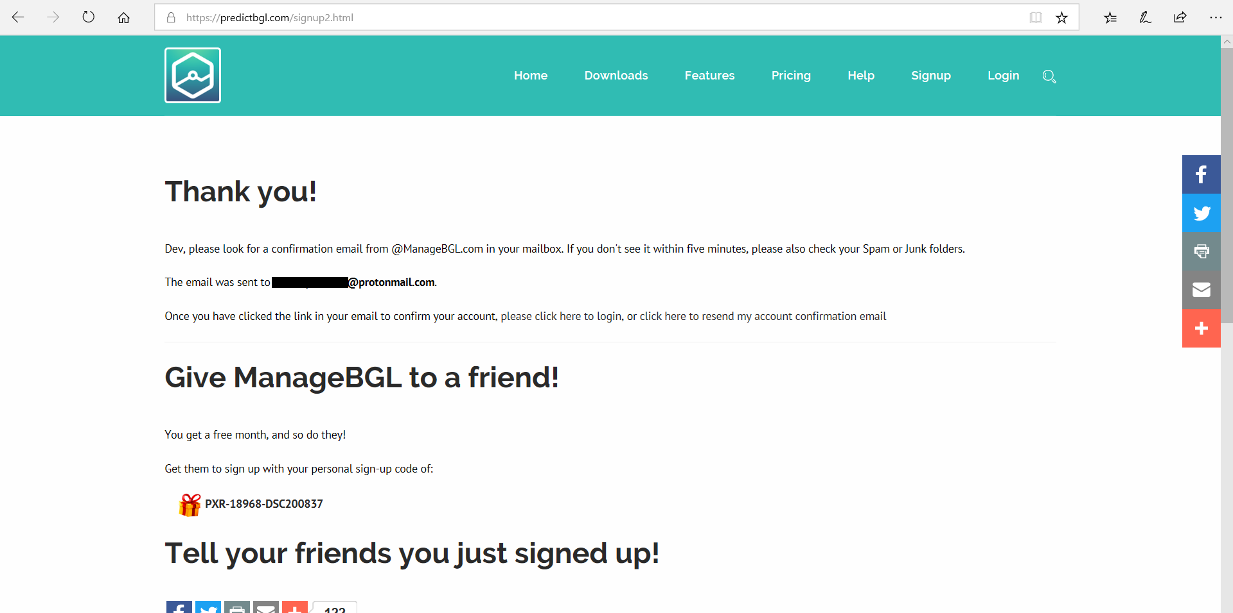

5. Go to e-mail which was sent with a message.

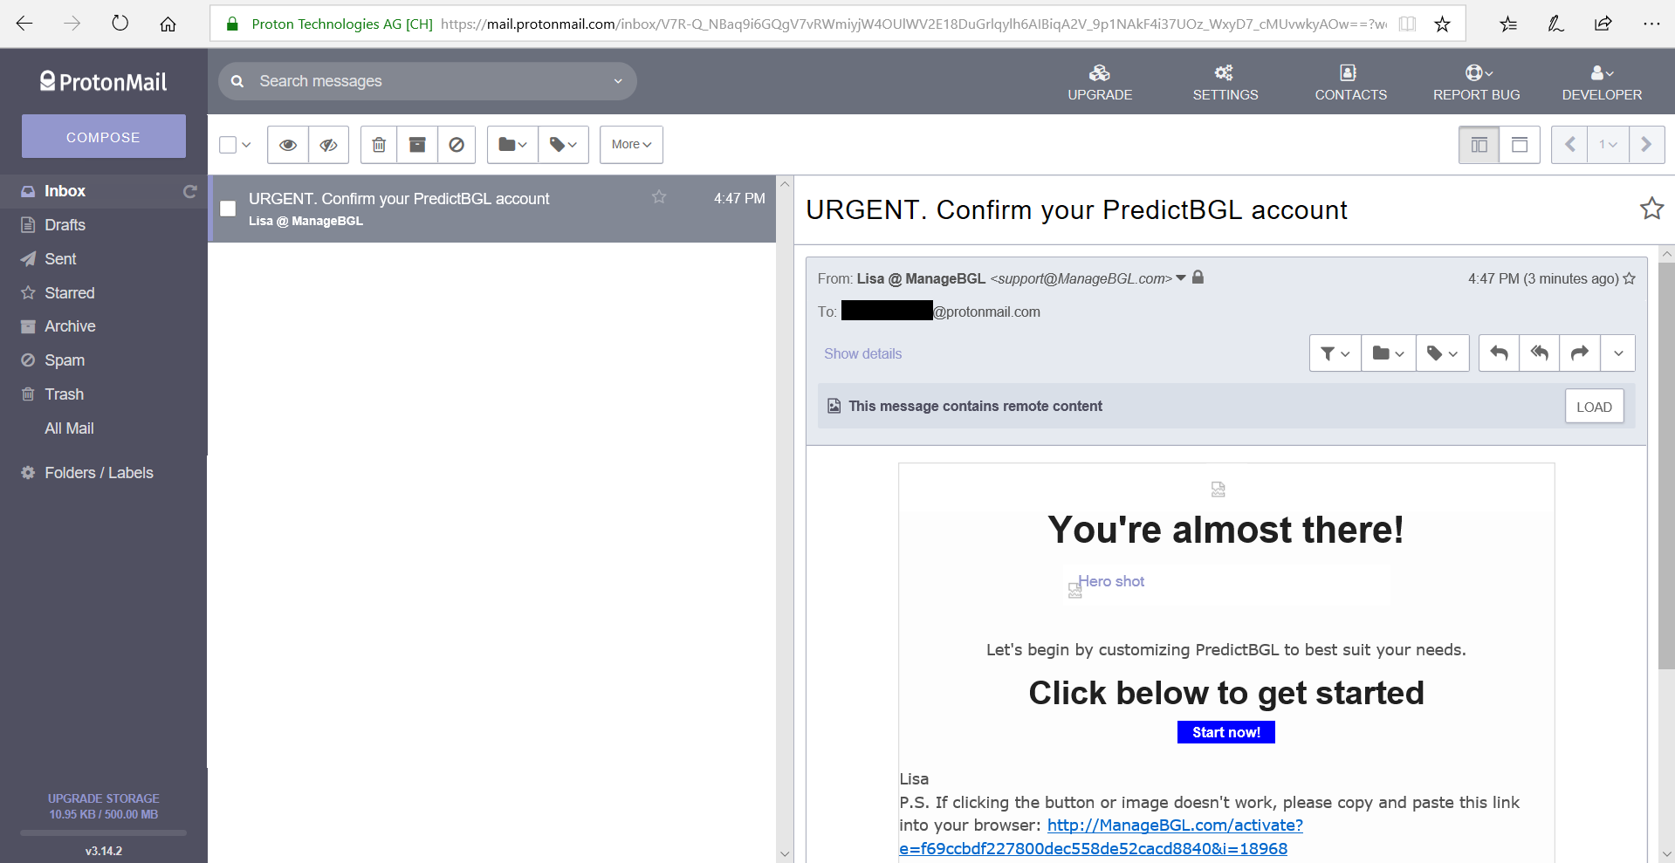

6. Click on “activation” link, then browser will be redirected to next page.

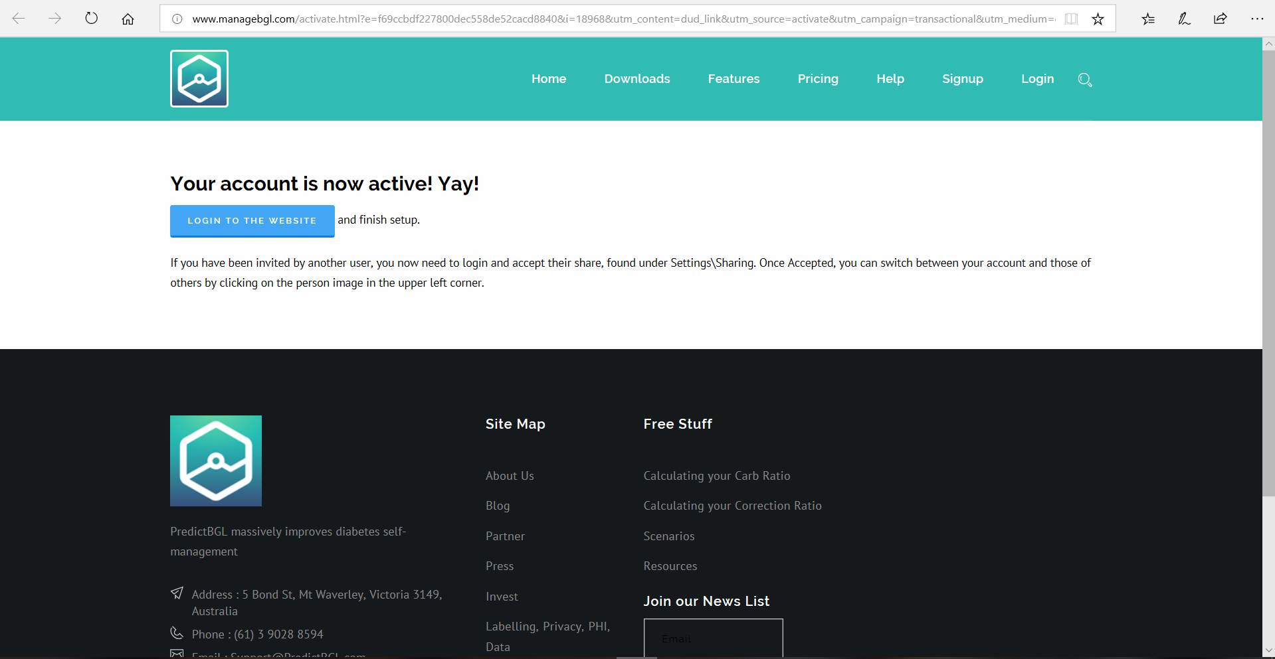Press “LOGIN TO THE WEBSITE” button and authorize.

7. Press on “Settings” button.

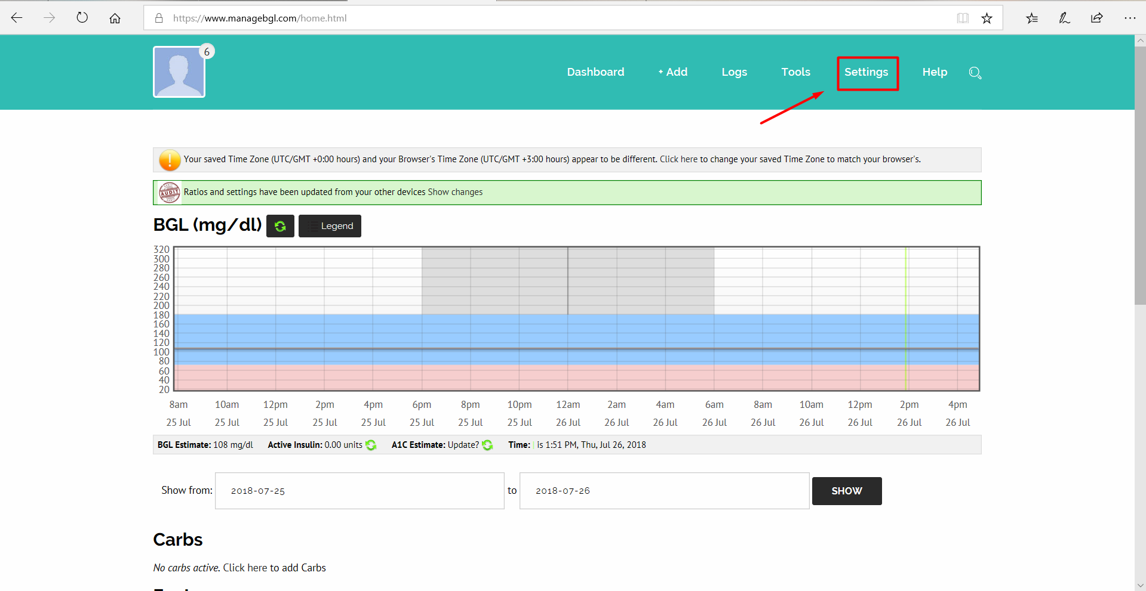

7. In the next page find “Sharing and APIs”.

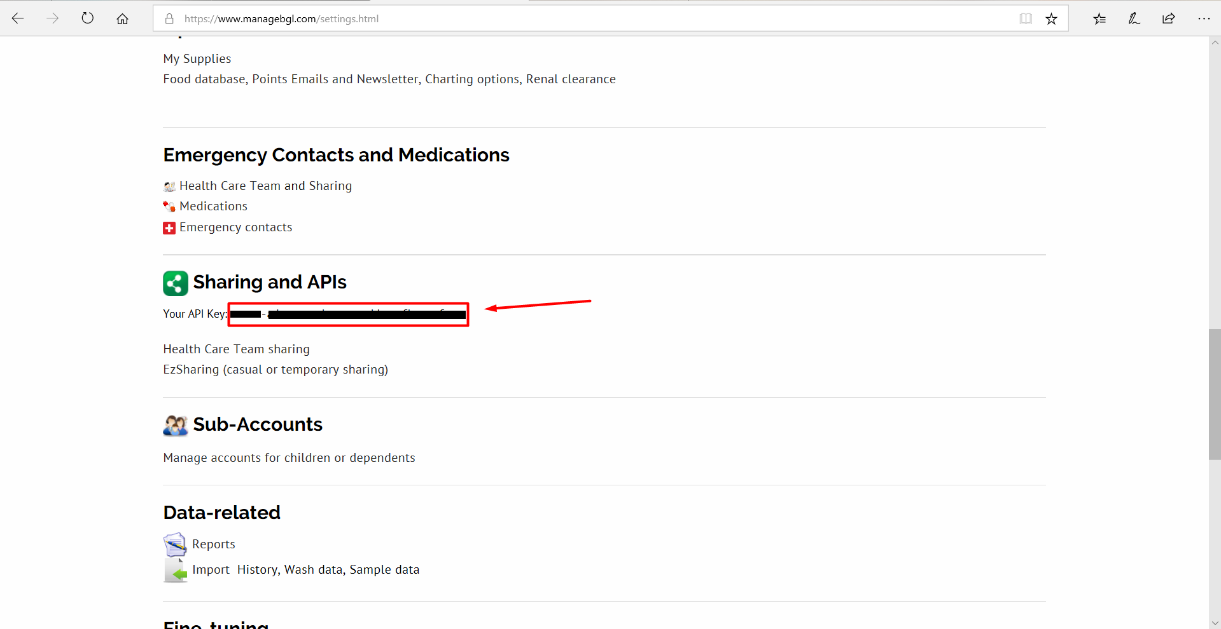Copy your Api_key to your APP.

Good Luck!