React

**----------------------------------------20/08/2024-------------------------------------------------**

*DataTypes in js

Primitive – Number,String,Boolean,undefined,null,BigInt,Symbol.

Non-Primitive – array,object.

*Types of function in js

1. function expression/anonymous function

2.Arrow function

3.Named function

**----------------------------------------27/08/2024-------------------------------------------------**

**\* React**

* React is single page application cause it avoid re-rendering it only render changed containet.
* React is js library.
* It is only used for frontend
* Run on port: 3000
* When we react project only one component by default create i.e. App.jsx

**\* Create React Project**

- npm: node package manager(use when you want to create project locally)

- nvm: node version manager

- npx: node package runner(use when you want to create project globally)

[ for creating folder react : npm i create-react-app -g]

npx create-react-app project_name

cd project_name

npm start

**\*Folder Structure**

* Node_modules: all packages used in react project store here
* Package.json: maintain Dependances and Dev-Dependances.
* Dependances: use to develop project (packages versions )
* Dev-Dependances: use for production packages.

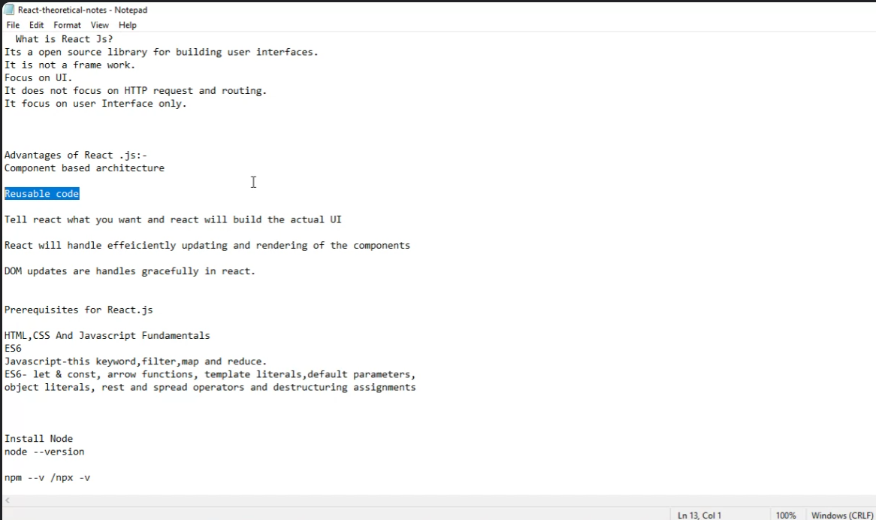

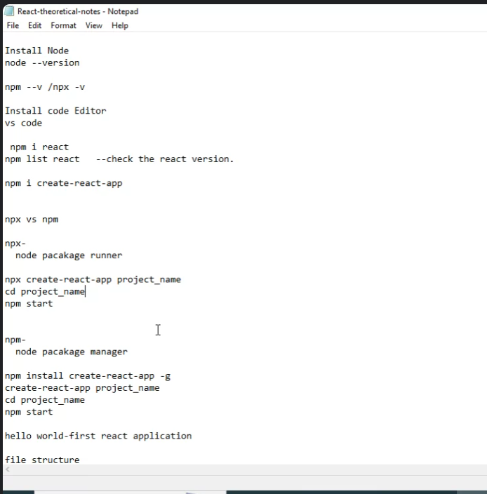

**-----------------------------------------------28/08/2024------------------------------------------**

**Hierarchy :**

Custom components->App.js->index.js->Index.html

* Package.log.json: maintain packages version data(do not change the containt inside package.log.json)
* To share react project : select all folders except node module and share in other computer install npm and start

**-------------------------------------------30/08/2024----------------------------------------------**

**export default ComponentName:** default mule akach component return karta ato.

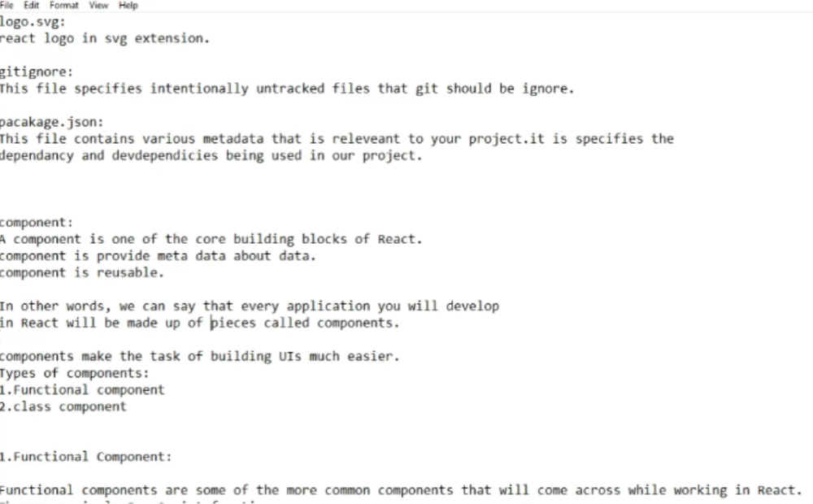

**Shortcuts for creating components:**

**(Install ES7 vsCode Extension)**

1. **rafc:** create component with arrow function
2. **rfc:** create component with normal function