React

**----------------------------------------20/08/2024-------------------------------------------------**

*DataTypes in js

Primitive – Number,String,Boolean,undefined,null,BigInt,Symbol.

Non-Primitive – array,object.

*Types of function in js

1. function expression/anonymous function

2.Arrow function

3.Named function

**----------------------------------------27/08/2024-------------------------------------------------**

**\* React**

* React is single page application cause it avoid re-rendering it only render changed containet.
* React is js library.
* It is only used for frontend
* Run on port: 3000
* When we react project only one component by default create i.e. App.jsx

**\* Create React Project**

- npm: node package manager(use when you want to create project locally)

- nvm: node version manager

- npx: node package runner(use when you want to create project globally)

[ for creating folder react : npm i create-react-app -g]

npx create-react-app project_name

(Note: Project name must in smallcase)

cd project_name

npm start

**\*Folder Structure**

* Node_modules: all packages used in react project store here
* Package.json: maintain Dependances and Dev-Dependances.
* Dependances: use to develop project (packages versions )
* Dev-Dependances: use for production packages.

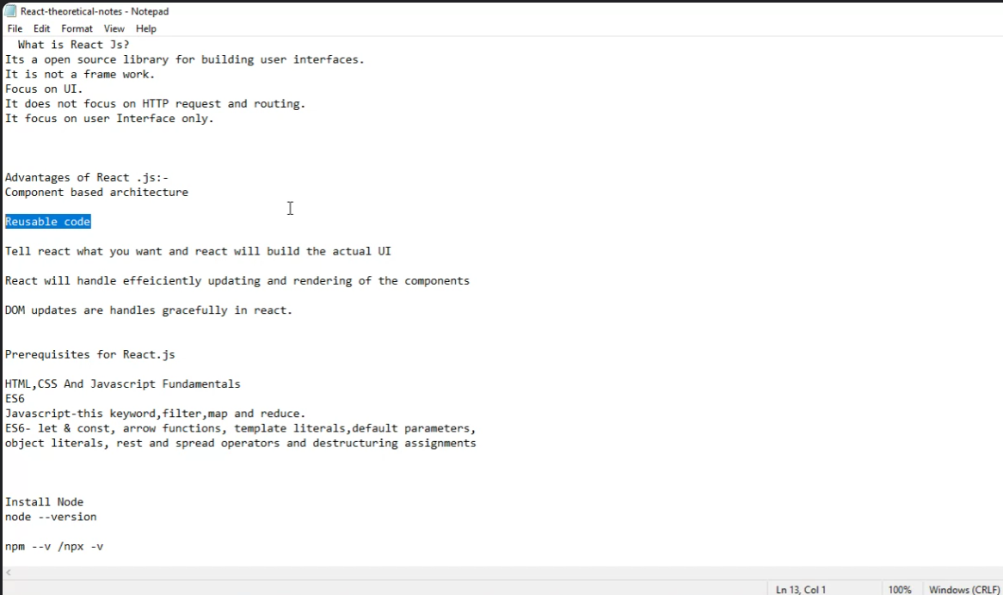

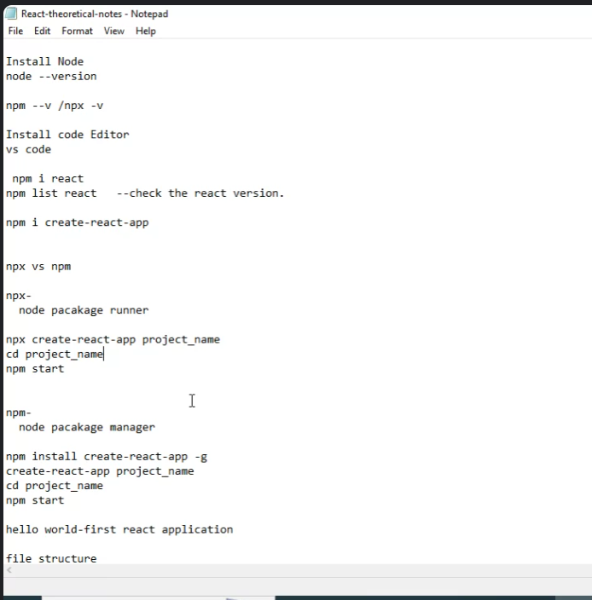

**-----------------------------------------------28/08/2024------------------------------------------**

**Hierarchy :**

Custom components->App.js->index.js->Index.html

* Package.log.json: maintain packages version data(do not change the containt inside package.log.json)
* To share react project : select all folders except node module and share in other computer install npm and start

**-------------------------------------------30/08/2024----------------------------------------------**

**export default ComponentName:** default mule akach component return karta ato.

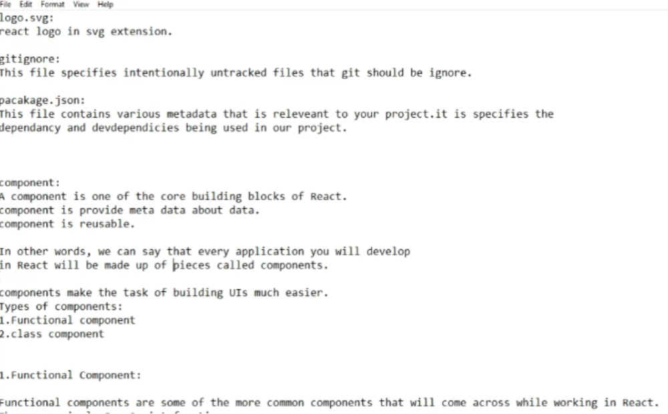

**Shortcuts for creating components:**

**(Install ES7 vsCode Extension)**

1. **rafc:** create component with arrow function

**2)rfc:** create component with normal function

*

Function fun(){

ruturn React.createElement(“<div>”,null(property/attribute/selector),”Hello React”);

is same as

return(

<div>

Hello React

</div>

)

}

**--------------------------------------4/09/2024------------------------------------------------**

**\*useState**

**- useState is consider as private access specifier**

**import React,{useState} from 'react'**

**function StateInReact(){**

**// const[currentVal,updatedVal] = useState(initialVal);**

**const[count,setCount] = useState(1);**

**return(**

**<div>**

**<h1>Current value is: {count}</h1>**

**<button onClick={()=>setCount(count+1)}>Change Values</button>**

**</div>**

**)**

**}**

**export default StateInReact;**

**-----------------------------------------------6/09/2024---------------------------------------**

**For implementing react-bootstrap:**

**In vsCode cmd type: npm install react-bootstrap bootstrap->*import* 'bootstrap/dist/css/bootstrap.min.css'; paste it in src/Index.js**

**\*Tailwind CSS**

**Installation:**

**1) npm install -D tailwindcss , npx tailwindcss init (This will create tailwind.config.js)**

**2)**

**\*Tailwind Css**

**Installation:**

1)npm install -D tailwindcss

2) npx tailwindcss init

3) in tailwind.config.js add   "./src/**/*.{html,js}" inside content [ ],

4) paste this in index.js

@tailwind base;

@tailwind components;

@tailwind utilities;

--------------------------------------------19/09/2024-----------------------------------------

Hooks

Why hook?

* React hooks make component development easier while also improving readability and organization. They allow for code reuse , improve performance, and are compatible with functional programming.

**-------------------------------------------27/09/2024----------------------------------------------**

**Router installation:**

- “npm install react-router-dom@6” type in cmd

- in index.js replace <React.StringMode></React.StringMode> with <BrowserRouter></BrowserRouter>

- import {BrowserRouter} from 'react-router-dom'

**---------------------------------------------29/09/2024--------------------------------------------**

BrowserRouter : stores HTML Api’s for that particular session like storing cache (jevha aka page varun dusarya page vr jato to ani parat previous page vr ato tyaveli part dom code kade jaun render krt nahi BrowserRouter madhe to as a cache store asto tyamule to easily access hoto)