Lab 3. BLASTing through the kingdoms of life

Goal: Use the BLAST tool to identify an unknown DNA sequence.

Steps:
- Open and read the BLAST tutorial: https://digitalworldbiology.com/BLAST/slide1.html
- I have added some nucleotide sequences to Canvas in the Lab 3 assignment, under the DNA Sequence Analysis module (filename is Lab_3_Sequences.fasta). Go ahead and download them to your computer.
- Open the .fasta file in the text editor of your choice.
- Select one of the unknown sequences from the sequence data set, copy the DNA sequence. Paste your sequence in the BLAST text box.
**Be sure to copy the entire sequence including the > symbol and the name.
- Identify the sequence using BLAST, and answer the questions on the BLAST worksheet

You should be aware that the NCBI web changes regularly. Although the information in this document is current, the NCBI web page may appear slightly different.

- How long is the sequence that was used to search the database? Include the units.

Sequence_20: 11333 bases

- Download your results, for later use. From the “Download” dropdown menu, select “FASTA (aligned sequences)”. Place the file in your project folder.

- Which sequence matches your query the best? What data support this conclusion?
NC_033413.1 (Glaucis hirsutus) had the best match with an e-value of 0.0 and a percent identity of 88.20%.

- What organism is the mostly likely source of the sequence?

Glaucis hirsutus (Rufous-breasted hermit) is the most likely organism.

- What is the common name for this organism?

The Rufous-breasted hermit.

- What phylum contains this organism?
Chordata

- What is the accession number for the best-matching sequence?
NC_033413.1

- Estimate the number of sequences with an E-value less than 0.01.

BLAST resulted 100 sequences with an e-value of 0.0.

- If possible, give the names of at least three different organisms with significant E-values. If there are fewer than three significant E-values, give the names of the significant matches. Record the name of the organism, the common name, and the E-value.

Phaethornis malaris, Great-billed hermit, e = 0.0
Florisuga mellivora, White-necked Jacobin, e = 0.0
Oreotrochilus melanogaster, Black-breasted hillstar, e = 0.0

- Look at the first matching sequence in the table. For that subject sequence, determine the length of the alignment, in nucleotides, and the fraction of nucleotides that match your query sequence.

11852 nucleotides with an 88% query cover.

- Look at the alignment to the first-matching sequence and determine the length of the alignment and the fraction of nucleotides that match your sequence. Draw a picture to represent the alignment between the two sequences and include the starting and ending map positions for both sequences.
Start
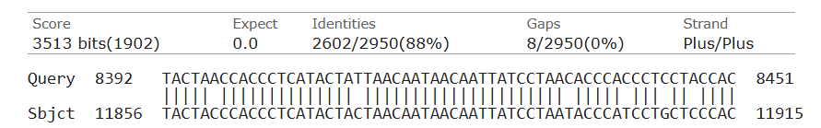
End
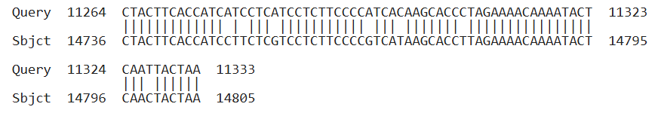

- Enter the sequence (copy / paste) or upload a file to BLASTx. Did your sequence match any known proteins? Which protein?
NADH dehydrogenase subunit 5

- What is the difference between BLAST and BLASTx?

BLAST compares nucleotide matches while BLASTx translates a nucleotide sequence and compares amino acid sequences.

- Use GenBank, PubMed, Gene, and HomoloGene records to find the possible function of the protein that's specified by your DNA sequence. Describe what's known about the role of this protein in the organism that provided the DNA.

“Enables NADH dehydrogenase (ubiquinone) activity. Involved in mitochondrial electron transport”.

- Is this sequence expressed? How do you know?
Yes. Gene type: protein coding.

- If your sequence is expressed, where is it expressed?

It is expressed in mitochrondria.

- Is there a specific time during development when this gene is expressed?

At all times.

- Is anything known about factors that cause your sequence to be expressed?

Necessary for electron transport. Always expressed.

- In RStudio, write a script that does the following:
  - Read your downloaded BLAST results into RStudio. I recommend using the package ‘Biostrings’. The code chunk below will install Biostrings.

1. if (!requireNamespace("BiocManager", quietly = TRUE))
2. install.packages("BiocManager")
3. BiocManager::install("Biostrings")
A function you can use to read in .fasta files is below, but there are others.

1. readDNAStringSet()

  - Do a Pairwise Sequence Alignment between the first sequence in your results and the Query sequence from your BLAST search. I recommend using the R package ‘pwalign’, but other R packages can do this as well.

  - In your submission, include your R script (or R markdown) and the percent identity of your two sequences.

Score: 6507.596
Percent Identity: 88.20%

