**Implementation Plan**

**Phase 1: Core Features**

1. **User Authentication and Authorization**
   * Implement user registration, login, and role-based access control.
   * Create database schemas for user and role management.
2. **Employee Information Management**
   * Develop forms and interfaces for adding and editing employee profiles.
   * Implement functionality for document uploads.
3. **Basic UI/UX Design**
   * Design the basic layout and navigation of the application.

**Phase 2: Interactive Features (out of scope)**

1. **Attendance Tracking**
   * Implement check-in/check-out functionality.
   * Develop leave management interfaces and approval workflows.
2. **Performance Evaluation**
   * Create interfaces for setting goals and tracking performance.
   * Implement functionality for recording performance reviews.
3. **Payroll Management**
   * Develop interfaces for managing salary details.
   * Implement payslip generation and download functionality.

**Phase 3: Advanced Features (out of scope)**

1. **Reporting and Analytics**
   * Implement reporting features for attendance, performance, and leave statistics.
   * Develop graphical representations of data for better insights.
2. **Notifications and Announcements**
   * Implement email and in-app notifications for important updates.
3. **Performance Optimization and Security Enhancements**
   * Optimize the application for performance and scalability.
   * Implement advanced security measures to protect user data.

**Phase 4: Testing and Deployment**

* **Unit Testing:** Test individual functionalities of the application to ensure they work as expected.
* **Integration Testing:** Test how different parts of the application work together seamlessly.
* **User Acceptance Testing (UAT):** Get feedback from potential users to identify usability issues and ensure the application meets their needs.
* **Deployment:** Deploy the application to a web server for user access. Consider cloud platforms like AWS or Google Cloud Platform for scalability and reliability.

**Development Workflow**

1. **Requirement Analysis**: Gather detailed requirements and create a project plan.
2. **System Design**: Design the system architecture, database schema, and API endpoints.
3. **Implementation**: Develop the application in phases, starting with the core features.
4. **Testing**: Conduct unit testing, integration testing, and user acceptance testing.
5. **Deployment**: Deploy the application to a cloud platform (AWS, Azure, GCP) and configure the necessary services.
6. **Maintenance and Updates**: Regularly update the platform based on user feedback and add new features.

**Data Model**

We are using AWS Dynamodb as a persistent data storage. Dynamodb is a nosql database. In a NoSQL database like DynamoDB, we’ll able to organize our data in tables, with items (rows) and attributes (columns). DynamoDB is schema-less for the most part, but we need to define the primary key and optionally secondary indexes for efficient querying.

**Table Schema**

**1. Employees Table**

* **Primary Key**: EmployeeID (Partition Key), Email (Sort Key)
* **Attributes**:
  + EmployeeID (String): Unique identifier for each employee.
  + Name (String): Full name of the employee.
  + Email (String): Email address of the employee.
  + Position (String): Job position of the employee.
  + Department (String): Department the employee belongs to.
  + DateOfJoining (String): Date the employee joined the company.

**User management (AWS Cognito)**

In AWS Cognito, you can define these roles using Cognito User Pools and Identity Pools. Here’s how you can set it up:

1. **Create User Pool**:
   * Define attributes for user registration (e.g., email, username, role).
   * Configure sign-up and sign-in settings.
2. **Create Identity Pool**:
   * Link the user pool to the identity pool.
   * Define roles and policies for authenticated users.
3. **Assign Roles**:
   * Use AWS IAM to create roles with specific permissions.
   * Map these roles to users in Cognito based on their attributes (e.g., role).
   * Roles (groups): admin, HR, manager, employee.

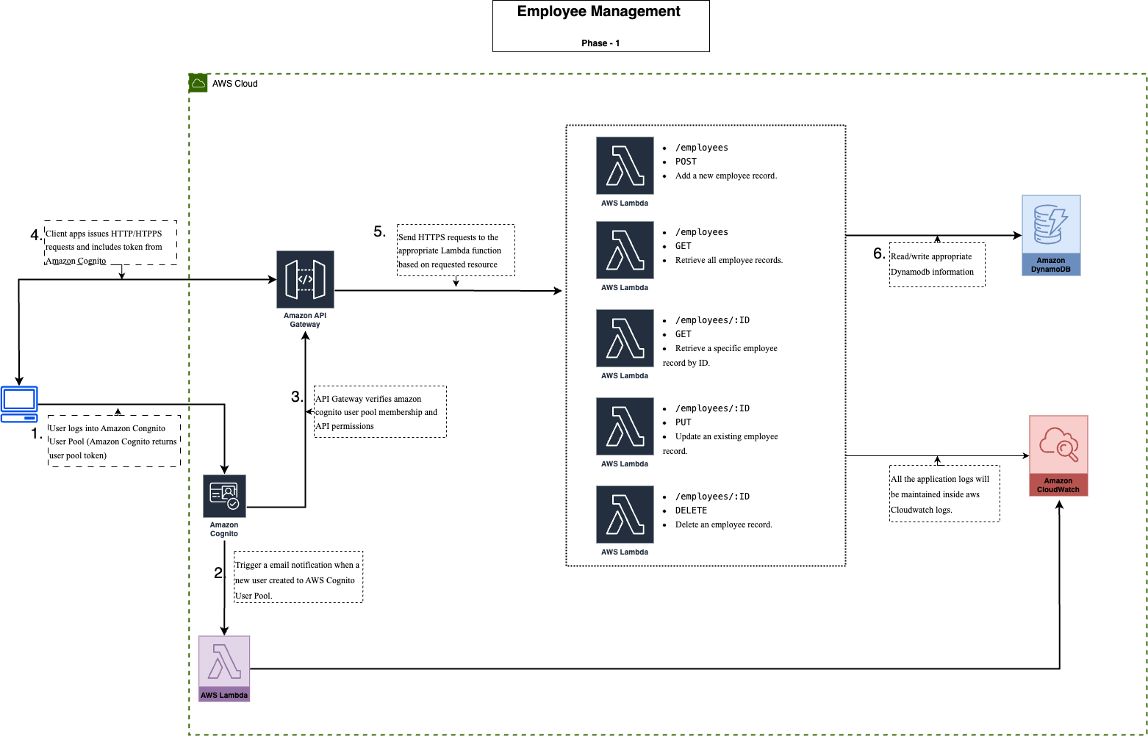**Architecture Diagram**