Guide :From excel table to wiki table page

1. Install anaconda

See folder install anaconda

<https://github.com/bVdCreations/NotebooksWork/tree/master/Install_anaconda>

1. download the folder from github

<https://github.com/bVdCreations/NotebooksWork>

and place it in the correct folder

1. Open anaconda

After installation open anaconda

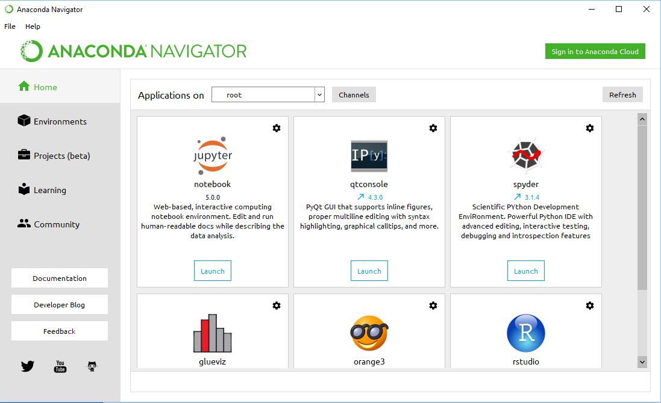

1. Press launch on jupyter notebook

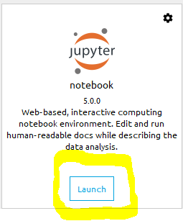

This will launch jupyter notebook and that will open a notebook the browser

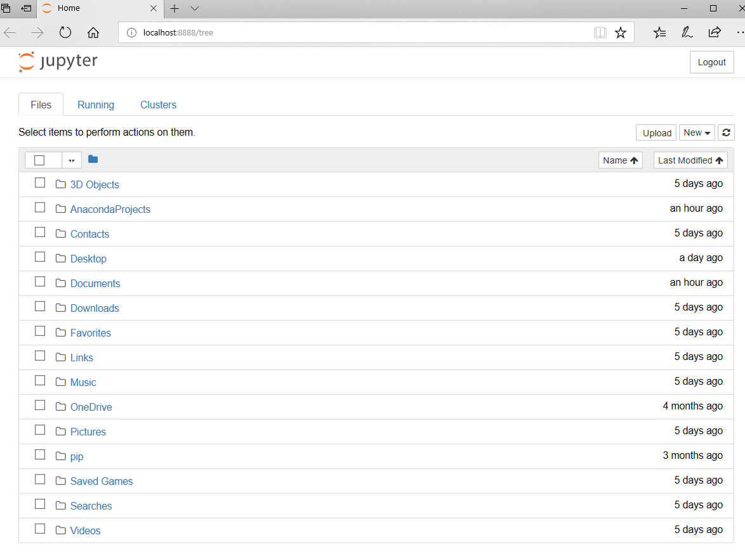

Go to the filepath where you downloaded the folder

1. Open the notebook

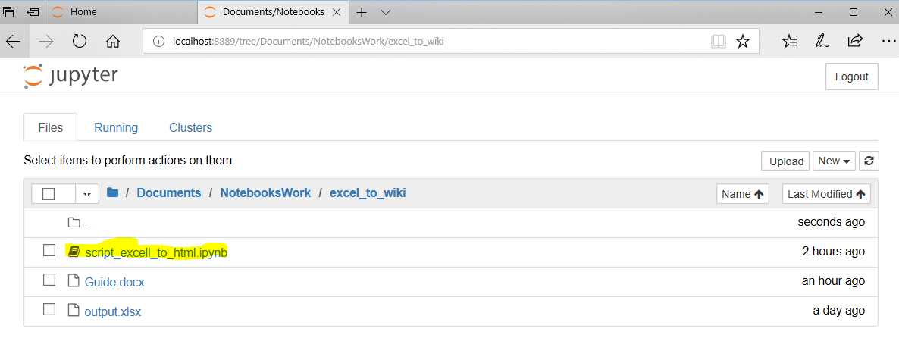

1. Run the script

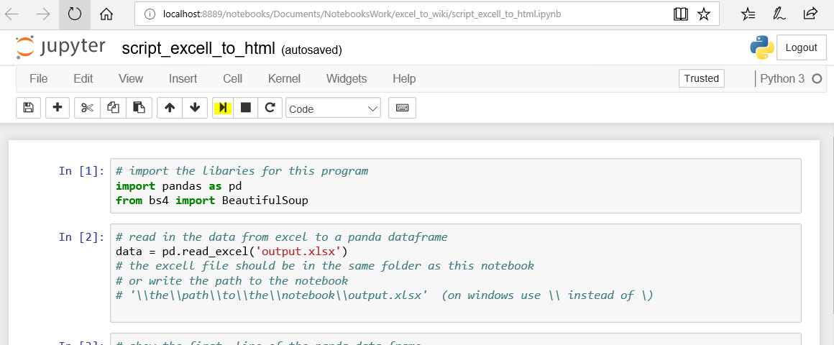

By pressing this button multiple times

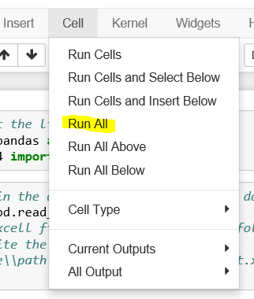

Or by running them all at ones

1. Copy paste the HTML to wiki

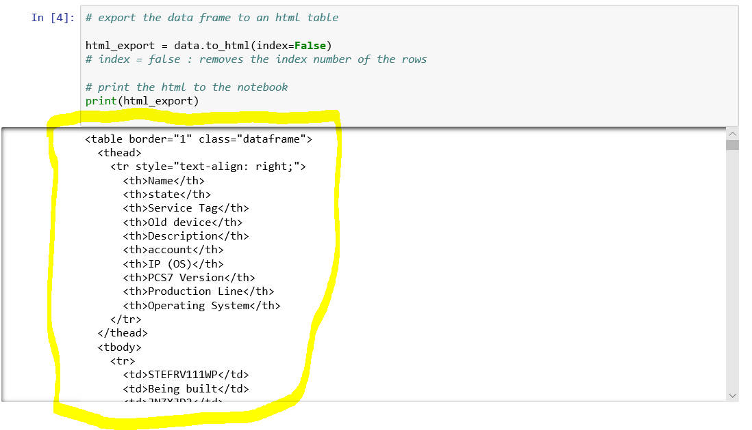

Copy the HTML output

Paste it in the wiki page

When editing a page and pressing this button

1. Done