Guide :From scarping WUG to excel

1. Install anaconda

See folder install anaconda

<https://github.com/bVdCreations/NotebooksWork/tree/master/Install_anaconda>

1. download the folder from github

<https://github.com/bVdCreations/NotebooksWork>

and place it in the correct folder

1. Open anaconda

After installation open anaconda

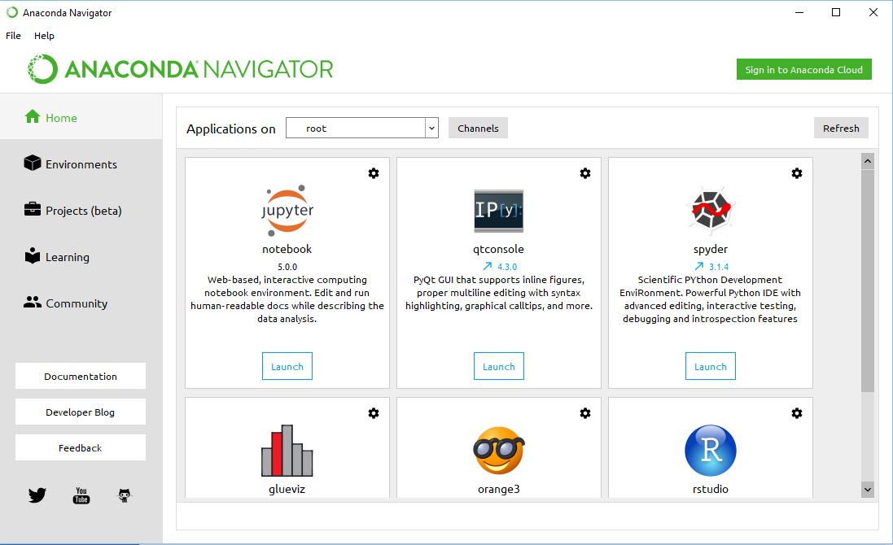

1. Press launch on jupyter notebook

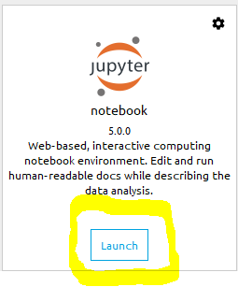

This will launch jupyter notebook and that will open a notebook the browser

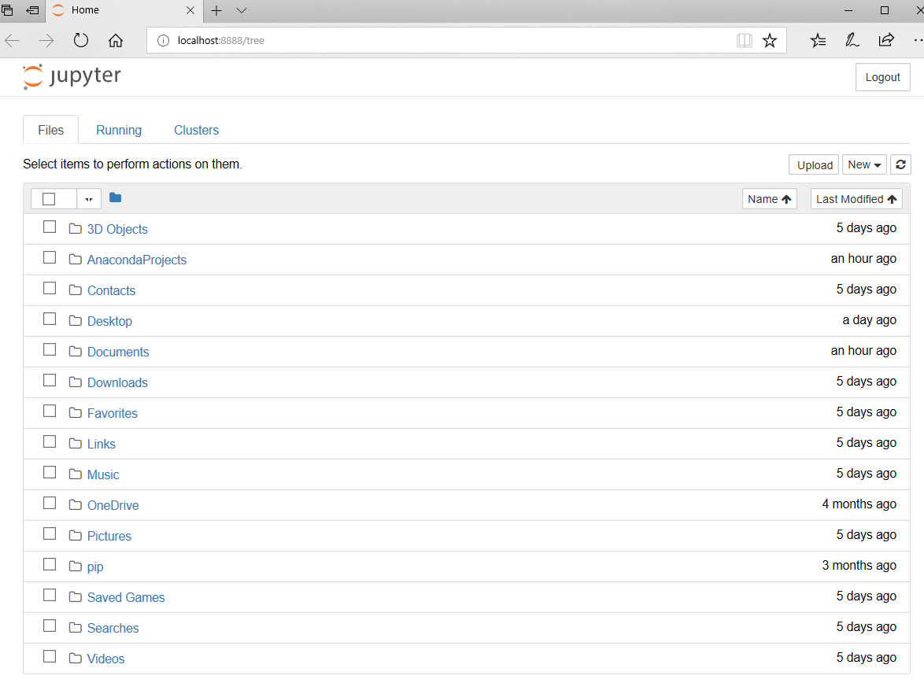

Go to the filepath where you downloaded the folder

1. Open the notebook

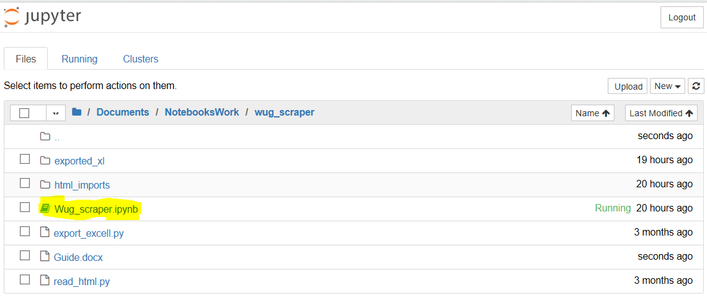

1. Copy html from wug
   1. Login in wug
   2. Go the devices page
   3. Go to the details view
   4. Left mouse click => view page source or (CRTL + U )
   5. Select all the html code => CRTL + A => CRTL + C
   6. Create a new txt file in notebooksWork\wug_scraper\html_imports

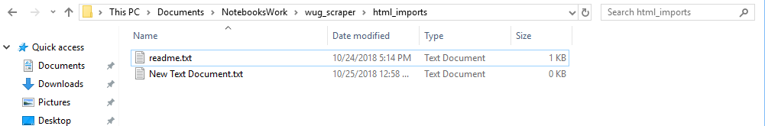

* 1. Paste the copied html code in the txt file AND **save the file**

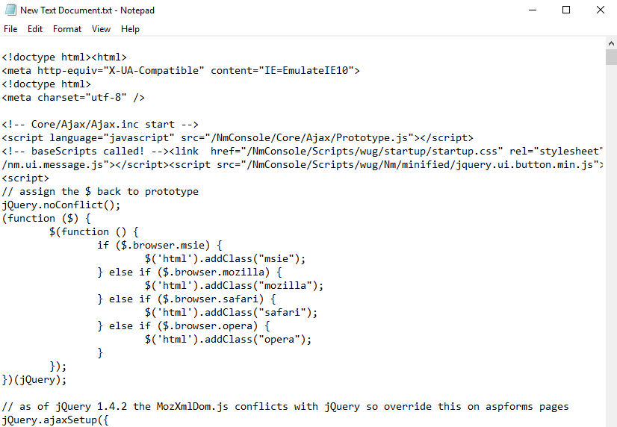

* 1. Rename the txt file to raw_html.txt

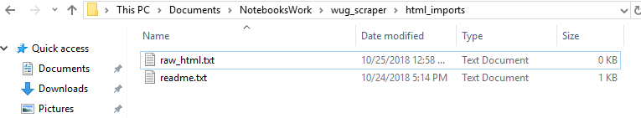

1. Run the lines of code

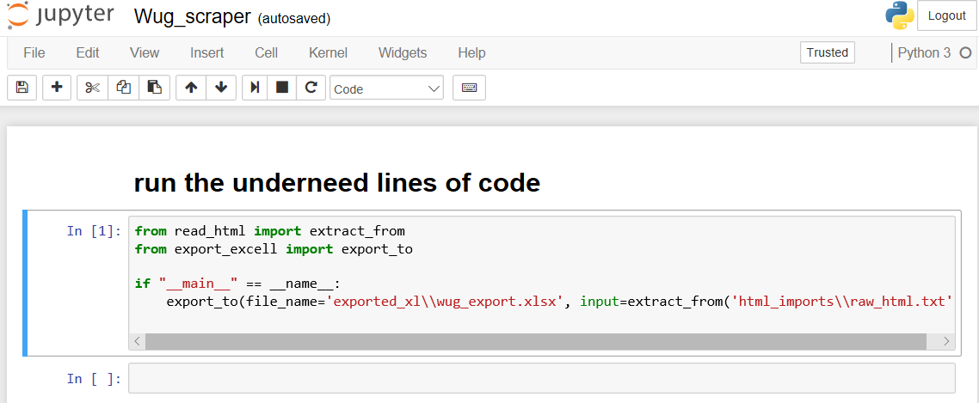

1. Find the excel file : wug_export

Go to

notebooksWork\wug_scraper\exported_xl

