MIPS-ARCH-32

Problem Statement
The objective is to create a new processor CSE-BUBBLE that has the instruction set architecture as shown in Table 1 below. We assume that the processor word size and instruction size are 32 bits and we use the VEDA memory as implemented in Assignment 4. The VEDA memory has two parts: Instruction Memory & Data Memory
You have to make sure that these two sections do not overlap. We also assume that RISC-BUBBLE has total 32 registers of which certain registers follow the same roles as in MIPS-32 ISA. For example, Program Counter (PC) register holds the address of the next instruction. The target is to:
- Create the op-code formats for the given ISA, shown in Table 1
- Decide upon the data path elements (such as addition, subtraction, shift, jump)
- Develop different verilog modules for the same
- Develop the finite state machine for the control path
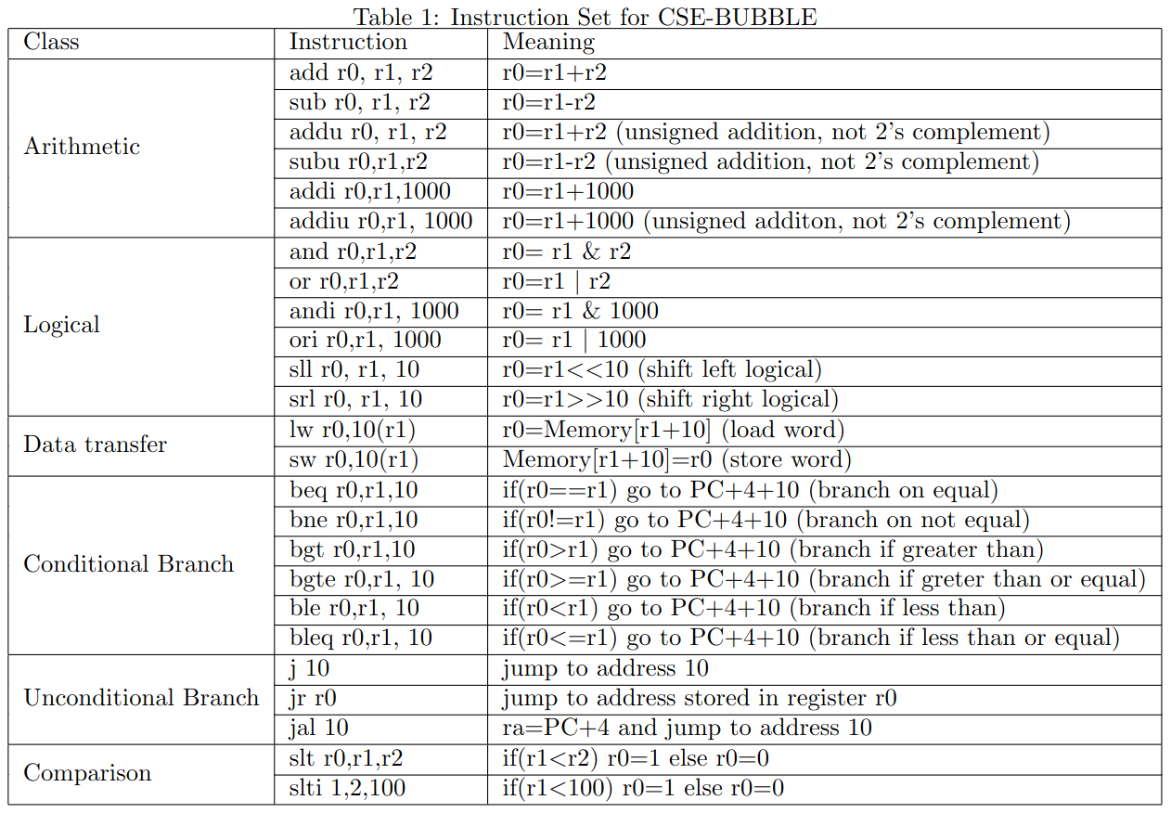
- Build a single-cycle instruction execution unit for CSE-BUBBLE.

Our Problem in hand is to create a hardware that can perform the bubble sort algorithm, given an array of numbers.
The algorithm itself can be summarized as:
1. function bubbleSort(arr: list of sortable items):
2. n <= length(arr)
3. repeat:
4. swapped <= false
5. for i=1 to n-1 inclusive do
6. if arr[i-1] > arr[i] then
7. swap(arr[i-1], arr[i])
8. swapped <= true
9. end if
10. end for
11. until not swapped
12. end function
Clearly, the algorithm requires the capabilities of branching, adding, comparison, data transfer and logical operations.
MIPS program for BubbleSort can be:

.data

numbers: .word 8, 100, 0, 3, 7, 9, 2, 7, -3, 0 # create array which holds numbers
size: .word 10

.text
main:
la $s7, numbers # load address of numbers into $s7
li $s0, 0 # initialize counter 1 for loop 1
lw $s6, size # n
addi $s6, $s6, -1 # n-1
li $s1, 0 # initialize counter 2 for loop 2

loop:
sll $t7, $s1, 2 # multiply $s1 by 2 and put it in t7
add $t7, $s7, $t7 # add the address of numbers to t7
lw $t0, 0($t7) # load numbers[j]
lw $t1, 4($t7) # load numbers[j+1]
slt $t2, $t0, $t1 # if t0 < t1
bne $t2, $zero, increment
sw $t1, 0($t7) # swap
sw $t0, 4($t7)

increment:
addi $s1, $s1, 1 # increment t1
sub $s5, $s6, $s0 # subtract s0 from s6
bne $s1, $s5, loop
addi $s0, $s0, 1 # otherwise add 1 to s0
li $s1, 0 # reset s1 to 0
bne $s0, $s6, loop # go back with s1 = s1 + 1

The above consists of 21 lines of instructions. Also the instructions used include:
add, addi, sub, ori, sll, slt, sw, lw, bne, lui

Pseudo instructions li and la are condensed to ori and lui repectively.

Processor Design Strategy

[PDS1] Decide registers and their usage protocols
Given the processor word size is 32b, and so is an instruction size. Therefore this would require 32b sized registers.
There can be 32 registers, with the following convention for being MIPS-compatible:
Number | Name | Usage
0 | zero | constant zero
1 | at | for assembler
2-3 | v0-v1 | for storing results
4-7 | a0-a3 | argument registers
8-15 | t0-t7 | temporary registers
16-23 | s0-s7 | saved registers
24-25 | t8-t9 | temporary registers, not for user
26-27 | k0-k1 | kernel registers
28 | gp | global data pointer
29 | sp | stack pointer
30 | fp | frame pointer
31 | ra | Return address

This convention would be helpful to extend the architecture's purpose for including furthur MIPS-compatible code.

[PDS2] Decide upon size of instruction and data memory in VEDA
Size of instruction and data memory depends on our purpose. Because this architecture is being formulated for implementation of `bubble_sort`, we can restrict their sizes accordingly.
We can decide upon keeping a maximum size of data memory, each address pointing to a word size, which would require 16b addresses. From above, 20 instructions were enough to implement the bubble sort, so keeping a buffer, size of instruction memory would be sufficient.

[PDS3] Design instruction layout of 'R-', 'I-' and 'J-' type instructions and their respective encoding methodologies
Again, keeping in mind the capability of executing MIPS code, we should keep instruction layout similar to MIPS.
Therefore R-type instruction would be of format:
31-26 | 25-21 | 20-16 | 15-11 | 10-6 | 5-0
opcode | rs | rt | rd | shamt | funct
6b | 5b | 5b | 5b | 5b | 6b

Similarily, I-type instruction would be of format:
31-26 | 25-21 | 20-16 | 15-0
opcode | rs | rt | address/immediate
6b | 5b | 5b | 16b

And J-type instruction format:
31-26 | 25-0
opcode | target address
6b | 26b

[PDS4] Design and Implement an instruction fetch phase where the instruction next to the one executed will get stored in the instruction register
Implemented.

[PDS5] Design and implement a module for instruction decode to identify which data path element to execute given the opcode of the instruction
The following instructions need to be implemented, assume signed unless specified otherwise:
- R-type
  - Arithmetic: add, sub, addu, subu
  - Logical: and, or, sll, srl, nor
  - Comparison: slt
- I-type
  - Arithmetic: addi, addiu
  - Logical: andi, ori
  - Data Transfer: lw, sw
  - Conditional: bne, beq
  - Comparison: slti
- J-type
  - Unconditional: j, jr, jal
Rest of the instructions are:
- Logical: not
- Data Transfer: li, la
- Conditional: bgt, bgte, ble, bleq
- Comparison: seq, sgt
These can be treated as pseudo instructions, breaking them down to:
not $r0, $r1 | nor $r0, $r1, $0
seq $r0, $r1, $r2 | not $r2, $r2 ; invert $r2  and $r0, $r1, $r2
sgt $r0, $r1, $r2 | slt $r0, $r2, $r1
bgt $r0, $r1, LABEL | slt $t8, $r1, $r0  bne $t8, $0, LABEL
bgte $r0, $r1, LABEL | slt $t8, $r0, $r1  beq $t8, $0, LABEL
ble $r0, $r1, LABEL | slt $t8, $r0, $r1  bne $t8, $0, LABEL
bleq $r0, $r1, LABEL | slt $t8, $r1, $r0  beq $t8, $r0, LABEL
li $r0, VAL | ori $r0, $0, VAL
la $r0, ADDR | MANY FORMS

The following are the encodings of the above needed instructions:
Instruction Opcodes:
\28-26b  31-29b | 000 | 001 | 010 | 011 | 100 | 101 | 110 | 111
000 | R-FORMAT |  | j | jal | beq | bne | blez | bgtz
001 | addi | addiu | slti |  | andi | ori | xori | nori
010
011
100 |  |  |  | lw
101 |  |  |  | sw
110
111
if in R-FORMAT, Funct:
\2-0b  5-3b | 000 | 001 | 010 | 011 | 100 | 101 | 110 | 111
000 | sll |  | srl
001 | jr
010
011
100 | add | addu | sub | subu | and | or | xor | nor
101 |  |  | slt | sltu | seq
110
111

[PDS6] Design and implement the Arithmetic Logic Unit (ALU) in top-down approach to develop different modules for different types of instructions. There might be some hardware parts in the ALU that can be shared by different modules if required. This will reduce the footprint of the hardware.
Note that if the instruction is of immediate type, but an operation, the ALU still assumes the value of immediate part is passed as $b.
ALU is required to implement the following operations:
Operations | ALU_CONTROL
sll $a $b | 000000
srl $a $b | 000010
add $a $b | 100000
addu $a $b | 100001
sub $a $b | 100010
subu $a $b | 100011
and $a $b | 100100
or $a $b | 100101
xor $a $b | 100110
nor $a $b | 100111
slt $a $b | 101010
sltu $a $b | 101011

[PDS7] Design and implement the branching operation along the ALU implementation.
Done.

[PDS8] Design the finite state machine for the control signals to execute the processor. Please ensure that every instruction should be executed in single clock cycle. Finally write the test benches to simulate the CSE-BUBBLE.
Done

[PDS9] Develop the MIPS code for Bubble Sort. Then convert it into machine code following the ISA given above.
Done

[PDS10] Store the machine code in the instruction memory and execute CSE-BUBBLE. Store the output of the bubble sort in the data memory.
Incomplete

