Brian Chin

IS 322 Homework 2

1)

The purpose for this website is to deliver information towards readers who are interested in the news and for people to know what’s going on in the world.

2)Smartphone

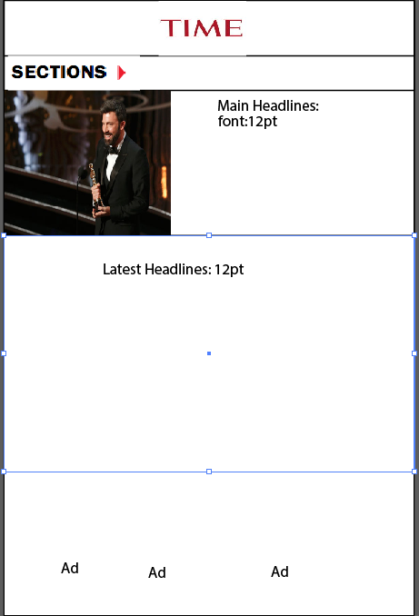

The primary Navigation would be at the right side of the screen, also Secondary Navigation would be for the sections.

The size of the image is 130 by 113.

Ipad portrait

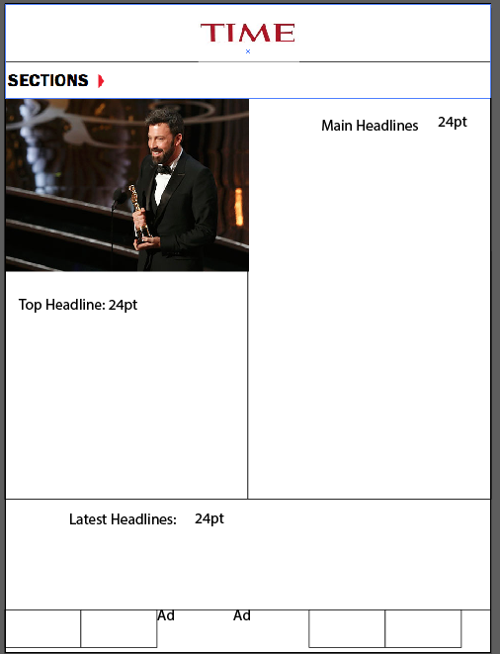

The primary Navigation would be at the right side of the screen, also Secondary Navigation would be for the sections.

The size of the image is 385 by 273

Ipad landscape

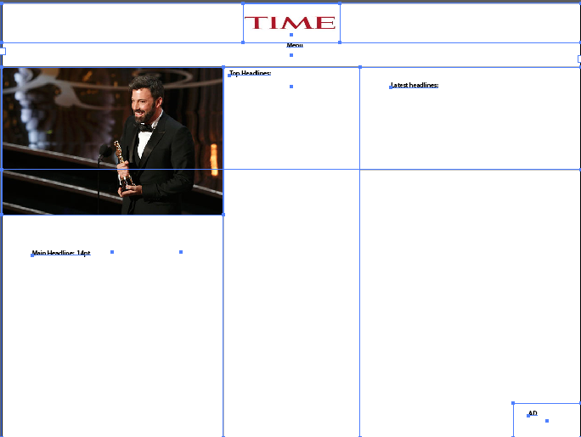

The primary Navigation would be at the right side of the screen, also Secondary Navigation would be through the menu.

The size of the image is 392 by 261

The ad would be at the bottom right.

Desktop

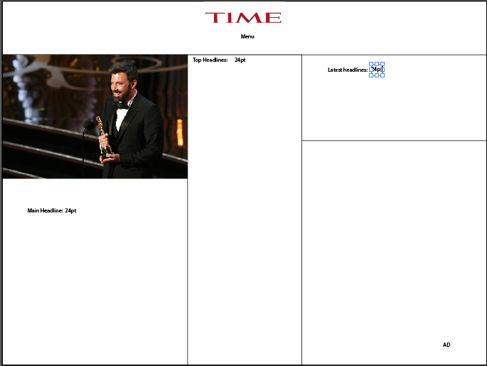

The primary Navigation would be at the right side of the screen, also Secondary Navigation would be through the menu.

The size of the image is 392 by 261

The font for the writing would be 24pt

The ad would be at the bottom right

This is similar to the ipad landscape view.

Bigger desktop

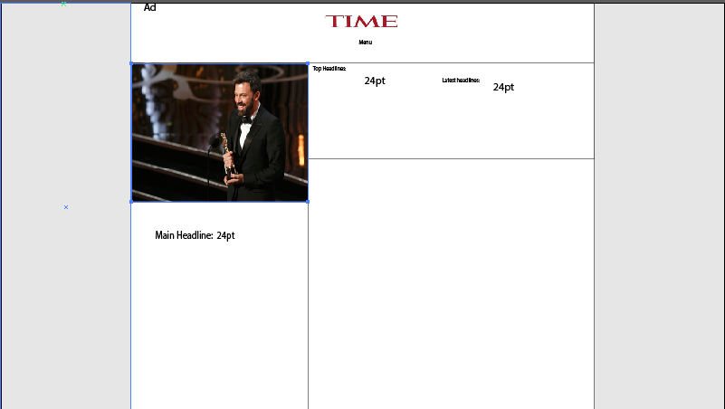

The primary Navigation would be at the right side of the screen, also Secondary Navigation would be through the menu.

The size of the image is 391 by 306.

The font for the writing would be 24pt

The ad would be at the top left.