Create a separate file and import this

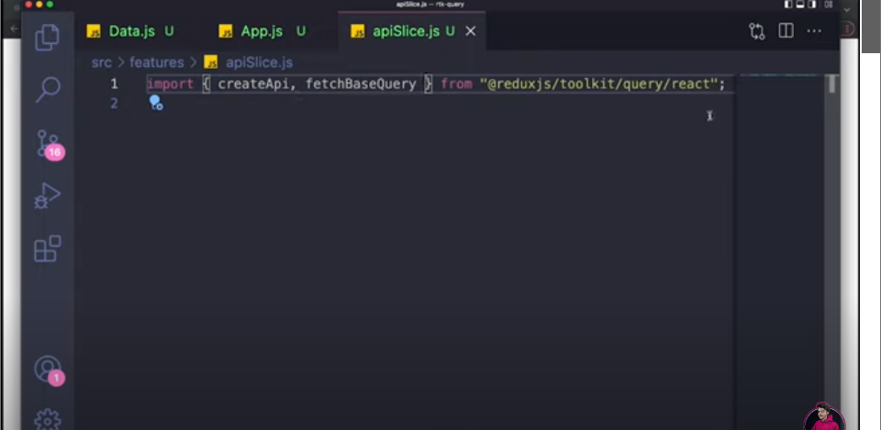

Add basequery and endpoints

Add apiprovider also and wrap parent elements when using rtk query

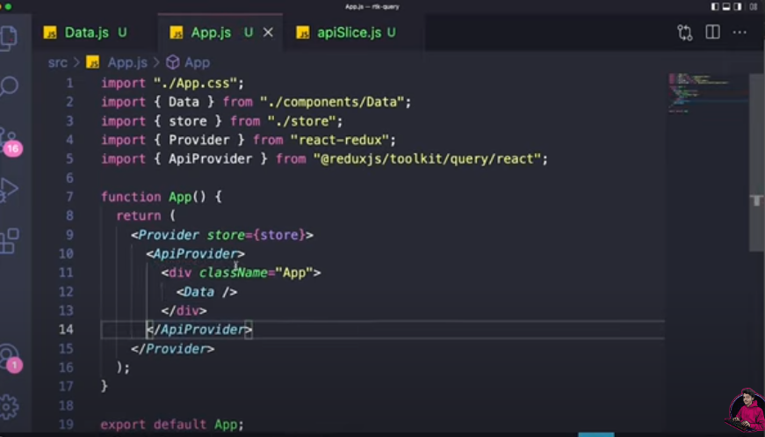

Add the reducerpath in apiprovider

Add another query for single products fetching

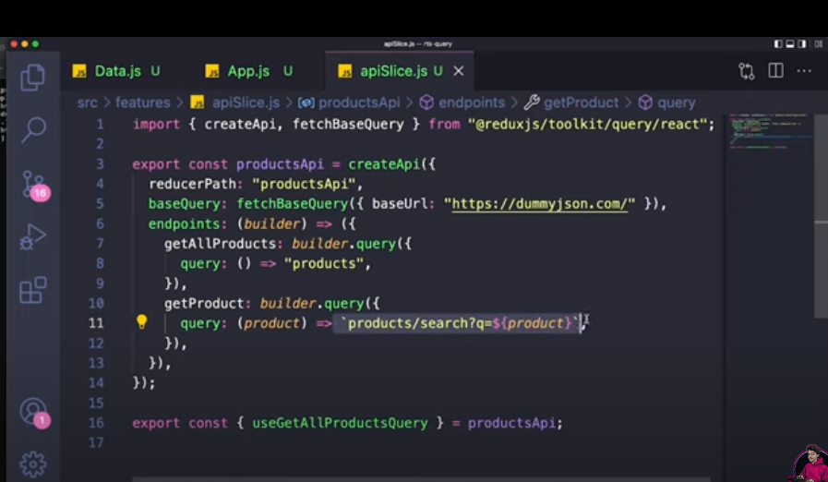

Now use the query In required file

