***Blast Builder***

Table of Contents

1.Introduction 2

1.1 Project Overview 2

***1.1.1 Title*** 2

***1.1.2 Genre*** 2

***1.1.3 Concept*** 3

***1.1.4 Theme*** 3

***1.1.5 Playtime*** 3

***1.1.6 Graphic Orientation*** 3

***1.1.7 Platforms*** 3

1.2 Game Description 3

2.SPECIFICATIONS 4

2.1 Story 4

2.2 World 4

3.Gameplay 4

***3.1 Progression*** 4

***3.3 Play Flow*** 5

***3.4 Blast Mechanic*** 6

4.Art & Sound 7

***4.1 Visual Style*** 7

# 1.Introduction

## 1.1 Project Overview

### **1.1.1 Title**

Blast Builder

### **1.1.2 Genre**

Puzzle/Match-2

### **1.1.3 Concept**

Rebuilding a ruined city with using match-2 blast mechanic

### **1.1.4 Theme**

Cartoon City

### **1.1.5 Playtime**

10-15 Minutes

### **1.1.6 Graphic Orientation**

2D

### **1.1.7 Platforms**

Android

## 1.2 Game Description

Dive into a colorful world of puzzle solving and city restoration! This original blast puzzle lets players match colors to clear the board and earn points.

# 2.SPECIFICATIONS

## 2.1 Story

## 2.2 World

# 3.Gameplay

In this sliding puzzle game, players are presented with a grid of colored blocks. Match tiles by slidding blocks into empty place, create a path to 3 match occifently colorsblocks to clean those clear block points. With each, a resource pool is gradually repaired and will be put back to use for fixing up the buildings on that island. Levels begin small and basic, only to grow in size and density later on as you are introduced with different types of challenges which reiterate the core gameplay like moving limits or blocked pathways; additionally special items like bombs or boosters make your game more versatile.

## **3.1 Progression**

As players progress through levels, the game world evolves around them.

* **Map Progression:** Restored buildings provides visual upgrades.
* **Level Progression:** As players restore more buildings, the levels become more challenging and enjoyable.

## **3.3 Play Flow**

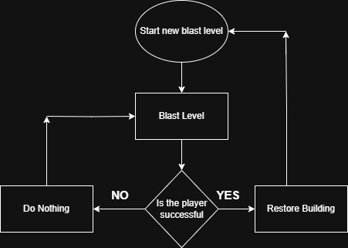

**Start a Level:** Players enter a new puzzle grid with a specific aim.

**Solve the Puzzle:** Match blocks strategically to maximize points and clear obstacles within a set number of moves.

**Restore Buildings:** After successfully completing a level, restore the buildings in the city.

## **3.4 Blast Mechanic**

The Blast Mechanic is shaped based on the grid information entered through the editor. Using this data, the boxes in the generated grid become destructible if there are at least two or more in a row. To help the player find them more easily, there is a hint algorithm consisting of 3 states. If the boxes are aligned with fewer than 5, no action is triggered. If there are between 4 and 7, state A is activated; between 6 and 9, state B is triggered; and if there are more than 8, state C is activated. In these states, each color has its own unique sprite, making it easier for the player to spot the boxes. The objective of this mechanic is to reach a predetermined score. The way to collect points is by exploding the boxes found in states A, B, and C.

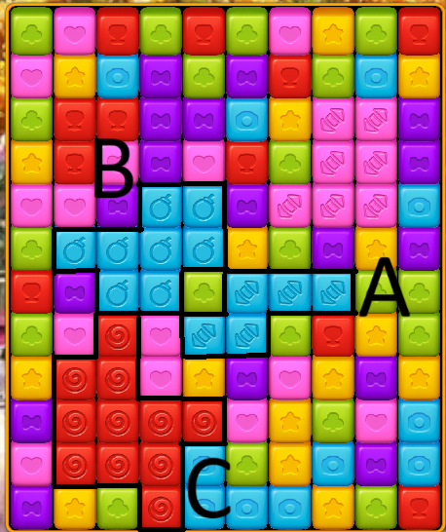

# 4.Art & Sound

## **4.1 Visual Style**

Pre-made assets with a cartoonish style have been used.

## 

**4.5 Sound**

The audio was outsourced. For mixing and polishing, Reaper was utilized.