Playwright MCP (Model Context Protocol) and GitHub Copilot in PyCharm IDE for generating and executing Playwright Python tests (Web/UI + API):

1. Prerequisites
Before starting, ensure you have the following installed:
- Python 3.8+
- Node.js (for Playwright browsers)
- PyCharm IDE
- GitHub account (for Copilot)

2. Install and Configure GitHub Copilot in PyCharm (Refer The document)
- Open PyCharm IDE.
- Go to
File → Settings → Plugins → Marketplace
- Search for “GitHub Copilot” and click Install.
- After installation, restart PyCharm.
- Log in with your GitHub account → authorize Copilot.

3. Install MCP Server and Enable it in PyCharm
- Open PyCharm IDE.
- Go to
File → Settings → Plugins → Marketplace
- Search for “MCP Server” and click Install.
- After installation, restart PyCharm.
- To Enable MCP Server:
Go to
File → SettingsToolsMCP ServerCheck Enable MCP Server
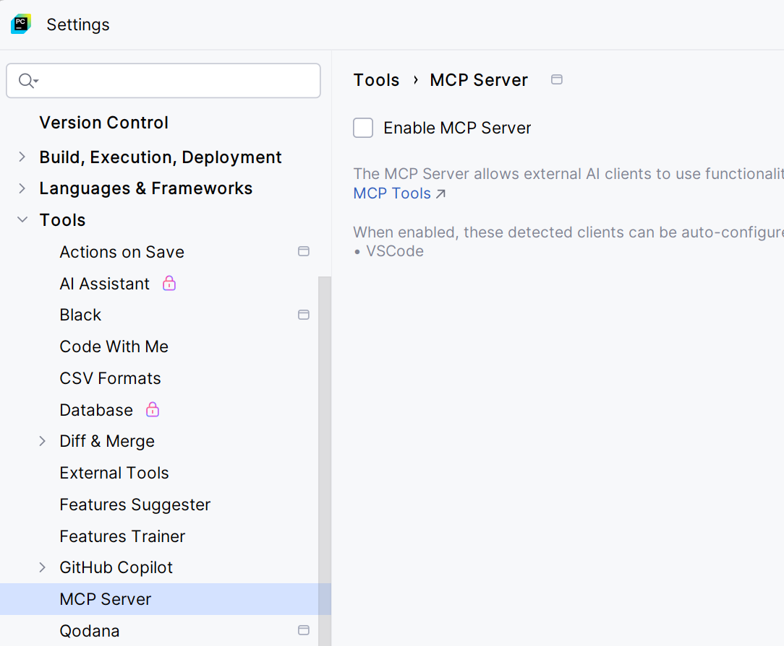

4.Integrate MCP Server with Copilot
- Go to
File → SettingsToolsGitHub Copilot Model Context Protocol (MCP)
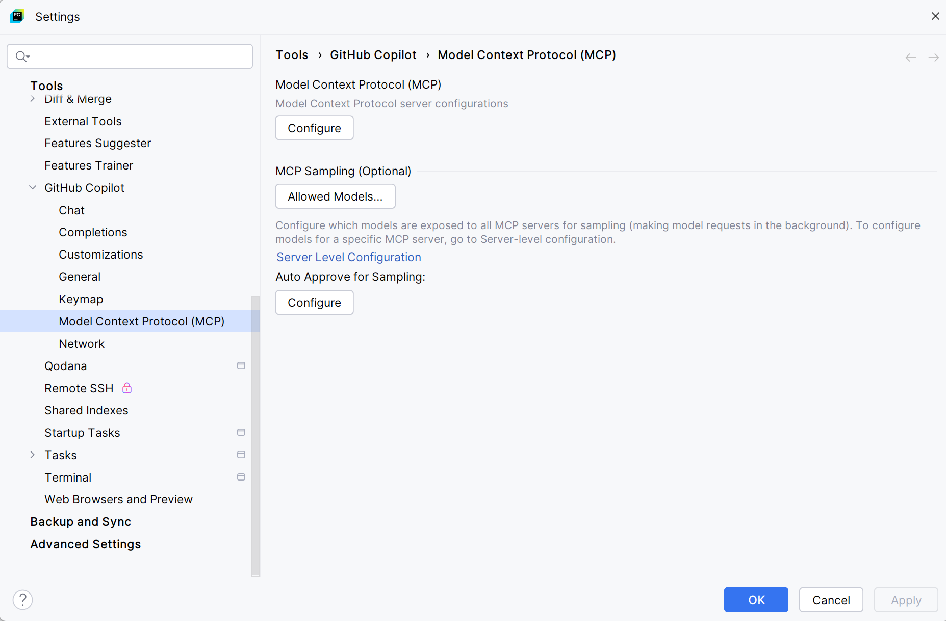
- Click on Configure button.
- Add entry in the mcp.json file.

{
"mcpServers": {
"playwright": {
"command": "npx",
"args": [
"@playwright/mcp@latest"
]
}
}
}

- Restart PyCharm after saving.

5. Create Playwright Python Tests using Copilot with MCP

Example 1: Web/UI Test:
Open Copilot Chat window then provide the prompt as below.
Prompt:
Generate and execute a Playwright test using pytest and Playwright MCP.
Test Scenario:
Open http://www.automationpractice.pl/index.php
Search for "T-shirts"
Verify that "Faded Short Sleeve T-shirts" is displayed in the search results
Implementation Requirements:
Use pytest-style structure (functions starting with test_).
Execute each step interactively through Playwright MCP tools.
Once all steps succeed, generate and save the final test script as aitesting/search_product.py.
Run the saved test automatically in headed mode (browser visible).
If any step or assertion fails, identify and fix the issue, then rerun until the test passes.
Expected Output:
A fully working Playwright + pytest test script.
The script should automate the complete flow described above and successfully validate the product name in the results.

Now, do the code changes to fail the test(manually).
search_box = page.locator("input[name='search_query123']")
Give another prompt to Fix the errors.
Prompt:
Execute the test file ai/search_product.py. If the test fails, automatically rerun it until it passes successfully.

Example 2: Web/UI Test with Page Object Model:
Open Copilot Chat window then provide the prompt as below.
Prompt:
Generate and execute a Playwright test using pytest and Playwright MCP.
Test Scenario:
Open the URL: https://www.demoblaze.com/index.html
Click on the “Log in” link in the top navigation bar.
Enter pavanol in the Username field.
Enter test@123 in the Password field.
Click on the “Log in” button.
Verify that the “Log out” link is visible.
Verify that the text “Welcome pavanol” appears at the top right of the page.
Click on the “Log out” link.
Verify that the “Log in” link is visible again after logging out.
Implementation Requirements:
Apply the Page Object Model (POM) design pattern for page structure and element management.
Save all page object files inside the project’s ai/ directory.
Follow the pytest-style convention (functions starting with test_).
Execute each step interactively using Playwright MCP tools to validate flow and elements.
Once all steps are validated successfully, generate and save the final test script as ai/test_login_logout.py.
Automatically execute the saved test in headed mode (browser visible).
If any step or assertion fails, analyze, fix, and rerun the test until it passes successfully.
Expected Output:
A fully functional Playwright + pytest test suite using the POM pattern.
The generated script should perform the complete login and logout flow on Demoblaze, accurately validating UI elements and messages at each stage.

Example 3: API Test :
Open Copilot Chat window then provide the prompt as below.
Prompt:
Generate and execute an API test using pytest and Playwright MCP.
Test Scenario:
Set the API endpoint to https://fakestoreapi.com/products/1.
Send a GET request to the endpoint.
Verify the response status code is 200.
Validate that the response JSON contains the keys:
id, title, price, category, and description.
Verify the JSON response includes the following expected values:
{
"id": 1,
"price": 109.95,
"category": "men's clothing"
}
Log the complete response body to the console.
Implementation Requirements:
Follow the pytest-style structure (functions start with test_).
Execute each step interactively using Playwright MCP tools for validation.
After successful validation, save the generated script as ai/test_apitest_mcp.py.
If any step or assertion fails, identify and fix the issue, then rerun until the test passes.
Expected Output:
A complete and functional Playwright + pytest API test script that verifies the product details from the Fake Store API and logs the response body.

