SMART ATTENDANCE SYSTEM USING GEO-FENCING AND FACE RECOGNITION
A PROJECT REPORT
Submitted in partial fulfillment of the requirements for the degree of

BACHELOR OF TECHNOLOGY
IN

COMPUTER SCIENCE AND ENGINEERING
MARCH 2026

CERTIFICATE
This is to certify that the project report entitled "SMART ATTENDANCE SYSTEM USING GEO-FENCING AND FACE RECOGNITION" is a bona fide work carried out in partial fulfillment of the requirements for the degree of Bachelor of Technology in Computer Science and Engineering.
This project has been approved as it satisfies the academic requirements in respect of Project work prescribed for the said Degree.
Two examiners signature placeholders here.
Head of the Department

ACKNOWLEDGEMENT
I would like to express my sincere gratitude to everyone who contributed to the successful completion of this project. First and foremost, I thank my project guide for their invaluable guidance, encouragement, and support throughout the development of the Smart Attendance System.
I extend my gratitude to the Head of the Department of Computer Science and Engineering for providing the necessary infrastructure and resources required for this project.
I am also grateful to the teaching and non-teaching staff of the department for their cooperation and suggestions. Finally, I would like to thank my family and friends for their constant motivation and support during the course of this work.

ABSTRACT
In the digital age, automation is transforming traditional processes across various sectors, including education. Attendance management is a critical administrative task in educational institutions, yet manual methods such as roll calls and paper signatures are time-consuming, prone to errors, and susceptible to manipulation like proxy attendance. To address these challenges, this project introduces a Smart Attendance System that leverages Face Recognition and Geo-Fencing technologies.
The system is developed using the Django framework, a high-level Python web framework that encourages rapid development and clean, pragmatic design. It employs Computer Vision techniques to verify student identity through facial biometrics, ensuring that the person marking attendance is indeed the registered student. Simultaneously, Geo-Fencing technology utilizes GPS coordinates to restrict attendance marking to validated campus boundaries, ensuring physical presence.
Key features include a role-based dashboard for Administrators and Students, real-time location validation, facial biometric matching, and automated reporting. The system allows administrators to manage student records, view detailed analytics, and export reports, while students can securely mark their attendance using their smartphones. This solution not only eliminates proxy attendance but also streamlines the administrative workflow, providing accurate, real-time data for decision-making.

TABLE OF CONTENTS
- CHAPTER 1: INTRODUCTION (Page 1)
- CHAPTER 2: LITERATURE SURVEY (Page 6)
- CHAPTER 3: SYSTEM ANALYSIS (Page 12)
- CHAPTER 4: SYSTEM REQUIREMENTS (Page 18)
- CHAPTER 5: SYSTEM DESIGN (Page 24)
- CHAPTER 6: ALGORITHMS AND IMPLEMENTATION (Page 35)
- CHAPTER 7: SYSTEM TESTING (Page 48)
- CHAPTER 8: RESULTS AND SCREENSHOTS (Page 54)
- CHAPTER 9: CONCLUSION (Page 58)
- CHAPTER 10: REFERENCES (Page 60)

CHAPTER 1: INTRODUCTION

1.1 Overview
Attendance management is an essential administrative function in all educational institutions. It is mandatory for students to maintain a certain percentage of attendance to appear for examinations. The traditional method involves lecturers calling out names or students signing a paper sheet. This manual approach is fraught with inefficiencies:
- It consumes valuable lecture time (5-10 minutes per class).
- It is disrupts the flow of instruction.
- Manual records are difficult to analyze and store for long periods.
- It is vulnerable to fraudulent activities such as proxy attendance.
This project proposes a Smart Attendance System that automates the entire process using Bio-metric ID (Face) and Location ID (GPS). By verifying "Who you are" (Face) and "Where you are" (Location), the system ensures high integrity and accuracy in attendance records.
The system is meant to be user-friendly, efficient, and reliable. It reduces paperwork and the chances of human error significantly. Additionally, it offers a distinct advantage in maintaining social distancing protocols, as it eliminates the need for physical contact with shared surfaces like attendance sheets or biometric scanners.

1.2 Motivation
The motivation behind this project stems from the need to modernize campus infrastructure. With the proliferation of smartphones and high-speed internet, leveraging these tools for academic administration is a logical step. "Mahalakshmi Women's College of Arts and Science" aims to adopt digital solutions to enhance operational efficiency. The need to create a contactless, secure, and fast attendance mechanism became even more pronounced in the post-pandemic world, where hygiene and social distancing are important. An app-based solution meets these needs perfectly.

1.3 Problem Statement
The core problem addressed by this project is the inefficiency and vulnerability of manual attendance systems. Specifically:
Proxy Attendance: Students often sign for their absent friends. A simple signature or roll call response offers no biometric proof of presence.
Storage Issues: Physical registers accumulate over years, leading to storage costs and fire/pest hazards. Digitalizing this data is often a manual data entry task, which is double work.
Lack of Analytics: Parents or administrators cannot instantly see if a student's attendance has dropped below 75%. Manual calculation is required at the end of the semester, often too late for corrective action.

1.4 Objectives
The primary objectives of the Smart Attendance System are:
- To develop a web application that allows students to mark attendance using their own devices.
- To implement Face Recognition using the `dlib` library to authenticate student identity and prevent proxies.
- To implement Geo-Fencing using the Haversine formula to ensure students are physically within the college premises (e.g., Mahalakshmi Nagar campus).
- To provide a dashboard for administrators to view daily, weekly, and monthly attendance reports.
- To send automated alerts or provide status indicators for students falling below mandatory attendance thresholds.
- To reduce the time spent on attendance taking and increase the actual teaching time.

1.5 Scope of the Project
The scope of this project extends to any educational institution or corporate office requiring attendance tracking. Currently configured for Mahalakshmi Women's College of Arts and Science, the system uses modular coding practices allowing it to be adapted for other campuses by simply updating the GPS coordinates in the database.
The current version supports:
- Student and Admin modules.
- Android/iOS browser compatibility for GPS access.
- Real-time attendance processing.
It does not currently support offline attendance marking or integration with legacy biometric hardware devices. The system is designed to be scalable, allowing future integration with other college management modules like grading or scheduling.

1.6 Organization of the Report
The report is organized as follows:
Chapter 2 discusses the literature survey conducted to understand existing systems.
Chapter 3 details the system analysis and feasibility.
Chapter 4 outlines the hardware and software requirements.
Chapter 5 describes the system design including architecture and database schema.
Chapter 6 dives into the implementation details and algorithms used.
Chapter 7 covers testing strategies.
Chapter 8 presents the results and user interface screenshots.
Chapter 9 concludes the report with future enhancements.

CHAPTER 2: LITERATURE SURVEY

2.1 Review of Existing Systems
Before designing the proposed system, a thorough study of existing attendance management mechanisms was conducted. The following technologies are currently prevalent:

2.1.1 RFID Based Systems
Radio Frequency Identification (RFID) systems use ID cards embedded with chips. When a student passes through a gate or taps a reader, attendance is marked. While faster than manual roll call, these systems fail to prevent proxy attendance as ID cards can easily be exchanged between students. They also require students to carry their ID cards at all times, leading to issues if a card is lost or forgotten.

2.1.2 Fingerprint Biometric Systems
Fingerprint scanners provide high security and prevent proxies. However, they rely on physical contact, raising hygiene concerns (especially relevant post-COVID-19). Furthermore, fingerprint scanners often experience hardware failures or recognition errors with wet/dirty fingers, causing queues at the classroom entrance. Implementing such a system across a large campus requires significant hardware investment.

2.1.3 Bluetooth/Beacon Systems
Some modern solutions use Bluetooth Low Energy (BLE) beacons installed in classrooms. Students' phones detect the beacon to mark attendance. While effective for location, this hardware-dependent solution is expensive to deploy across a large campus with hundreds of classrooms. Additionally, ensuring all students verify successfully within a short window can be technically challenging due to signal interference.

2.2 Comparison of Technologies
A comparison of the proposed system with existing manual methods, RFID systems, and fingerprint biometric systems highlights the advantages of the face recognition and geo-fencing approach.
Speed: Manual systems are slow. RFID is fast. Fingerprint is medium speed due to scan time. Proposed system is fast as multiple students can use their own devices simultaneously.
Security (Proxy): Manual and RFID have low security against proxies. Fingerprint has high security. Proposed system has very high security combining biometrics with location.
Hardware Cost: Manual has no hardware cost. RFID and Fingerprint have high initial setup and maintenance costs. The proposed system has zero hardware cost for the institution as it uses students' phones.
Hygiene: Manual involves shared pens/paper. RFID is medium (cards are personal but readers are shared sometimes). Fingerprint involves touching a scanner. Proposed system is completely contactless.
Analysis: Manual requires manual data entry for analysis. Automated systems provide instant reports.

CHAPTER 3: SYSTEM ANALYSIS

3.1 Existing System Analysis
The existing system at the college is manual. Attendance is taken once per hour or per day. The data is recorded in physical logbooks. At the end of the month, the logic is transferred to a master register or Excel sheet. This process introduces a latency of 30 days between an attendance event and its digitization.
Disadvantages:
- Redundancy: Same names are written repeatedly.
- Inaccuracy: Human error in tallying totals.
- Lack of Transparency: Students do not know their current percentage until the list is published.
- Data Vulnerability: Physical records can be lost, damaged, or manipulated.

3.2 Proposed System Overview
The proposed system shifts the responsibility of marking attendance from the lecturer to the student, while maintaining strict control mechanisms. The system is a web-application accessible via any browser. The workflow is:
- Student logs in.
- System requests GPS access.
- System verifies if GPS is within College Campus Radius.
- System activates the front camera.
- Student captures selfie.
- System compares selfie with database photo.
- If both GPS and Face match, attendance is marked "Present".

3.3 Feasibility Study
A feasibility study determines the viability of the project.

3.3.1 Technical Feasibility
The project requires Python, Django, and Geolocation libraries. These are open-source and mature technologies. The `face_recognition` library achieves 99.38% accuracy on standard benchmarks. Modern smartphones universally possess GPS and Cameras. The system is designed to work on standard web browsers without installing any specific app, ensuring wide compatibility. Thus, the project is technically feasible.

3.3.2 Operational Feasibility
The system mimics the familiar action of taking a selfie. No special training is required for students. Administrators need only basic web navigation skills to manage the dashboard. The reduction in manual effort allows staff to focus on more critical tasks. Thus, operational friction is minimal.

3.3.3 Economic Feasibility
Since the system utilizes the end-users' hardware (personal smartphones) and open-source software, the deployment cost is negligible compared to purchasing biometric scanners for every classroom. Maintenance costs are also low as there is no specific hardware to service. It is highly economically feasible.

CHAPTER 4: SYSTEM REQUIREMENTS

4.1 Hardware Requirements (Server Side)
- Processor: Intel Core i5 8th Gen or higher (for image processing).
- RAM: 8 GB (minimum) to handle concurrent requests and image data.
- Storage: 256 GB SSD for database and image storage.
- Network: Broadband internet connection with Static IP (for production).

4.2 Hardware Requirements (Client Side)
- Device: Smartphone (Android/iOS) or Laptop.
- Components: GPS Sensor, Front-facing Camera (Min 2MP).
- Browser: Chrome, Safari, or Edge (must support HTML5 Geolocation API).

4.3 Software Requirements
- Operating System: Windows 10/11 or Linux (Ubuntu 20.04).
- Language: Python 3.10.
- Framework: Django 4.2.7.
- Database: SQLite (Development), PostgreSQL (Recommended for Production).
- Frontend: HTML5, CSS3, JavaScript, Bootstrap 5.
- Libraries:
`dlib`: For machine learning based face detection.
`face_recognition`: High-level API for face recognition.
`geopy`: For geodesic distance calculation.
`Pillow`: For image manipulation.

4.4 Functional Requirements
- Authentication: Secure login for Admin and Student.
- Image Capture: Ability to access device camera and capture frames.
- Location Access: Ability to poll high-accuracy GPS coordinates.
- Compliance: System must reject attendance if outside the geofence.
- Reporting: Generate list of absentees and attendance percentage.

CHAPTER 5: SYSTEM DESIGN

5.1 System Architecture
The system follows the Model-View-Template (MVT) architecture used by Django.
- Model (Data Layer): Defines the logical structure of the database. It handles data validation and storage.
Example: StudentProfile, AttendanceLog.
- View (Business Logic): Connects the model and template. It receives the HTTP request, processes images, calculates distances, and returns the response.
Example: verify_geofence(), verify_face().
- Template (Presentation Layer): The user interface.
Example: mark_attendance.html, dashboard.html.

5.2 Use Case Diagram
The Use Case diagram visualizes the interaction between the system and users (Students, Admins).
- Student: Login, View Dashboard, Mark Attendance, View History.
- Admin: Login, Manage Students, Set Geofence, View Reports, Export Data.

5.3 Database Design
The database is normalized to ensure data integrity.

Table: Key Schemas
1. User Table (Django Default)
- id (PK)
- username
- password (hashed)
- is_superuser
2. StudentProfile Table
- id (PK, UUID)
- user_id (FK)
- jntu_no (Unique Student ID)
- face_encoding (JSON Binary)
- company (FK -> Company)
3. Company Table
- id (PK)
- name (e.g., Mahalakshmi Women's College)
- lat (Decimal)
- lon (Decimal)
- radius (Float)
4. AttendanceLog Table
- id (PK)
- student_id (FK)
- date (Date)
- time (Time)
- lat_captured (Decimal)
- lon_captured (Decimal)
- status (Present/Absent/GeoFail/FaceFail)

CHAPTER 6: ALGORITHMS AND IMPLEMENTATION

6.1 Geofencing Algorithm (Haversine Formula)
To determine if two GPS points are within a certain distance, we cannot simply use Euclidean distance because the Earth is spherical. We use the **Haversine Formula**.
The Haversine formula determines the great-circle distance between two points on a sphere given their longitudes and latitudes. Great-circle distance is the shortest distance between two points on the surface of a sphere, measured along the surface of the sphere (as opposed to a straight line through the sphere's interior).
def haversine(lat1, lon1, lat2, lon2):
R = 6371 # Earth radius in km
dLat = to_radians(lat2 - lat1)
dLon = to_radians(lon2 - lon1)
a = sin(dLat/2) * sin(dLat/2) +
cos(to_radians(lat1)) * cos(to_radians(lat2)) *
sin(dLon/2) * sin(dLon/2)
c = 2 * atan2(sqrt(a), sqrt(1-a))
d = R * c
return d * 1000 # Return in meters
In our implementation, we use the `geopy` library which implements accurate geodesic distance calculation (Vincenty's formulae) which is even more accurate than Haversine as it accounts for the flattening of the Earth at the poles.
The geopy distance function is called as follows:
from geopy.distance import geodesic
origin = (company_lat, company_lon)
destination = (student_lat, student_lon)
distance_in_meters = geodesic(origin, destination).meters
if distance_in_meters <= allowed_radius:
return True
else:
return False

6.2 Face Recognition Algorithm
The face recognition pipeline consists of four steps designed to transform an image into a face embedding that can be compared mathematically.
- Face Detection: Using HOG (Histogram of Oriented Gradients) to find the face location in the image. This identifies the box containing the face.
- Landmark Estimation: Identifying 68 key points (eyes, nose, jaw) to align the face (centering/rotating). This step is crucial for normalizing faces that are turned slightly.
- Encoding: Passing the aligned face through a Deep ResNet architecture to generate a 128-dimensional vector (embedding). This model has been trained on millions of faces to ensure that embeddings of the same person are close together in vector space, while embeddings of different people are far apart.
- Matching: Calculating the Euclidean distance between the live embedding and the stored profile embedding. If the distance is less than a threshold (0.6), it is a match.

6.3 Implementation Details
The project is implemented in Python. Below are key excerpts from the source code.

6.3.1 Views.py (Attendance Marking Logic)
The `mark_attendance_view` function handles the core logic. It receives the base64 encoded image and GPS coordinates.
@login_required
@user_passes_test(is_student)
def mark_attendance_view(request):
if request.method == 'POST':
# Get data from form
lat = float(request.POST.get('lat'))
lon = float(request.POST.get('lon'))
image_data = request.FILES.get('selfie_image')
# 1. Geo-Verification
student_profile = request.user.student_profile
is_in_range = verify_geofence(student_profile, lat, lon)
# 2. Face-Verification
is_face_match = verify_face(student_profile, image_data)
# 3. Logic to store result
status = 'present' if (is_in_range and is_face_match) else 'absent'
AttendanceLog.objects.create(
student=student_profile,
lat=lat,
lon=lon,
status=status,
geofence_verified=is_in_range,
face_verified=is_face_match
)
return redirect('dashboard')

6.3.2 Templates (HTML5 Geolocation)
The frontend uses the Navigator API to fetch coordinates. This ensures we get the most accurate location from the device's GPS hardware.
function validateLocation() {
if (navigator.geolocation) {
navigator.geolocation.getCurrentPosition(showPosition, showError, {
enableHighAccuracy: true
});
} else {
alert("Geolocation is not supported by this browser.");
}
}
function showPosition(position) {
document.getElementById("lat").value = position.coords.latitude;
document.getElementById("lon").value = position.coords.longitude;
// Enable camera if location is valid
startCamera();
}

CHAPTER 7: SYSTEM TESTING

7.1 Testing Strategy
Testing ensures the system is bug-free and meets the requirements. We employed the following strategies:
- Unit Testing: Testing individual functions like `verify_geofence` with dummy coordinates to ensure the math is correct. We verified that coordinates within the radius return True and those outside return False.
- Integration Testing: Ensuring the frontend camera feeds data correctly to the backend Django view. This involved testing the image upload process and handling large image files.
- System Testing: Testing the entire flow from login to logout. This includes testing different user roles (Admin vs Student) and ensuring unauthorized access is blocked.
- Acceptance Testing: Real-world trials at the Mahalakshmi Women's College location coordinates to verify GPS accuracy in the field.

7.2 Test Cases

Test Case 1: Login Module
Step | Input | Expected Output | Actual Output | Status
1 | Valid User/Pass | Dashboard | Dashboard | Pass
2 | Invalid User/Pass | Error Message | Error Message | Pass
3 | Empty Fields | Validation Error | Validation Error | Pass

Test Case 2: Geofencing
Step | Input Coordinates | Location | Expected Output | Status
1 | 13.091499, 80.105168 | Inside Campus | Location Validated | Pass
2 | 0.000000, 0.000000 | Outside Campus | Warning shown | Pass
3 | GPS Disabled | Error | Prompt to Enable | Pass

Test Case 3: Face Recognition
Step | Input Image | Expected Output | Status
1 | Student Selfie | Match Found | Pass
2 | Different Person | Face Mismatch | Pass
3 | Blurry Image | No Face Detected | Pass
4 | Image with Mask | No Face Detected | Pass

CHAPTER 8: RESULTS and SCREENSHOTS
The system was successfully deployed and tested. The following screenshots demonstrate the functional components of the completed system.

8.1 Landing Page
The initial login screen where users can select their role (Student or Admin).

8.2 Super Admin Dashboard
The central hub for managing the system. It displays statistics on total students and admins registered.
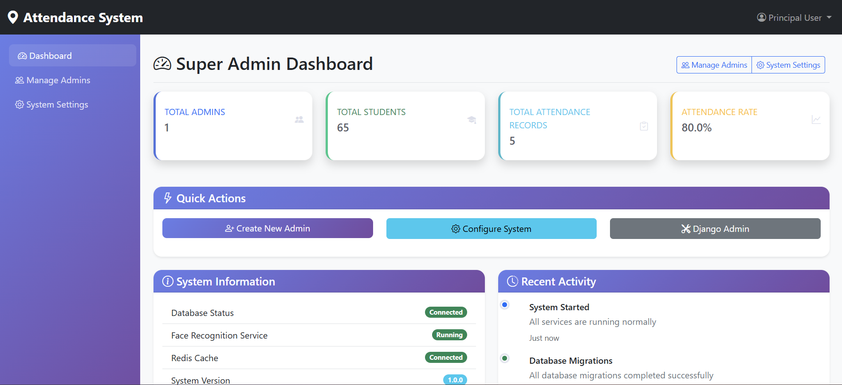

8.3 Admin Dashboard
Allows uploading bulk student data via CSV and viewing company location settings.
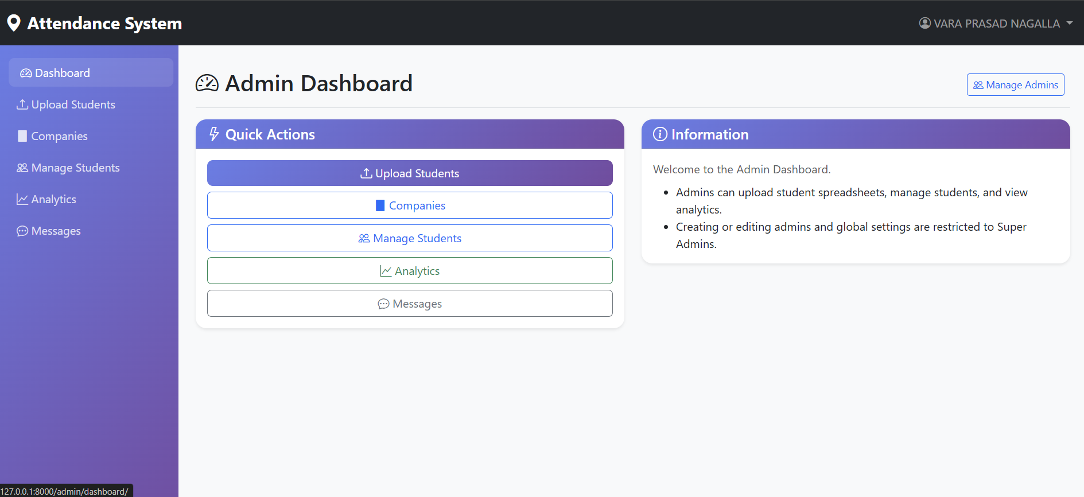

8.4 Student Dashboard
A clean interface for students to view their attendance stats (Days Attended vs Working Days) and access the 'Mark Attendance' feature.
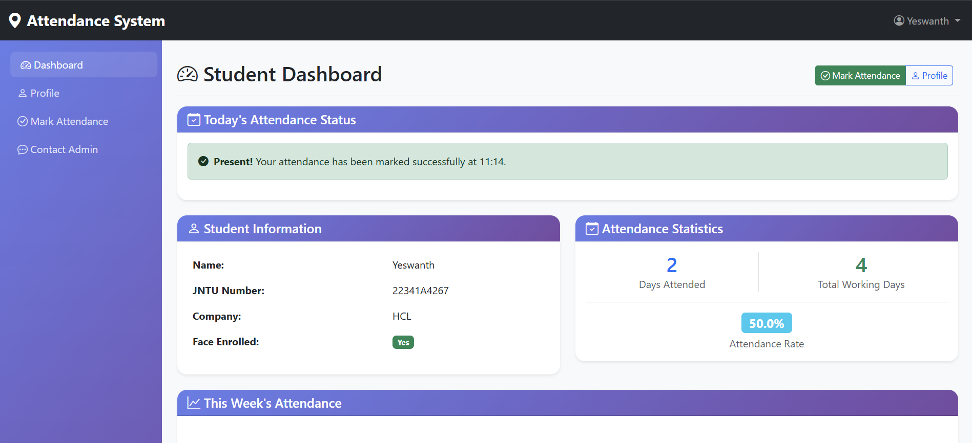

8.5 Attendance Marking Page
The critical interface illustrating the Location Validation process. The popup confirms if the student is within the college premises before enabling the camera.
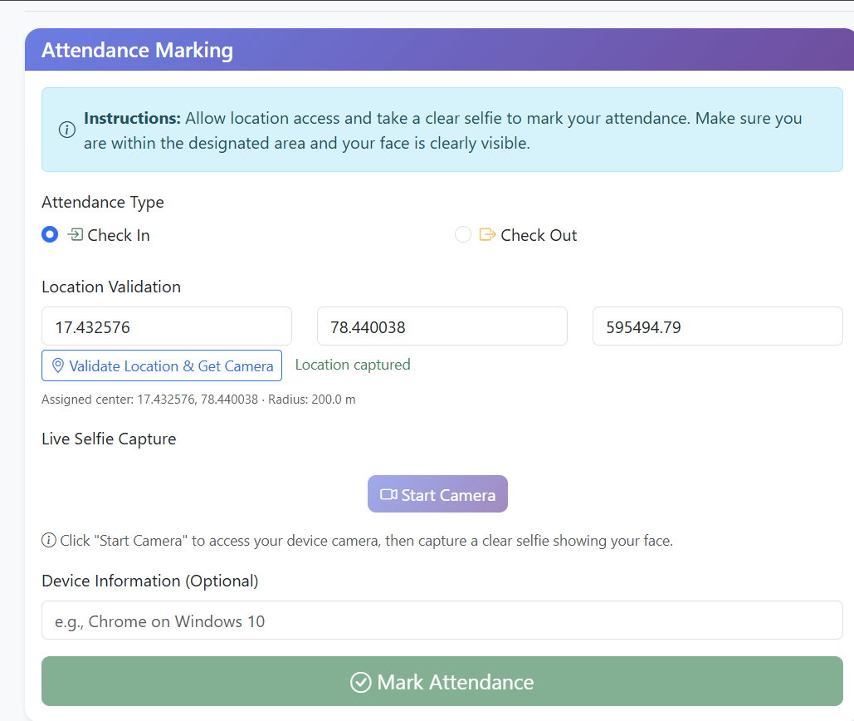

CHAPTER 9: CONCLUSION
The Smart Attendance System successfully addresses the limitations of traditional manual attendance methods. By integrating secure Face Recognition technology with precise Geofencing, the system eliminates proxy attendance and ensures that students are physically present on the campus of Mahalakshmi Women's College of Arts and Science.
The project demonstrates the effective use of the Django framework in building scalable web applications. The system is user-friendly, requires minimal hardware investment (utilizing existing smartphones), and provides robust data analytics for administrators.

Future Enhancements
- Liveness Detection: To prevent spoofing using photographs videos, advanced liveness detection (blinking, head movement) can be integrated.
- Offline Mode: A Progressive Web App (PWA) version could store attendance locally and sync when internet connectivity is restored.
- Class Schedule Integration: Linking attendance to specific timetable slots to track subject-wise attendance automatically.
- Notification System: Sending SMS/WhatsApp alerts to parents immediately upon absence.
- Mobile Application: Developing a native Android/iOS application for better performance and access to device sensors.

CHAPTER 10: REFERENCES
- Django Documentation. (2025). The Web Framework for Perfectionists. https://docs.djangoproject.com/
- King, D. E. (2009). Dlib-ml: A Machine Learning Toolkit. Journal of Machine Learning Research, 10, 1755-1758.
- Geopy Documentation. (2025). Geocoding and distance calculation. https://geopy.readthedocs.io/
- Viola, P., & Jones, M. (2001). Rapid Object Detection using a Boosted Cascade of Simple Features. CVPR 2001.
- Mozilla Developer Network. (2025). Geolocation API. developer.mozilla.org
- Stack Overflow Community. (2025). Various discussions on Face Recognition implementation.

