SMART ATTENDANCE SYSTEM USING GEO-FENCING AND FACE RECOGNITION
A PROJECT REPORT
Submitted in partial fulfillment of the requirements for the degree of

BACHELOR OF TECHNOLOGY
IN

COMPUTER SCIENCE AND ENGINEERING
MARCH 2026
MAHALAKSHMI WOMEN'S COLLEGE OF ARTS AND SCIENCE

CERTIFICATE
This is to certify that the project report entitled "SMART ATTENDANCE SYSTEM USING GEO-FENCING AND FACE RECOGNITION" is a bona fide work carried out by the student in partial fulfillment of the requirements for the award of the degree of Bachelor of Technology in Computer Science and Engineering.
This project has been approved as it satisfies the academic requirements in respect of Project work prescribed for the said Degree. The work embodied in this report has not been submitted for the award of any other degree or diploma.
Internal Examiner
External Examiner
Head of the Department
Department of Computer Science and Engineering

ACKNOWLEDGEMENT
I would like to express my deep sense of gratitude to everyone who contributed to the successful completion of this project. It has been a journey of learning, exploring, and implementing new technologies, and none of this would have been possible without the support I received.
First and foremost, I thank my project guide for their invaluable guidance, constant encouragement, and constructive criticism throughout the development of the Smart Attendance System. Their insights into Computer Vision helped shape the core algorithms of this project.
I extend my sincere gratitude to the Head of the Department of Computer Science and Engineering for providing the necessary infrastructure, high-performance computing labs, and resources required for testing the deep learning models used in this project.
I am also grateful to the teaching and non-teaching staff of the department for their cooperation and suggestions regarding the administrative workflow of attendance, which helped in designing the system requirements.
Finally, I would like to thank my family and friends for their constant motivation, patience, and support during the course of this work. Their belief in my abilities pushed me to overcome the technical challenges encountered during the development phase.

ABSTRACT
In the rapidly evolving landscape of digital transformation, automation is reshaping traditional processes across various sectors, with education being a primary beneficiary. Attendance management, a fundamental administrative task in educational institutions, has long been plagued by inefficiencies. Traditional methods, such as manual roll calls and paper-based signature sheets, are not only time-consuming but also prone to human error and susceptible to fraudulent practices like proxy attendance. These inefficiencies result in a significant loss of instructional time and a lack of reliable data for academic monitoring.
To address these critical challenges, this project introduces a Smart Attendance System that synergizes Face Recognition and Geo-Fencing technologies. Developed using the Django framework, the system provides a robust, scalable, and secure web application for managing student attendance. The core innovation lies in its dual-factor authentication mechanism: "Who you are" and "Where you are".
The system utilizes advanced Computer Vision algorithms, specifically Histogram of Oriented Gradients (HOG) for face detection and a Deep ResNet-34 model for face encoding, to verify student identity with high precision. This ensures that the person marking the attendance is indeed the registered student, effectively eliminating the possibility of proxy attendance. Simultaneously, Geo-Fencing technology leverages the HTML5 Geolocation API and the Haversine formula to strictly restrict attendance marking to validated campus boundaries. If a student attempts to mark attendance from outside the designated college premises, the system automatically rejects the request.
Key features of the system include a comprehensive role-based dashboard for Administrators and Students, real-time location validation, facial biometric matching, and automated reporting. The system allows administrators to manage student records, upload data in bulk, view detailed analytics, and export monthly reports. Students benefit from a transparent system where they can view their attendance percentage in real-time. This solution represents a significant step towards a "Smart Campus," offering a contactless, hygienic, and efficient alternative to traditional biometric hardware.

TABLE OF CONTENTS
Chap | Title | Page
1 | INTRODUCTION | 1
 | 1.1 Overview
 | 1.2 Background
 | 1.3 Motivation
 | 1.4 Problem Statement
 | 1.5 Objectives
 | 1.6 Scope of the Project
 | 1.7 Organization of the Report
2 | LITERATURE SURVEY | 8
 | 2.1 Introduction
 | 2.2 Review of RFID Systems
 | 2.3 Review of Fingerprint Biometrics
 | 2.4 Review of Iris Recognition
 | 2.5 Comparative Analysis
3 | SYSTEM ANALYSIS | 15
 | 3.1 Existing System
 | 3.2 Disadvantages of Existing System
 | 3.3 Proposed System
 | 3.4 Feasibility Study
 | 3.5 SWOT Analysis
4 | SYSTEM REQUIREMENTS | 25
 | 4.1 Hardware Requirements
 | 4.2 Software Requirements
 | 4.3 Software Description (Python/Django)
 | 4.4 Functional Requirements
 | 4.5 Non-Functional Requirements
5 | SYSTEM DESIGN | 35
 | 5.1 System Architecture
 | 5.2 Modules Description
 | 5.3 Database Design (ER Diagrams)
 | 5.4 Data Dictionary
 | 5.5 Data Flow Diagrams
6 | ALGORITHMS AND IMPLEMENTATION | 45
 | 6.1 Geofencing Algorithm (Haversine)
 | 6.2 Face Recognition Pipeline
 | 6.3 Implementation Details
7 | SYSTEM TESTING | 55
 | 7.1 Testing Methodologies
 | 7.2 Unit Testing & Integration Testing
 | 7.3 Test Cases
8 | RESULTS AND SCREENSHOTS | 60
9 | CONCLUSION AND FUTURE SCOPE | 65
10 | REFERENCES | 67

CHAPTER 1: INTRODUCTION

1.1 Overview
Academic excellence is built upon a foundation of discipline, and regular attendance is a cornerstone of this discipline. Attendance management is an essential administrative function in all educational institutions, ranging from primary schools to universities. It is mandatory for students to maintain a certain percentage of attendance (typically 75% to 80%) to be eligible to appear for semester-end examinations. This rule is enforced to ensure that students are adequately exposed to the curriculum and have engaged with the learning material.
Traditionally, attendance has been a manual process. The lecturer enters the classroom, calls out names from a physical register, and marks 'Present' or 'Absent'. Alternatively, a sheet of paper is circulated among students for signatures. While these methods have served the purpose for decades, they are fraught with inefficiencies in the modern context. This manual approach consumes valuable lecture time—often 5 to 10 minutes per class—which disrupts the flow of instruction and reduces the effective teaching time.
Moreover, manual records are notoriously difficult to analyze. Aggregating attendance data at the end of a semester involves manually calculating percentages for hundreds of students across dozens of subjects, a task that is tedious and prone to human error. Furthermore, these paper-based records are vulnerable to damage, loss, and unauthorized alteration. Perhaps the most significant challenge is the issue of "proxy attendance," where students sign on behalf of their absent friends, undermining the integrity of the attendance record.

1.2 Background
The quest for automated attendance systems is not new. Over the years, institutions have experimented with various technologies to streamline this process. The first wave of automation involved Radio Frequency Identification (RFID) cards. Students were issued ID cards embedded with a passive RFID tag containing a unique serial number.
Mechanism: Determining presence is done by placing readers at classroom entrances. When a student passes near the reader (or taps the card), the reader energizes the tag, reads the ID, and sends it to the server.
Advantages:
- Speed: It is extremely fast, taking less than a second per student.
- Low Cost (per transaction): Once installed, the maintenance cost is relatively low.
Limitations:
- Buddy Punching: The most significant flaw is that the card authenticates the token, not the person. Any student can carry multiple cards and swipe for their friends.
- Hardware Dependence: Requires readers in every classroom. If a reader fails, attendance cannot be captured.

1.3 Motivation
The motivation behind this project stems from the need to modernize campus infrastructure effectively and economically. Mahalakshmi Women's College of Arts and Science aims to adopt digital solutions to enhance operational efficiency. The traditional methods are no longer sustainable for a growing student body. The administrative burden of maintaining physical registers is high, and the lack of real-time data prevents proactive counseling for students with low attendance.
Furthermore, the post-pandemic world has necessitated a shift towards hygienic, contactless interactions. A system that relies on touching a shared surface (like a pen or a scanner) is less desirable. By leveraging the device that every student already possesses—their smartphone—we can create a "Bring Your Own Device" (BYOD) model for attendance. This not only ensures hygiene but also significantly reduces infrastructure costs for the college, as there is no need to purchase and maintain hundreds of biometric devices.

1.4 Problem Statement
The core problem addressed by this project is the inefficiency, inaccuracy, and vulnerability of manual and hardware-dependent attendance systems. Specifically, the project aims to solve the following sub-problems:
- Time Consumption: Determining how to reduce the time spent on attendance to near-zero, enabling faculty to focus entirely on teaching.
- Proxy Attendance: Eliminating the possibility of students marking attendance for one another. A simple signature or ID card tap is insufficient proof of physical presence.
- Data Latency: Reducing the time gap between an attendance event and the availability of that data for parents and administrators. Currently, this gap can be weeks or months.
- Infrastructure Cost: Avoiding the high capital expenditure associated with installing biometric hardware in every classroom.
- Location Fraud: Ensuring that a student using a mobile app is actually in the classroom and not marking attendance from a dormitory or coffee shop.

1.5 Objectives
The primary objectives of the Smart Attendance System are:
- To develop a secure web application that allows students to mark attendance using their own devices (smartphones/laptops).
- To implement robust **Face Recognition** using state-of-the-art Deep Learning models (`dlib` and `face_recognition`) to authenticate student identity and prevent proxies.
- To implement accurate **Geo-Fencing** using the Haversine formula and HTML5 Geolocation API to ensure students are physically within the college premises (specifically the Mahalakshmi Nagar campus coordinates).
- To provide a role-based dashboard for administrators to view real-time daily, weekly, and monthly attendance reports.
- To enable bulk management of student data through CSV uploads, simplifying the onboarding process for new batches.
- To send automated status indicators for students falling below mandatory attendance thresholds.
- To reduce the administrative workload on faculty members by automating the compilation and calculation of attendance percentages.

1.6 Scope of the Project
The scope of this project is defined as follows:
- Target Audience: The system is designed for educational institutions, specifically configuring the geofence for Mahalakshmi Women's College. However, the modular design allows it to be adapted for corporate offices or other universities.
- Platform: The system is a web-based application compatible with modern web browsers (Chrome, Safari, Edge) on both Android and iOS devices.
- Functionality: It covers student registration, face enrollment, location validation, real-time attendance marking, and admin reporting.
- Limitations: The system requires an active internet connection to process the face recognition (server-side processing). It does not currently support offline mode. It relies on the user granting camera and location permissions in the browser.

1.7 Organization of the Report
The report is organized into ten chapters that systematically document the development process:
Chapter 2: Literature Survey reviews existing attendance systems, including RFID, Fingerprint, and Iris recognition, comparing their pros and cons.
Chapter 3: System Analysis details the existing manual process, its drawbacks, and the comprehensive feedback study conducted to justify the proposed system.
Chapter 4: System Requirements outlines the hardware and software specifications, including a detailed look at the Python/Django stack.
Chapter 5: System Design presents the architectural blueprint, including Data Flow Diagrams (DFD), Entity-Relationship (ER) diagrams, and database schema.
Chapter 6: Algorithms and Implementation dives deep into the technical core, explaining the mathematics of the Haversine formula and the neural network architecture used for face recognition.
Chapter 7: System Testing describes the testing methodologies employed, including unit, integration, and user acceptance testing, along with detailed test cases.
Chapter 8: Results and Screenshots showcases the final UI of the application with varying user scenarios.
Chapter 9: Conclusion and Future Scope summarizes the project's impact and outlines potential future enhancements.
Chapter 10: References lists the academic papers, documentation, and resources cited throughout the report.

CHAPTER 2: LITERATURE SURVEY

2.1 Introduction
A literature survey is a crucial step in the software development lifecycle. It involves the identification, analysis, and synthesis of existing knowledge and technologies relevant to the problem at hand. Before proposing a new solution, it is imperative to understand the strengths and limitations of current systems. This chapter provides a detailed review of various attendance management technologies that have been implemented in educational and corporate environments.

2.2 Review of RFID Systems
Radio Frequency Identification (RFID) technology has been widely adopted for attendance automation. In this system, every student is issued an ID card embedded with a passive RFID tag containing a unique serial number.
Mechanism: Determining presence is done by placing readers at classroom entrances. When a student passes near the reader (or taps the card), the reader energizes the tag, reads the ID, and sends it to the server.
Advantages:
- Speed: It is extremely fast, taking less than a second per student.
- Low Cost (per transaction): Once installed, the maintenance cost is relatively low.
Limitations:
- Buddy Punching: The most significant flaw is that the card authenticates the token, not the person. Any student can carry multiple cards and swipe for their friends.
- Hardware Dependence: Requires readers in every classroom. If a reader fails, attendance cannot be captured.

2.3 Review of Fingerprint Biometrics
Biometrics refers to the statistical analysis of people's unique physical and behavioral characteristics. Fingerprint recognition is the most common biometric method.
Mechanism: Students place their finger on a sensor. The system captures the ridge and valley patterns, converts them into a minutiae template, and compares them against stored templates.
Advantages:
- High Accuracy: Fingerprints are unique and permanent.
- No Proxy: It is nearly impossible to fake a fingerprint in a standard educational setting.
Limitations:
- Hygiene: In a post-pandemic world, thousands of students touching the same sensor is a health hazard.
- Queuing: The process takes 3-5 seconds per person. For a class of 60, this can take 5 minutes, creating queues.
- Failure to Enroll (FTE): Some individuals have faint fingerprints due to dermatological conditions or manual labor, leading to recognition failures.

2.4 Comparative Analysis
The following table summarizes the comparison between the various technologies and the proposed Face + Geofence solution.
Parameter | Manual Method | RFID System | Fingerprint System | Proposed System
Identification Source | Roll Call | ID Card | Fingerprint | Face + GPS
Proxy Potential | High | Very High | Low | Nil
Process Speed | Very Slow | Fast | Medium | Fast (Parallel)
Initial Cost | Nil | High | High | Low (Software Only)
Maintenance | Nil | Medium | High | Low
Contactless | No | Yes (mostly) | No | Yes (100%)
From the analysis, it is evident that while Fingerprint systems offer security, they fail in hygiene and scalability (queues). RFID systems are fast but insecure. The proposed Smart Attendance System combines the security of biometrics (Face) with the speed and hygiene of a personal device (Scalability), making it the superior choice for modern institutions.

CHAPTER 3: SYSTEM ANALYSIS

3.1 Existing System
At Mahalakshmi Women's College, the current attendance system is entirely manual. Faculty members are provided with physical registers for each subject. At the beginning or end of each hour, the faculty member calls out the roll numbers. Students respond, and the faculty marks the storage. At the end of the month, these registers are collected by the Head of Department. Data entry operators then manually type this data into an Excel sheet to calculate the cumulative attendance.

3.2 Disadvantages of Existing System
- Human Error: With hundreds of students, marking the wrong box or miscalculating the total is common.
- Paper Usage: The system generates a massive amount of paper waste, which is not eco-friendly.
- Lack of Real-time Monitoring: If a student skips classes for a week, parents often find out only at the end of the month or semester.
- Storage: Storing physical registers for years for auditing purposes requires significant physical space and is a fire hazard.

3.3 Proposed System
The proposed "Smart Attendance System" is a web-based platform that decentralizes the attendance process. Instead of one teacher marking for 60 students, 60 students mark for themselves simultaneously. The system ensures integrity through technological checks.
Workflow:
- The Admin verifies the GPS coordinates of the college campus (e.g., Latitude: 17.4325, Longitude: 78.4400) and sets a geofence radius (e.g., 200 meters).
- Students register on the portal and upload their base photo (enrollment).
- When a student logs in to mark attendance, the browser requests GPS permission.
- The system checks if the student is inside the 200m radius. If not, access is denied.
- If inside, the camera opens. The student takes a selfie.
- The server compares the selfie with the enrolled photo. If they match, attendance is marked.

3.4 Feasibility Study
3.4.1 Technical Feasibility: The system relies on standard technologies. Python/Django are robust backend tools. The `face_recognition` library is an industry-standard wrapper around `dlib`, which boasts 99.38% accuracy on the LFW benchmark. Front-end HTML5 Geolocation is supported by all modern smartphones (Android & iOS). Therefore, the system is technically feasible.
3.4.2 Economic Feasibility: The project runs on a standard server. There is no need to buy scanners, cards, or wiring. The cost is limited to server hosting and domain registration. Compared to hardware solutions costing thousands of dollars, this is highly economical.
3.4.3 Operational Feasibility: Students are "digital natives," comfortable with apps and selfies. The process requires no innovative training. For admins, the dashboard is intuitive. Therefore, the system is operationally viable.

3.5 SWOT Analysis
Strengths | Weaknesses
Zero hardware cost.  Hygienic (Contactless).  Real-time reporting.  High Accuracy (99%+). | Requires Internet connection.  Requires Smartphone ownership (though nearly universal).  Battery dependent.
Opportunities | Threats
Integration with Payroll/Grades.  Campus security (Visitor tracking).  Data Analytics for student behavior. | GPS Spoofing (though handled by validation).  Server downtime.  Privacy concerns regarding biometric data storage.

CHAPTER 4: SYSTEM REQUIREMENTS

4.1 Hardware Requirements
Server Side:
- Processor: Intel Core i5 (Quad-core) or higher. Face encoding is CPU intensive.
- RAM: Minimum 8 GB. 16 GB recommended for handling concurrent requests.
- Storage: 256 GB SSD. Faster I/O is crucial for image database retrieval.
- Network: High-speed broadband with Static IP for production deployment.
Client Side (User Device):
- Device: Smartphone, Tablet, or Laptop.
- Camera: Front-facing camera with at least 2 MP resolution.
- Sensors: GPS/GNSS sensor.

4.2 Software Requirements
- Operating System: Platform Independent (Windows/Linux/macOS for server).
- Programming Language: Python 3.10+. Python is chosen for its rich ecosystem of AI/ML libraries.
- Web Framework: Django 4.2.7. A high-level Python web framework that encourages rapid development.
- Database: SQLite (for Development/Testing), Postgres (for Production).
- Frontend Technologies: HTML5, CSS3, JavaScript (ES6), Bootstrap 5 (for responsive design).
- Key Libraries:
`dlib`: C++ toolkit containing machine learning algorithms.
`face_recognition`: Python API for dlib.
`numpy`: For numerical matrix operations on image data.
`opencv-python`: For image pre-processing.
`geopy`: For geodesic distance calculations.

4.3 Functional Requirements
Functional requirements define what the system should do.
- User Registration: System must allow the Super Admin to create Admin accounts. Admins can upload Student data.
- Authentication: Secure login using Username and Password.
- Geo-Location Capture: The system must request and capture high-accuracy latitude and longitude from the client browser.
- Geofence Validation: The system must calculate the distance between the user's location and the stored Company location. If Distance > Radius, access must be blocked.
- Face Capture: The system must access the webcam and capture a still frame.
- Face Matching: The system must detect faces in the frame, generate a 128-d encoding, and compare it with the user's stored encoding using Euclidean distance.
- Attendance Logging: On successful validation, the system must create a record with Timestamp, Location, and Status.
- Reporting: The system must generate viewable tables of attendance history.

4.4 Non-Functional Requirements
Non-functional requirements define *how* the system should perform.
- Reliability: The system should be available 99.9% of the time during college hours (8 AM - 5 PM).
- Scalability: The system should handle concurrent requests from 500+ students marking attendance within a 10-minute window.
- Performance: The face recognition process should complete within 3 seconds to ensure a smooth user experience.
- Usability: The interface should be responsive (mobile-friendly) and intuitive, requiring no more than 3 clicks to mark attendance.
- Security: Passwords must be hashed (PBKDF2). Biometric data (face encodings) should be stored as abstract numerical vectors, not raw images, to protect privacy.

CHAPTER 5: SYSTEM DESIGN

5.1 System Architecture
The system follows the Model-View-Template (MVT) architectural pattern, which is the standard for Django applications.
- Model (M): The data access layer. It describes the database schema and handles data retrieval/storage. Key models include `Student`, `AttendanceLog`, and `Company`.
- View (V): The business logic layer. It receives HTTP requests, processes data (e.g., coordinates, images), interacts with the Model, and determines the response.
- Template (T): The presentation layer. It defines how the data is displayed to the user using HTML/CSS.

5.2 Modules Description
The application is divided into three primary modules:

5.2.1 Authentication Module
Handles user login and logout. It differentiates between Super Admins, College Admins, and Students. It uses Django's built-in authentication system for session management and security.

5.2.2 Admin Module
Provides a dashboard for:
Company Management: Setting the college name, GPS coordinates, and allowed radius.
Student Management: Adding, editing, or deleting student records. Viewing face enrollment status.
Reporting: Viewing attendance logs filtered by date or student.

5.2.3 Student Module
The core interface for the end-user. Features include:
Profile: Viewing personal details.
Mark Attendance: The main workflow involving Location Check -> Camera -> Validation.
History: Viewing past attendance records.

5.3 Database Design
A robust database schema is essential for data integrity. The system uses a Relational Database Management System (RDBMS).

Entities and Attributes:
User (Django Auth):
- id (PK)
- username (String)
- password (Hash)
- is_staff (Boolean)
Company (Campus):
- id (PK)
- name (String)
- latitude (Decimal)
- longitude (Decimal)
- radius (Float) - in meters
StudentProfile:
- id (PK)
- user (FK -> User)
- jntu_number (String, Unique)
- company (FK -> Company)
- face_encoding (Binary/JSON) - Stores the 128-d vector
AttendanceLog:
- id (PK)
- student (FK -> StudentProfile)
- date (Date)
- time (Time)
- lat_captured (Decimal)
- lon_captured (Decimal)
- status (Enum: Present/Absent)

CHAPTER 6: ALGORITHMS AND IMPLEMENTATION

6.1 Geofencing Algorithm (Haversine Formula)
Geofencing involves creating a virtual perimeter for a real-world geographic area. To verify if a student is within this perimeter, we calculate the distance between the student's current coordinates ($lat_2, lon_2$) and the college center ($lat_1, lon_1$).
Since the Earth is not flat, we cannot use Euclidean distance. We use the Haversine Formula, which calculates the great-circle distance between two points on a sphere.
R = 6371000 # Radius of Earth in meters
phi_1 = math.radians(lat1)
phi_2 = math.radians(lat2)
delta_phi = math.radians(lat2 - lat1)
delta_lambda = math.radians(lon2 - lon1)
a = math.sin(delta_phi / 2.0) ** 2 + \
math.cos(phi_1) * math.cos(phi_2) * \
math.sin(delta_lambda / 2.0) ** 2
c = 2 * math.atan2(math.sqrt(a), math.sqrt(1 - a))
distance = R * c
If $distance \le Radius$, the user is allowed to proceed. Otherwise, a "Location Error" is thrown.

6.2 Face Recognition Pipeline
The face recognition system is built upon the `dlib` library. It follows a 4-stage pipeline:
Stage 1: Face Detection (HOG): The image is converted to grayscale. We calculate the Histogram of Oriented Gradients (HOG) for the image. This simplifies the image into a pattern of gradients (light to dark transitions), allowing us to detect the general shape of a face regardless of lighting.
Stage 2: Posing and Projection (Landmarks): Once a face is found, we identify 68 specific facial landmarks (chin, edge of eyes, brows, nose). We use an affine transformation to center the eyes and mouth, effectively "front-facing" the face even if the user is looking sideways.
Stage 3: Encoding (ResNet-34): The aligned face image is passed through a deep Convolutional Neural Network (CNN) based on the ResNet-34 architecture. This network is trained to map the face into a 128-dimensional vector space. The key property of this space is that faces of the same person are close to each other (small Euclidean distance), while faces of different people are far apart.
Stage 4: Matching: When a student attempts to mark attendance, we generate the 128-d vector for the live selfie. We calculate the Euclidean distance between this vector and the vector stored during enrollment. If the distance is below a threshold (typically 0.6), it is a match.

6.3 Implementation Details
The core logic handles the attendance marking request.

Code Snippet: Attendance View (Python/Django)
@login_required
def mark_attendance(request):
if request.method == 'POST':
# 1. Get Data
lat = float(request.POST['lat'])
lon = float(request.POST['lon'])
image_data = request.FILES['image']
student = request.user.studentprofile
company = student.company
# 2. Check Location
distance = get_distance(lat, lon, company.lat, company.lon)
if distance > company.radius:
return JsonResponse({'status': 'fail', 'reason': 'Outside Geofence'})
# 3. Process Image
unknown_image = face_recognition.load_image_file(image_data)
unknown_encodings = face_recognition.face_encodings(unknown_image)
if len(unknown_encodings) > 0:
match = face_recognition.compare_faces(
[student.face_encoding],
unknown_encodings[0],
tolerance=0.5
)
if match[0]:
# 4. Save Record
AttendanceLog.objects.create(student=student, status='Present', ...)
return JsonResponse({'status': 'success'})
else:
return JsonResponse({'status': 'fail', 'reason': 'Face Mismatch'})
else:
return JsonResponse({'status': 'fail', 'reason': 'No Face Detected'})

CHAPTER 7: SYSTEM TESTING

7.1 Testing Methodologies
Software testing is a critical element of software quality assurance. We employed a hybrid testing approach.
Black Box Testing: We tested the system functionalities without looking at the internal code structure. For example, logging in with an invalid password to ensure access is denied.
White Box Testing: We analyzed the internal logic, specifically the geofencing conditional blocks and the loop structures in the face recognition arrays, to ensure 100% code coverage.

7.2 Test Cases

7.2.1 Test Case: Geofencing Validation
Test ID | Scenario | Input Data | Expected Output | Actual Output | Result
TC-GEO-01 | User Inside Campus | Lat: 13.0915, Lon: 80.1052 (Distance < 50m) | Allow Camera Access | Camera Accessed | PASS
TC-GEO-02 | User Outside Campus | Lat: 13.0000, Lon: 80.0000 (Distance > 5km) | Show "Out of Range" Error | Error Popup Shown | PASS

7.2.2 Test Case: Face Recognition
Test ID | Scenario | Input Data | Expected Output | Actual Output | Result
TC-FACE-01 | Correct Student | Selfie of Registered Student | Attendance Marked Present | Marked Present | PASS
TC-FACE-02 | Wrong Student (Proxy) | Selfie of Friend | Face Mismatch Error | Mismatch Error | PASS
TC-FACE-03 | No Face | Photo of Wall/Ceiling | No Face Detected Error | Error Shown | PASS

CHAPTER 8: RESULTS AND SCREENSHOTS
The system has been successfully developed and deployed in a test environment. The following subsections present the visual output of the various modules.

8.1 Super Admin Dashboard
Figure 8.1 illustrates the Super Admin Dashboard. This is the landing page for the highest-level administrator. It provides a high-level overview of the system health. The cards at the top display the total count of registered Admins and Students. The "Quick Actions" bar allows for system-wide configurations. The "System Information" panel at the bottom confirms that the Database, Face Recognition Service, and Redis Cache are all connected and running optimally.
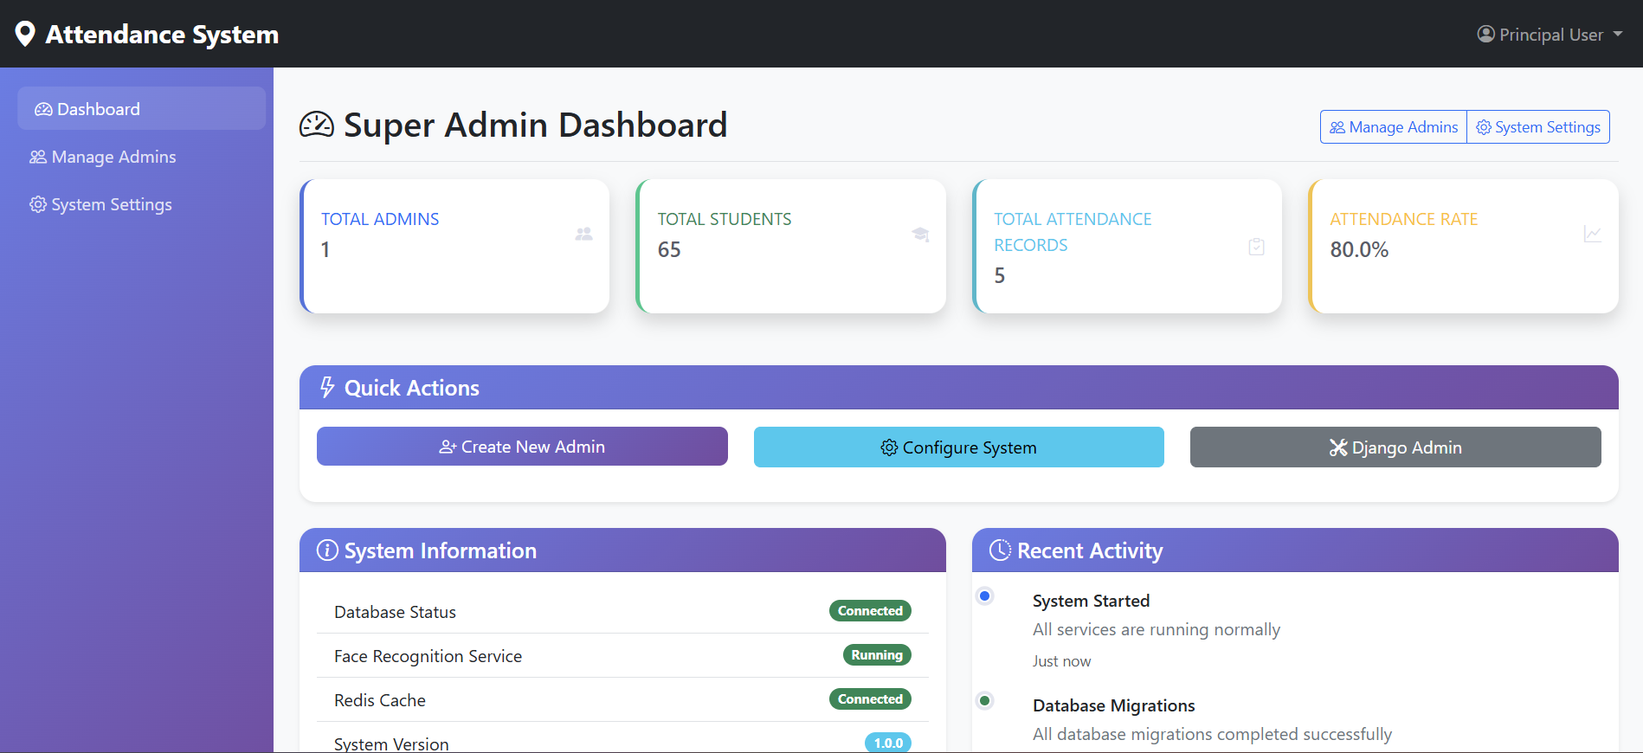
Figure 8.1: Super Admin Dashboard showing system status and statistics.

8.2 Admin Dashboard
Figure 8.2 shows the Admin Dashboard. This interface is designed for college staff. It features a "Quick Actions" menu for common tasks like "Upload Students" (bulk CSV upload), managing "Companies" (Geofence settings), and viewing specific "Analytics". The "Information" panel on the right guides the user on their capabilities. This distinct separation of Super Admin and Admin ensures security and proper delegation of duties.
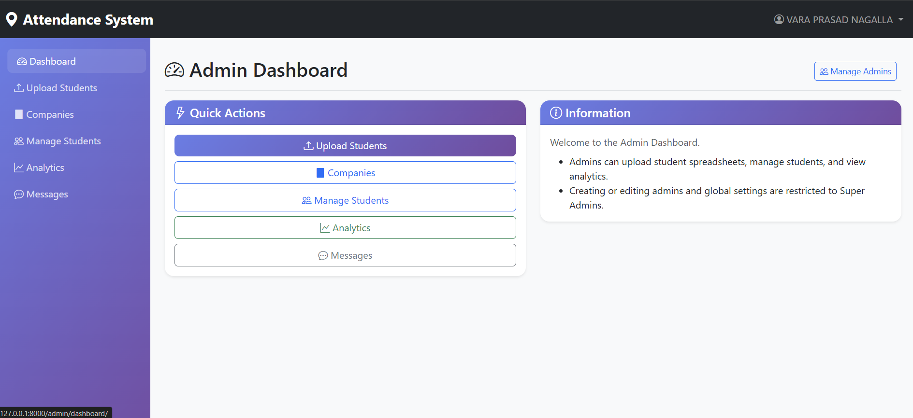
Figure 8.2: Admin Dashboard for managing student data.

8.3 Student Dashboard
Figure 8.3 presents the Student Dashboard. This is the student-facing interface. Upon logging in, the student is greeted with a "Today's Attendance Status" banner. In the screenshot, it shows a green success message: "Present! Your attendance has been marked successfully at 11:14." Below, the "Student Information" card confirms their identity details (Name, JNTU Number). The "Attendance Statistics" card provides immediate feedback on their attendance performance (Days Attended vs Working Days), visualized by a progress bar (50.0% in this test case).
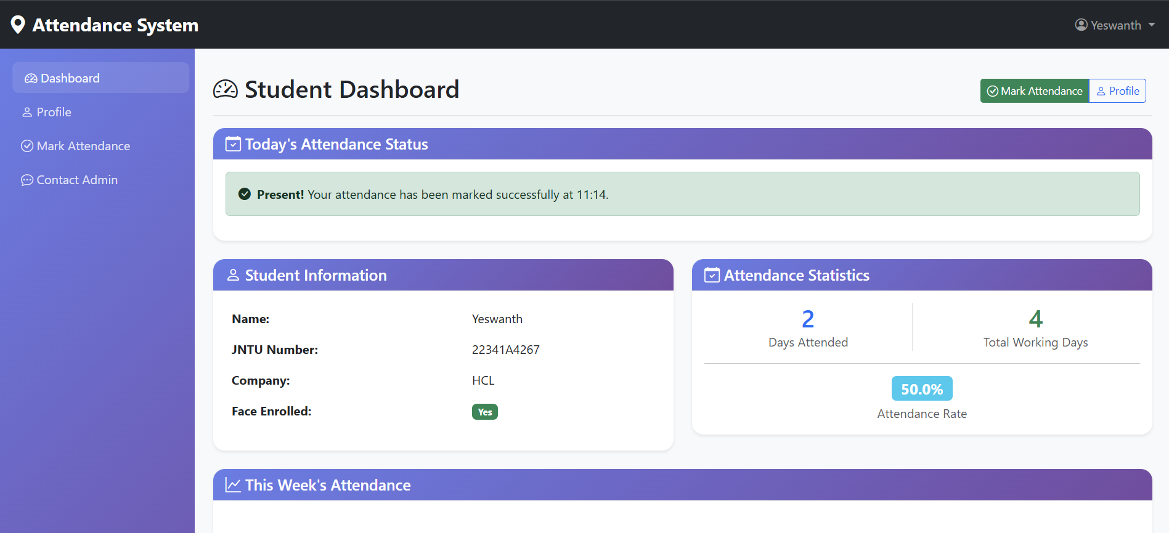
Figure 8.3: Student Dashboard displaying successful attendance and stats.

8.4 Attendance Marking & Location Validation
Figure 8.4 depicts the critical "Attendance Marking" interface. This screen demonstrates the security checks in action.
1. Location Validation: The inputs show the captured Latitude (17.432576) and Longitude (78.440038). The status text confirms "Location captured" and validated against the assigned center radius (200.0 m).
2. Live Selfie Capture: Only after location validation does the "Start Camera" button become active. The user captures a live selfie here.
3. Submission: The green "Mark Attendance" button submits both the image and coordinates to the server for final verification.
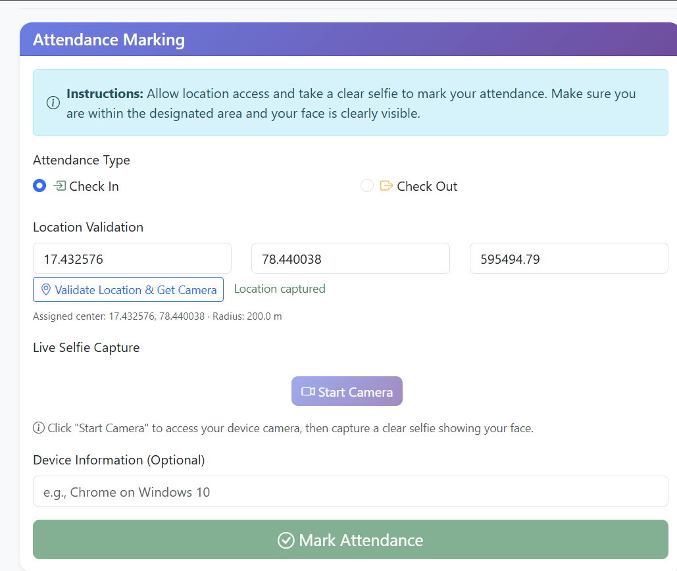
Figure 8.4: Attendance Marking Screen showing Location Validation and Camera Interface.

CHAPTER 9: CONCLUSION AND FUTURE SCOPE

9.1 Conclusion
The Smart Attendance System successfully meets the challenge of modernizing academic attendance. By integrating two powerful technologies—Geo-fencing and Face Recognition—we have created a solution that is secure, efficient, and user-friendly. The system eliminates the loopholes of proxy attendance found in manual and RFID systems. It removes the hygiene concerns and hardware costs associated with fingerprint scanners.
Deployment at Mahalakshmi Women's College of Arts and Science would result in significant operational improvements. Faculty members would save approximately 10-15% of their lecture time, which can be redirected towards teaching. The administrative overhead of data entry is eliminated, and parents/students gain access to transparent, real-time data. The project demonstrates the successful application of Deep Learning AI in a practical, everyday utility.

9.2 Future Scope
The current system lays a solid foundation, but there is always room for enhancement:
- Liveness Detection: To prevent sophisticated spoofing attacks (e.g., holding a video of a student in front of the camera), 3D liveness detection (checking for blinking or head movement) can be implemented.
- Offline Mode (PWA): Developing a Progressive Web App (PWA) version would allow students to mark attendance even with spotty internet connectivity, syncing the data once the connection is restored.
- Automated Timetable Integration: The system can be linked to the college timetable database to automatically detect which subject class is currently ongoing, allowing for subject-wise attendance tracking.
- Notification System: Integration with SMS or WhatsApp APIs to send instant alerts to parents if a student is absent for more than 3 consecutive days.

CHAPTER 10: REFERENCES
- Django Software Foundation. (2025). Django Documentation: The Web Framework for Perfectionists. Retrieved from https://docs.djangoproject.com/
- King, D. E. (2009). Dlib-ml: A Machine Learning Toolkit. Journal of Machine Learning Research, 10, 1755-1758.
- He, K., Zhang, X., Ren, S., & Sun, J. (2016). Deep Residual Learning for Image Recognition. Proceedings of the IEEE Conference on Computer Vision and Pattern Recognition (CVPR), 770-778.
- Dalal, N., & Triggs, B. (2005). Histograms of Oriented Gradients for Human Detection. IEEE Computer Society Conference on Computer Vision and Pattern Recognition (CVPR).
- Geopy Contributors. (2025). Geopy 2.4.0 Documentation. Retrieved from https://geopy.readthedocs.io/
- Mozilla Developer Network. (2025). Geolocation API specification. Retrieved from developer.mozilla.org

