ASSIGNMENT 2.3

Starting Solr :-

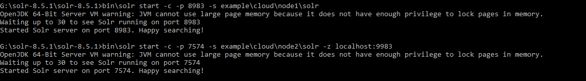

Creating the collection with default configurations. 2 Shards and 2 Replicas



Collection in the GUI

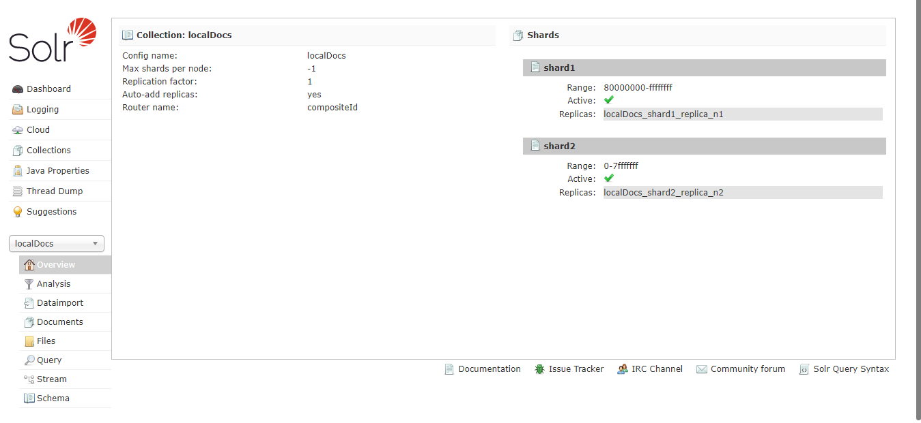

Using the Local file, the indexing of the XML document

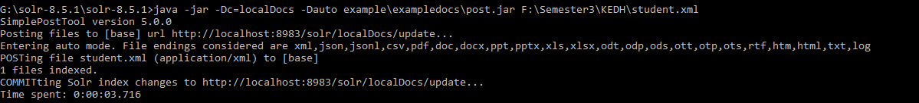

Querying all entries using \*:\* as the search term

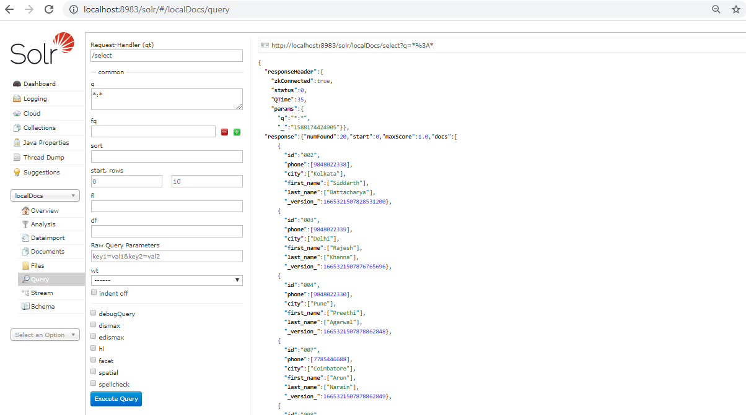

Field specific Search – city = Kolkata

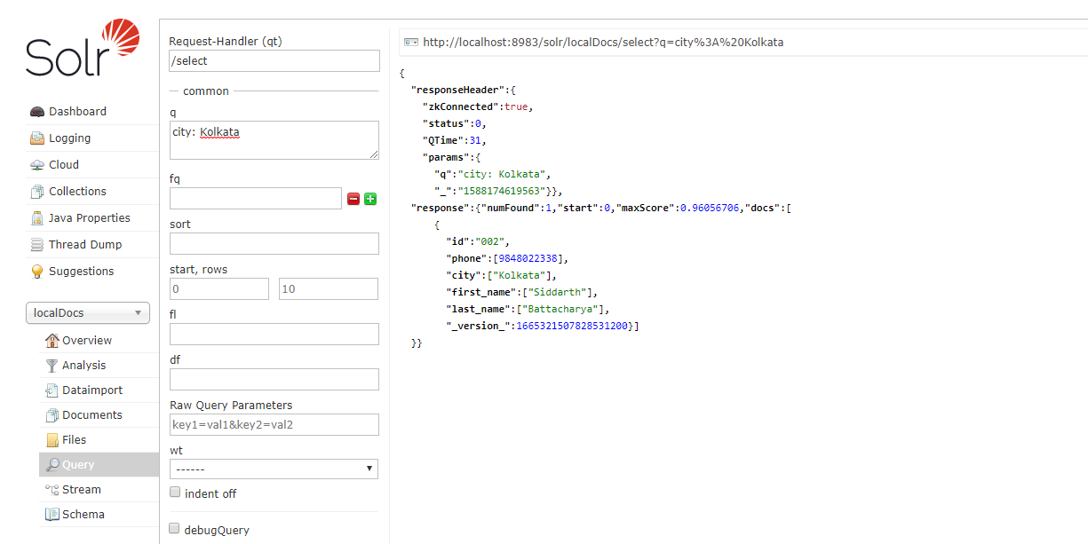

Using Faceting on Phone Field

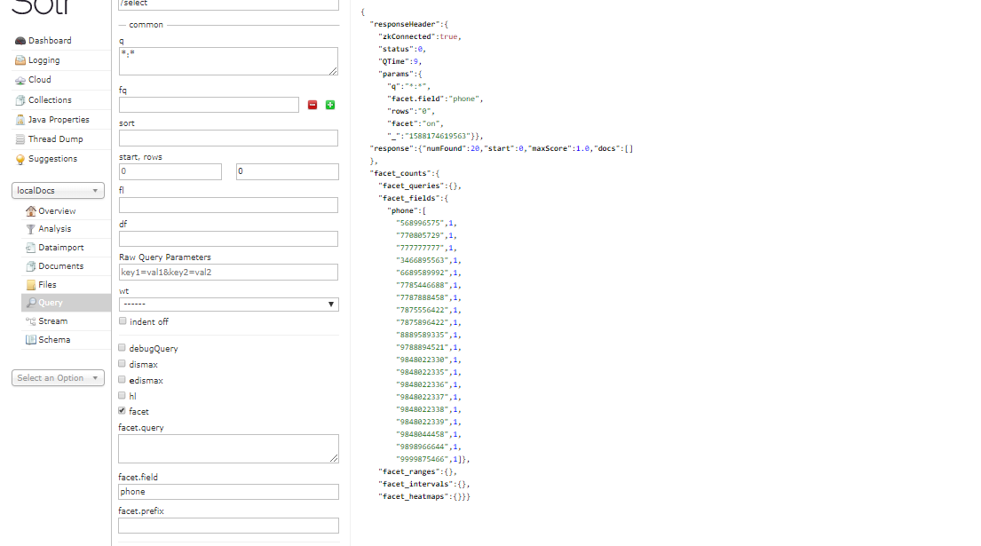

Pivot Facet on City field with min facet count =2.

