Exercise 9.1 – Conceptual questions

❖ Answer the following questions:

1. How are Digitization, Digitalization, and Digital Transformation defined?

Solutions:-

Digitization is the process of taking analogue information and encoding it so that it can be stored and transmitted via a compute

Digitalization is the use of digital technologies to change a business model and provide new revenue and value-producing opportunities; it is the process of moving to a digital business.

Digital Transformation is a strategically planned organizational change and Is mainly driven by companies that adapt their services and products to digital technologies for economic reasons.

Digital Transformation includes a wide number of organizational, social, cultural, creative and management innovations leading to fundamental changes in the way companies work and provide value to their customers.

1. How Digital Transformation is expressed in companies and research institutes?

Solution:

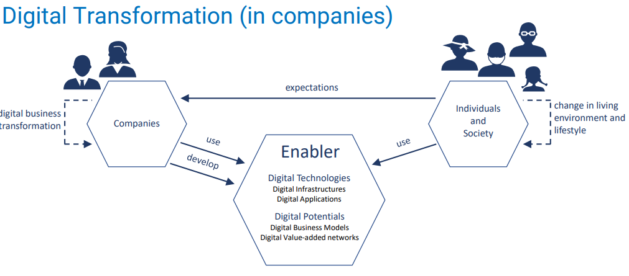

Simple idea:-Digital transformation in companies is driven by the need to provide improved services to clients (individuals and society) and also improve economic benefits of use digital products in their work environment.

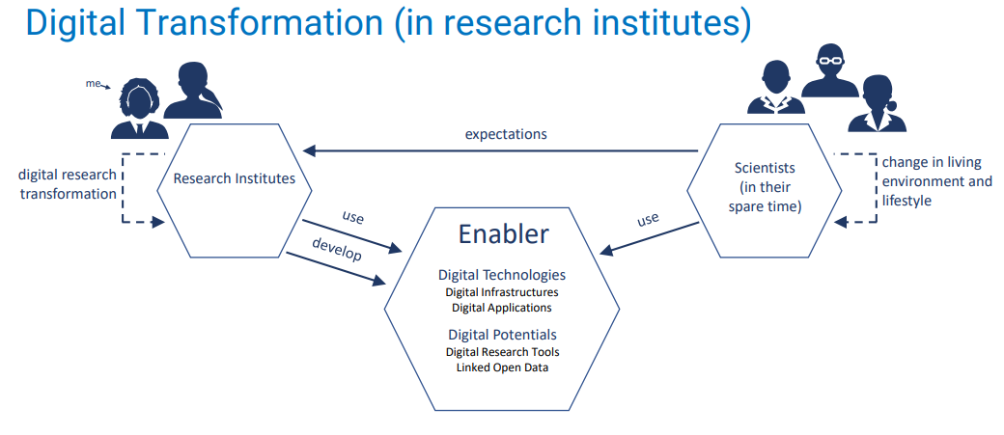

Simple idea:- Research institutes and Scientist view the digital transformation as the next frontier and the means for better quality of advanced research which can be carried out with the support of technology. While use of digital infrastructure hugely affects the process, some of the innovations and the big ideas of technology are from the research institutes which contribute to digital transformation further.