Answer the following questions:

A) How is a Context-free Grammar defined? Explain each symbol.

Intuitive Definition:-

A context-free grammar consists of a set of rules or productions, each of which expresses the ways that symbols of the language can be grouped and ordered together, and a lexicon of words and symbols

Formal Definition:

A context-free grammar G is defined by the following four parameters :

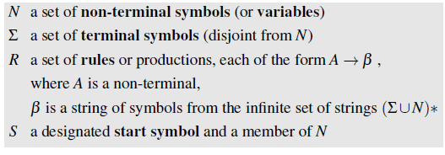

B) What is a corpus? Give a complete definition.

solution:-a collection of texts with linguistic annotations is known as a corpus

C) What a Part-of-Speech tagger is?

The process of classifying words into their parts of speech and labeling them accordingly is known as part-of-speech tagging, POS-tagging, or simply tagging. Parts of speech are also known as word classes or lexical categories. The collection of tags used for a particular task is known as a tagset.

A tagger tags one of the word classes from the tagset to a word.