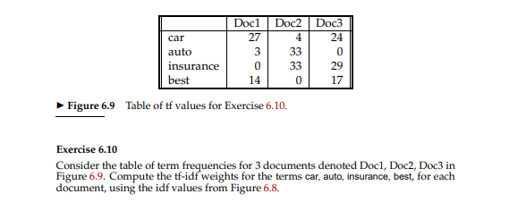

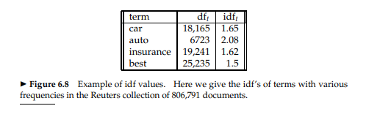

Solution:-

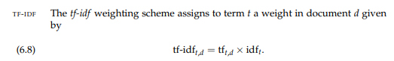

Therefore, the weight for the term car with tf in doc1 =27 and idf score of 1.65 is computed as

tf-idft,d=27*1.65= 44.55

Similarly if we calculate the weights of all the term – document combination as follows:-

|  |  |  |  |
| --- | --- | --- | --- |
| Terms | Doc1 | Doc2 | Doc2 |
| car | 44.55 | 6.6 | 39.6 |
| auto | 6.24 | 68.64 | 0 |
| insurance | 0 | 53.46 | 46.98 |
| best | 21 | 0 | 25.5 |