Autonomous Maritime Cyber Range — Progress Report
Real-physics USV simulation (ArduPilot SITL + Gazebo/VRX) with GPS/AIS/C2 attack modules and live monitoring dashboard
Where We Started
- Goal: a professional, non-"mimicked" cyber range for AUV/MASS vessels — simulate real navigation, then test GPS spoofing, AIS spoofing, and C2 replay/MITM attacks against it.
- Initial approach (custom Python kinematic model) was rejected in favor of real infrastructure: ArduPilot SITL (production autopilot firmware) + Gazebo Harmonic + VRX (the reference USV simulator behind the RobotX competition).
Direction & Key Milestones
- Phase 1 — Physics bridge: connected ArduPilot SITL to Gazebo’s WAM-V hull. Debugged UDP protocol mismatches and thrust scaling; verified real hydrodynamic motion with cross-checked displacement math.
- Phase 2 — Sensors: realistic GPS noise (matched a documented Gazebo bug) and standards-compliant AIS broadcasting (pyais), verified by manual bit-level MMSI decoding.
- Phase 3 — Live dashboard: Leaflet + Socket.IO map showing true vs. ArduPilot-believed position and AIS contacts; verified with browser automation and measured latency.
- Phase 4 — Attacks: GPS spoofing (step/ramp) and AIS spoofing (ghost + impersonation) implemented — forged data confirmed to fool ArduPilot’s real navigation state, not just the display.
- Phase 5 — Autonomy check: root-caused a real AUTO-mode arming blocker (AHRS attitude fault) to an accel_body sign mismatch vs. ArduPilot’s documented convention.
Where We Are Now
- Working: real autopilot + real hydrodynamics, noisy GPS + AIS emulation, live dashboard, GPS spoofing, AIS spoofing — all independently verified against raw data, not just agent-reported claims.
- In progress: C2 replay/MITM module (written, initial run pending full verification) and the AUTO-mode arming fix (root cause identified, fix not yet applied).
Next Plan
- Apply and verify the accel-sign fix to unblock autonomous AUTO-mode waypoint navigation.
- Complete verification of C2 replay/MITM (forged command actually moving the real vessel).
- Build detection layer (rule-based + ML) closing the attack → alert loop on the dashboard; compile final evaluation report.
Visual Evidence
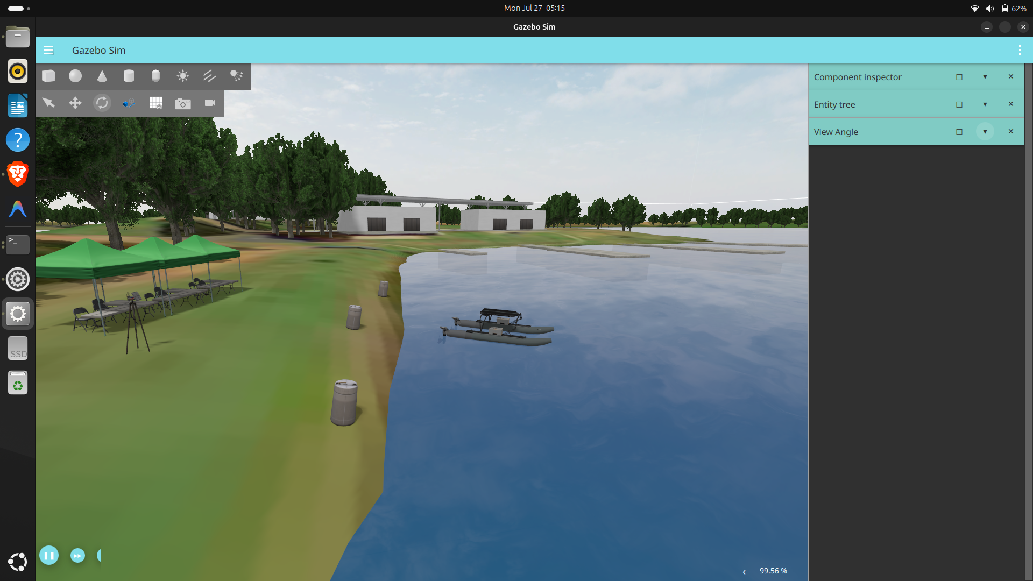  Real 3D hydrodynamic simulation — WAM-V hull on live water physics | 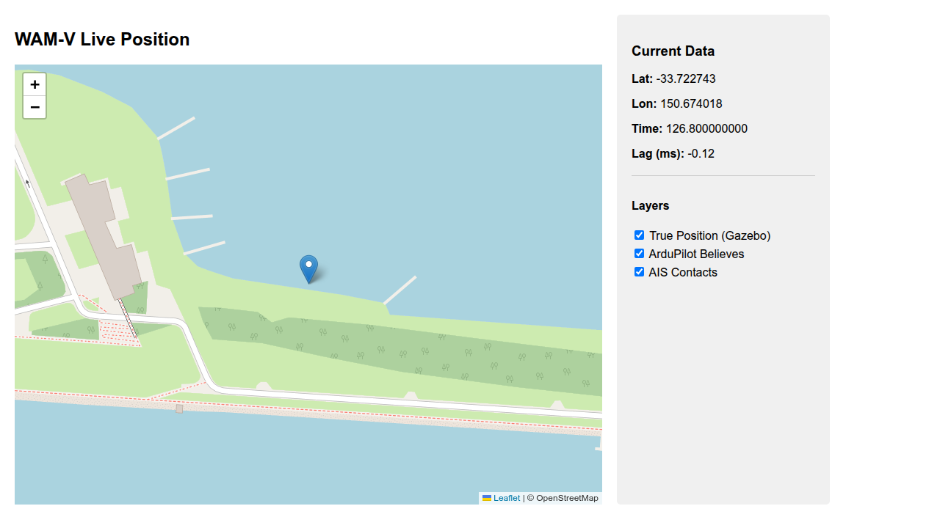  Dashboard: true vs. ArduPilot-believed position (GPS spoof, recovered)
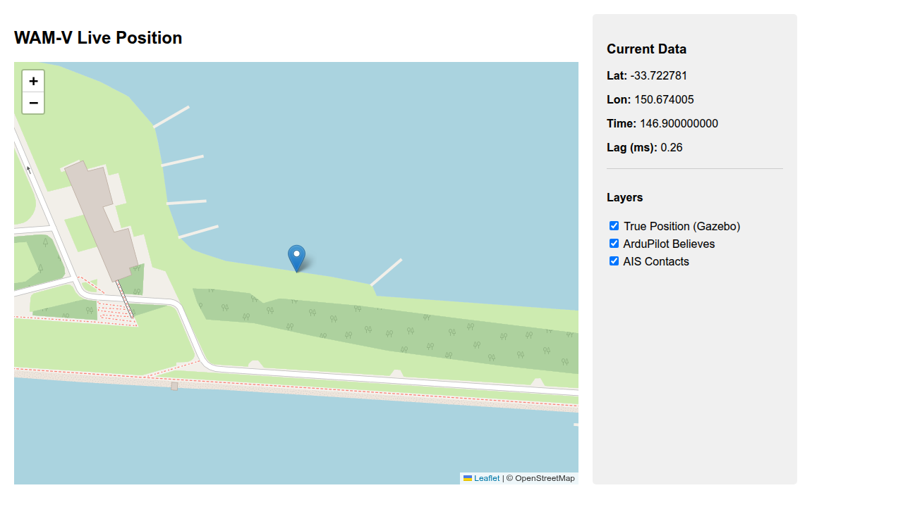  AIS ghost-vessel injection: fabricated contact beside genuine vessel | 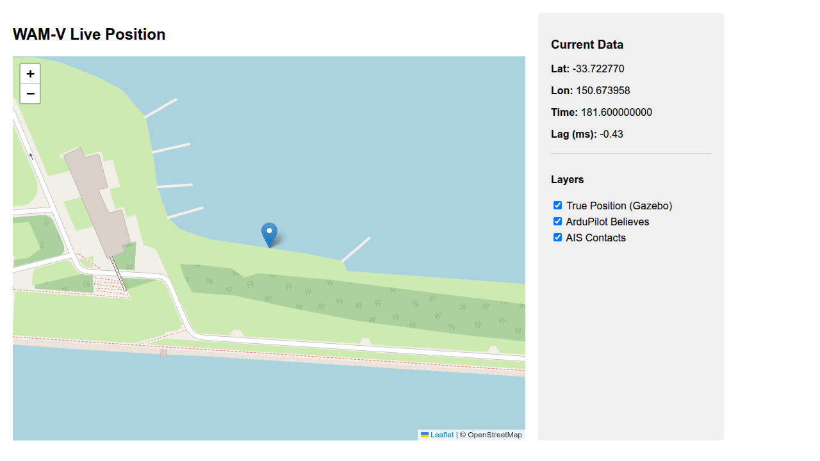  Dashboard baseline / all-clear state after attack testing

