XY-6020L 1200W 20A CVCC Buck Power Supply Module

Description:
XY-6020L is a DC-DC 20A 1200W High Power CVCC Adjustable Automatic Buck Power Supply Module with a new generation of larger LCD display screen. It is a non-isolated converter which supports solar charging. It can convert DC 6V-70V to DC 0.0V-60V power supply and can provide stable output.It can be used as ordinary buck power supply module, battery/solar charger or LED constant current drive and so on.
Its main function is output voltage as a constant voltage constant current source. It can be used to test the discharge time and discharge capacitance of the input voltage.
Especially, its controller and output driver are designed separately, allowing users to flexibly adjust installation and usage methods according to their actual situation. It is a worthwhile power adapter to have.

Features:
1>.1200W High Power: It adopts digital control technology to obtain stable output power supply. Up to 1200W output power which can meet the vast majority of needs. Input DC 6V-70V and max output 60V/20A equipped with aluminum heat sink and fan.
2>.Solar Charging: It can output a stable voltage value when the input voltage changes which is very suitable for solar energy systems such as solar charging, solar power supply, solar voltage conversion.
3>.Adjust CVCC: Constant voltage and constant current can not only stabilize the voltage, but also set the limit output current value to meet the current demand of the load. At the same time, it can also protect the load to avoid entering the over-current state.
4>.Larger HD LCD display screen: It adopts an upgraded full view large screen, which can display multiple parameters and working status at the same time.Experience more fluency.
5>.Programmable Multi Parameter: It can set/display output voltage/current/power,work time, output electric energy, output capacity, input voltage and ON/OUT/CV/CC work status.You can also set default output state after power on.
6>.Multiple Protection Mechanisms: Under-voltage, over-voltage, over-current, over-power protection, over-temperature, over-capacity, over-energy protection, timeout-protection and so on.

Functions:
1>.Max 1200W/20A Output Voltage 2>.Larger HD Full View LCD Display Screen 3>.Adjust CVCC Control Output
4>.DC 6V-70V Wide Range Input Voltage 5>.DC 0V-60V Wide Range Output Voltage 6>.Solar Charging Control
7>.Separate Controller
8>.RS485 MODBUS Communication Control 9>.10 sets output preset function 10>.Display output voltage/current/power 11>.Display time/energy/capacity
12>.Display Multiple Parameters Simultaneously 13>.Display input voltage, ON/OUT/CV/CC work status 14>.10 working protection modes
15>.Power-down Memory Function 16>.Power-down Saving Work Mode 17>.Parameter locking to avoid misoperation 18>.Automatic control cooling fan
19>.Drive board independent output voltage

4.Parameters:
1>.Work Voltage:DC 6V-70V 2>.Output Voltage: DC 0V-60V 3>.Output Current: 0~20A 4>.Output Power: 1200W(Max)
5>.Max Output Voltage: (IN-volt/1.1)-2 6>.Output Ripple: 100mV VPP

7>.Voltage Display Resolution:0.01V 8>.Current Display Resolution:0.001A 9>.Current Display Precision:+/-0.5%+0.003A
10>.Input Voltage Display Precision:+/-1%+0.01V 11>.Output Voltage Display Precision:+/-0.4%+0.01V 12>.Conversion efficiency:About 90%
13>.Input Under-voltage Protection:Yes(4.8V-71V adjustable, default 4.8V) 14>.Input over-voltage Protection:Yes(0V-71V adjustable, default 71V) 15>.Output over-voltage Protection:Yes(0V-65V adjustable, default 65V) 16>.Output over-current Protection:Yes(0A-22A adjustable, default 22A) 17>.Output over-power Protection:Yes(0W-1250W adjustable, default 1250W) 18>.OnBoard Over-temperature Protection:Yes(60-110℃ adjustable, default 95) 19>.External Over-temperature Protection:Yes(0-110℃ adjustable, default OFF)) 20>.Timeout Protection:Yes(0-100H adjustable, default OFF)
21>.Over-capacity Protection:Yes(0-9999AH adjustable, default OFF) 22>.Over-energy Protection:Yes(0-9999WH adjustable, default OFF) 23>.Work Temperature:-20℃~85℃
24>.Work Humidity:10%~85%RH 25>.Driver Size:109*72*42mm 26>.Controller Size:79*43*27mm

Potentiometer Function:
1>.Normal Display Status:
  - >.Short(click) press: Switch display output power, output capacity, output energy, output time at the third line.
  - >.Long(keep) press: ON/OFF parameter locking function. There is a lock symbol on left at the first line if turn ON parameter locking function. The parameter value cannot be changed at this status.It can be used to protect parameters from being modified by mistake.
  - >.Rotate: Change output constant voltage value or constant current value or no function.
Note:Parameters can be switched through ‘V/A’ button.
2>.Voltage/Current Set Status:
  - >.There is a ‘SET’ and ‘CV’ or ‘CC’ symbol on left at the third line if enter Voltage/Current Set Status by rotate potentiometer.
  - >.Short press:Switch the modified parameter bit.
  - >.Long press: Not available.
  - >.Rotate: Change output voltage value or constant current value or no function. 3>.Parameter Set Status:
  - >.Short press:Switch the modified parameter bit.
3.2>.Long press: Not available. 3.3>.Rotate: Change parameter value.

V/A Button Function:
1>.Normal Display Status:
  - >.Short press:Enter the modified parameter voltage or current status.
  - >.Long press: Not available. 2>.Voltage/Current Set Status:
2.2>.Short press:Switch the modified parameter voltage or current or save/exit.
2.3>.Long press: Save voltage or current value and exit. 3>.Parameter Set Status:
  - >.Short press:Not available.
  - >.Long press: Not available.

SW Button Function:
1>.Normal Display Status:
  - >.Short press: Switch display input voltage or output voltage at the first line. Note: There is a ‘IN’ symbol on left when display input voltage.
  - >.Long press: Enter parameter set interface. 2>.Voltage/Current Set Status:

2.2>.Short press:Switch the modified parameter bit.
2.3>.Long press: Not available. 3>.Parameter Set Status:
  - >.Short press:Switch the modified parameter.
  - >.Long press: Save parameter value and exit parameter set status.

ON/OFF Button Function:
1>.Normal Display Status:
  - >.Short press: Turn ON or OFF output voltage.
  - >.Long press: Clear statistical value at Power/Capacity/Energy/Time display interface. 2>.Voltage/Current Set Status:
2.2>.Short press:Turn ON or OFF output voltage.
2.3>.Long press: Not available. 3>.Parameter Set Status:
  - >.Short press:Turn ON/OFF OAH/OPH/OHP function. Note: ‘ ’ means turn OFF this function.
  - >.Long press: Switch the decimal point position to change the parameter unit for OAH/OPH. OAH range is 9.999Ah/99.99Ah/999.9Ah/9999Ah. OPH range is 9.999Wh/99.99Wh/999.9Wh/9999Wh.

Set Parameter:

1>.Set Output Voltage/Current.
  - >.At Normal Display Status, short press ‘V/A’ button enter into voltage/current set interface.
  - >.There is a ‘SET’ and ‘CV’ symbol on left at the third line and the bit keep flashing. It means to modify the voltage value first.
1.3>.Short press ‘SW’ button or Potentiometer can switch the modified bit. 1.4>.Rotating potentiometer changes the voltage value.
  - >.Press ‘V/A’ button again to change current value and display ‘CC’ symbol and change value by the same method.
  - >.Press ‘V/A’ button again to save and exit. 2>.Quickly Set Voltage or Current.
  - >.This method is use to set voltage or current by rotary potentiometer without any other additional operations.However, it is not recommended, because as long as the potentiometer is turned, the output value can be changed which is easy to misoperate.
  - >.Set parameter ‘FET’ to select ‘CV’ or ‘CC’ or ‘OFF’.
  - >. ‘CV’ means enable voltage quick setting at Normal Display Status by rotary potentiometer.
  - >. ‘CC’ means enable current quick setting at Normal Display Status by rotary potentiometer.
  - >. ‘OFF’ means disable quickly set voltage or current function. No change when rotary potentiometer at Normal Display Status. Recommend!
3>.Set Parameter.
  - >.At Normal Display Status, keep press ‘SW’ button 2second enter into parameter set interface.
  - >.Short press ‘SW’ button to switch parameter.
3.3>.Short press potentiometer to switch the modified bit. 3.4>.Rotating potentiometer changes the parameter value.
  - >.Short press ‘ON/OFF’ button to turn ON/OFF Max-capacity OAH, Max-energy OPH, Max-running-time OHP function. ‘ ’ means turn OFF this function
  - >.Keep press ‘ON/OFF’ button to set parameter unit at Max-capacity OAH, Max-energy OPH interface.Switch the decimal point position to change the parameter unit for OAH/OPH. OAH range is 9.999Ah/99.99Ah/999.9Ah/9999Ah. OPH range is 9.999Wh/99.99Wh/999.9Wh/9999Wh.
  - >.Keep press ‘SW’ button 2second to save parameter and exit. 4>.Switch Display Input Voltage or Output Voltage.
  - >.At Normal Display Status, short press ‘SW’ button to switch display input voltage or output voltage at the first line.
  - >.Note: There is a ‘IN’ symbol on left when display input voltage. 5>.Query Parameter Power W, Capacity AH, Energy WH, Time H.
  - >.At Normal Display Status, short press potentiometer to switch display Power W, Capacity AH, Energy WH, Time H at the third line.
  - >.Pay attention to unit change. 6>.Lock/Unlock Parameter.

  - >.At Normal Display Status, keep press potentiometer 2second to lock or unlock parameter output voltage and current.
  - >.There is a lock symbol on left at the first line.
  - >.The parameter value cannot be changed at lock status.
  - >.It can be used to protect parameters from being modified by mistake.Recommend! 7>.10 Sets Output Preset Function.
  - >.This function is used to preset output voltage and current values, facilitating quick switching of output voltage and current values in the later stage. A total of 10 sets of parameter values can be set, and users can set commonly used values in advance.
  - >.The preset numbers for the data group are Cd0~Cd9.
  - >.Data is saved in Cd0 by default. Cd8 is 12V and Cd9 is 24V, these two can not be modified.
  - >.At Normal Display Status, keep press ‘V/A’ button 2second enter into Output Preset interface. It is used to set/save new Output Preset Value or switch Output Preset Value that have already been set.
  - >.Short press ‘V/A’ button to switch select output voltage CV, output current CC or data group numbers Cd.
  - >.Rotating potentiometer changes the selected parameter value.
  - >.Keep press ‘V/A’ button 2second to save parameter value and exit.
  - >.Note: User just need change Cd value if just switch Output Preset Value that have already been set.

Auxiliary Function:

1>.Statistics Capacity, Energy and Work Time.
  - >.The statistics are started when turn ON output, and the statistics are stopped when the turn ON at next time.
  - >.Stop statistics after turn OFF output.
  - >.start the statistics again when the output power is turned on again.
  - >.Keep press ‘ON/OFF’ button 2second to clear statistical value at Power, Capacity, Energy, Time display interface.

2>.Set Maximum Output Capacity OAH.
  - >.It turns OFF output and LCD flashing display OAH when Statistics Capacity Value is more than set maximum value OAH if enabled OAH function.
  - >.Automatically clear capacity statistics after the alarm is cleared.
  - >.It will automatically count whether or not OAH is turn ON. But it will keep output if turn OFF OAH function.
  - >.Its set range is 0~9999Ah. 3>.Set Maximum Output Energy OPH.
  - >.It turns OFF output and LCD flashing display OPH when Statistics Energy Value is more than set maximum value OPH if enabled OPH function.
  - >.Automatically clear energy statistics after the alarm is cleared.
  - >.It will automatically count whether or not OPH is turn ON. But it will keep output if turn OFF OPH function.
  - >.Its set range is 0~9999Wh. 4>.Set Maximum Running Time OHP.
  - >.It turns OFF output and LCD flashing display OHP when Statistics Work Time is more than set maximum value OHP if enabled OHP function.
  - >.Automatically clear work time statistics after the alarm is cleared.
  - >.It will automatically count whether or not OHP is turn ON. But it will keep output if disabled OHP function.It is countdown mode if enabled OHP.
  - >.This function can be used for timed power supply.
  - >.Its set range is 0~100H.

5>.Set Output Voltage by 3Bit Toggle Switch.
  - >.The power drive motherboard can be used separately, and the output voltage value can be changed by switching the red 3Bit toggle switch.
  - >.It can output 5V,9V,12V,24V,36V,48V,60V separately. Note: It can not output other voltage value.
  - >.Output current can not be set and the maximum output current is 20A.
  - >.It must be switched to the NC state if the output value is controlled by LCD Controller.

6>.RS485 MODBUS Communication Control.
  - >.It can be controlled by a TTL/RS485 UART MODBUS module. It can achieve simultaneous control of multiple power motherboards.
  - >.Note: MODBUS Module is not included in the product list. It need to purchase it separately if users need to use MODBUS control.

7>.WIFI Remote Control.
  - >.It can be controlled by a XY-WFPOW WIFI Receiver Module. It can connect the power supply to the internet and monitor and modify parameter values in real-time through the APP SiniLink.
  - >.Note: XY-WFPOW WIFI Receiver Module is not included in the product list. It need to purchase it separately if users need to use wireless control.
  - >.Note: APP SiniLink must be registered before it can be used. Please consider whether to accept the registration function.

Protection mechanism:
1>.LVP under voltage protection.The default protection value is 4.8V.But user can modify the values as required.Its set range is 4.8V-71V. Screen will display LVP and flashing after start under voltage protection.In the battery discharge test, setting the appropriate LVP can effectively prevent the battery from being over-discharged, so as not to damage the battery.
2>.OVP over voltage protection.The default protection value is 65V.But user can modify the values as required.Its set range is 0V-65V.Screen will display OVP and flashing after start over voltage protection.
3>.OCP over current protection.The default protection value is 22A.But user can modify the values as required.Its set range is 0V-22V.Screen will display OCP and flashing after start over current protection.
4>.OPP over power protection.The default protection value is 1250W.But user can modify the values as required.Its set range is 0W-1250W.Screen will display OPP and flashing after start over power protection.
5>.OTP over temperature protection.The default protection value is 95℃.Its set range is 60-110℃. Screen will display OTP and flashing after start over temperature protection. Note: This temperature sensor on power motherboard.
6>.ETP over temperature protection.The default is OFF status.Its set range is 0-110℃. Screen will display ETP and flashing after start over temperature protection. Note: This 10K NTC temperature sensor needs to be prepared and connected by the user to the XH2.54-2P white socket on power motherboard.

Use steps:
1>.Connect right work voltage from VIN+ and VIN-. 2>.Set output voltage and output constant current. 3>.Set others parameters as require.
4>.Remove work power supply. 5>.Connect load at output terminal. 6>.Re-power ON and use this item.

Note:
1>.It is a DC power module,So it can not connect to AC power.
2>.3Bit Red Toggle Switch must be switched to the NC state if the output value is controlled by LCD Controller.
3>.It is a step down power supply, so the output voltage must be less than the input voltage.
4>.The maximum output voltage is ‘(IN-volt/1.1)-2’, that means the maximum output is ‘44/1.1-2’=38V if the input voltage is 44V. So the set output voltage can not more then 38V.
5>.Please connect input before connect battery when use as charge and make sure output voltage is higher than battery voltage.
6>.Please make sure input power is more than load power. 7>.Please step down output power if module is hot.
8.>Please read use manual and description before use.

Application:
1>.High-power LED constant current drive 2>.Lithium battery charging
3>.Ni-Cd or Ni-MH battery charging 4>.Solar panel
5>.Wind Turbines

6>.Ordinary power supply 7>.Instrument voltage display 8>.Test meter
9>.Circuit test 10>.Power conversion

Package:
1>.1pcs XY-6020L 1200W 20A CVCC Buck Power Supply Driver Module 2>.1pcs XY-6020L 1200W 20A CVCC Buck Power Supply Controller Module 3>.2pcs 20cm 1.27mm 5Pin Wire
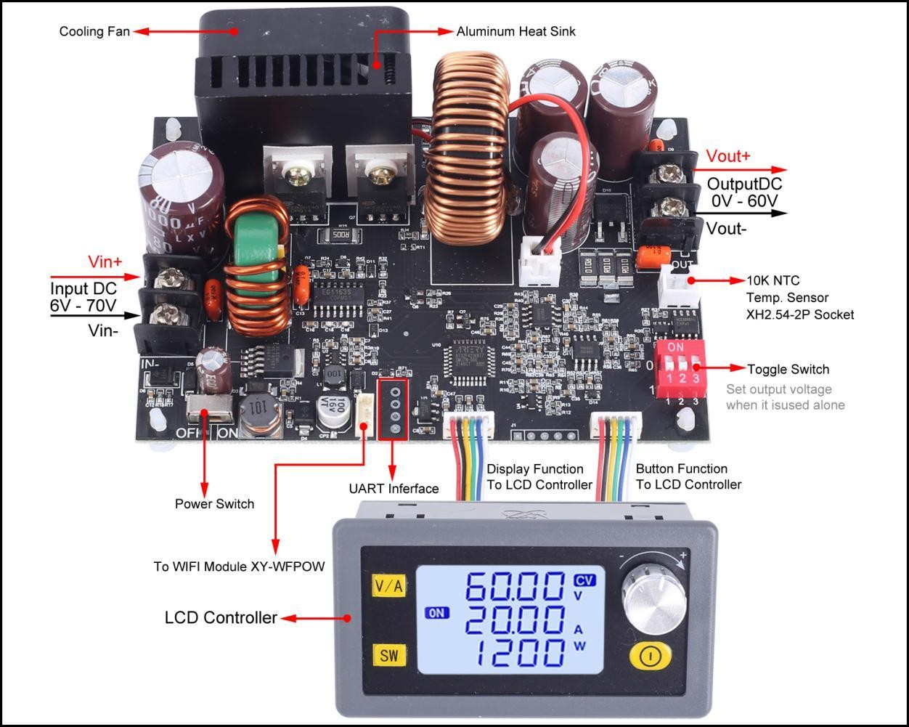

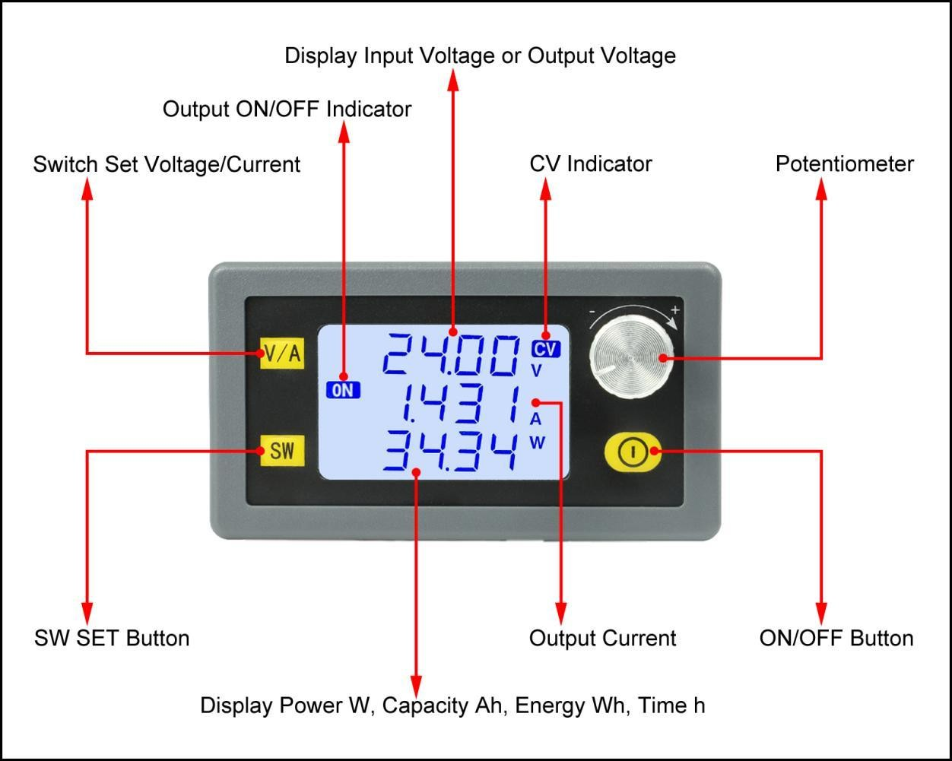
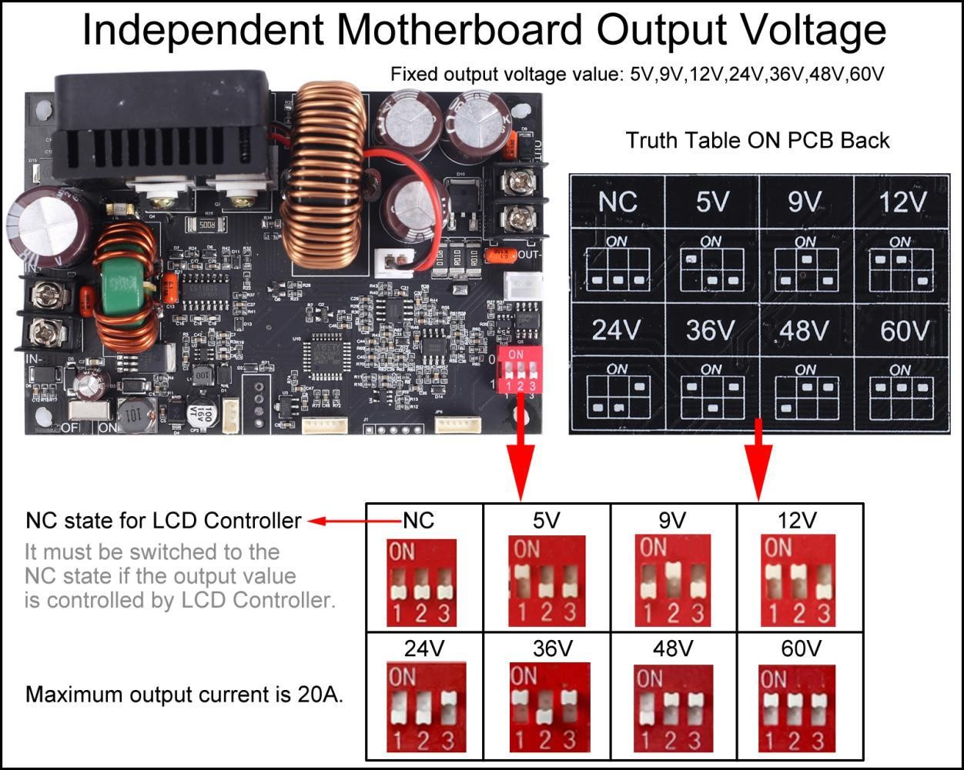

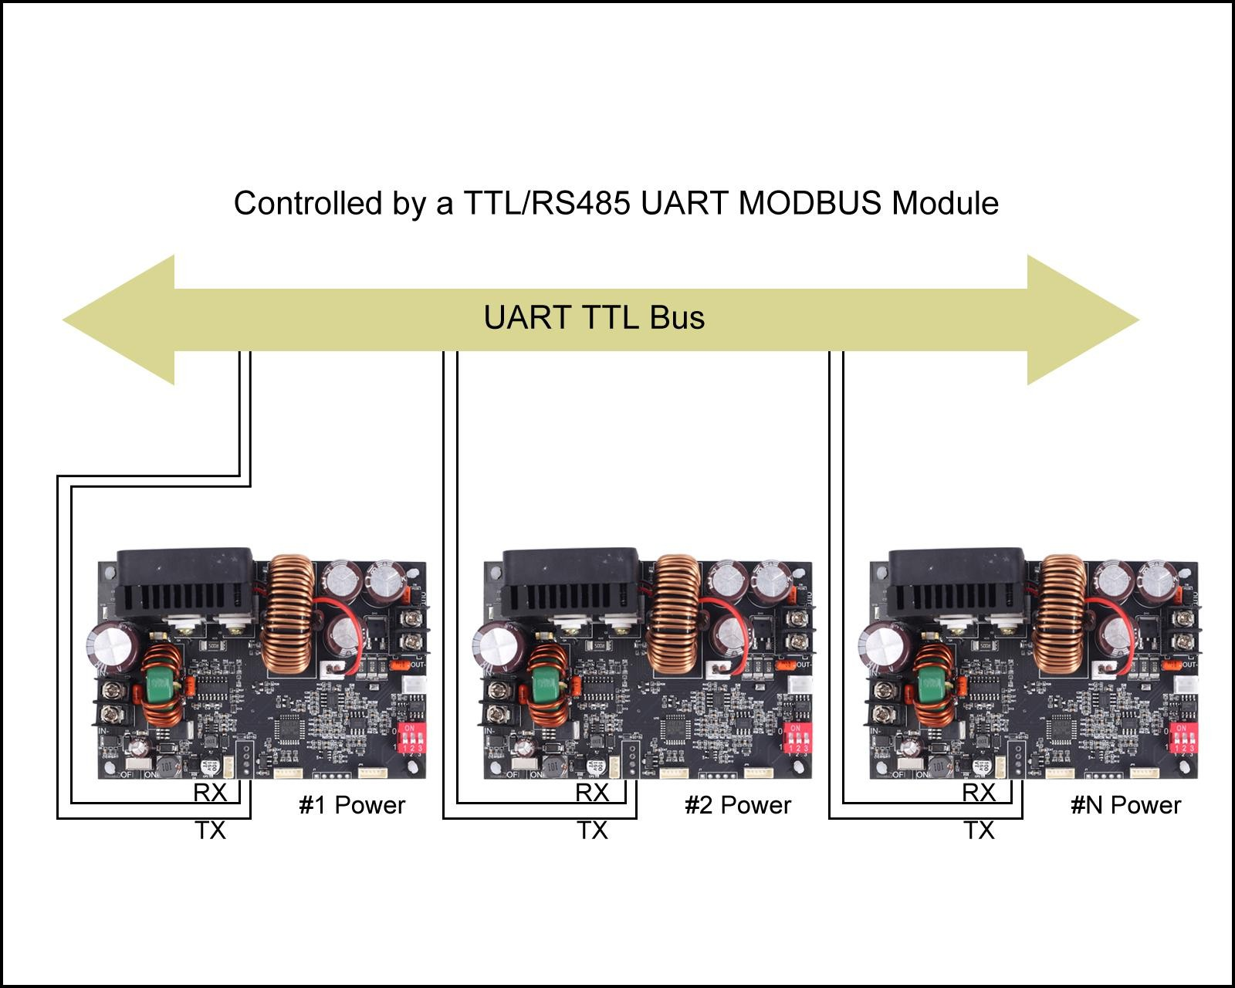
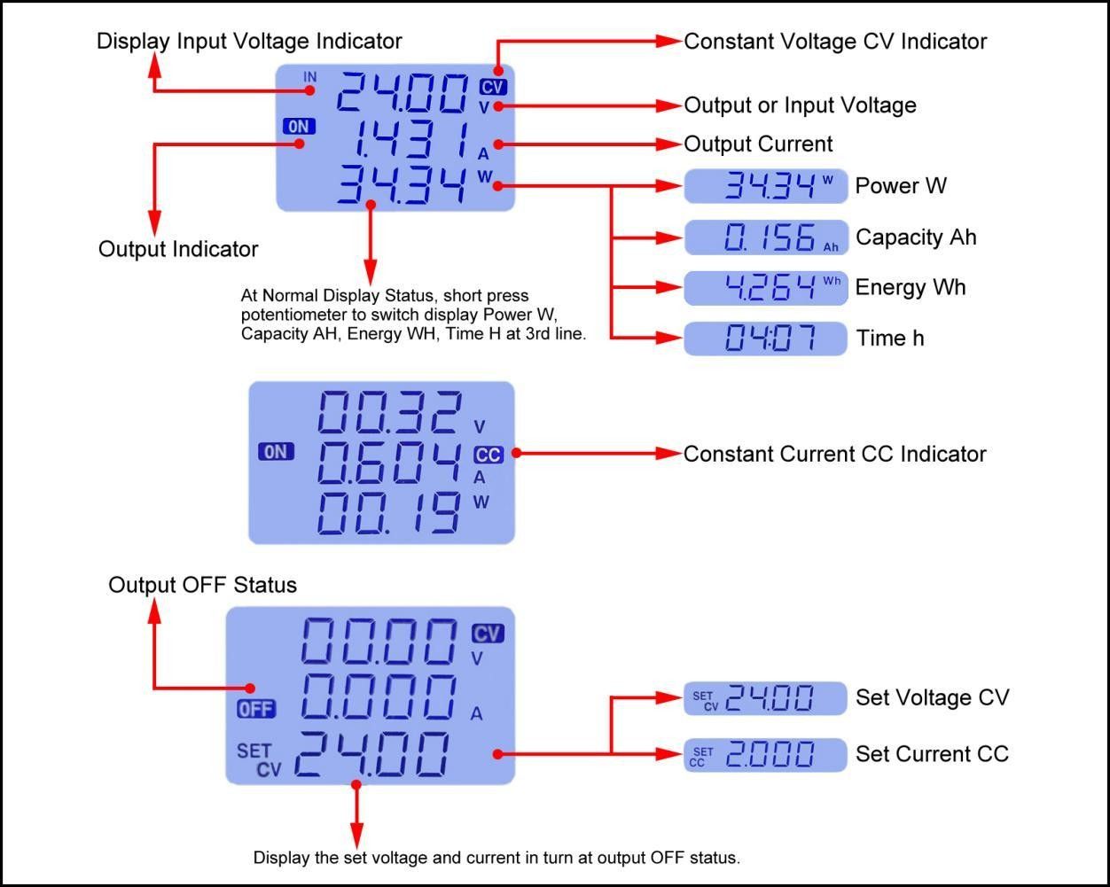

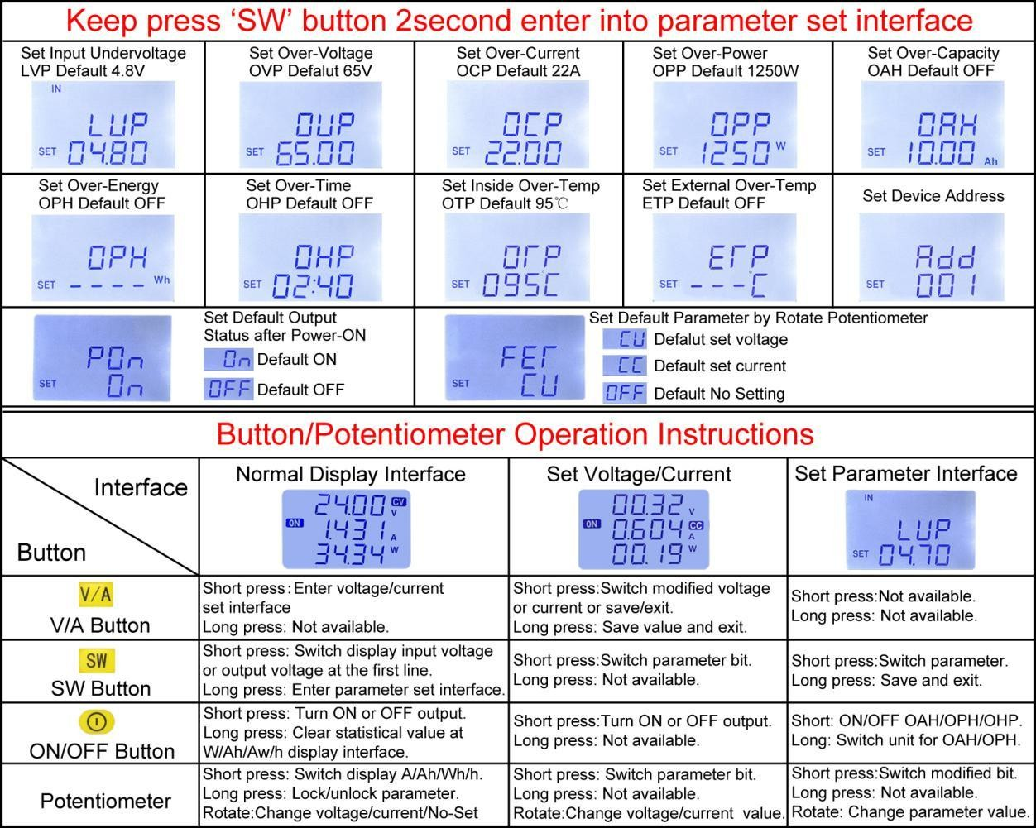
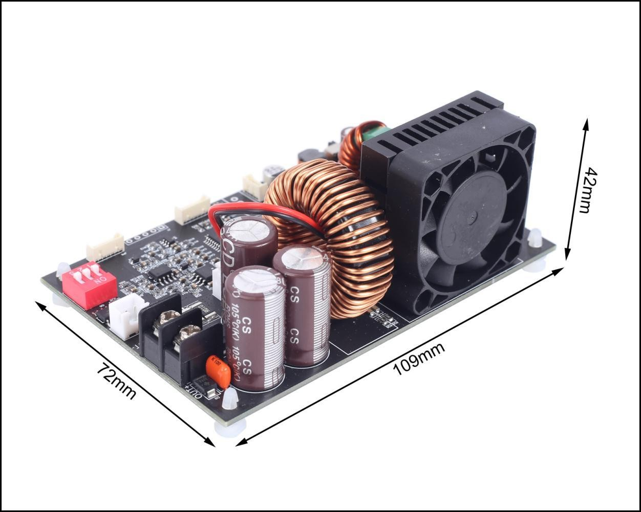

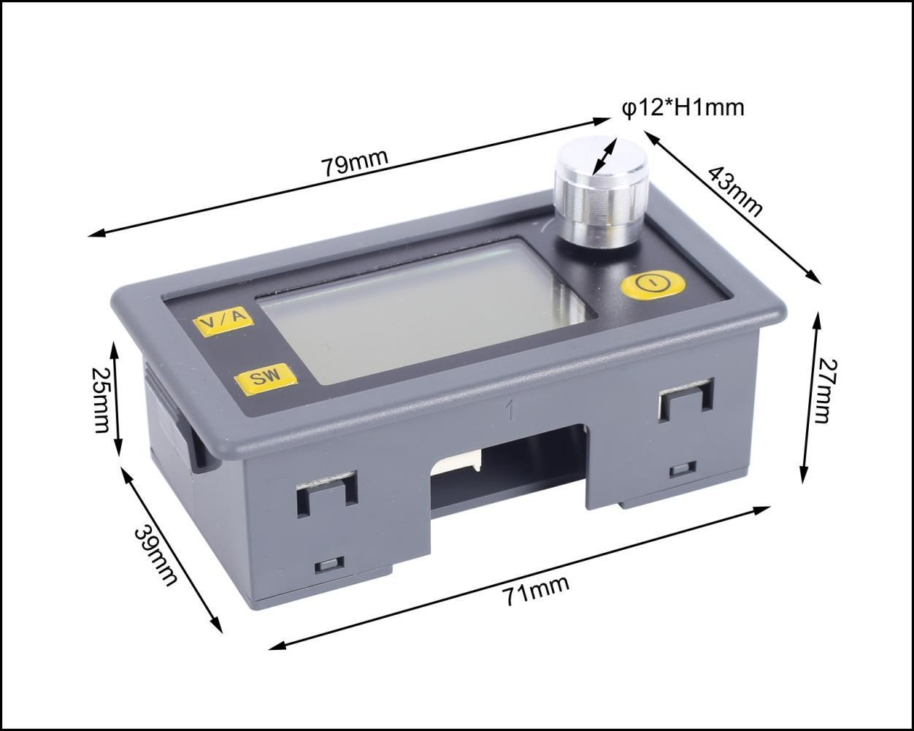
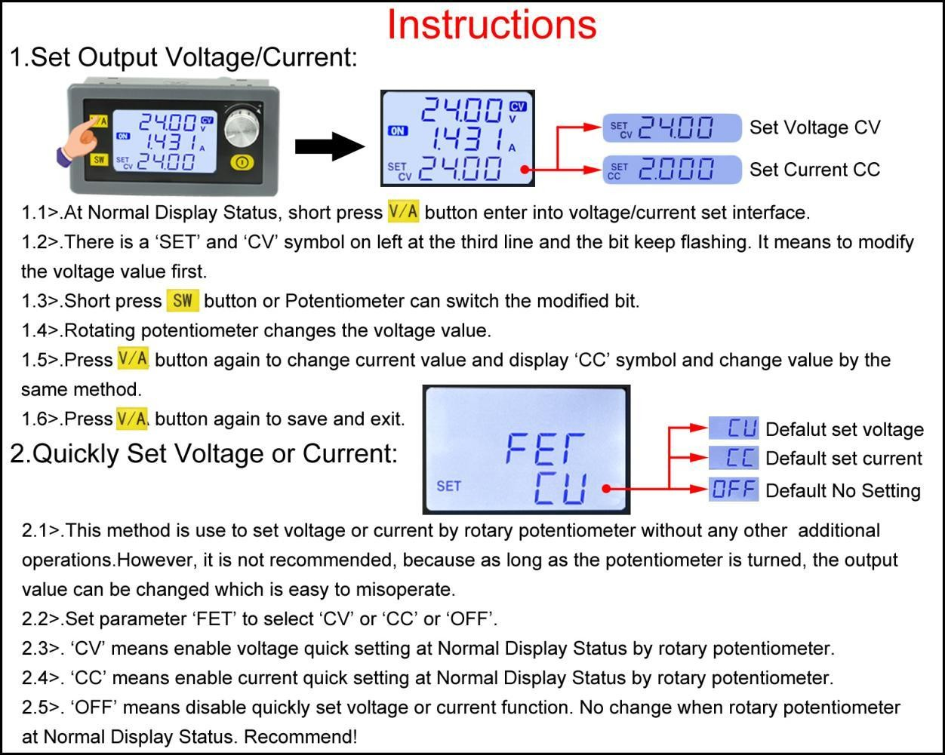

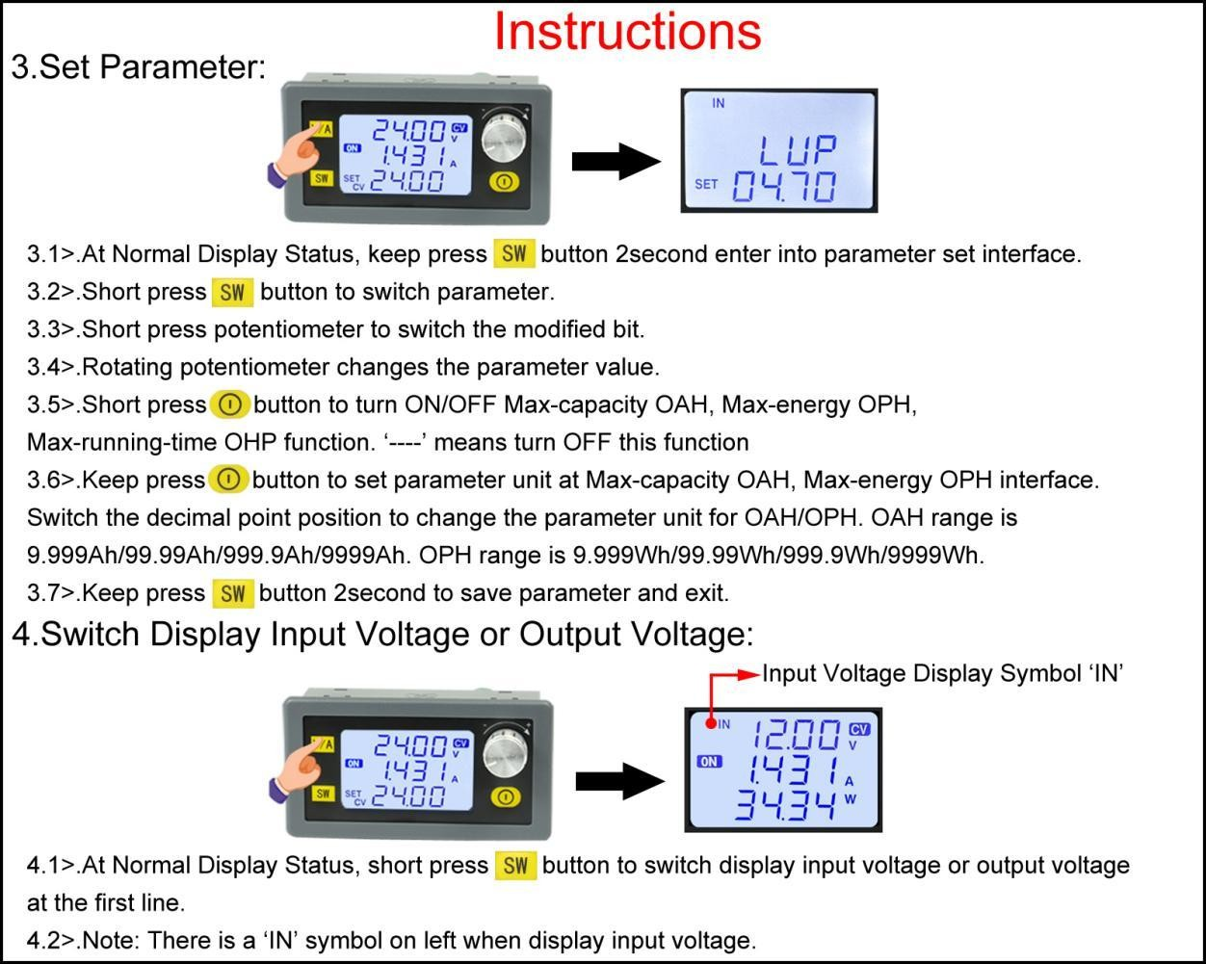
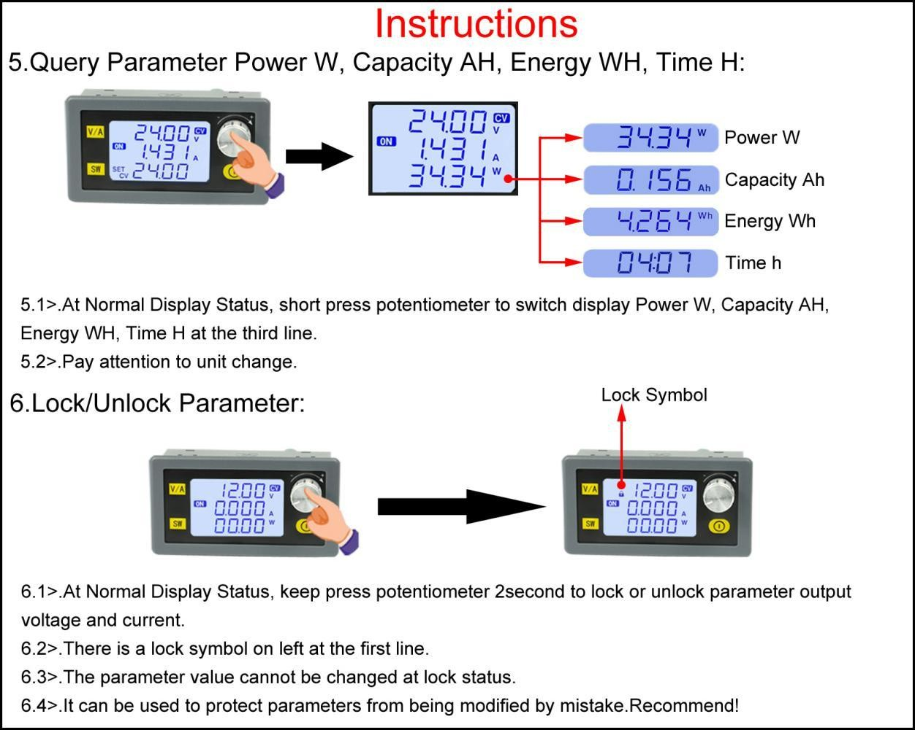

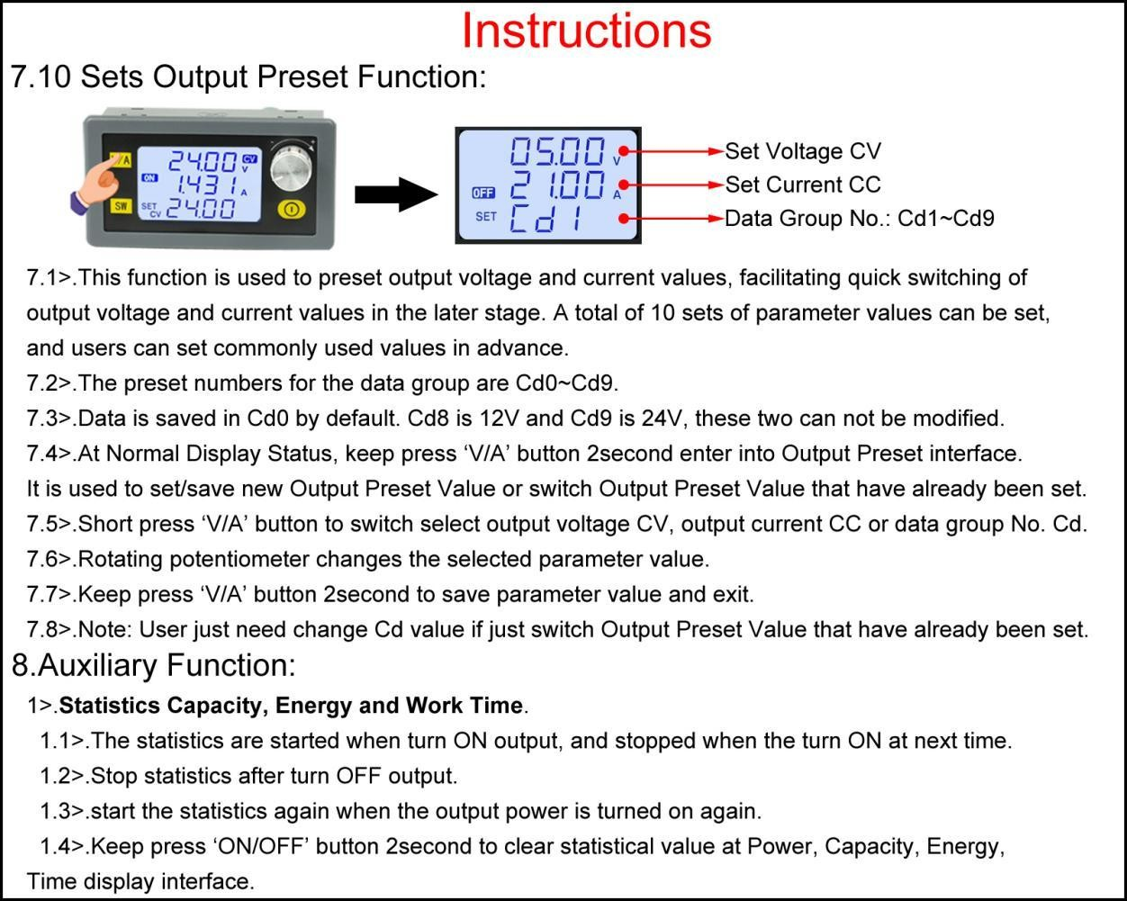
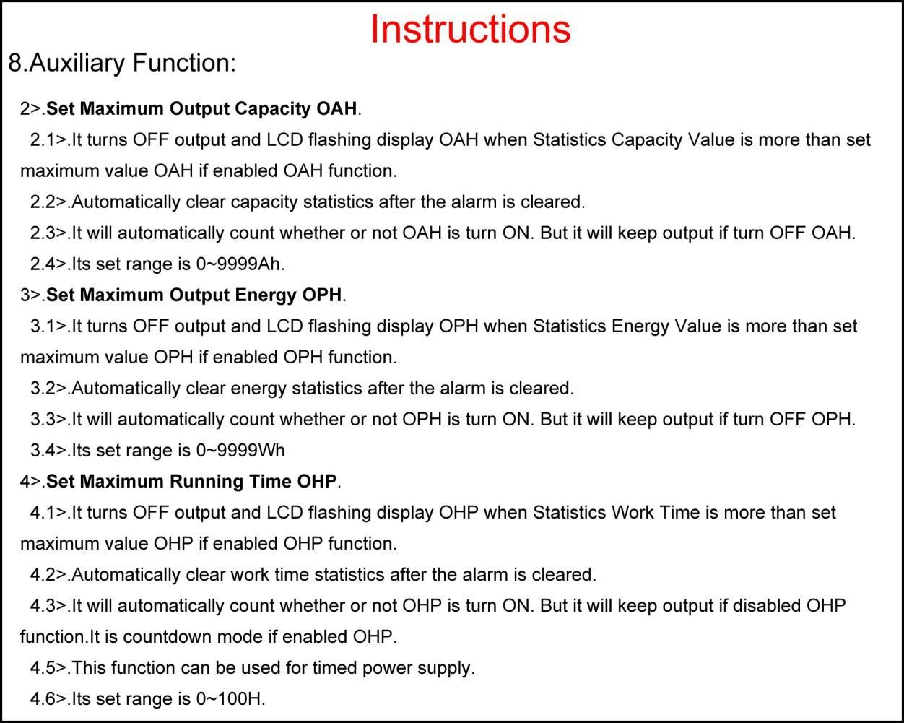

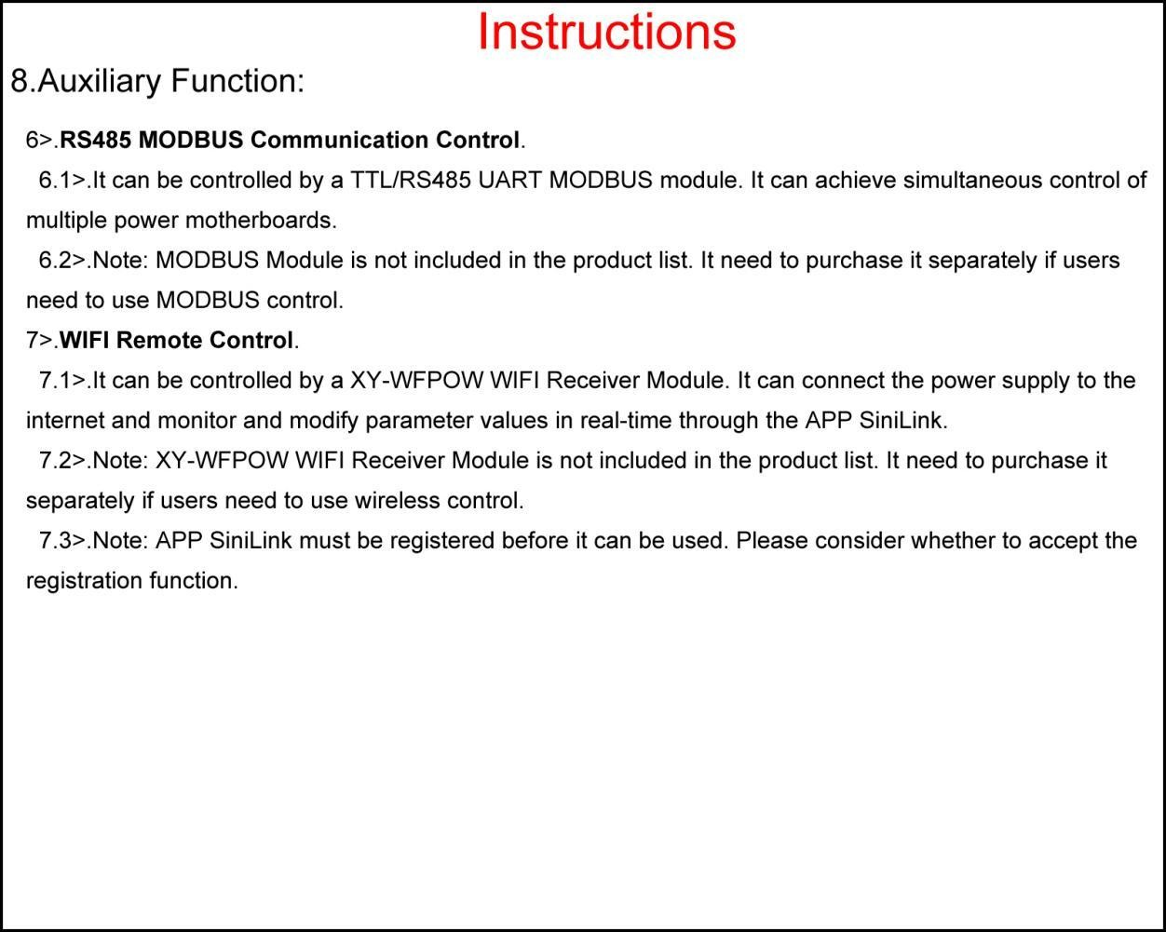

XY6020L 20A / 1200W Programmable Power Supply

Modbus Interface Documentation

Preface:
Those modules are currently sold at AliExpress (tm).
Unfortunately a feasible documentation of the Modbus interface is missing. I could not find out the original manufacturer to ask for any docs. At least a friendly seller provided a documentation written in Chinese.
Nowadays Google translator allows me to read such stuff … :-)

So here is my compilation of the most relevant translated excerpts from the original Chinese document (which has no Copyright notice and does not mention the author).
I applied some corrections and added some more explanations and hints.

Addressed to people who are already familiar with Modbus RTU. Other’s may want to try a Google search for ‘Modbus RTU Tutorial’ first.

-- Disclaimer --

I am not responsible or liable for any errors or omissions contained in this document.
The information is provided on an "as is" basis with no guarantees of completeness, accuracy, usefulness or timeliness…
I am not responsible for any damage that may occur from using the information contained herein.

Use it at your own risk.

-- Disclaimer --

Released to the Public Domain. tinkering4fun at GitHub
April 2023

Communication Interface

The communication protocol is MODBUS-RTU. Factory Modbus ID setting is 01H
The communication interface is TTL serial port;
The data format is 8,N,1 (8 data, no parity, one stop bit(s)) The factory baudrate setting is 115200

Interface Connector:
VCC: 5V supply (used for e.g. isolated RS485 adapter)
TX: Serial data input (connect it to master’s transmitter output) RX: Serial data output (connect it to master’s receiver input) GND: Ground
Unfortunately there was nothing said about the expected ‘TTL’ signal levels.
As the module provides 5V on the VCC pin, it should be 5V tolerant on the input as (‘TTL’ would imply).
During my testing, it worked with either 3.3V or 5V.

Rem: The XY6020L module is typically bundled with a ‘SiniLink XY-WFPOW’ Wifi interface board which is based on ESP8285. I guess this module works with 3.3V I/O levels.)

Connection to a RS485 interface line (real Modbus) requires e.g. HW-519 RS485 adapter. In this case TX goes to adapter’s RXD and RX to adapter’s TXD

Function Codes
This machine only supports 0x03, 0x06, 0x10 function codes.
This means, all mentioned registers are ‘Holding Registers’

Function code | Definition | Operation (binary)
0x03 | Read register data | Read data from one or more registers
0x06 | Write a single register | Write a set of binary data to a single register
0x10 | Write multiple registers | Write multiple sets of binary data to multiple registers

Register Set (Holding Registers)
Rem: Each register consists of 16 bits, transferred as 2 bytes.

Name | Description | Bytes | Dec. | Unit | Read and write | Register address
V-SET | Voltage setting | 2 | 2 | V | R/W | 0000H
I-SET | Current setting | 2 | 2 | A | R/W | 0001H
VOUT | Output voltage display value | 2 | 2 | V | R | 0002H
IOUT | Output current display value | 2 | 2 | A | R | 0003H
POWER | Output power display value | 2 | 1 | W | R | 0004H
UIN | Input voltage display value | 2 | 2 | V | R | 0005H
AH-LOW | Output AH low 16 bits | 2 | 0 | maH | R | 0006H
AH-HIGH | Output AH high 16 bits | 2 | 0 | maH | R | 0007H
WH-LOW | Output WH low 16 bits | 2 | 0 | mwH | R | 0008H
WH-HIGH | Output WH high 16 bits | 2 | 0 | mwH | R | 0009H
OUT_H | Open time - hours | 2 | 0 | H | R | 000AH
OUT_M | Start time - minutes | 2 | 0 | M | R | 000BH
OUT_S | Open time - seconds | 2 | 0 | S | R | 000CH
T_IN | internal temperature value | 2 | 1 | F/C | R | 000DH
T_EX | External temperature value | 2 | 1 | F/C | R | 000EH
LOCK | key lock | 2 | 0 | - | R/W | 000F
PROTECT | protection status | 2 | 0 | - | R/W | 0010H
CVCC | Constant voltage and constant current state | 2 | 0 | - | R | 0011H
ONOFF | Switch output | 2 | 0 | - | R/W | 0012H
F-C | Temperature symbol | 2 | 0 | - | R/W | 0013H
B-LED | Backlight brightness level | 2 | 0 | - | R/W | 0014H
SLEEP | off screen time | 2 | 0 | M | R/W | 0015H

MODEL | Product number (was 6100h) | 2 | 0 | - | R | 0016H
VERSION | Firmware version number (was 0071h) | 2 | 0 | - | R | 0017H
SLAVE-ADD | slave address | 2 | 0 | - | R/W | 0018H
BAUDRATE_L | baud rate (6 == 115200) | 2 | 0 | - | R/W | 0019H
T-IN-OFFSET | internal temperature correction | 2 | 1 | F/C | R/W | 001AH
T-EX-OFFSET | External temperature correction | 2 | 1 | F/C | R/W | 001BH
BUZZER | buzzer switch (not implemented ?) | 2 | 0 | - | R/W | 001CH
EXTRACT-M | Quickly call out data sets | 2 | 0 | - | R/W | 001DH
DEVICE | device status  This did not work on my device! | 2 | 0 | - | R/W | 001EH
Data set area for Memory M0
V-SET | voltage setting | 2 | 2 | V | R/W | 0050H
I-SET | current setting | 2 | 2 | A | R/W | 0051H
S-LVP | Low voltage protection value | 2 | 2 | V | R/W | 0052H
S-OVP | Overvoltage protection value | 2 | 2 | V | R/W | 0053H
S-OCP | Overcurrent protection value | 2 | 2 | A | R/W | 0054H
S-OPP | Over power protection value | 2 | 0 | W | R/W | 0055H
S-OHP_H | Maximum output time--hours | 2 | 0 | H | R/W | 0056H
S-OHP_M | Maximum output duration—minutes | 2 | 0 | M | R/W | 0057H
S-OAH_L | Maximum output AH low 16 bits | 2 | 0 | maH | R/W | 0058H
S-OAH_H | Maximum output AH high 16 bits | 2 | 0 | maH | R/W | 0059H
S-OWH_L | Maximum output WH low 16 bits | 2 | 0 | 10mw H | R/W | 005AH
S-OWH_H | Maximum output WH high 16 bits | 2 | 0 | 10mw H | R/W | 005BH
S-OTP | Over temperature protection value | 2 | 1 | F/C | R/W | 005CH
S-INI | Power-on output switch | 2 | 0 | - | R/W | 005DH

Note 1:
This product is designed with a total of 10 sets of storage data sets M0-M9, each set contains a total of 14 data registers. M0 data set starting address is 0050H.
The data group M0 is called by default when the product is powered on, the M1 and M2 data groups are the data groups quickly called out by the product panel, and the M3-M9 are common storage data groups Group, the calculation method of the starting address of the data group is: 0050H+data group number*0010H, for example, the starting address of the M3 data group is:
0050H+3*0010H=0080H.

A comment on the memory concept:

Calling memory M1-M9 is accomplished by writing the desired number 1..9 to the EXTRACT-M register at 001DH. As a result, the called memory values are copied to the M0 area at 0050H ff..
M0 is the current effective operation data set. Updates to this area take immediate effect. (Calling memory M0 has no effect.)

Programming memories M1-M9 is accomplished by writing the desired values to the respective register address area (M1 = 0060H ff., M2 = 0070H ff., …, M9 = 00E0H ff.). Updates have no effect, until the memory is called.
Writing to memory M0 area means to immediately change the current effective operation parameters (e.g. over voltage protection etc.)
Hint: Registers 0000H and 0001H are always mirrored to 0050H and 0051H.

Note 2:
The reading and writing values of the key lock function are 0 and 1, 0 is unlocked, and 1 is locked.

Note 3:
The read value of protection status is 0-10:
0: normal operation, 1: OVP, 2: OCP, 3: OPP, 4: LVP, 5: OAH, 6: OHP, 7: OTP, 8: OEP, 9: OWH, 10: ICP.

OVP is triggered when a programming request for a higher voltage is made (e.g write to register V-SET 0000H).
Display backlight starts blinking when a protection state is encountered. Protection state may be reset by clearing register PROTECT (0010H)

Note 4:
The reading value of constant voltage and constant current state is 0 and 1, 0 is CV state, 1 is CC state.

Note 5:
The reading and writing values of the switch output function are 0 and 1, 0 is off, and 1 is on.

Note 6:
The reading and writing range of backlight brightness level is 0-5, level 0 is the darkest, level 5 is the brightest.

Note 7:
The written value of the quick recall data group function is 0-9, and the corresponding data group data will be automatically called out after writing.

Note 8:
Description of WiFi related registers
Rem: Only relevant with Wifi module (not tested)

Name | Detailed description | Register address
MASTER | Host type (0x3B3A: WIFI, others to be determined) | 0030H
WIFI-CONFIG | WIFI pairing status (0: Invalid 1: Touch pairing 2: AP pairing) | 0031H
WIFI-STATUS | WIFI status (0: Invalid network 1: Connected to the router 2: Successfully connected to the server 3: Touch pairing 4: AP pairing) | 0032H
IPV4-H | The first two bytes of the IP address are 0xC0A8 | 0033H
IPV4-L | The last two bytes of the IP address are 0x0108 | 0034H
IPV4-H: 0xC0A8 - IPV4-L: 0x0108 IPV4 Address = 192.168.1.8

Communication example
The host reads the output voltage and output current display values

The message format sent by the host:

Data Item | Numbe r of bytes | Data sent | Remark
Slave address | 1 | 01 | Send to slave with address 01
Function code | 1 | 03 | Read register
Register start address | 2 | 0002H | Register start address
Number of register addresses | 2 | 0002H | 2 bytes in total
CRC code | 2 | 65CBH | The CRC code calculated by the host

For example, if the current display value is 05.00V, 1.500A, then the

Message format returned by the slave machine:

Data Item | Numbe r of bytes | Data sent | Remark
Slave address | 1 | 01 | Received from slave with address 01
Function code | 1 | 03 | Read register
Bytes in response | 1 | 04 | Number of data bytes in response
Content of register 0002H | 2 | 01F4H | Output voltage display value
Content of register 0003H | 2 | 05DCH | Output current display value
CRC code | 2 | B8F4H | The CRC code calculated by the slave

Output of Modbus test program

The following command of my Modbus utility, reads 2 holding registers, starting at register number 2.
The program prints out the bytes sent and received at the communication interface.
Just to illustrate the message data exchanged ...

./mbpoll -b 115200,8,N,1 -h 2 -n 2
Please consider that the current reading here was zero, and not 1.5 A
Opening /dev/ttyUSB0 at 115200 bauds (N, 8, 1)
[01][03][00][02][00][02][65][CB] << request sent
Waiting for a confirmation...
<01><03><04><01><F4><00><00><BA><3D> << response received
500 << Register #2 decimal value of voltage
0 << Register #3 decimal value of current

