**Project Statement**

Mobile Application Programming

CS 9033 FALL 2012

Biometric Password Technology Project

**Member:**

---------------------------------------------------

Maneli Kadkhodazadeh

Changpeng Li

Jiankai Dang (Team Leader)

Yang Li

Table of Contents

1. Objective.......................................................................................................................... 3

2. Requirements.................................................................................................................... 3

3. UI Design......................................................................................................................... 3

4. System Design.................................................................................................................. 3

5. Future Work...................................................................................................................... 3

6. References..........................................................................................................................3

# 1. Objective

With a growing dependence on websites for our daily lives, we are required to create and memorize a growing number of username/password combinations. Each website has different requirements for password formats and minimum requirements are growing in complexity to better ensure our security. These different and complex passwords is not only hard to remember but also time consuming and annoying. In addition, even by choosing complex passwords; we cannot ensure our security.

Given this problem, we need a new solution which is simpler and more secure. A solution which better parallels real-world usage before websites took hold of our lives. In the 'real world', signatures in-person are used to ensure security. Signatures are a simple method for a person to rely on since the same signature is used each time with no requirement to memorize username/password combinations.

With our application, we seek to re-create the benefits of the in-person signature to replace complex and insecure username/password combinations. The application will allow users to login easily to their bank accounts simply and quickly using a touch-signature or touch-phrase.

Therefore in our project we will create an un-real website bank application to demonstrate the solution to this problem that we mentioned above, using real signature to authorize users account instead of using password.

# 2. Requirements

1. User Interface:
   1. The interface must be consistent in both iPhone and iPad which support iOS5.0 and later versions;
   2. The interface must tell the end-user what the signature is being signed for, when the signature request is sent;
   3. The interface must show the result of signature authentication;
   4. The interface should be unaffected when the user switches the apps;
   5. The interface should inform the user when the communication between iOS device and back-end server is interrupted;
2. Security:
   1. The whole network communication must be encrypted;
   2. There should be a time limit during the process of signature authentication;
   3. The API libraries used for communication between iOS devices and back-end server are applicable to check incoming token which can prevent back-end server from potential injection attack;
3. Maintainability:
   1. All libraries must be well documented including at least library functionalities, API description, all variables, logic operations etc;
   2. The naming rule should strictly follow the naming document;
   3. The development over iOS should strictly follow MVC design pattern;
4. Interoperability:
   1. The API for third party should be clear and straightforward, and well-performed over the given protocol when it communicates with the customer program;
5. Timeline:
   1. The output timeline should include at least iOS app finished, back-end server(signature authentication server) setup finished, third party simulation server finished and final delivery;

# 3. UI Design

ui iPhone scenario

**4. System Design**

We have three major parts of our implementation.

1. iOS App

We’ll design a user friendly user interface of our iOS App and provide the following basic functions:

* + Training of user’s master signature
  + Sign and Tap Login
  + Cheat Sheet to save the passwords and PIN Numbers
  + Access bank account through signature

1. Back-End Server
   * Save the training signature data from iOS App to server database
   * Recognize and match signature data between iOS App and server database
   * Observe and handle the login event from bank service
   * Return the user authentication results to bank server
2. Bank Services
   * Provide login interface for user
   * Dispatch login event to Back-End Server
   * Receive the user authentication results from Back-End server and inform user about it

The implementation processes are shown in the following graph:

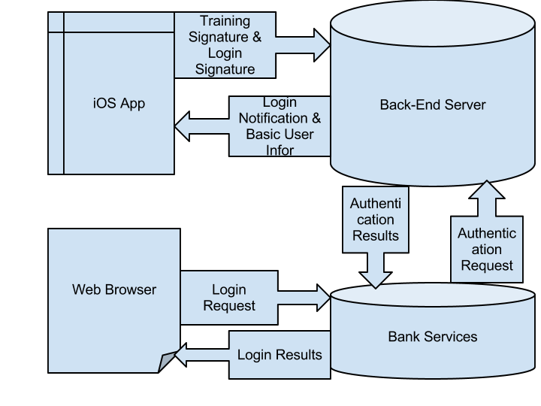

/*

todo

class

api

UML

*/

**5. Future Work**

**6. References**

Documents Version:

0.1 First Version by Yang Li, 2012-10-08