Date of Submission: Tuesday, 16 May 2023

Golden Organics/SeriousShea Project Summary

Question | General Information | Answer
1 | Project location - country, region & district  (Attach map if possible) | Senegal – Thies – Fatick - Diourbel (Merina Dakhar- Niakhane)  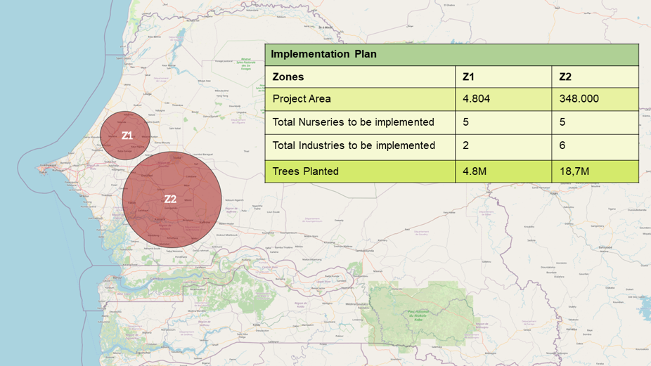
2 | Local partner contact  (Name, position, email, address, and website link) | William Kwende (MD@golden-organics.com) – Founding Partner& Managing Director.  Fatou Mboup - Country Manager (mboupfatou1@gmail.com)  Serious Shea Senegal - Avenue Peytavin, Dakar Senegal
3 | Since what year has the local partner been active in the project area? | 2007 in Burkina, Benin, Togo, Ivory Coast, Nigeria, Cameroun
4 | Partnering NGOs, farmer cooperatives or sub-contractors  (name & role in project) | PAPSEN -  PAPSEN is the most important achievement of the Senegalese, Italian and Israeli cooperation, with a financing of more than 30 million euros. The operational framework is composed by National Steering Committee and the Unit Programme Management. The Programme will contribute to the development of the horticultural sector in the Thiès, Diourbel Fatick regions, by achieving 400 ha of irrigated perimeters and creating a Service and Training Centre. The Program is in the regions of Kolda and Sédhiou and focuses on rural development and adaptation of agricultural production systems to climate change, to consolidate the achievements of the Senegal-Italian cooperation started in the '80.  Cooperatives – Production of Trees in Nurseries, Planting, and maintenance of trees.  Farmer cooperatives (Women, youth, and Men):  Services provide under contract with Serious Shea:  - Collect the planting material.  - Produce seedling in nursery.  - Plant trees  - Receive education in agroforestry systems.  Others:  Maintenance of the trees on partners Land:  - Bio fertilisation  - Protection with bio pesticides  - Manual Weeding
5 | Main cash crop(s) | Groundnuts, Millet, Rice, Maize, Sorghum
6 | Number of existing farmer participants | 50 in Koul (pilot community farms)
7 | Potential number of additional participants | 100,000 Community members, Women/Youth Groups and Families in next 10 years
8 | Estimated average plot size per existing farmer (ha) | 1 Ha per farmer
9 | Native language(s) spoken in the project area. | French, Wolof, Pulaar, Serer
10 | Describe how smallholder farmers/communities were involved and not only informed during the design of the agroforestry project  (Provide evidence of participation. For example, photos or minutes taken in workshops, meetings) | Serious Shea will provide employment opportunities to Farmers/women/youth groups/Families living in the region with the facilities to be established in the areas to be forested. Again, employment will continue to be provided to the project areas with the nurseries and infrastructure to be established.  Serious Shea is organising a full FPIC compliant process in each area.  In addition, Serious Shea eco processing facilities will provide a platform for processing fruits collected from the area, supporting the partners with foodstuff and economic income.  The partnership will choose which species will be planted and protect the trees.
11 | List the topics that have been raised with farmers/communities to seek their input on the project | Food collection storage and processing - Water management – Access to energy - Socio Economic development – Financial inclusion – Agroforestry - Land Degradation – deforestation for Firewood – Education (numeracy, literacy, and information technology usage – Sustainability – best agricultural processes – bio fertilisation and crop protection. (In partnership with the forestry department) – Fire prevention.
12 | Provide a general description of current socioeconomic conditions in the project area (including marginalised/minority groups, income, poverty level, remoteness, education, transport, gender balance, migration, population growth etc.) | https://bti-project.org/en/reports/country-report/SEN#pos9  (Attached)  Access to employment for young people and the population in general is problematic and unemployment remains high and particularly affects young people without diplomas or qualifications.  According to the results of the national survey on employment in Senegal by ANSD, Senegal has an employment rate of 35.6% in the first half of 2017 against 22.7% unemployment rate. These rates vary according to place of residence. They are respectively 39.6% for employment against 18.5% for unemployment in urban areas, and 30.8% for employment against 27.7% for unemployment in urban areas. rural. At regional level, the results of the 2013 RGPHAE revealed that with 21%, Matam was the region with the lowest employment rate and topped the list with 46% employment rate.  The low employment rate and the high unemployment rate explain, in places, the high level of poverty and social vulnerability in the country. Even if it has experienced a decline in recent years from 55.2% in 2001 to 48.3% in 2005, the poverty rate remains high until 2011 with 46.7% according to ANSD figures. Poverty does not affect to the same degree the different  different regions of the country. It is stronger in the southern regions: Kolda (77%), Kédougou (71%), Sédhiou (68%), and weaker in the regions of Dakar and Louga with  a respective poverty rate of 26% and 27% in 2011.  The typological analysis of the departments according to their level of access to basic social services shows that those in the south and east of the country mainly show difficulties related to access to drinking water and Electricity: Medina Yoro Foula, Bignona, Sédhiou, Kolda, Salémata, Vélingara, Goudomp, Bounkiling, Saraya, Kédougou, Oussouye, Ziguinchor, Tambacounda, Ranérou, Koungheul, Goudiry, Koumpentoum, Nioro and Fatick. Some of these departments have access rates to drinking water (Medina Yoro Foula, Goudomp 8%, Bounkiling 10%, and Kolda 16%) and to electrification (Ranerou 4%, Medina Yoro Foula 5%, Salemata 7%, and Malem Hodar: 9%) very low compared to national averages. These departments have in common their peripheral position and their isolation. The challenge is then to promote social connections to water, sanitation and electricity for the most vulnerable populations and the installation of boreholes in rural areas.  The map below highlights the problems of geographical accessibility, especially for regions with low population density, in particular: Kédougou (11.9 km on average to reach at least one health post), Tambacounda (9.8 km) and Matam (9.73 km on average).  In the Dakar region, it is necessary to travel less than one kilometer (0.78) to reach a health structure (hospital, center, or health post). The regions that are a little closer to Dakar are Thiès (3.22 km on average), Diourbel (3.57 km).  According to the RGPHAE, the Crude Mortality Rate is 8‰ with disparities between regions. Indeed, the lowest TBMs are recorded in the regions of Dakar (5.2‰) and Thiès (6.6‰), while the highest are noted in the regions of Tambacounda (10.4‰), Kédougou (12.4‰), Kolda (11.8‰), etc.  As for maternal mortality, it is 434 deaths per 100,000 births with disparities between regions.
13 | Describe any known local land degradation/deforestation processes or trends, and drivers of these (For example, population increase, fire, conversion for agriculture) | Deforestation is the result of clearing for fuelwood, charcoal, and logging, though poaching, wildlife trafficking, expansion of agriculture areas, and hydroelectric projects have further degraded forest areas.  Deforestation is responsible for increased soil erosion, flooding, and periodic drought which has had an adverse impact on regional agriculture.  Access to education  School infrastructure  In recent decades, the school map has gradually become denser. In fact, the number of schools in the levels primary, middle, and secondary increased from 7,320 establishments in 2007 to 10,561 establishments in 2017, corresponding to an average annual growth of 3.7% over 10 years. The number of pupils followed the same rhythm, increasing from  1,779,169 in 2007 to 2,567,603 pupils in 2017. At the same time, the average access distance to a school has been reduced. For example, the average access radius to a college has been reduced by  0.5 km: it went from 2.9 km to 2.4 km between 2007 and 2017.
14 | Please describe the type of land use that best represents the project area before intervention  (For example, existing agroforestry/fallow/tree plantation/monoculture perennial crop/monoculture annual crop/mixed crops  /Marginal land) | Monoculture Annual Crop/Mixed Crop
15 | How is land tenure organised among participants and in what form is this evidenced (formal titling, informal titling or land mapping – See 5.1.3 Acorn Framework) | Mayor, Sample of the title, and informal title.
 | Theory of Change
16 | Describe the target community of this project.  (e.g., gender, age, marginalised groups, location, other stakeholders) | Women / youth cooperative: 18 to 40  Men farmers
17 | What are the biggest agricultural challenges faced by farmers and their families, and the community in the project area? (Climate change, volatility in commodity prices, low productivity, access to resources, financial security, crop damage from wildlife, human conflict etc.) | Senegal is a country with a significant agricultural sector, and farming is a vital source of income for many rural communities. However, Senegalese farmers face several challenges that affect their productivity, income, and overall well-being. Some of the most significant agricultural challenges faced by Senegalese farmers and their families, and the community in the project area which is center, east and northern Senegal are:  - Climate change and environmental degradation: Senegal is a country that is particularly vulnerable to the impacts of climate change. The country's agricultural sector is highly dependent on rainfall, and changes in rainfall patterns and temperature can significantly affect crop yields. Environmental degradation, such as deforestation and soil erosion, can also contribute to reduced agricultural productivity.  - Limited access to credit and inputs: Many Senegalese farmers have limited access to credit and inputs, such as seeds, fertilizers, and equipment. This can make it difficult for them to invest in their farms and improve their productivity.  - Poor infrastructure: Senegal's agricultural sector is also hampered by poor infrastructure, including limited access to roads, markets, and storage facilities. This can make it difficult for farmers to transport their products to market and store their crops safely.  - Pests and diseases: Pests and diseases can significantly impact crop yields and reduce farmers' incomes. In Senegal, pests such as locusts and diseases such as the African swine fever have caused significant damage to crops and livestock.  - Limited technical skills and knowledge: Many Senegalese farmers have limited technical skills and knowledge, which can make it difficult for them to adopt new farming practices, technologies, and approaches. This can limit their ability to improve their productivity and income.  - Poverty and food insecurity: Finally, poverty and food insecurity are significant challenges facing many Senegalese farmers and their families. Limited access to food and income can affect the health and well-being of individuals and communities, particularly women and children.
18 | Describe the project’s aims and objectives.  (e.g. the desired change the local partner wants to achieve) | ​Implement a leading profitable business model in Senegal which won the United Nations, World Economic Forum endorsed Trillion Trees Sahel and Great Green Wall Challenge in 2021 for its native forest regeneration strategy, deforestation-free zero-carbon agroforestry processing value chain and women and youth group partners.​  Working Objectives​  (1) Plant and protect 15M native trees by 2030 with an 80% survival rate which sequester 1 tCO2/year each at maturity and contribute to climate change adaptation by greening and holding back Sahara Desert expansion from the north:​  - 3 nurseries each producing 1 million native tree seedlings.​  - 0.6 M ha of primary native forest plantations (10% of which are no harvest soil quality & biodiversity reference areas). ​  - 0.1M ha secondary plantations of native tree corridors & fences with crops such as moringa.​​  (2) Transition from firewood energy and create added economic value which stays in the region by building and operating:​  - 18 multi-use clean energy processing, quality control and true value chain data centres for processing forest fruits such as baobab and mango and agri-food products such as moringa. ​  - 2 clean energy shea butter processing clusters (2 regional centres each serviced by 3 collection centres).​  - a circular economy recycling 100% bio-waste from the 26 processing units to produce biogas fuel for processing and households, liquid fertilizer, and soil conditioners (biochars and compost).​​  (3) Achieve financial and business governance inclusion of women and youth groups through co-operative instruments which also give land ownership rights by: ​  - Increasing the income of 60,000 cooperative workers at least 5* the minimum wage (US$166.65/year as 23.03.23)​  - creating a Community Fund which achieves the minimum global estimate for all the households (1M people) to achieve the Sustainable Development Goals #3 Universal Healthcare; #4 Primary and Secondary Education; #6 Clean drinking water and sanitation by 2030.​​  ​  ​  ​  ​  ​
19 | Describe how and why the project intervention proposed is expected to positively/negatively impact the following;  (Provide examples or reasons) | Food security/nutritional intake: As a result of planting various species in the area, Trees will give fruits and other food resources to community. In our processing centers, SeriousShea will process the foods, like dried fruits, powders etc… Communities cooperative will own it and use the portion they require.
 |  | Farmer financial state: Beside the income from the Carbon, Farmers/Communities will provide service to our Nurseries, plantations, industrial centers. Which will give them extra income.
 |  | Gender equality individual income increase is at least doubled in a community fund to provide minimum financial flows estimated to achieve Universal Health Care; primary and secondary education for all, clean drinking water and sanitation (est. US$1100-US$1340 /household)
 |  | Farmer access to resources Farmers will have extra income, and this will lead them to afford everything with higher chances. Availability of education, food, planting materials, seedlings, fertilisers, pesticides, water access, clean energy.
 |  | Biodiversity on farms Increase in species of Crops/Trees, pollinators and organism in soil, habitat for wildlife, providing natural corridors.
Life on Land:
Private financial flows to plant and protect native forest are increased by US$ 30M by2030 planting and protecting 0.6M ha native forest, 15 M diverse native trees, reducing 1 M ha degraded land and creating 10% soil quality and biodiversity reference areas in preparation for potential soil carbon and biodiversity credits, for pollinators, and to help maintain genetic diversity.
Climate Action: US$ 30M is mobilised to mitigate and adapt to climate change, sequestering 4.2 tCO2e by 2033 and substituting CO2 from industry by replacing firewood fuel with
clean energy (to quantify).

Affordable And Clean Energy :100% clean energy (solar and biogas) powers 26 agri-food processing units linked to
60,750 jobs (Serious Shea employees and Co-operative workers), powers households
for 1M people and creates gross revenues of US$30M by 2030
Responsible Consumption and Production 3774TMT /year food is processed to reduce food loss to zero in processing and
minimised from a regional loss of 80% including storage and transport to wholesale.
1.0M ha and 3774MT agri-food are produced with sustainable practices which include
water saving technologies, deforestation-free, carbon-zero, zero waste processing.

Zero Hunger Income to 60,000 households is increased by at least 5* the minimum wage and
1.5* the average wage of the largest small holder farmers (3Ha US$734/year). 60,000 Co-operative workers, at least 50% women have equal payment and land rights secured through co-operative instruments.
 | The Agroforestry System
20 | How would you define an agroforestry system? | Agroforestry systems are land management practices in which trees and shrubs are produced on the same land area as agricultural crops or livestock. Therefore, agroforestry systems combine trees, crops, or livestock to increase diversity, productivity, profitability, and environmental stewardship. Therefore, agroforestry systems can provide a sustainable alternative to biologically simplified or low diversity cropping systems. Agroforestry systems are also suited for the rejuvenation of marginal land in both temperate and tropical biomes. Improved soil quality, through organic matter input from trees and crops lead to increased crop yield, ensuring the long-term security of food and soil. The tree and soil component of agroforestry systems can also be a long-term sink for carbon, thereby contributing to climate change mitigation. In 2013 the United Nations Federation of Agriculture Organization (UN-FAO) recommended the adoption of agroforestry practices for food security and the need for developing country governments to incorporate agroforestry into their national agricultural policies. Agroforestry systems are also of interest since they can offset the need for deforestation in tropical environments. It was estimated that for each hectare of sustainable agroforestry production, up to twenty hectares of deforestation could be prevented. Apart from enhancing soil health and crop productivity, agroforestry systems also have other environmental benefits. These include reduced nutrient leaching and soil erosion, maintenance of nutrient cycling, reduction of weeds and pests, enhanced soil water availability and enhanced biodiversity. Agroforestry provides a more diverse farming system, thereby reducing economic risks due to the production of multiple products. This also helps to stimulate the rural economy.
21 | Is this project new or existing agroforestry or a combination?  (Please note: Acorn considers “new” as no trees ever planted under an agroforestry project) | Existing and New Agroforestry  Existing (5%) = Recently planted trees in private farm, planted within 5 years, but agroforestry design or implementation plan is missing. They needed to plant these trees to be able to obtain the land.  New = 95%
22 | Type of trees that have/will be planted under agroforestry scheme (shade, fruit-bearing, medicinal) | - Acacia Mellifera (as Fences)  - Moringa (for oil and powder)  - Baobab (Fruit, powder)  - Shea (fruit, butter)  - Tallow Tree (fruit)  - Acacia Senegalese (gum)  - Balanites (oil)
23 | How will the project ensure the survival and health of both (1) trees that existed before the start of the Acorn project, and (2) trees that will be planted during the project?” | There are very few trees, SeriousShea has a strict policy supporting the national policy of preserving existing trees. Planted trees survival is supported by SeriousShea technologies for water management and bio fertilisation.  Senegal is confronted with a degradation of its environment, resulting from a complex interaction between drought, demographic growth, the poverty of the populations, the overexploitation of natural resources and the lack of application of some texts. Indeed, these are degradation factors that are of a natural nature.  (Drought, salinization, erosion) and of human order (bush fires, agricultural and mining pressures, overexploitation of forest products, etc.), acting according to a variable intensity, generally influenced by the local characteristics which determine the specific vulnerability. - specific to certain ecosystems. Thus, the increasing degradation increase in ecosystems has negative impacts on the various constituents of the biophysical environment (flora, fauna, soil).  Faced with this degradation of the environment and natural resources, the State has put in place strategies for the rational management of the environment and natural resources.  through legal instruments such as the Environment Code, the Forest Code, the Hunting and Wildlife Protection Code, adherence to various treaties and conventions, the adoption of a sector policy and development strategic framework.
24 | How do the agroforestry practices in this project differ to current farming practices in the region? | There are no current defined practices, education/training or understanding of the benefits, trees are use as delimitation only by owners.
25 | Is planned harvesting part of the agroforestry design for this project?  (Please note: Acorn considers harvesting in this case as cutting down the entire tree) | Not applicable.
 | Project Additionality
26 | Is the project incorporated by any other accounting program (For example, compliance, voluntary or national GHG program)? If yes, describe how project ensures no carbon credit is accounted for in in any other carbon program other than Acorn. | The project boundaries are well defined with prior consent and the agreement reviewed by the national government agency will specify the exclusivity of the carbon accounting for the ACORN project for the duration of 20 to 30 years preferably.
27 | In what year, season and month(s) will/were the first trees planted? | 2022 September
28 | If existing agroforestry, approx. how many farmers were onboarded each year over a five-year period | Year 1 | Only on pilot community farms in Koul
 |  | Year 2 | TBD
 |  | Year 3 | TBD
 |  | Year 4 | TBD
 |  | Year 5 | TBD
29 | Is this project mandatory under any national or local laws? (List relevant forestry regulations, national climate change commitments etc.) | No
30 | What is the main driver encouraging farmers to transition to agroforestry? | Improve Food Security,  Access to food  Additional income,  Access to water  Climate Action  Life on Land  Affordable And Clean Energy  Responsible Consumption and Production  Zero Hunger
31 | Was the promise of carbon credits an enabling factor for farmers to transition to agroforestry? | Yes
 | High-over business case
32 | If existing agroforestry, how has this project been funded to date?  (financed by the local partner, the farmers, grants/funding, or a combination) | The funding came from Golden Organics SeriousShea parent as a pilot to learn about Agroforestry dynamics in Senegal.
33 | Briefly describe the costs for the farmer in this project  (e.g. seedlings, fertilisers, pesticides, labour – planting and pruning, project cost, training, transport) | Maintenance of the trees on partners Land:  - Bio fertilisation: 4-10 ton of liquid fertiliser per day and per processing centre. 10 processing centres. Price of the liquid fertilizer is 2,5 USD per Liter  - Protection with bio pesticides: Only for the Nurseries  - Manual Weeding: €0
34 | Briefly describe the costs for the local partner in this project  (e.g. seedlings, onboarding, data collection, training, farmer engagement, planting materials, see Annex 1 for more examples) | See Attached Excel Sheet  - Single Nursery Cost (CAPEX): 534,843 EUR.  DETAILS: UNIT COSTS (PER TREE)  1) Opex. Nursery Production fees to women and youth cooperatives: 0.5 EUR  2) Supplies: 0.5 EUR  3) Plantation and Transport with the cooperatives: 0.5 EUR  4) Training TBD
35 | How will this project be financed and by whom during the design and implementation stage  (e.g. financed by the local partner, the farmers, grants/funding, or a combination) | This project will be financed by investors. We are still looking for these investors.
 | Farmer survey
36 | In addition to the mandatory indicators of farmer income, biodiversity, and nutrition, please choose at least 1 of the following additional indicators that you would like to monitor at least every 3 years through sampled farmer surveys;  - Agricultural land use productivity  - Women empowerment  - Youth inclusion | - Agricultural land use productivity  - Women empowerment  - Youth inclusion

Annex 1 Please attach a map of the project area


Annex 2: Please attach at least 2 examples of farmer land tenure documentation

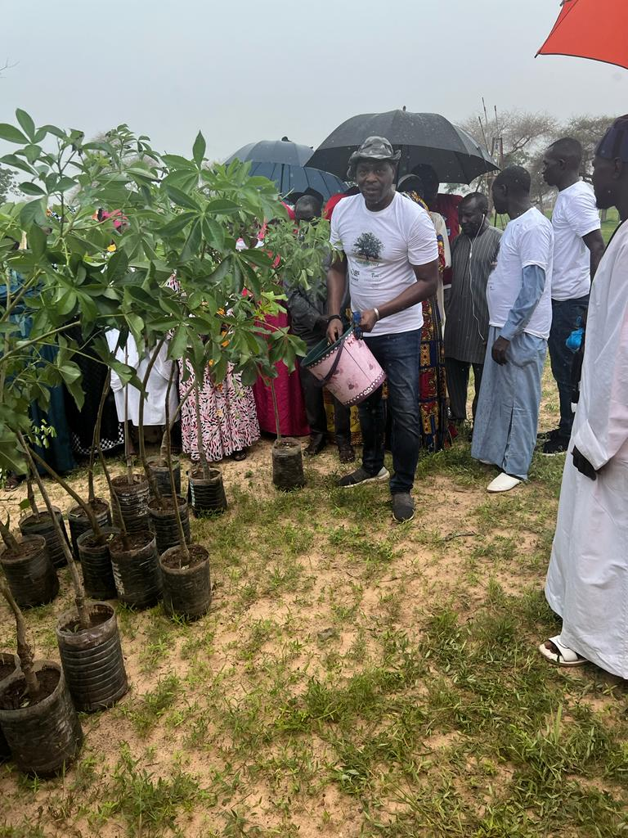
Annex 3: Please attach evidence of engagement with farmers and/or the community
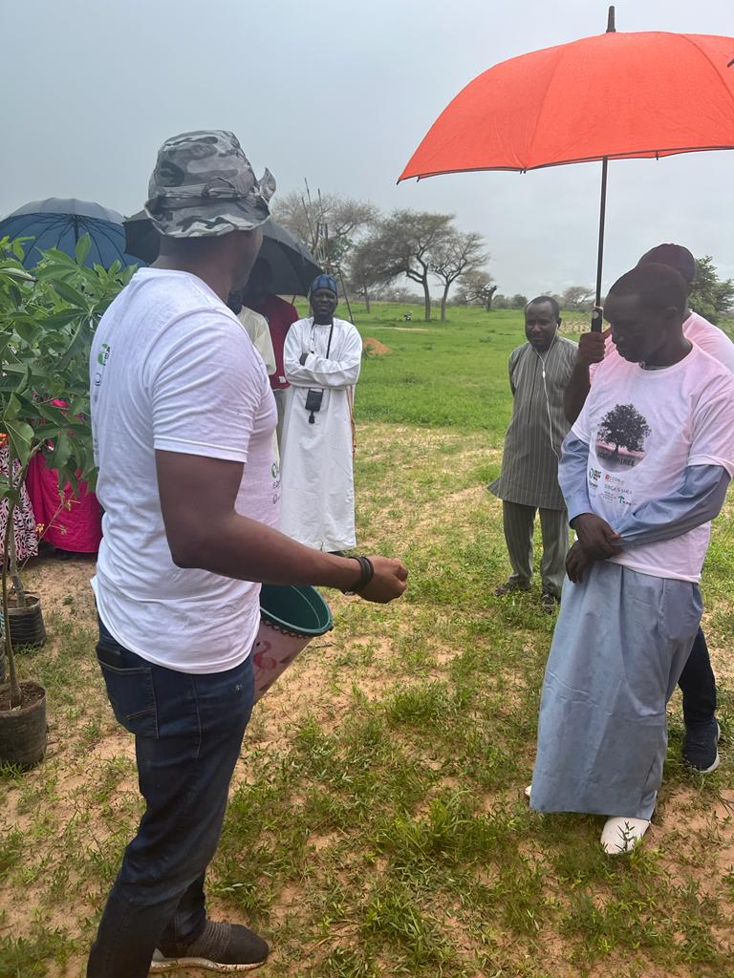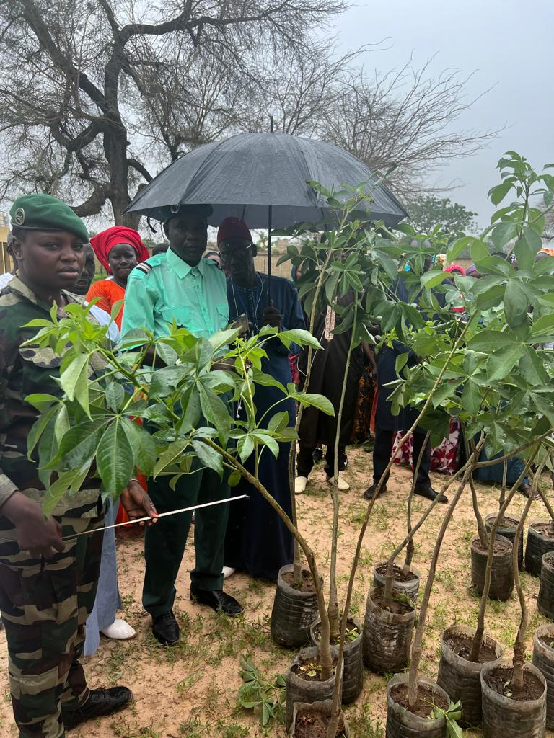

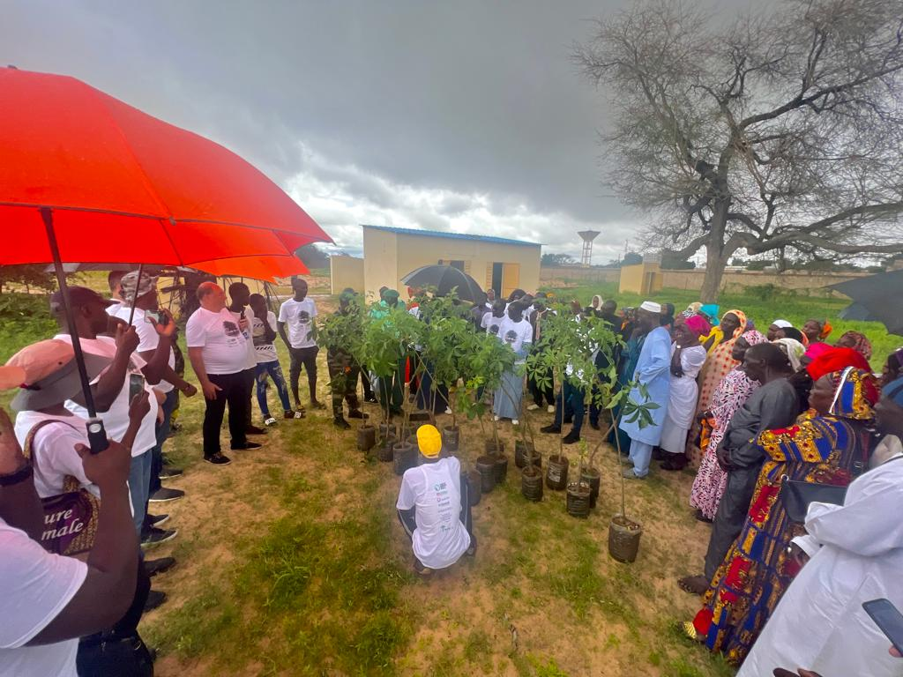

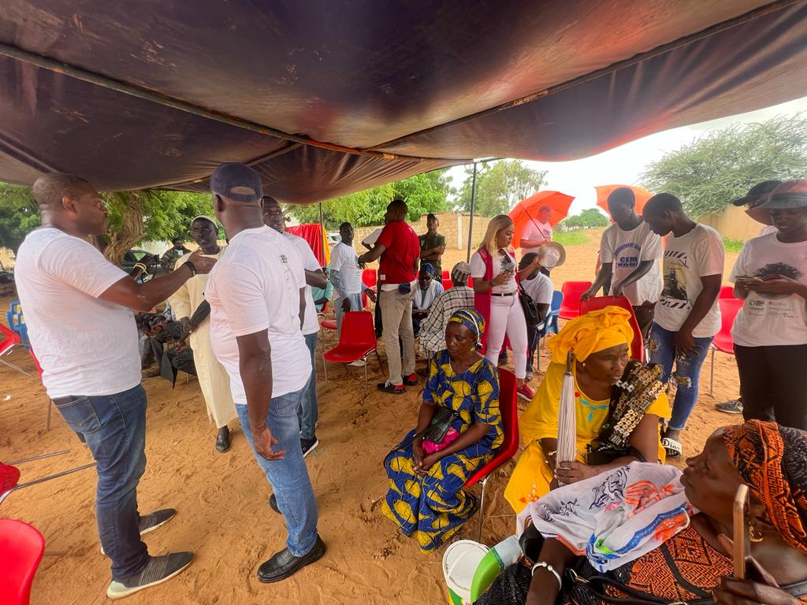

Annex 4: Examples of Local Partner costs (for row 34)

Cost item | Description
Planting materials | The costs of seedlings or fertilisers that the local partner provides to the farmer or discounts offered.
Farmer Training | Training lead farmers and field officer on agroforestry design principles.
Transport | The costs of fuel and other expenses related to the transport of planting materials and visits to farms and meetings.
Project description and documentation | Including  - project summary,  - eligibility checklist,  - additionality checks,  - reversal risk assessment and  - stakeholder analysis.
Farmer engagement & selection | Making farmers aware of Acorn, Agroforestry and CRU benefits.
Grievance mechanism establishment | The establishment of a grievance mechanism including a method for how grievances can be communicated and how grievances are dealt with in a transparent manner.
Project Council establishment | Establish a project council with farmer representatives and/or community groups that represents the participating farmers in the Acorn project, voice concerns and needs and actively engages in decision making.
Agroforestry Design | Design including  - details of species  - growth management  - expected benefits, i  - expected impact existing crops,  - impact on cost level and  - carbon potential
Business Case | A Business Case showing the impact on farmer, project and LP level according to Acorn template.
Community engagement | Ensuring (local) government, village leaders and farmer representatives are aware and support Acorn.
Carbon baseline | The carbon baseline needs to be established for a sample of 30-100 farmers including:  - questionnaire,  - tree count of trees <2m and iii) # of trees older than 5 years.
Project Baseline | Questionnaire for a sample of 30-100 farmers covering.  - carbon income,  - nutritional variety,  - agricultural biodiversity and  - land tenure documentation
Ground truth data collection | Ground truth data of 100 sample plots (1ha) need to be collected
Reversal risk assessment | An assessment of the risks of potential events that can lead to the reversal of previously stored carbon (e.g., wildfires, cutting down trees, pests)
Farmer data collection & consent forms | Including  - eligibility checks,  - farmer data collection (ID),  - polygons collection,  - farmer contracts and consent,  - land tenure documentation,  - travel expenses for data collection
Setting up loan/in-kind/payment administration | Setting up a payment/loan infrastructure with the farmers.
Additional ground truth data collection | In years 2-4, additional ground truth data needs to be collected for 30 sample plots (1ha)
Project Council reporting | A list of the lead farmers + the minutes of the project council meetings have to be reported upon.
Grievance mechanism reporting | A report on how the LP dealt with grievances and the actions that were taken to resolve them.
Project reporting | Annual progress reports including i) # of participants, ii) average hectare per farmer, iii) # of CRUs generated and sold, iv) total payments to participants and v) LP expenditure
Administration cost per farmer | cost of CRU payments, administration of (in-kind) loans
Establishing nurseries (if applicable) | Cost associated with the establishment of seedbanks and nurseries

