ER Diagram
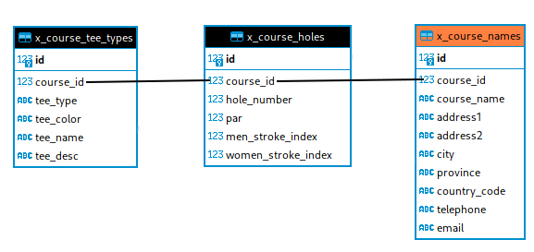

Here is the x_course_name data

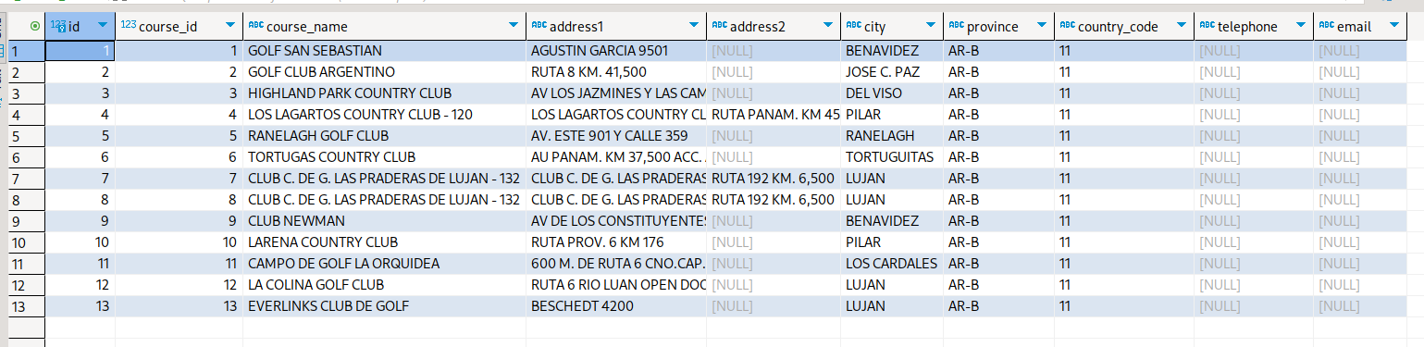

Here is the x_course_holes data:
This only shows the holes for course_id=11. There is also x_course_hole data for clients_id 12 and 13 not shown.

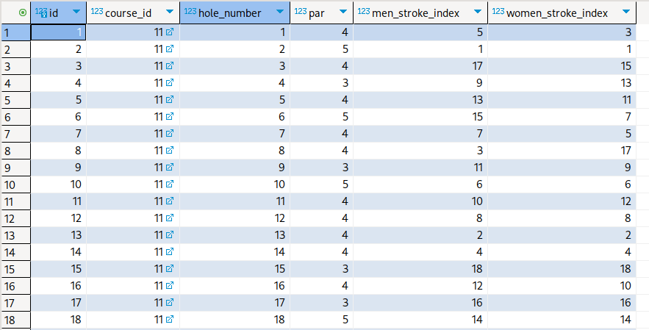
This is the x_course_tee_types.

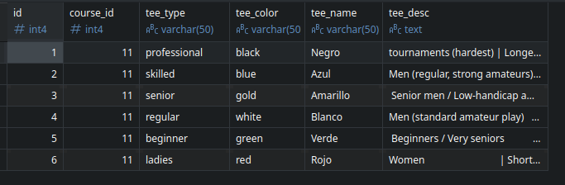

We have two “views”, one is the course_name and the course_data, which looks like:

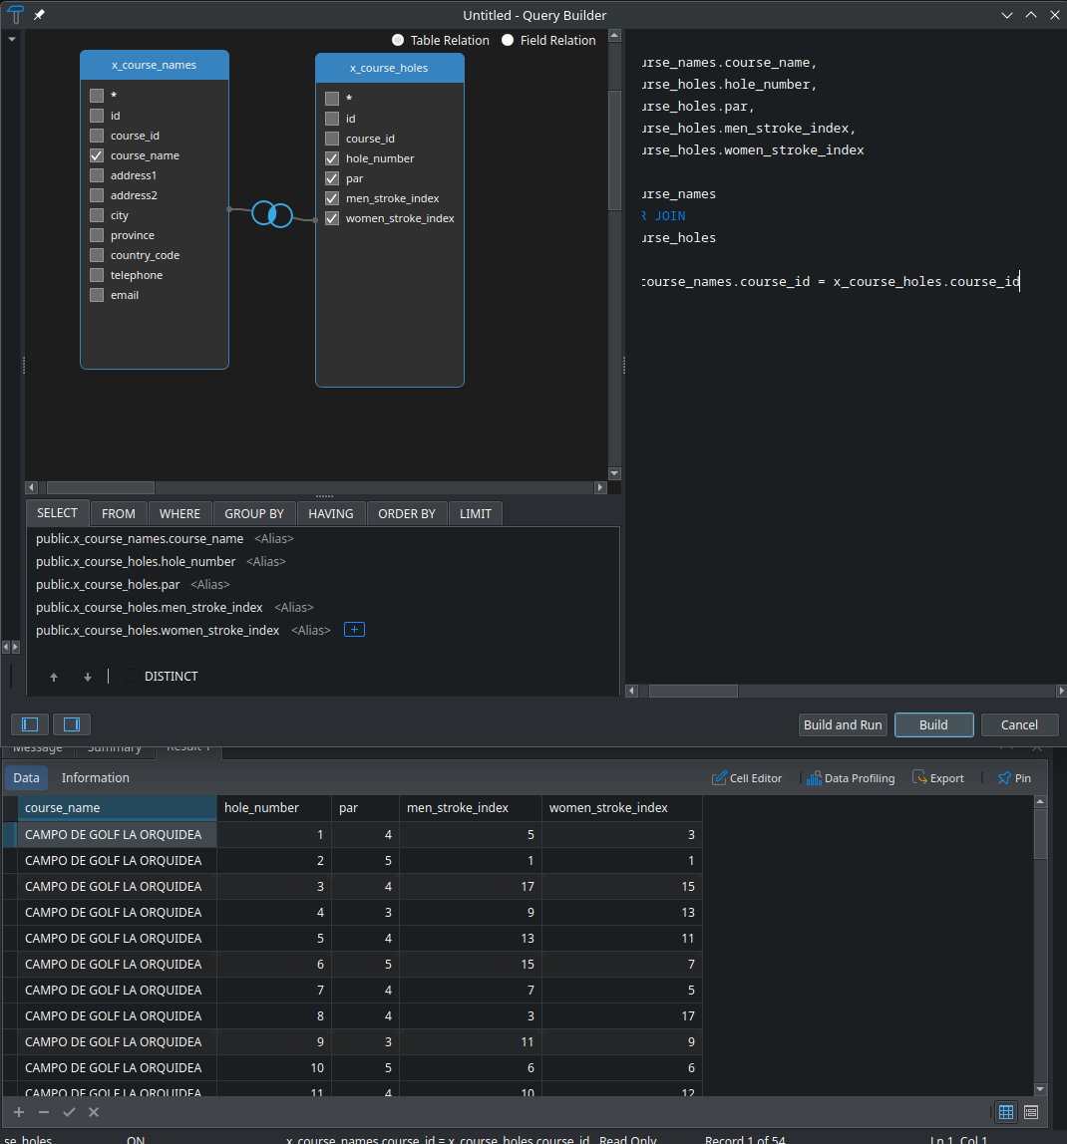

And the other is the course_name, and the course_tees:

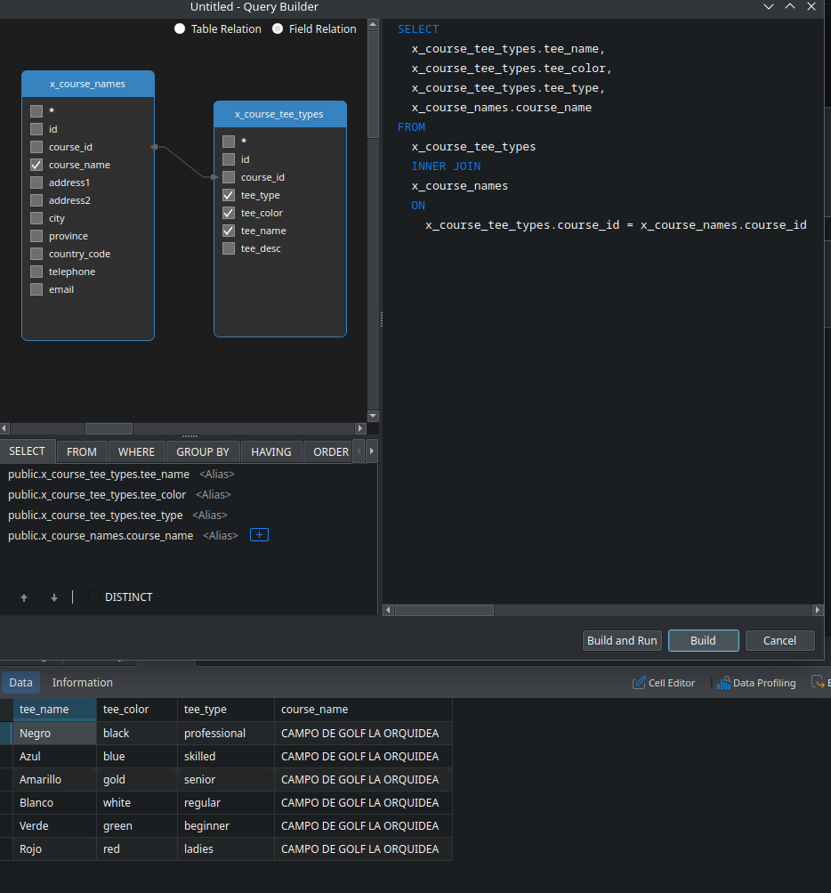

Now comes the messy part :/
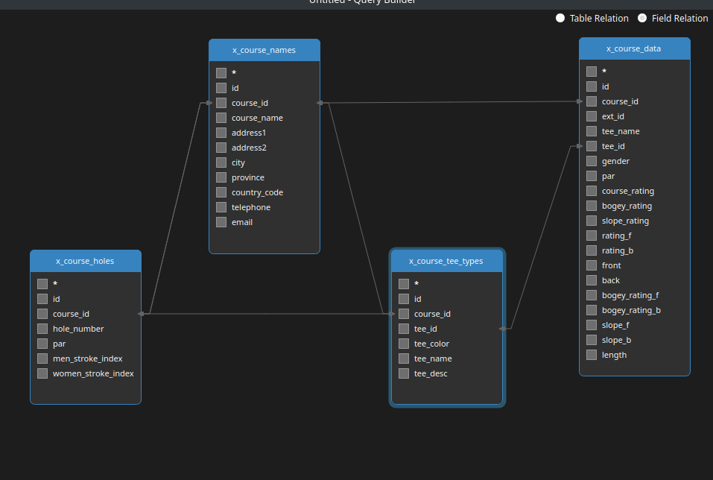
This is how all 4 tables are connected. Here are some of the iussues:

There is duplicated data in course_data and course_holes.

Gender should probably not be in the course_data, as it is implicit in the tee-types, and it’s already in the profile.

Some other vars in course_data can proably go into tee_types or course_holes. Victoria will have to infrom on that.

course_data::tee_name is now in tee_types

We can build a VIEWS for each query we need rather that do the relational query in the code.

