Glimmora ONE — Testing Guide
This guide shows you how to test the whole app, step by step. Each step has a picture so you know exactly what to click and what should happen. If your screen doesn't match the picture, something is broken.
Before you start, make sure two things are running:
- The backend at http://127.0.0.1:8000 (you should see {"ok": true} if you open it).
- The website at http://127.0.0.1:3000 (you should see the Glimmora landing page).
Throughout this guide, we use two test users:
- A new person (sign up fresh — see Step 3).
- The boss / superadmin → username: superadmin, password: ChangeMe!2026

Part A — The new-person flow (Member)
We pretend you've never used Glimmora before. We'll sign up, go through the four welcome steps, do a daily ritual, and write in the journal.
Step 1. Open the landing page
👉 You do: In your browser, go to http://127.0.0.1:3000
👀 You should see: A calm white/cream page with the words 'A calm room for your inner life.' in the middle. There's a 'Begin gently' button. In the top-right corner you can see a moon/sun icon — that's the dark mode switch.
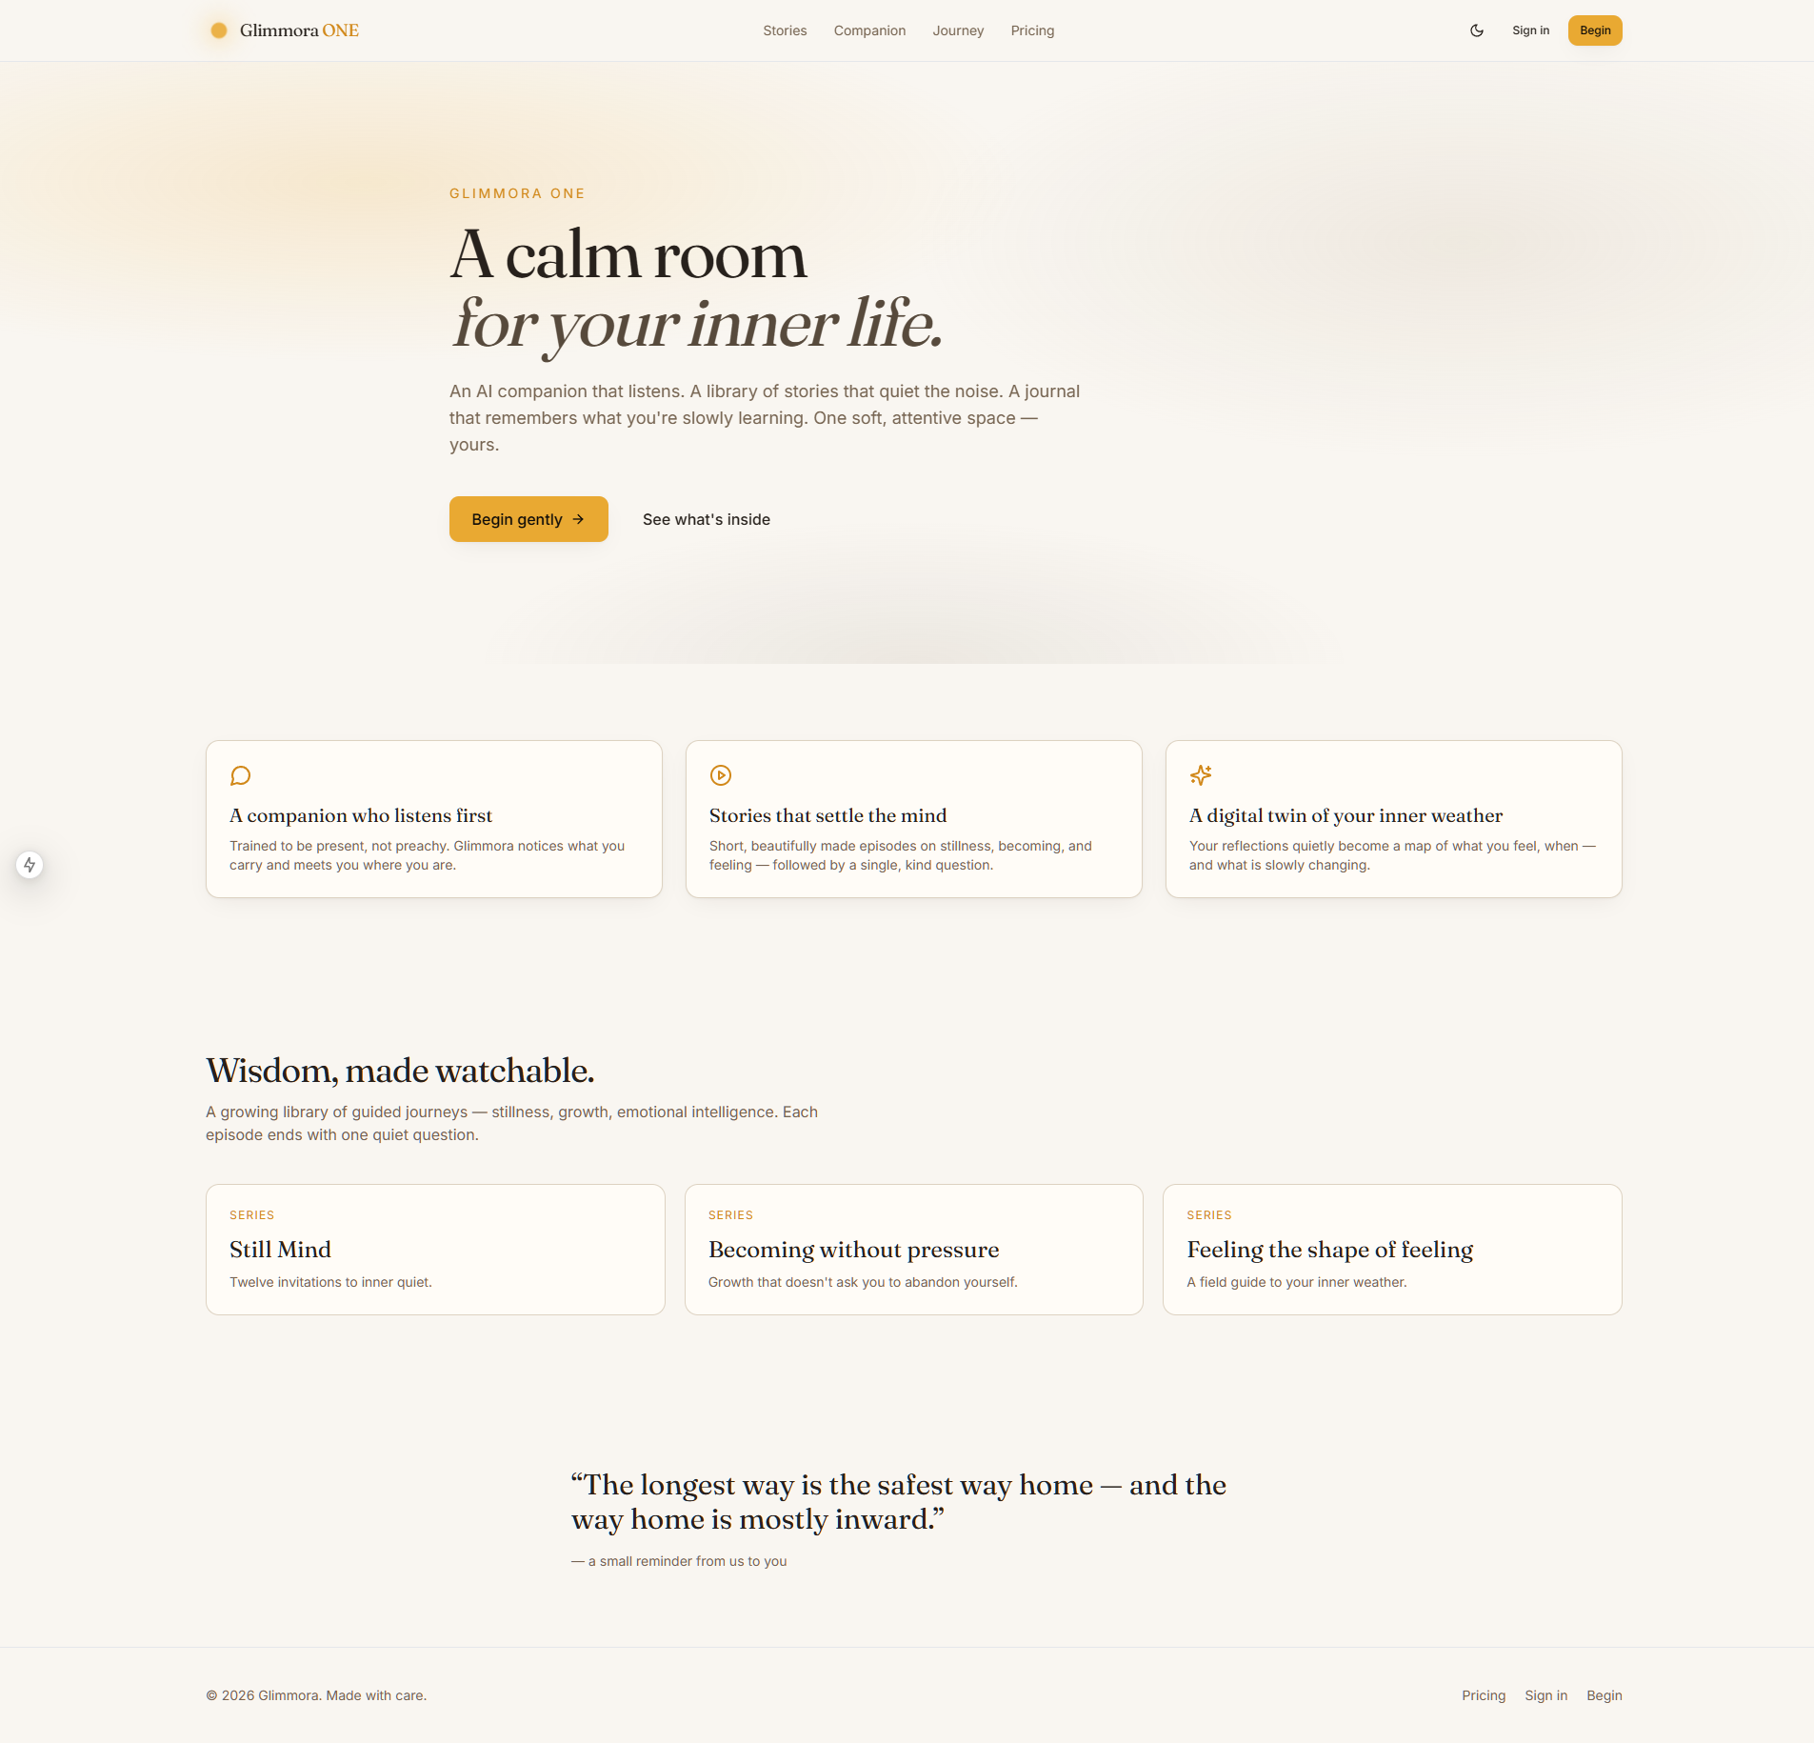
The landing page in light mode.
Step 2. Try the dark mode switch
👉 You do: Click the moon (or sun) icon in the top-right corner.
👀 You should see: The whole page turns dark. Click again and it turns light again. If you close the tab and come back, it remembers your choice.
Step 3. Click 'Begin gently' to start signing up
👉 You do: Click the big 'Begin gently' button on the landing page.
👀 You should see: You land on the sign-up page with four boxes: name, username, email (optional), password.
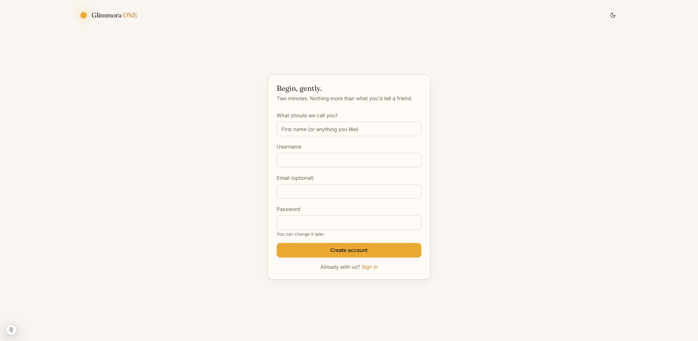
The sign-up page.
Step 4. Fill in the form
👉 You do: Type a name (like 'Ren'), a username (like 'ren_test'), leave email empty, and a password (just 'hello' is fine). Click 'Create account'.
👀 You should see: Right away you land on the welcome page — the first of four little steps. No flashing blank screen, no detour. The sidebar on the left says your name and 'Member · free' under it.
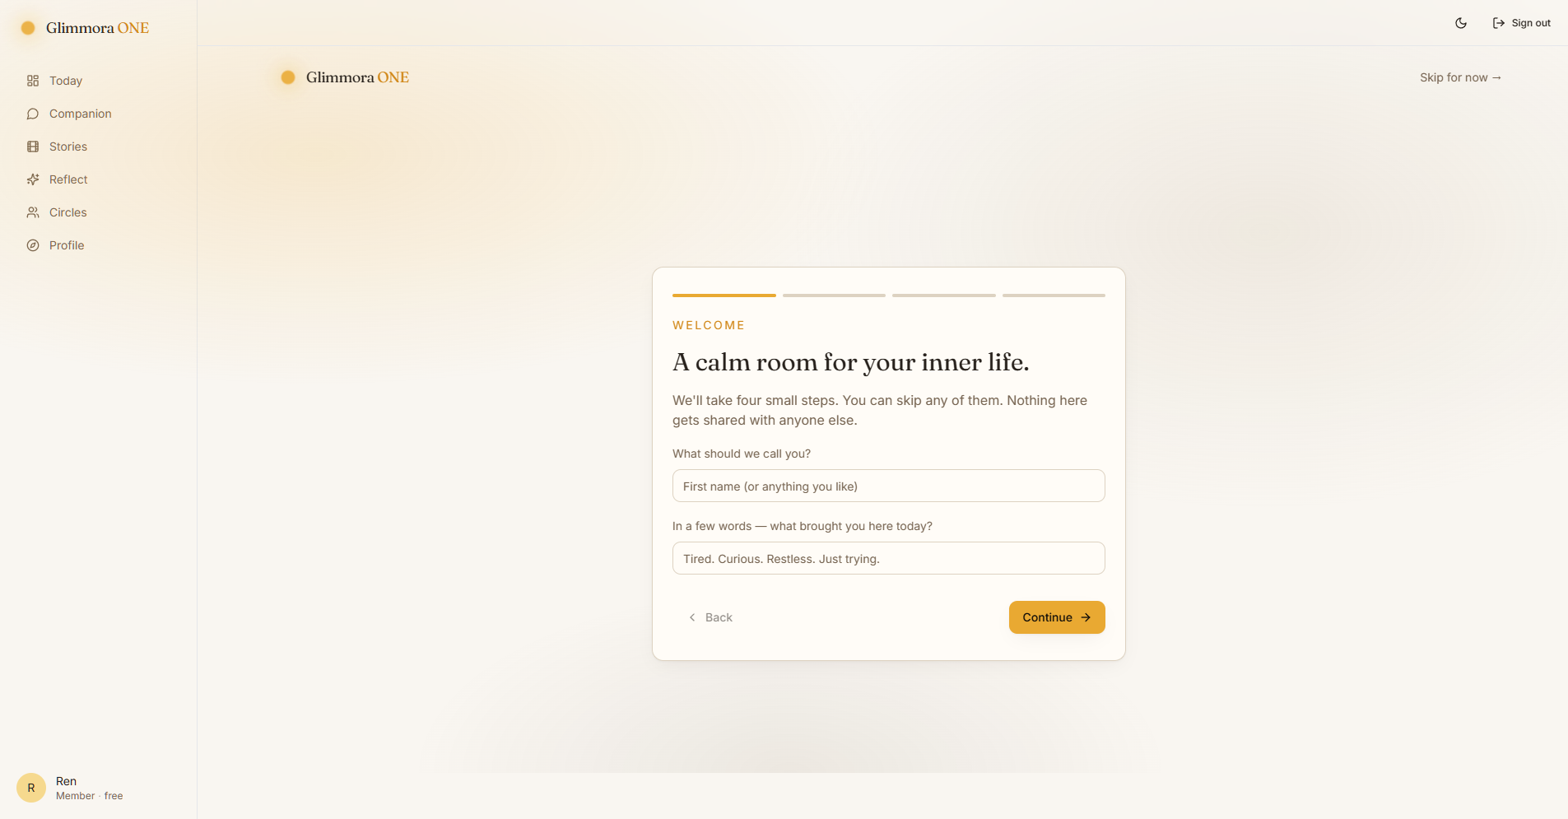
The welcome step (step 1 of 4).
Step 5. Walk through the four welcome steps
👉 You do: Type a friendly name. Click Continue. Write a one-line reason (like 'Just curious'). Click Continue. Pick up to four focus areas (try 'Stillness' and 'Sleep'). Click Continue. Read the final 'Ready when you are' page and click Begin.
👀 You should see: Each step fades in gently. You can press 'Skip for now →' in the top right at any time. When you press 'Begin' you land on the Dashboard.
Step 6. Read your dashboard
👉 You do: Look at the page.
👀 You should see: You see a greeting like 'Good morning, Ren.' and your intention quoted underneath. Below is a card called 'Three small steps' (Arrive, Notice, Reflect) — these are today's gentle nudges. Below that, a featured journey, your 'inner weather' stats, and 'Paths for you' tuned to what you picked.
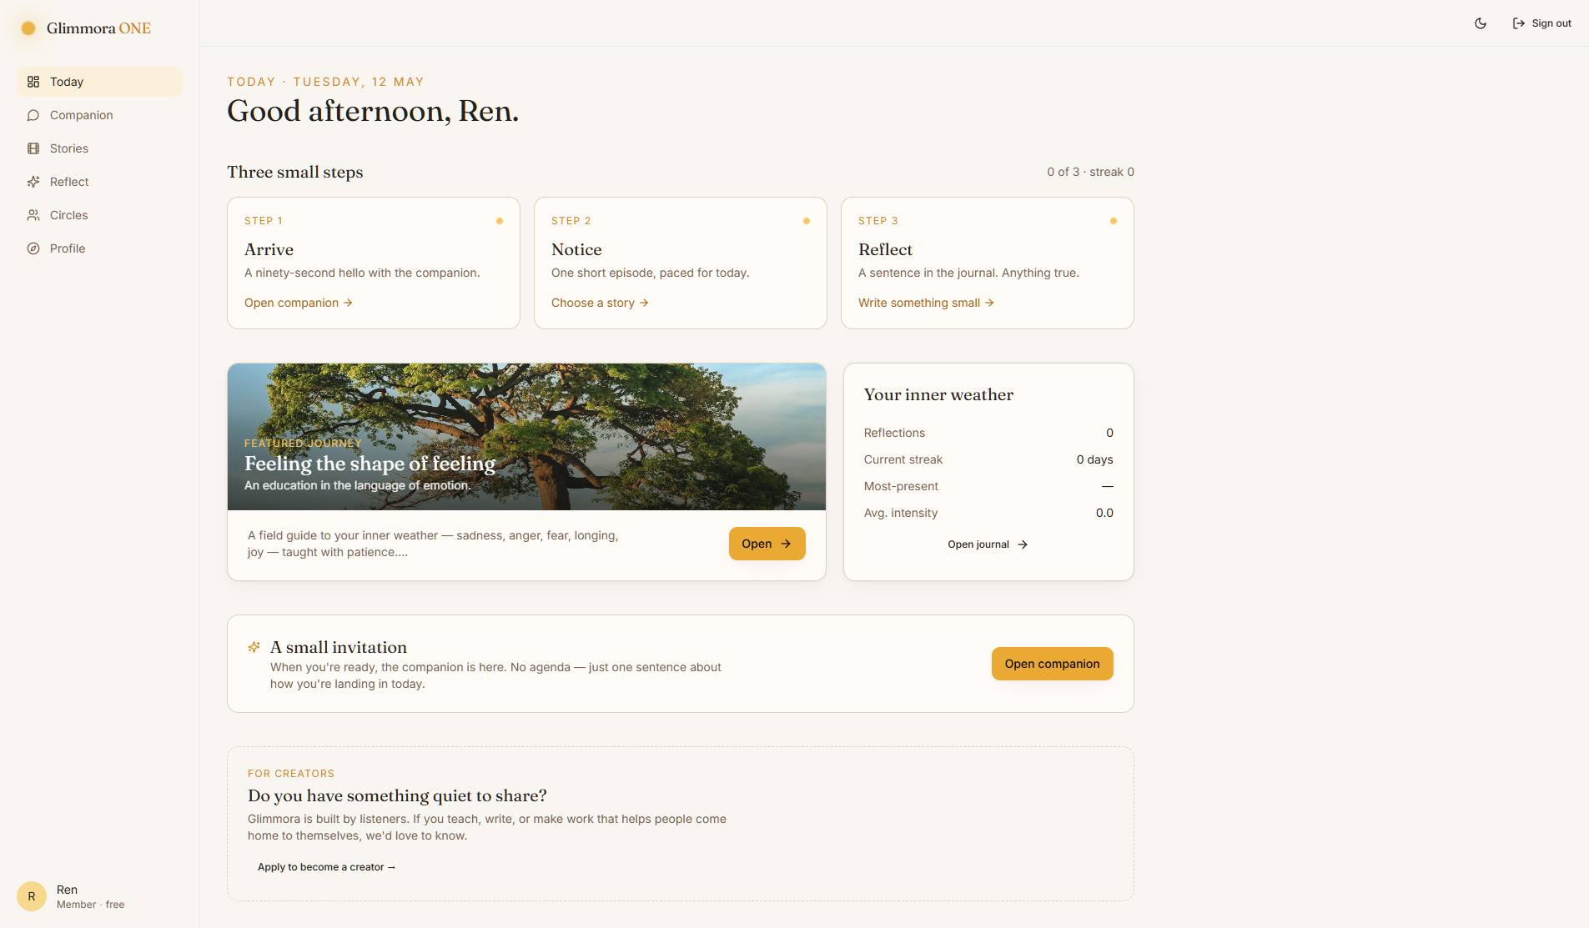
The dashboard for a brand-new member.
Step 7. Open the Companion (Step 1 — Arrive)
👉 You do: Click the 'Open companion' link on the first small-step card. (Or click 'Companion' in the left sidebar.)
👀 You should see: An empty chat with the headline 'I'm here.' and four friendly starter sentences you can tap. Below is a text box to type your own message.
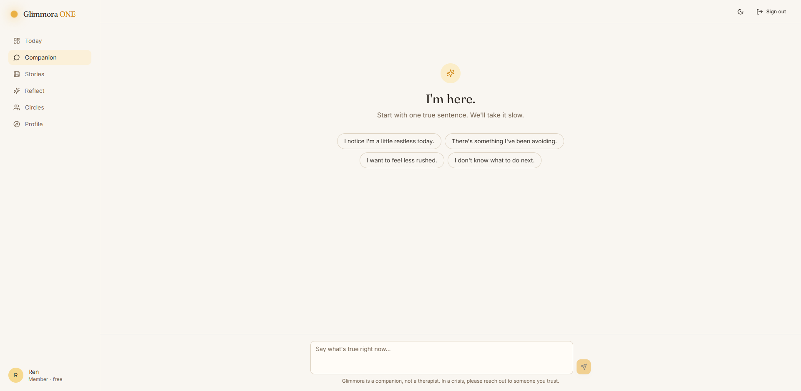
The empty Companion view.
Step 8. Talk to the Companion
👉 You do: Click a starter sentence (or type one and press Enter).
👀 You should see: Your message appears on the right in a peach bubble. After a moment, the Companion replies on the left. Below the reply is a card with 'A question to sit with' — that's your suggested reflection.
Step 9. Test the safety net (carefully)
👉 You do: Type a message with crisis words in it, like: 'honestly I want to die tonight'. Press Enter.
👀 You should see: A rose-colored card appears with helplines for India, US/Canada, UK, and a global directory. The Companion still replies kindly. This card only appears for very direct words — gentle/oblique sadness does NOT trigger it (that's on purpose).
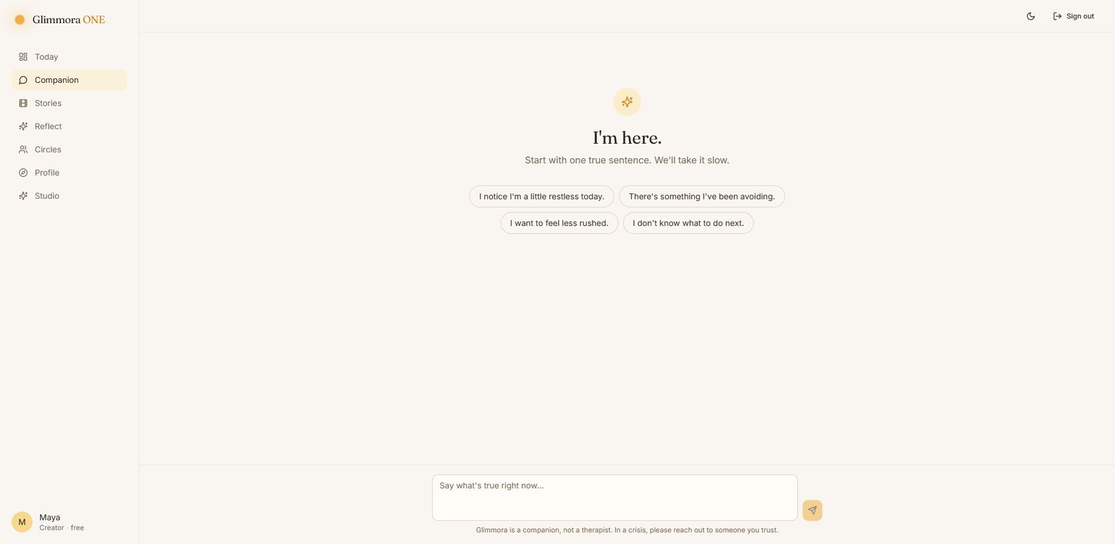
The crisis safety card.
Step 10. Write a reflection (Step 3 — Reflect)
👉 You do: Go to /reflect/new (or click 'Reflect' in the sidebar, then 'New reflection'). Type one sentence. Tap a mood (like 'hopeful'). Drag the intensity slider. Click 'Save reflection'.
👀 You should see: You land on the Reflect home page. The four stats at the top now show Reflections: 1, Day streak: 1, Most-present: hopeful, Avg. intensity: 5. Today's chip in the '30 days' row is colored. Your entry shows in the journal.
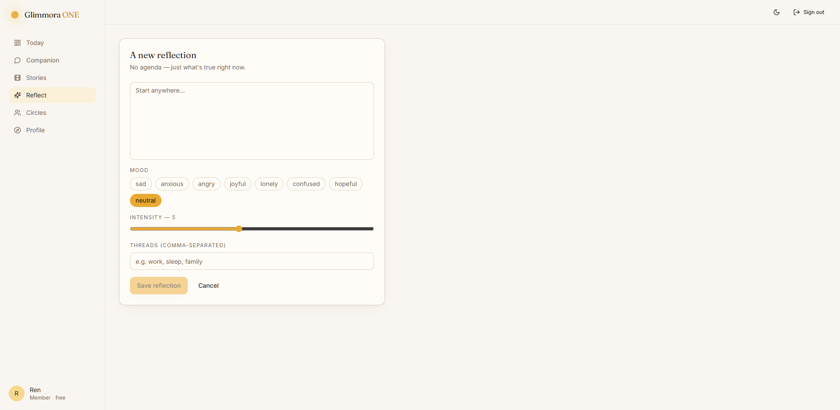
Writing a reflection.
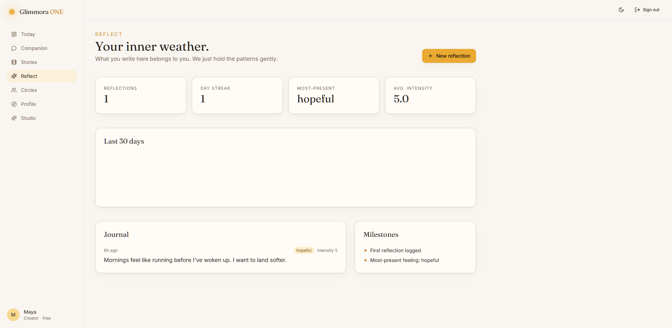
After saving — stats and journal updated.
Step 11. Browse Stories (Step 2 — Notice)
👉 You do: Click 'Stories' in the sidebar.
👀 You should see: A library page with three groups: Emotional intelligence, Growth, Meditation. Each group shows one or more series cards.
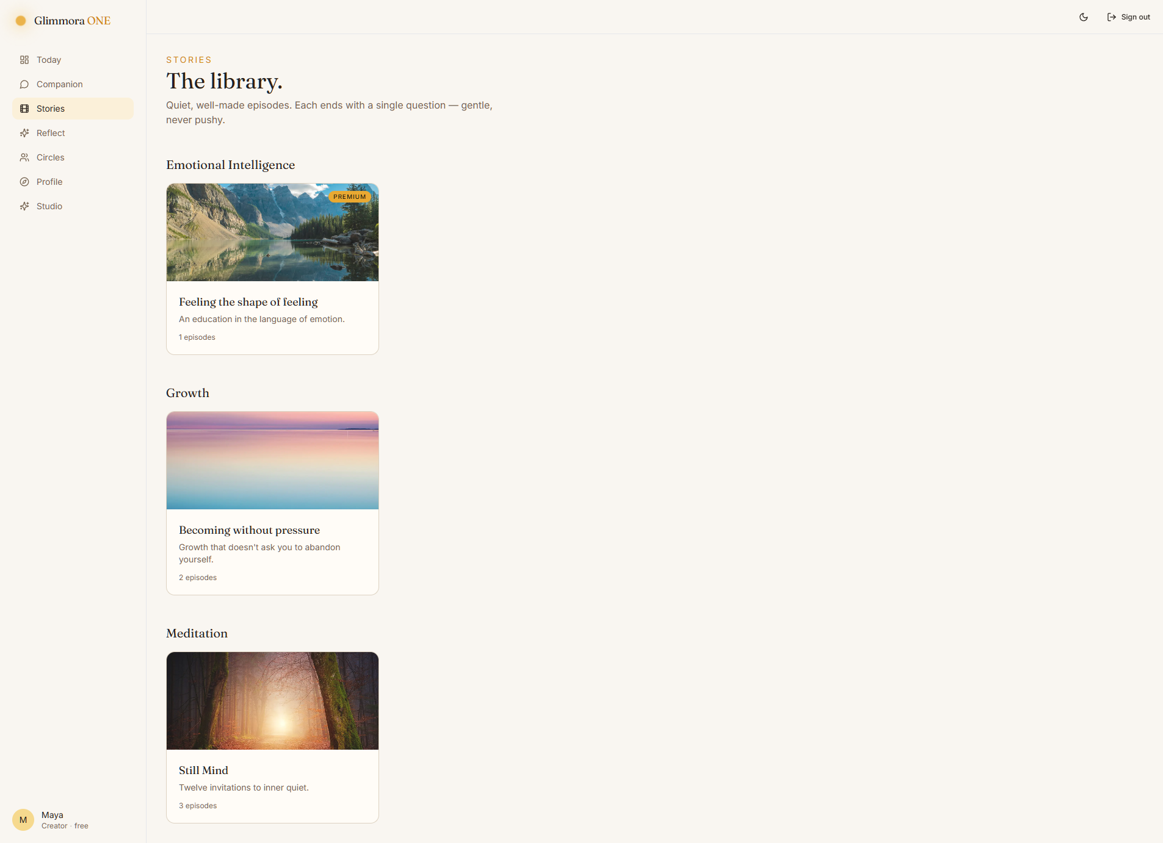
The stories library.
Step 12. Open a series
👉 You do: Click on 'Still Mind'.
👀 You should see: The series page shows the cover, a tagline 'Twelve invitations to inner quiet', and a list of episodes with durations.
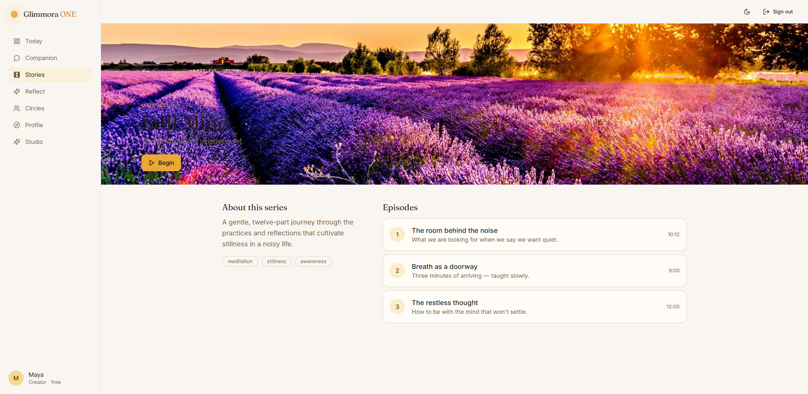
A series page.
Step 13. Open Circles
👉 You do: Click 'Circles' in the sidebar.
👀 You should see: Three quiet community spaces: Becoming, First Light, The Quiet Circle. Each is anonymous — you only ever appear as a quiet handle.
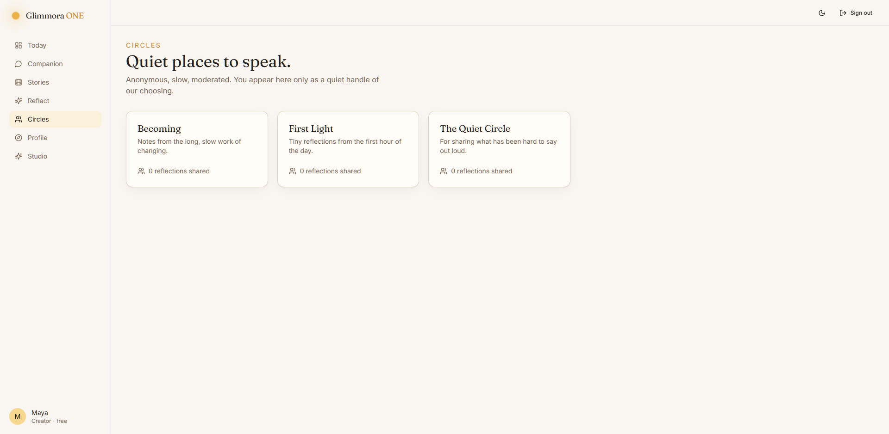
The Circles list.
Step 14. Open Profile
👉 You do: Click 'Profile' in the sidebar.
👀 You should see: Three cards: 'You' (edit your name/bio), 'Your role' (says you are a Member and what that means), 'Membership' (Glimmora Free).
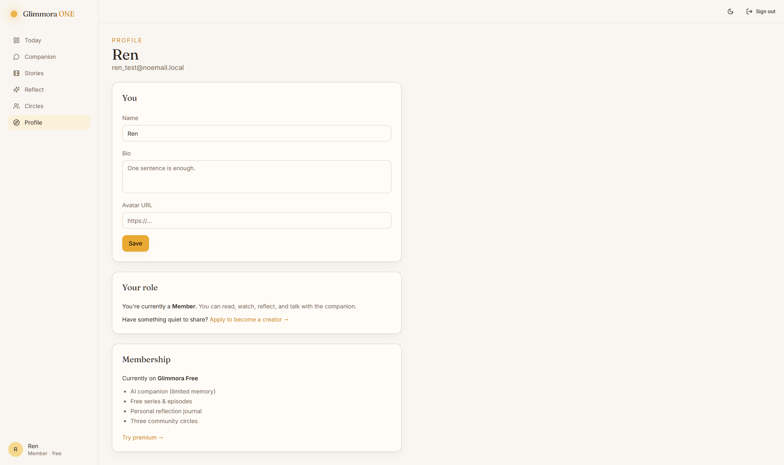
The Profile page as a Member.

Part B — Becoming a Creator
Now we make the same Member into a Creator. This takes two people (or one person who logs out and back in): the applicant, and the admin who approves.
Step 15. Apply to be a creator
👉 You do: While still logged in as the new member, go to /creator/apply. Write a sentence or two about what you'd like to share. Click 'Send application'.
👀 You should see: The page now shows 'YOUR APPLICATION — PENDING' with your words in italics. On the dashboard, the 'Apply' callout is replaced by a 'We're reading your application' card.
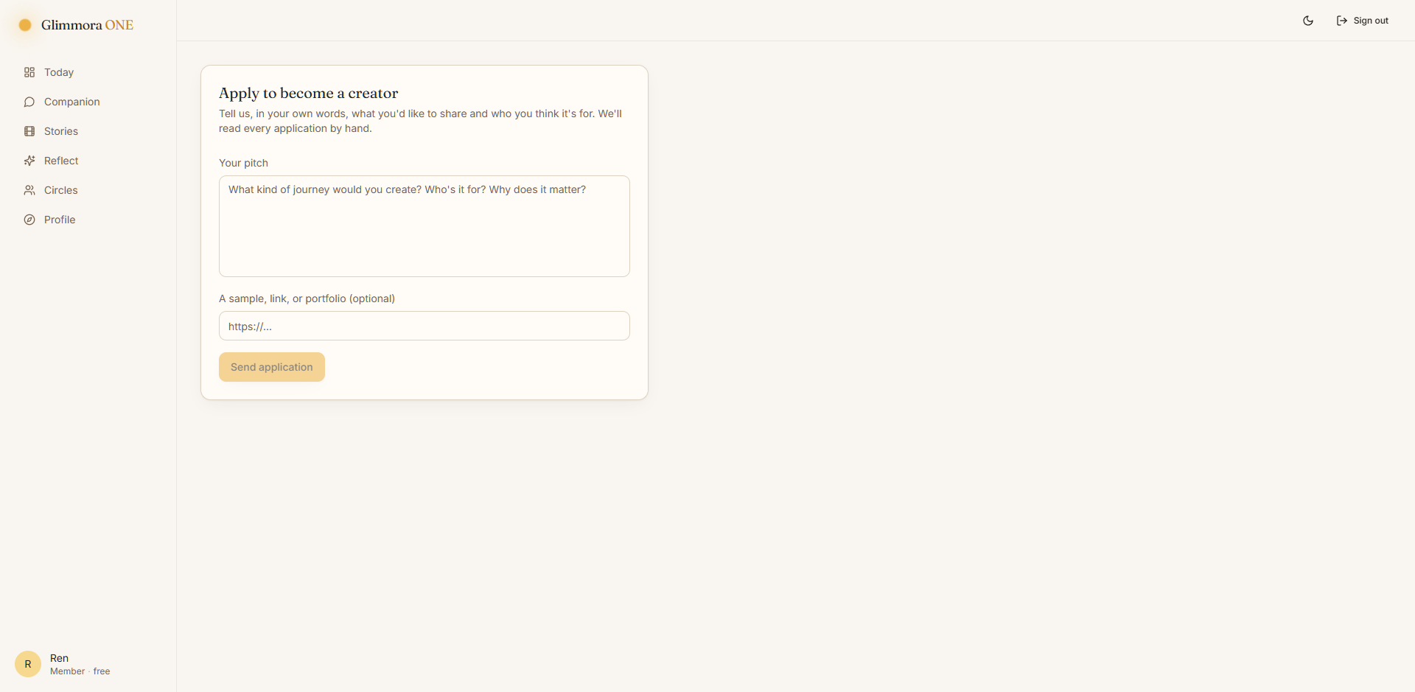
The Apply to become a creator form.
Step 16. Log out, log in as the boss
👉 You do: Click 'Sign out' (top-right header). Go to /login. Username: superadmin. Password: ChangeMe!2026.
👀 You should see: You land on the dashboard as superadmin.
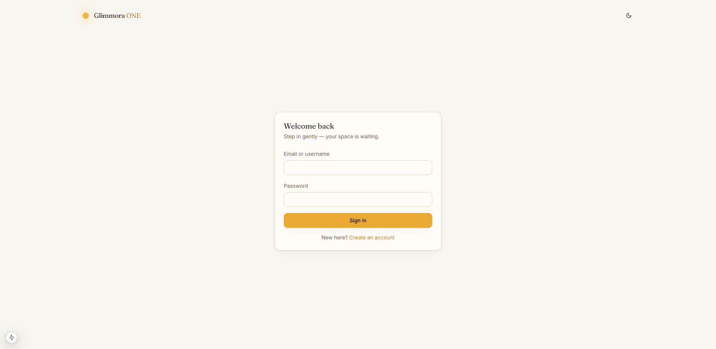
The login page.
Step 17. Open Admin and approve the application
👉 You do: Click 'Admin' in the sidebar (it only appears for admins). Find your test user's pitch under 'Creator applications'. Click 'Approve'.
👀 You should see: The pitch row updates to APPROVED. The user's role in the Users table flips from 'member' to 'creator'.
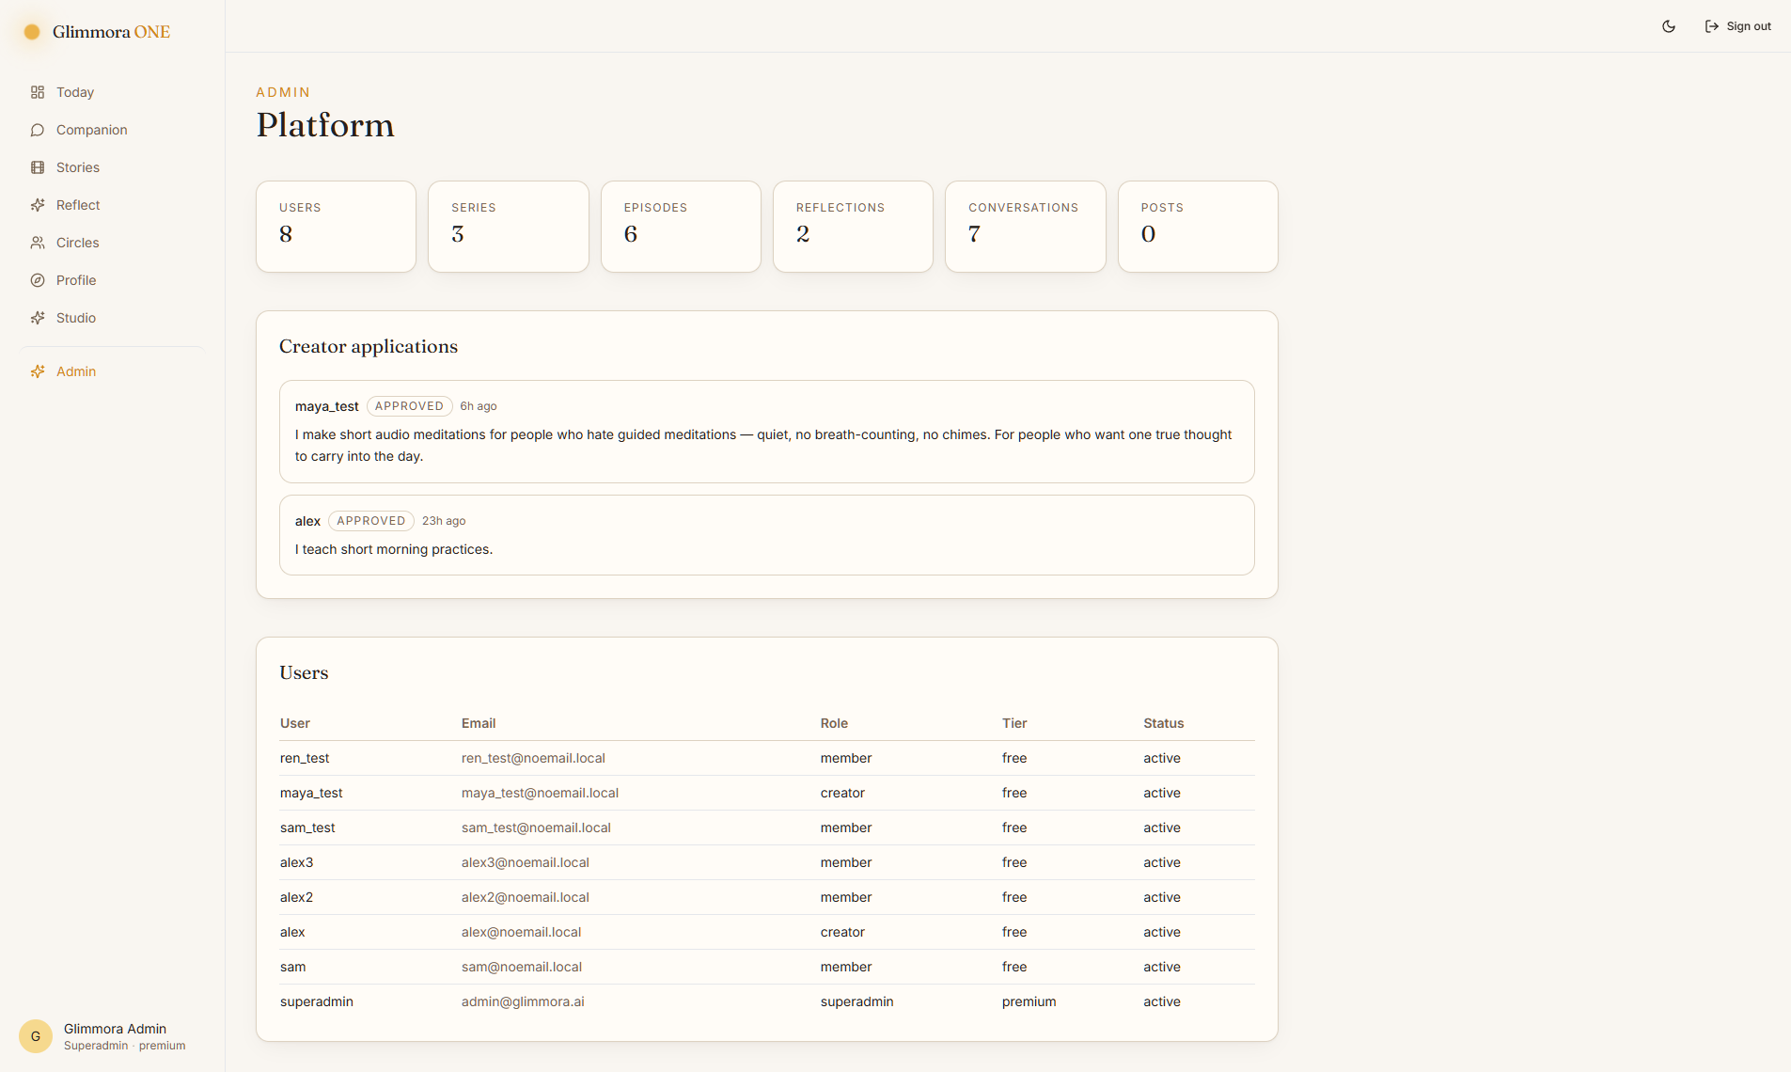
The Admin page with applications + user list.
Step 18. Log back in as the new creator
👉 You do: Sign out. Log in with the test user's username and password.
👀 You should see: The sidebar now reads '<Name> · Creator · free'. A new 'Studio' link appears in the sidebar.
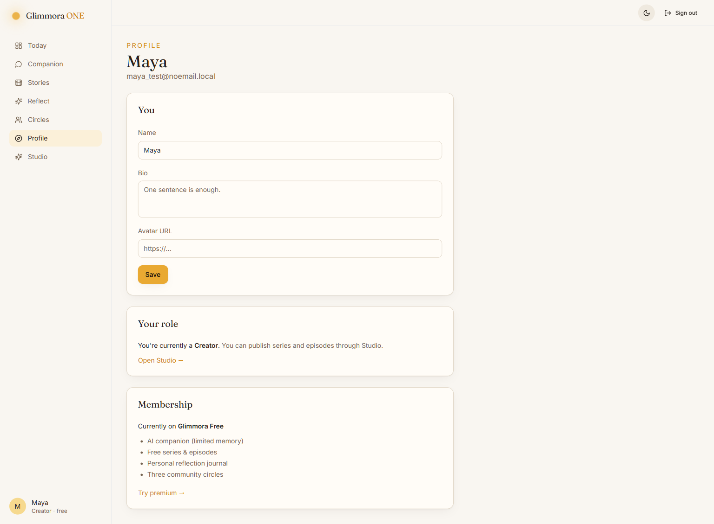
The Profile page now says 'Creator'.
Step 19. Open Studio
👉 You do: Click 'Studio' in the sidebar (or go to /creator).
👀 You should see: You can see your series, an analytics card, and a 'New series' button. Click into '+ New series' to add one; then add episodes inside it.
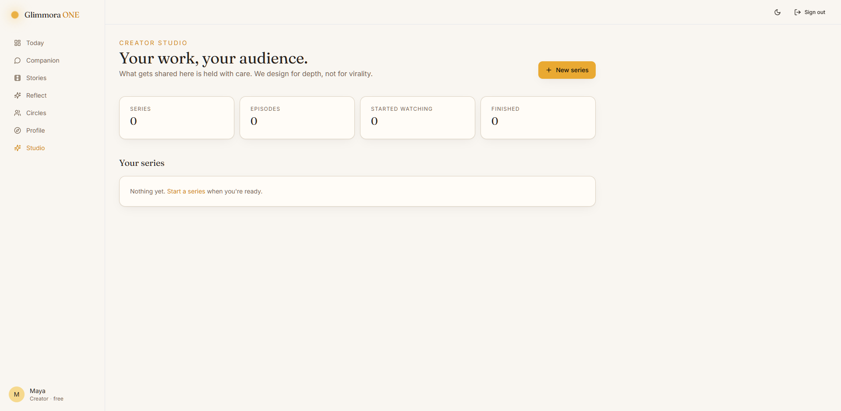
The Creator Studio.

Part C — Quick checklist by role
Anonymous visitor
- / landing renders without a login.
- /login and /signup show a theme toggle.
- Going to /dashboard sends you to /login.
Member (the default new user)
- Signup goes straight to /onboarding (no flicker).
- Sidebar shows 'Member · <tier>'.
- No 'Studio' or 'Admin' links in the sidebar.
- Going to /admin or /creator gives a not-allowed page.
Creator
- All Member powers, plus a Studio link.
- Can create series + episodes.
- Still cannot open /admin.
Admin / Superadmin
- All Creator powers, plus an Admin link.
- Can approve or deny applications.
- Approving an application instantly makes that user a creator.

Part D — If something looks wrong
These are the most common gotchas, in plain English:
- Blank page after signup → that bug was fixed in v0.2.1. If you see it, the dev server is probably caching old code — stop it, run 'pnpm dev' again.
- Login works but dashboard is empty → the session cookie was dropped. Make sure you're on http://127.0.0.1:3000 (NOT https), and that the dev server is in dev mode, not 'next start'.
- Crisis card didn't show for a sad message → that's on purpose. It only triggers on very explicit words (suicide, want to die, hurt myself…). Better to under-react than over-react.
- Backend won't start: port 8000 is busy → run: taskkill /F /IM uvicorn.exe then start again.

